AI-ASSISTED CODING
ASSIGNMENT-11.1
NAME:: SARAB RAJESH
2303A52459

TASK-1

Prompt
Generate a Stack class in Python with push, pop, peek, and is_empty methods including proper docstrings

CODE

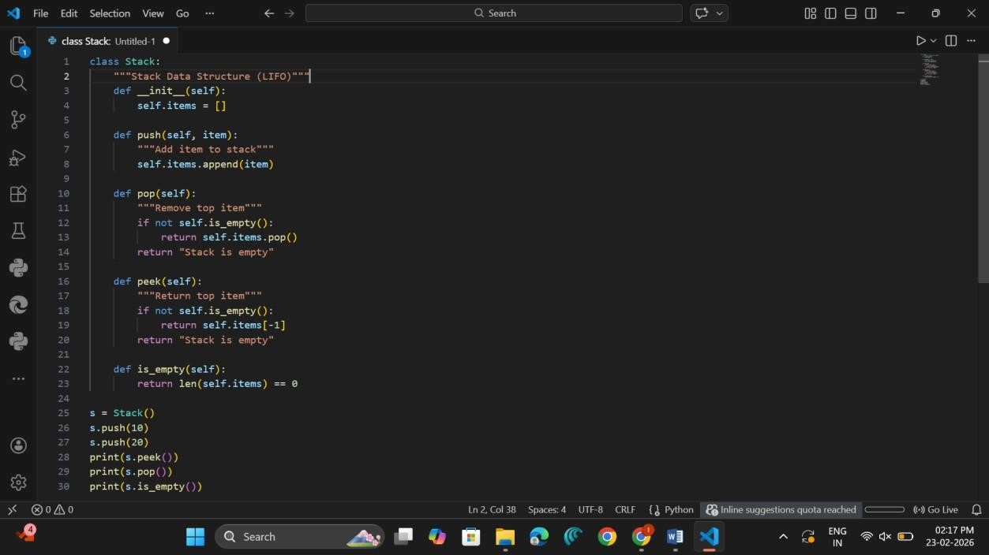

OUTPUT

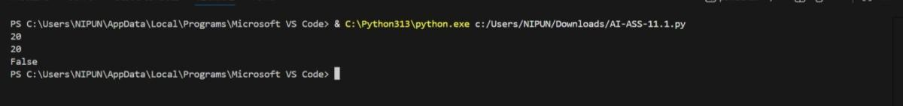

Observation
The Stack follows the LIFO (Last In First Out) principle, meaning the last element inserted is removed first.
The push() and pop() operations both take O(1) time, making it efficient. The peek() method helps to check the top element without removing it.

Stacks are commonly used in function calls, undo/redo operations, expression evaluation, and backtracking algorithms.
Since it uses a Python list, memory grows dynamically.
TASK-2
Prompt
Implement a Queue using Python list with enqueue, dequeue, peek, and size methods.

CODE

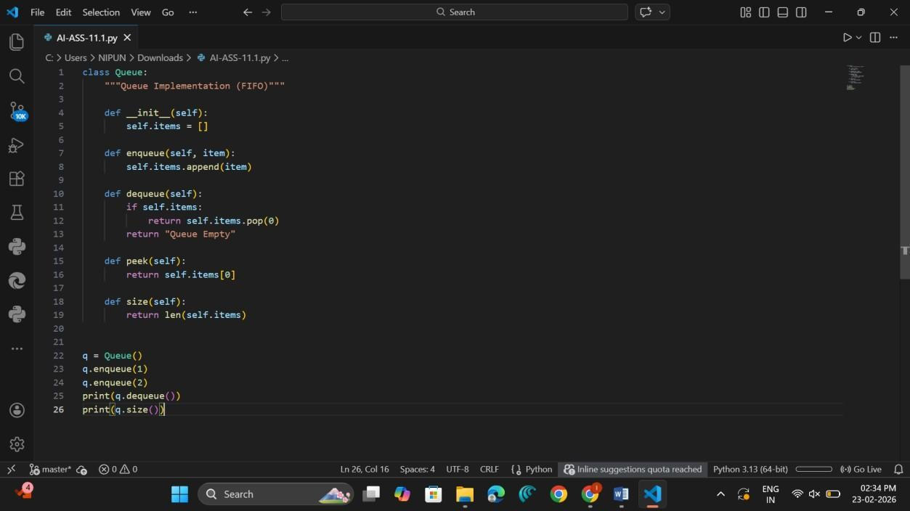

OUTPUT

Observation
The Queue follows the FIFO (First In First Out) principle, meaning elements are processed in the order they are inserted.
The enqueue() operation takes O(1) time, while dequeue() using list pop(0) takes O(n) time due to element shifting.
Queues are commonly used in scheduling systems, printer queues, BFS traversal, and service systems where fairness is required.
TASK-3

Prompt
Generate a Singly Linked List with insert and display methods.

CODE

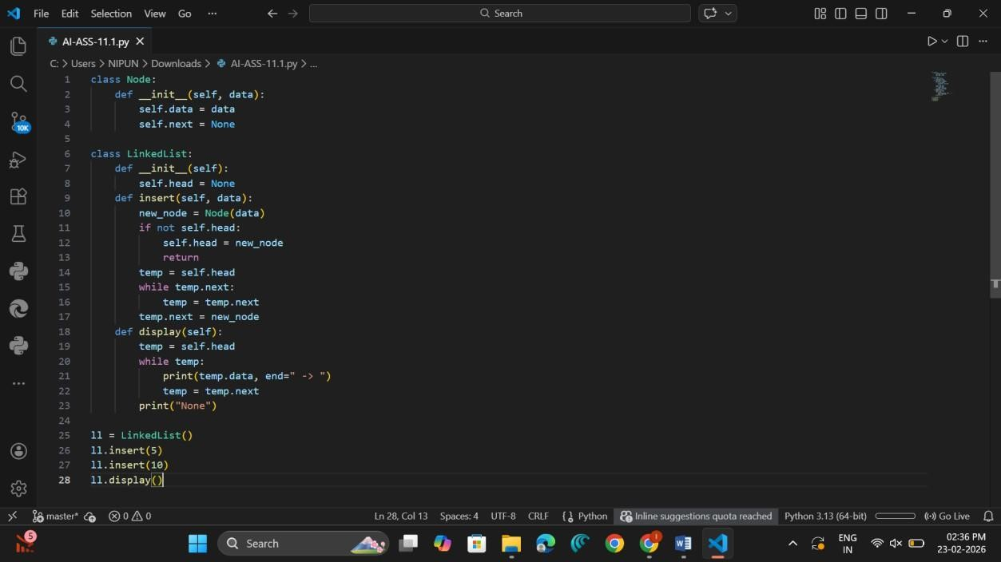

OUTPUT

Observation
A Linked List stores elements in nodes connected by pointers instead of contiguous memory locations.
It allows dynamic memory allocation and flexible insertion or deletion of elements. Insertion at the beginning takes O(1), but insertion at the end requires traversal, so it takes O(n).
Linked Lists are useful in implementing stacks, queues, and dynamic memory structures.
TASK-4

Prompt
Create a BST with insert and inorder traversal methods.

CODE

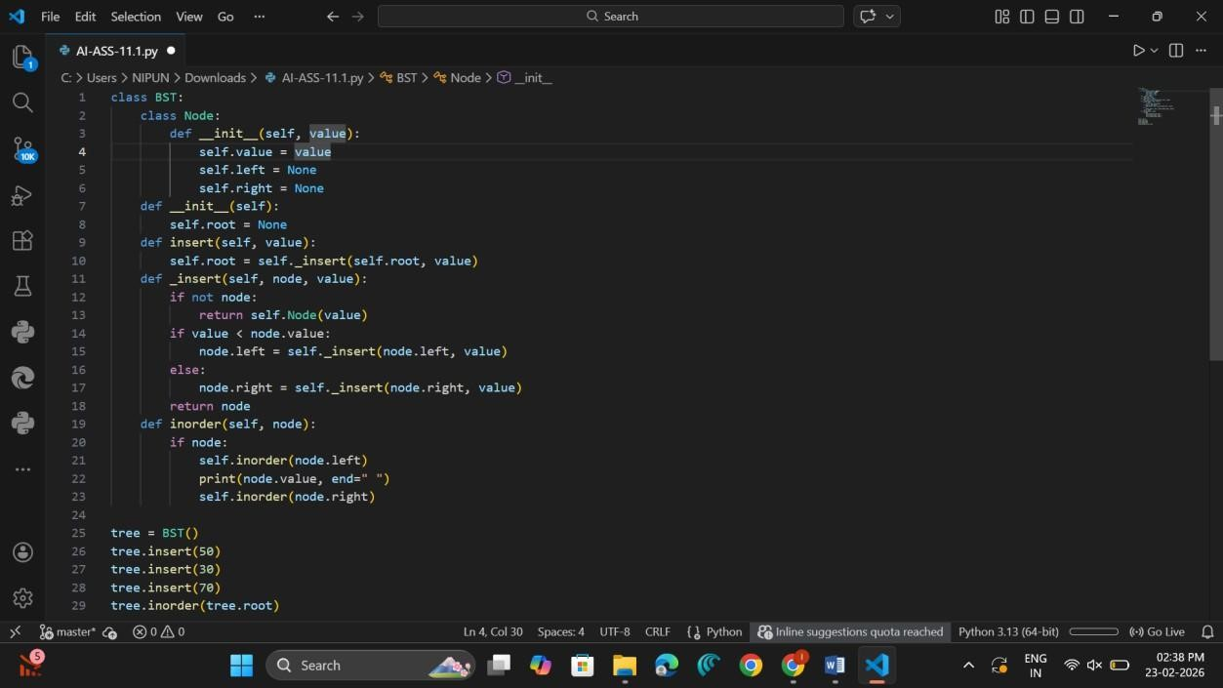

OUTPUT

Observation
A Binary Search Tree maintains elements in sorted order by placing smaller values on the left and larger values on the right.
Insertion and search operations take O(log n) time on average, but O(n) in worst case if the tree becomes unbalanced.
In-order traversal prints elements in ascending sorted order.
BSTs are widely used in searching, sorting, and database indexing applications.

TASK-5

Prompt
Implement a Hash Table with insert and search methods.

CODE

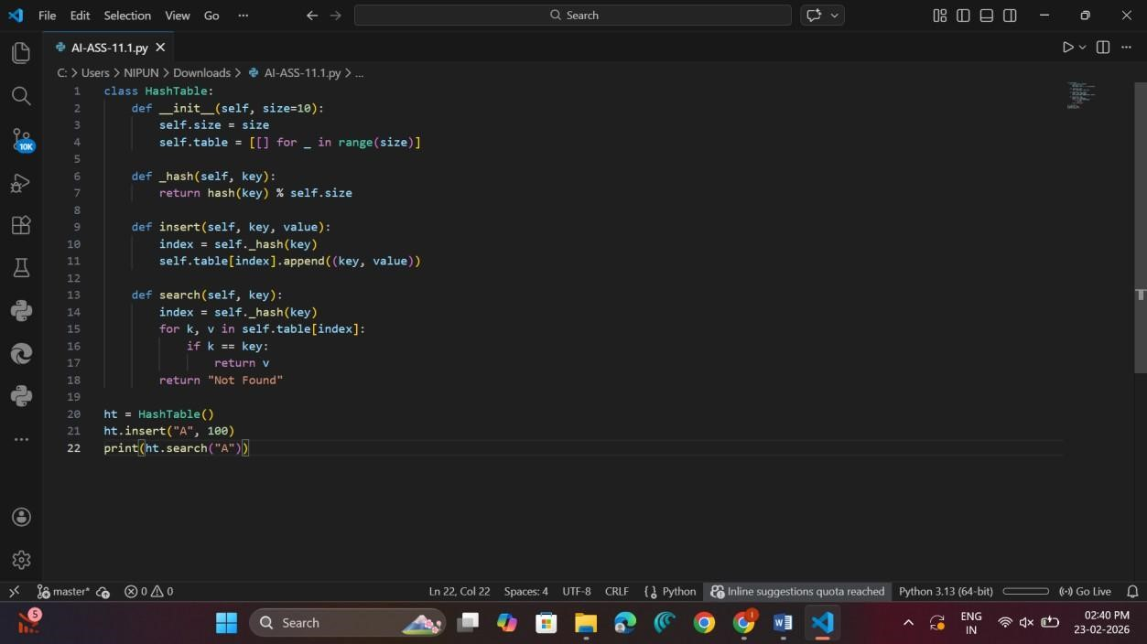

OUTPUT

Observation
A Hash Table stores key-value pairs using a hash function to compute index positions.
It provides average O(1) time complexity for insert, search, and delete operations.
Collisions are handled using chaining, where multiple values are stored in the same bucket. Hash Tables are widely used in dictionaries, caching systems, and fast lookup applications.
TASK-6

Prompt
Implement a Graph using adjacency list.

CODE

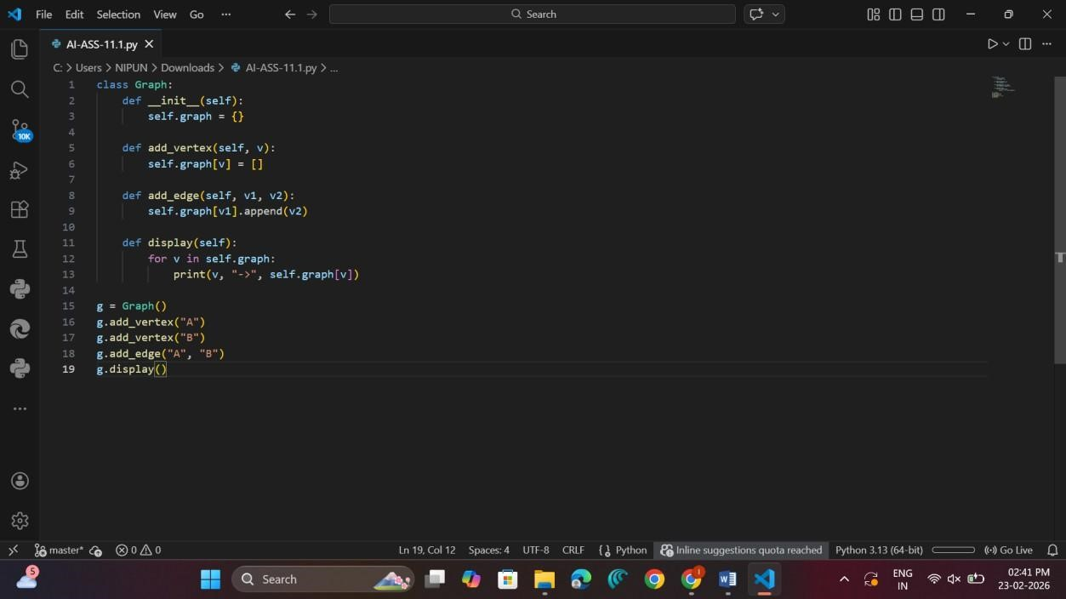

OUTPUT

Observation
A Graph represents relationships between nodes using edges.
In adjacency list representation, each vertex maintains a list of connected vertices, making it memory efficient.
Graphs are used in route planning, social networks, and communication systems.
Traversal algorithms like BFS and DFS are commonly applied to explore graph structures.
TASK-7

Prompt
Implement a Priority Queue using heapq.

CODE

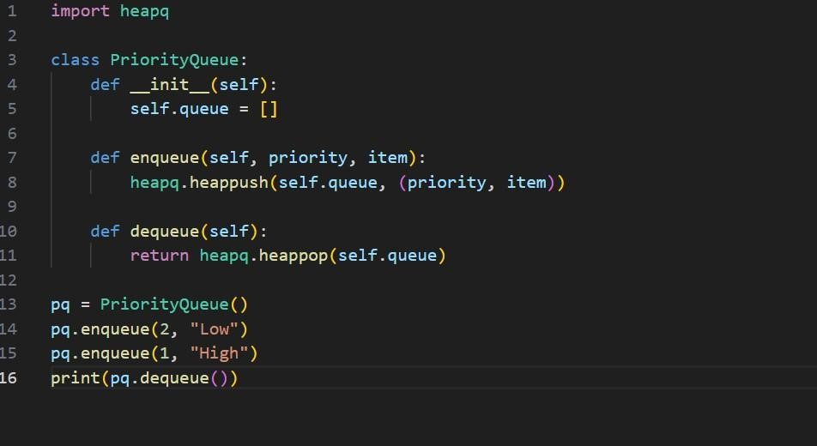

OUTPUT

Observation
A Priority Queue removes elements based on priority rather than insertion order.
It is implemented using a heap structure, where insertion and deletion take O(log n) time.
Elements with higher priority are processed first.
Priority Queues are used in scheduling systems, Dijkstra’s algorithm, and task management systems.
TASK-8

Prompt
Implement a Deque using collections.deque.

CODE
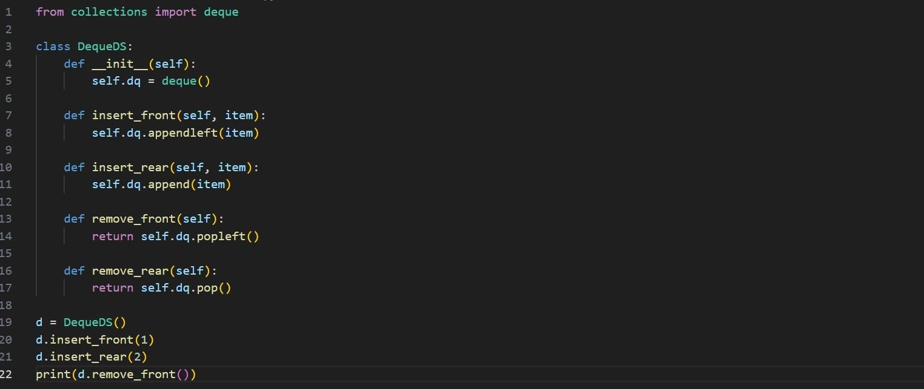

OUTPUT

Observation
Deque (Double Ended Queue) allows insertion and deletion from both front and rear ends.
Using collections.deque, operations such as append and pop take O(1) time.
It provides more flexibility compared to a normal queue.
Deque is commonly used in sliding window problems, palindrome checking, and caching mechanisms.
TASK-9

Prompt
Select suitable data structure for cafeteria order queue and implement it.

CODE
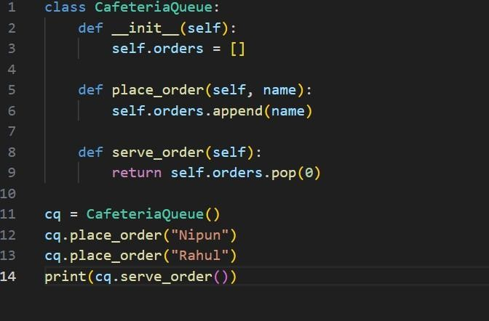

OUTPUT

Observation
In the campus system, different data structures are chosen based on functionality.
Queue is suitable for cafeteria orders and attendance tracking because it follows FIFO order.
Hash Table is useful for event registration due to fast search and deletion.
Graph is ideal for bus scheduling since routes and stops form network connections. Selecting appropriate data structures improves system efficiency and performance.
TASK-10

Prompt
Implement product search using Hash Table.

CODE
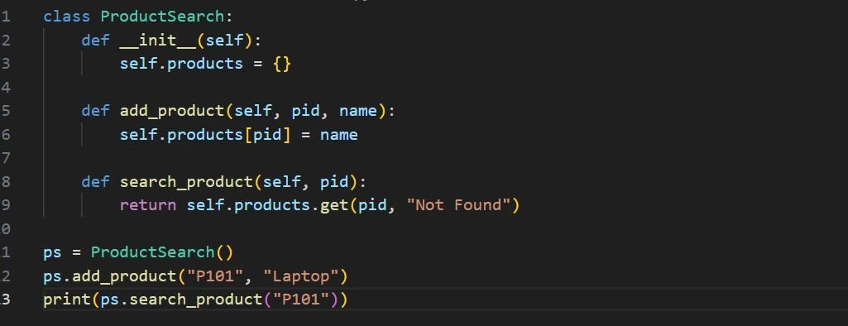

OUTPUT

Observation
In the e-commerce system, different data structures solve different problems efficiently.
Hash Table is best for product search because it provides O(1) lookup time.
Queue is suitable for order processing since orders are handled in arrival order.
Priority Queue helps track top-selling products based on sales priority.
Using the correct data structure ensures fast performance and scalability of the system.

