Task-1A
Observe layout of data in memory using gdb
Define variables of different types initialized with predefined data. The variables should be local variables, global variables, static variables, constants. Put a break point in gdb on main function and observe the memory layout of the variables in memory. Understand stack and heap memory areas.
// observe layout of data in memory using gdb

#include <stdio.h>
#include <stdlib.h>

//defining constants
#define CONST_INT 500
#define CONST_FLOAT 600.5

//global variables
int g_var = 100;
float g_float = 200.5;

//static variables
static int s_var = 300;
static float s_float = 400.5;

int main() {
//local variables
int l_var = 700;
float l_float = 800.5;

//defining constants
const int c_var = 900;
const float c_float = 500.5;
const int a = CONST_INT;
const float b = CONST_FLOAT;

printf("Address of g_var: %p\n", (void*)&g_var);
printf("Address of g_float: %p\n", (void*)&g_float);
printf("Address of s_var: %p\n", (void*)&s_var);
printf("Address of s_float: %p\n", (void*)&s_float);
printf("Address of l_var: %p\n", (void*)&l_var);
printf("Address of l_float: %p\n", (void*)&l_float);
printf("Address of c_var: %p\n", (void*)&c_var);
printf("Address of c_float: %p\n", (void*)&c_float);
printf("Address of CONST_INT: %p\n", (void*)&a);
printf("Address of CONST_FLOAT: %p\n", (void*)&b);
return 0;
}
Break point 1
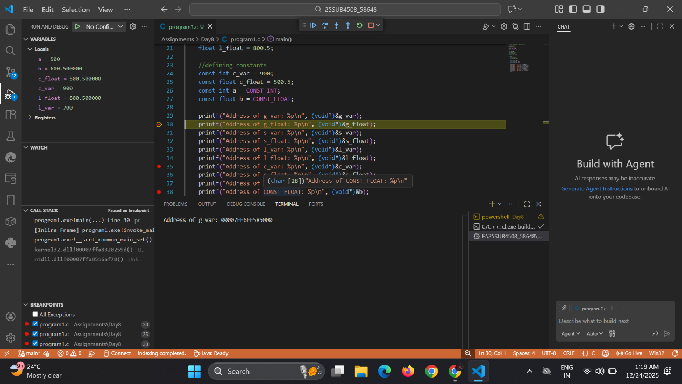
Call stack
Break point 3
Break point 2

Call stack:
- call stack keep track of function calls and variable we use .call stack is a stack follows LIFO order to provide faster access.
- Data exist here until function execution feed freed here.
- Automatic Memory allocation
- Exception –StackOverFlow error

Heap Memory:
- Heap memory follows first in first out (FIFO).
- Manual memory allocation, we need to free it.
- Slower accesss due to dynamic allocation
- Execution – OutofMemoryError

