Linux History and philosophy
Linux began in 1991 with Linus Torvalds creating a free kernel, combining it with GNU tools for a full OS, driven by the philosophy of free and open-source software (FOSS), emphasizing collaboration, transparency, user freedom (to use, study, modify, share), and a decentralized approach, growing from a hobby into powering servers, Android, supercomputers, and more, contrasting proprietary models.
History of Linux
- 1991: Finnish student Linus Torvalds started developing a Unix-like kernel as a personal project, inspired by the MINIX OS, aiming for a free alternative to proprietary systems.
- Early Development: Torvalds released his kernel's source code, and it quickly grew through global developer contributions, combining with the GNU Project's free tools to form complete operating systems (distributions like Debian, Red Hat).
- Licensing Shift: Initially restricted, the kernel adopted the GNU General Public License (GPL) in 1992, ensuring its continued free and open nature.
- Growth & Adoption: Linux gained traction in servers, embedded systems, and eventually powered Android, supercomputers, cloud infrastructure, and became a stable, secure alternative to Windows/macOS.
Linux Philosophy
- Free & Open Source (FOSS)
- User Freedom
- Collaboration & Transparency
- Decentralization
- Customization & Control

- write a brief history of linux
- Creating a LinuxHistory.txt file and editing it in nano.

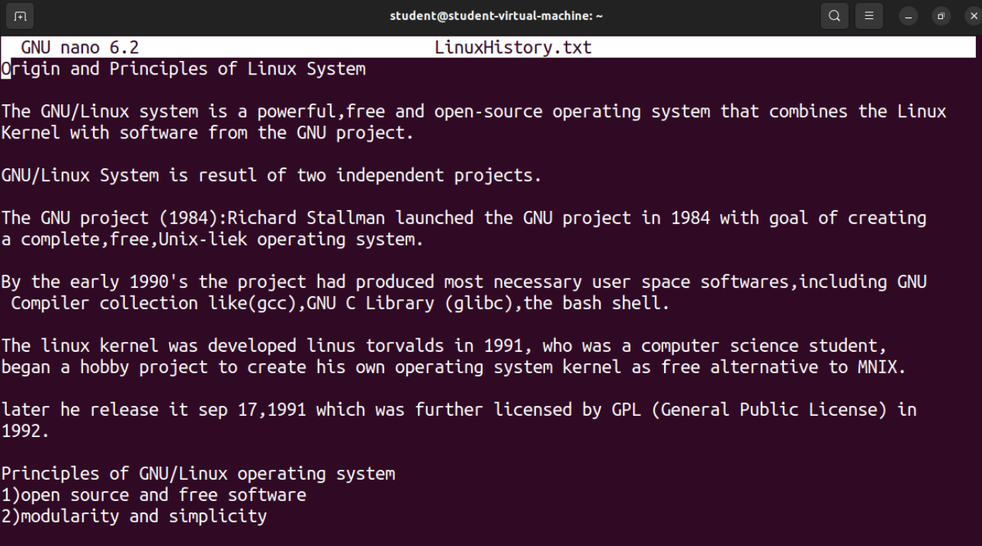

- File Navigation and Directory Structure
- ls – cmd used to display the files in a directory
- -l - flag used to list in vertical format
- -a – used to display the hidden files.
- pwd – cmd used to print the correct working directory.
- realpath – cmd also used to view the abspath of a file/folder.

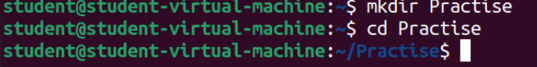
- mkdir – command use to create a make directory
- -p – flag used to create a non parent directory

- File management commands to organize files and directories
touch – cmd used to create any file in a directory or folder.
cp- cmd used to copy the file from one directory/folder to another directory or folder or within same directory or folder.
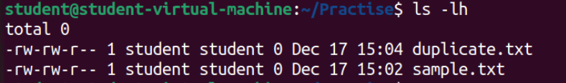

rm – command used to delete a file,folder,directory.

ssh

File Operations

1) Copying, Moving , Removing Files
cp- command used to copy the files
(eg) copying file root directory to specific folder

mv- command used to move files between folders and directories.
(eg) moving demo.cpp from p1 folder to root directory.

