LSP_Task2
1)create a directory structure /tmp/myfiles and navigate into it.
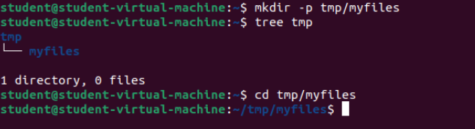

2)create three text files and write a sample content in each and list files in directory.
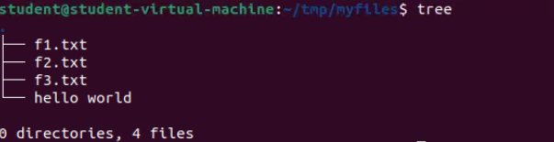
3) change permission for one of the file to read only for group.
