Define a pointer initialized with string constant. Observe using gdb, the address where pointer is stored, the address contained the pointer where the string is stored. Observe are they in different areas of data storage classes (stack, data section etc.).

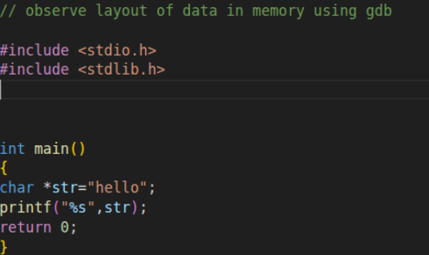

Observe where data is stored
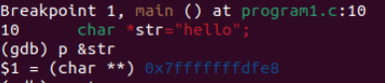
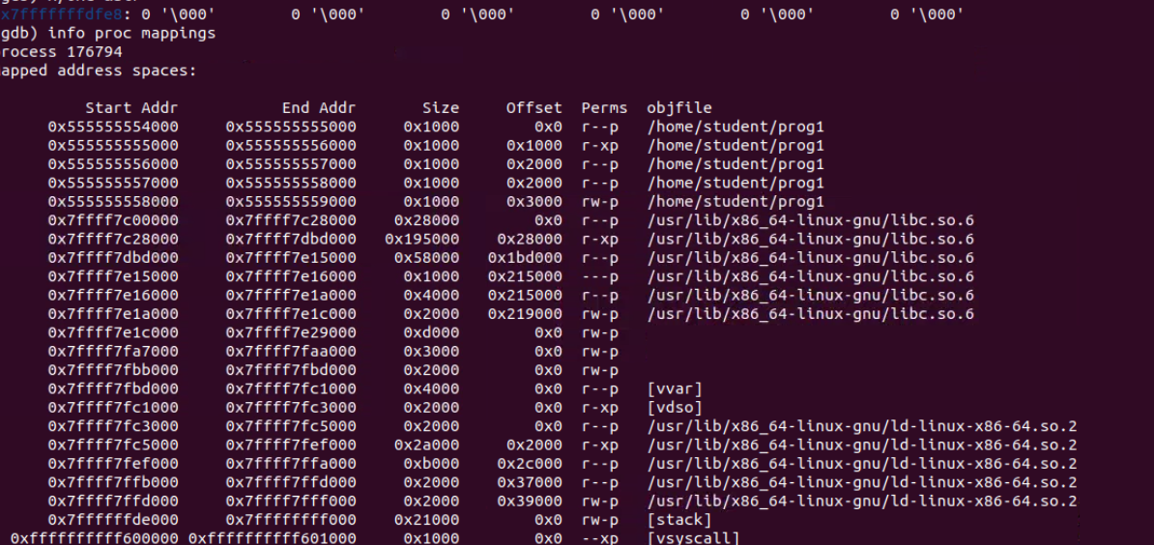

Printing literals
