Assignment -1
Text Processing and Automation - Write a bash script that uses grep, sed, and awk to list all login attemtps to a linux system, extract attempted user and error messages to a separate file.

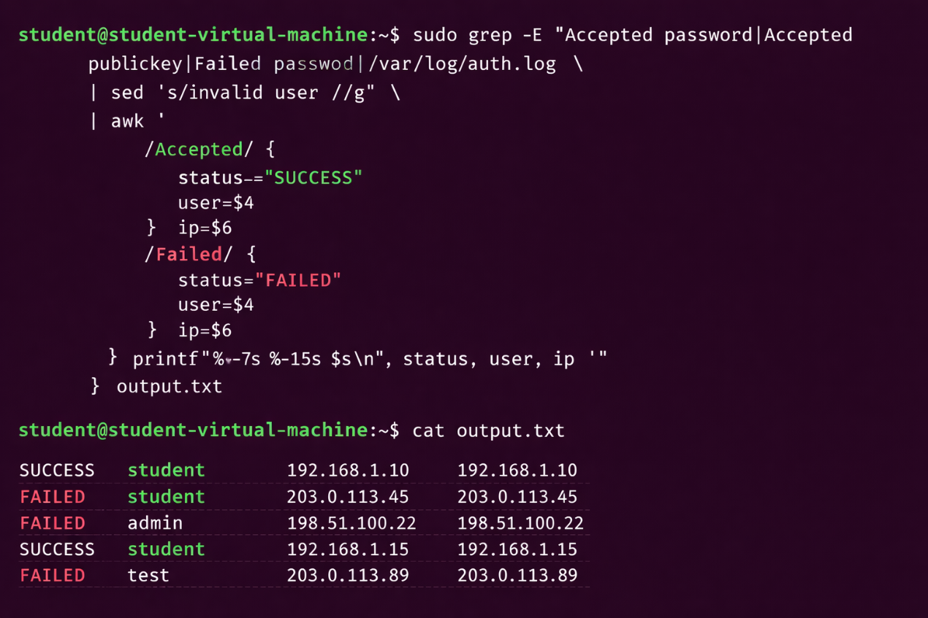

Assignment-2
Version Control with Git - Initialize a new Git repository, simulate making changes to a project by adding text files, and commit those changes. Create a new branch, make further changes in this branch, and merge it back to the main branch, resolving a simulated merge conflict.
#created a new git local repository and pushed changes to the remote repository.
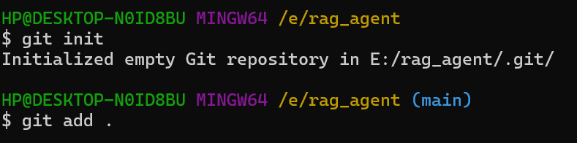
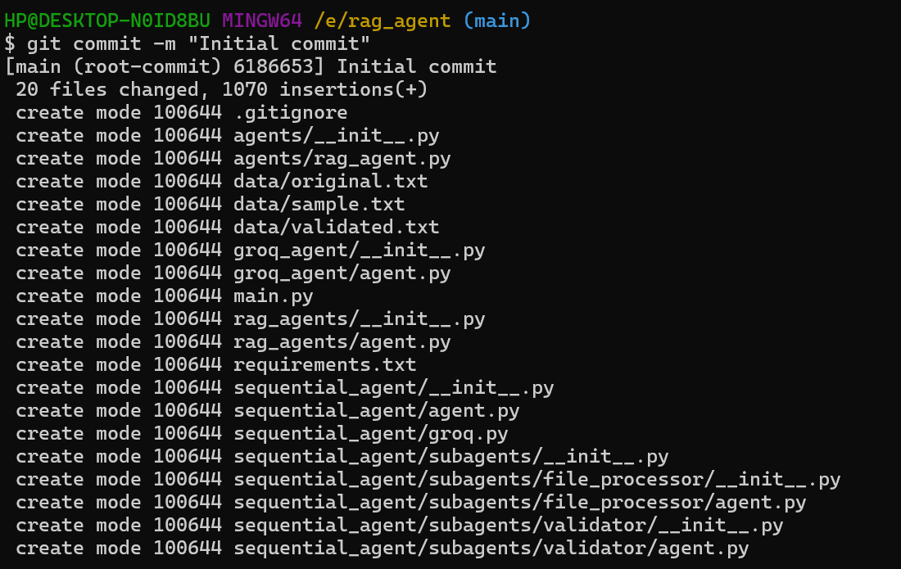
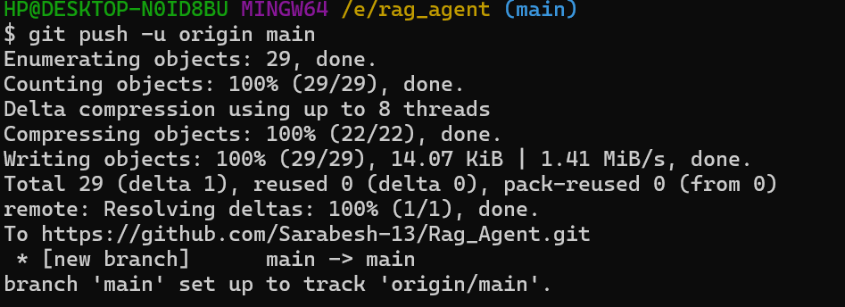

#now create another branch and made some changes, then merged changes to the main branch also.
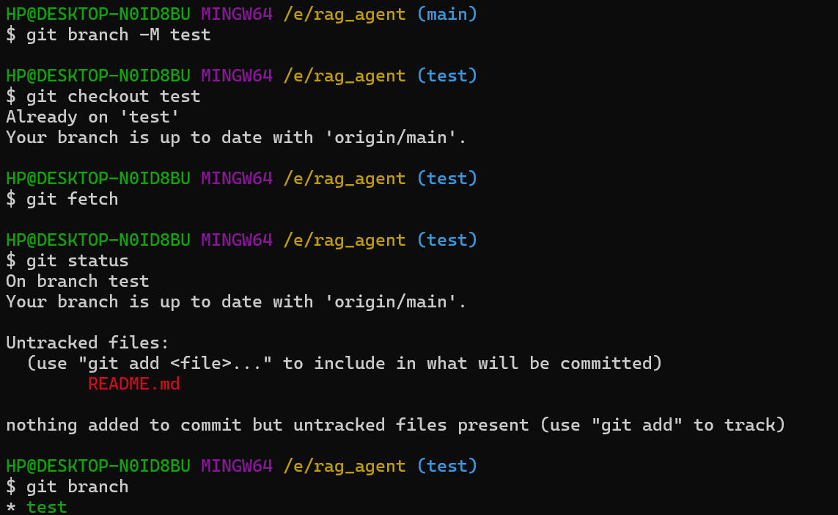
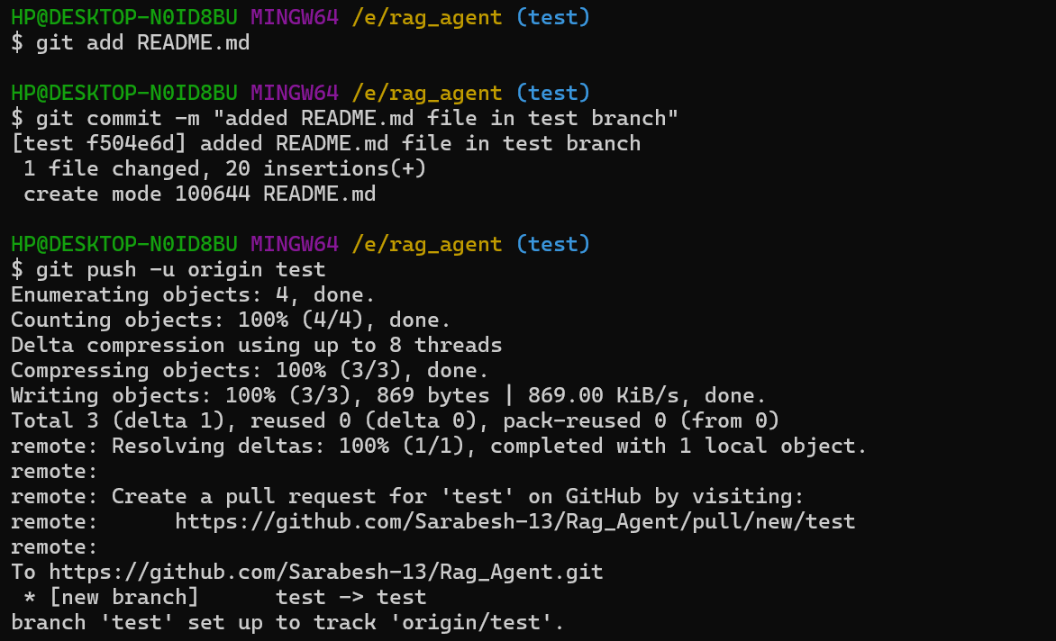
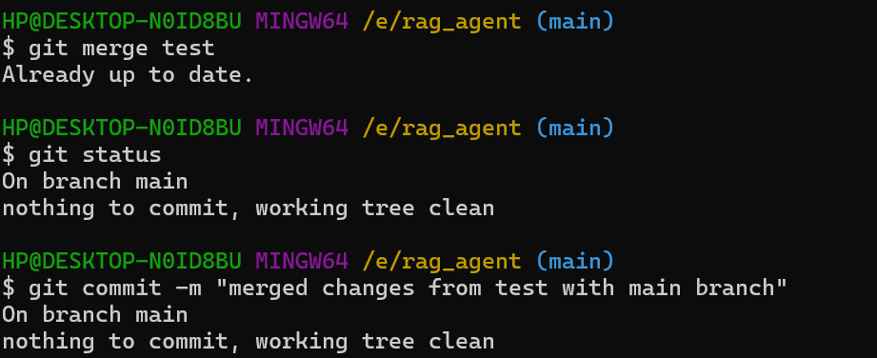
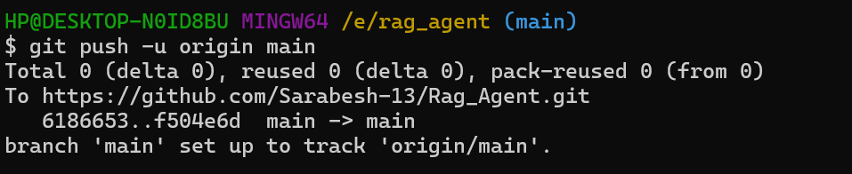

Assignment-3
Collaborative Development Using Git - Fork an existing repository (this can be a simulated action if no actual repository is available), clone it locally, and demonstrate managing updates from the original repository. Create a pull request to the original repository with changes made in the forked repository, and outline a simple code review process.
#fork an existing repository
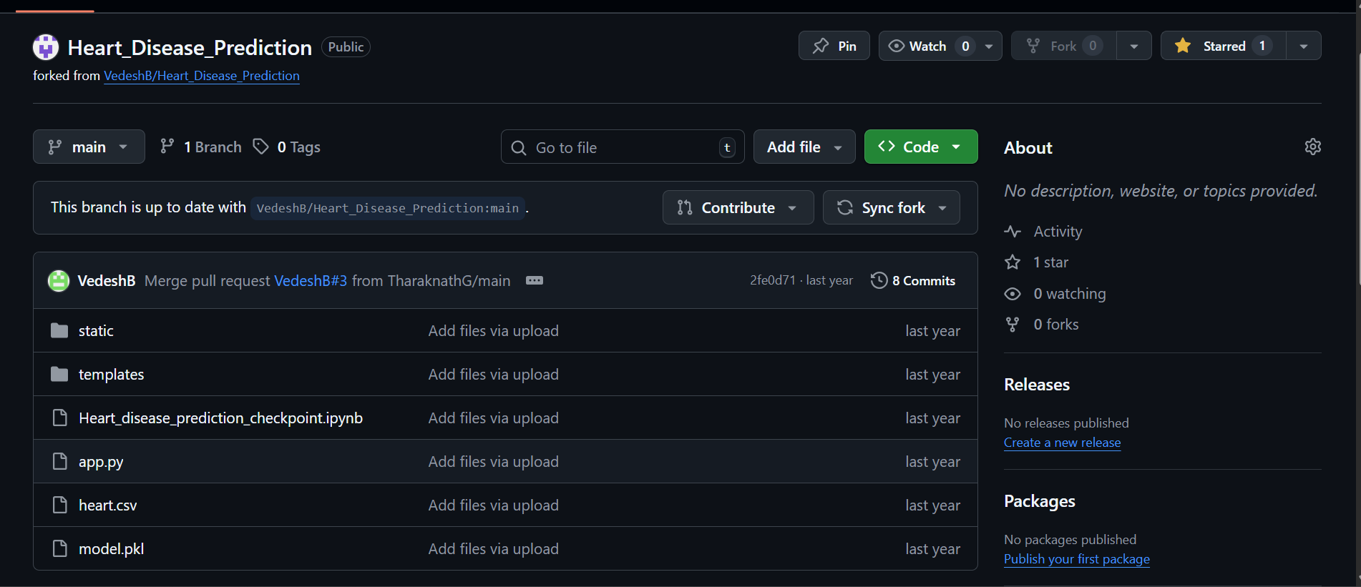

#cloning forked repository
This forked repository has link to the original repository we can make pull request to original repository and keep forked repo up to date.

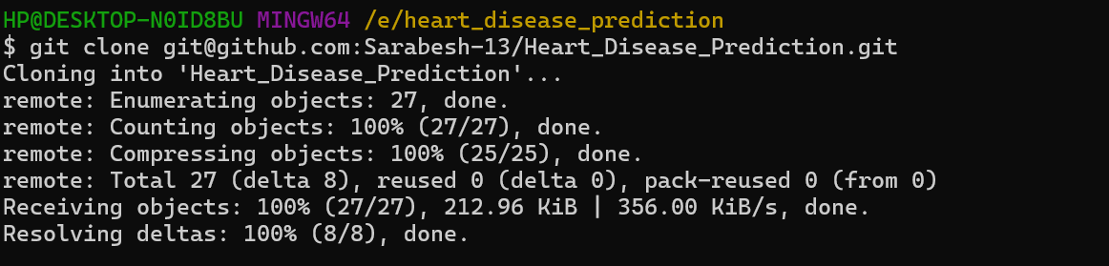

#add original repository as upstream
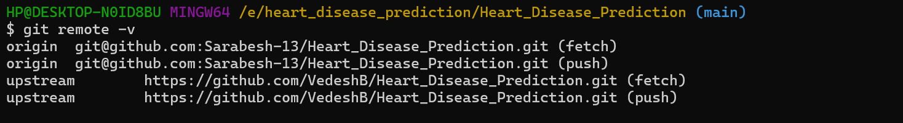

#make changes to fork repository
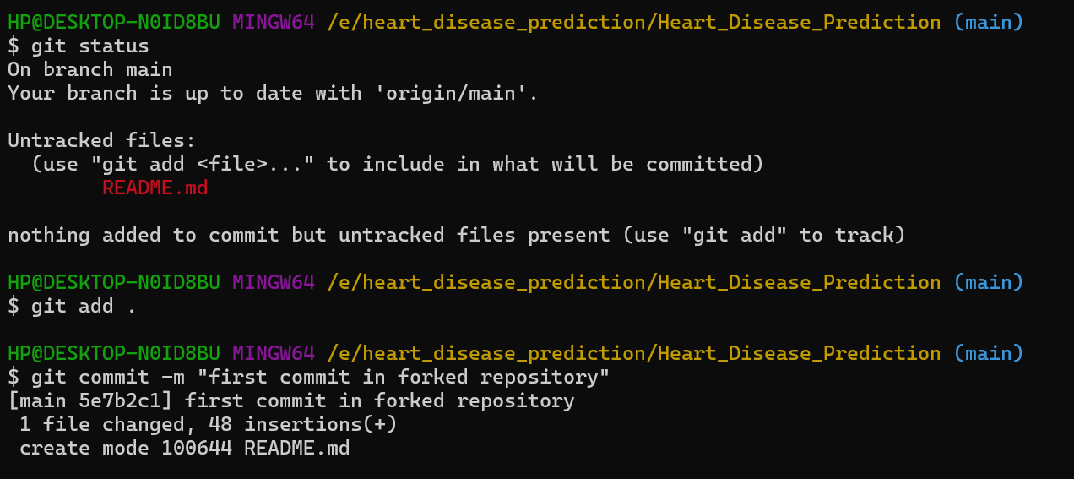
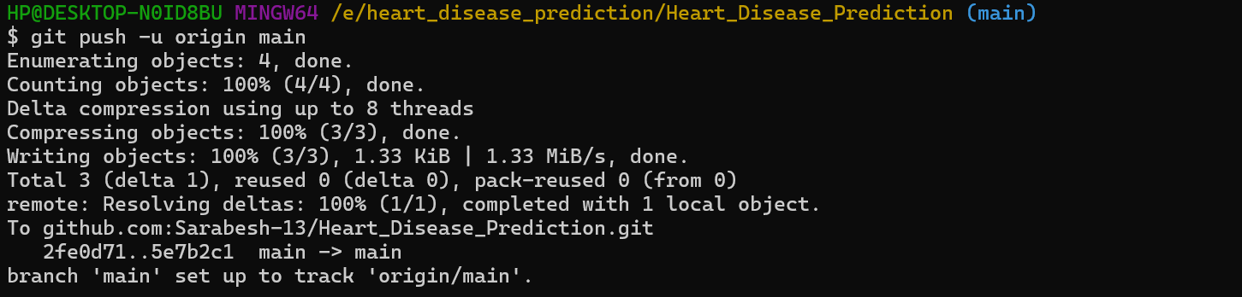

#manages changes from original repository
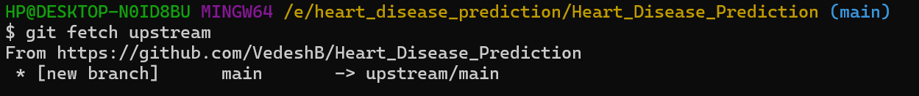
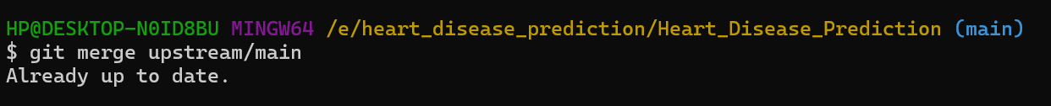

#create pull request to original repository

#simple outline code review process
- Forked repository in GitHub. which has access to make only pull request original repository and makes the forked repo up to date with the upstream/original repository,
- Clone the forked repo and make some changes and push to main branch .these changes are reflected to only forked repository.
- We will get to know as updates if there is a new changes in main branch of original repository.
At that time we can first use git fetch to know about changes to original/main repo and then make pull request to origin main branch and make push request to remote fork main branch to keep code up to date.

