Task-4
Use grep cmd to find all the instance of “Linux” in LinuxHistory.txt
and redirect output to LinuxInstances.txt.

#creating file LinuxHistory.txt.
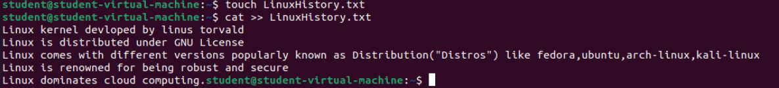
# Use grep to filter all line that contain instance of Linux.
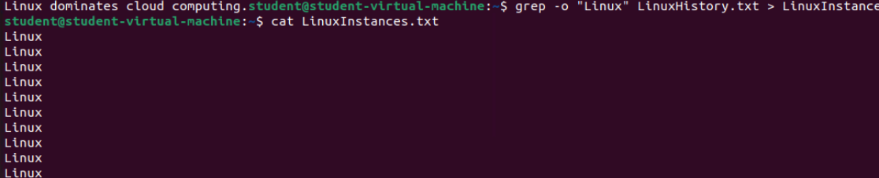

Task-5
Permissions and Ownership
#View current permissions for sample.txt
#change the permission of sample.txt to read only for the owner and no permission for others.
#change the ownership of LinuxHistory.txt to another user.
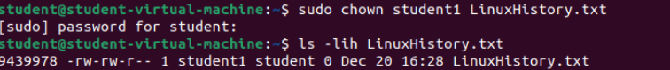

Task -6
Remote System Access
#use ssh to connect to remote system
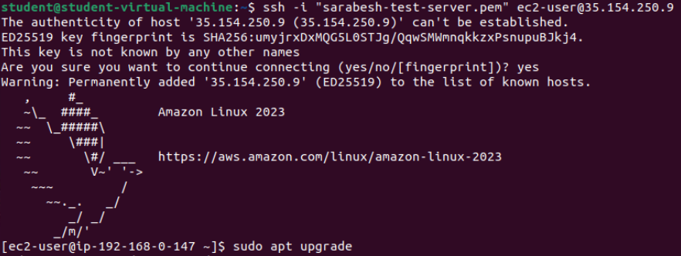

#once connected use scp to copy LinuxHistory.txt from local machine to remote system.
