Crime Data Analysis in Tamil Nadu (2014–Present)

# 1. Introduction

This report presents a comprehensive analysis of crime trends in Tamil Nadu from 2014 to the present. It draws on data from NCRB, Tamil Nadu State Police, and local news sources. The goal is to analyze crime patterns, classify types of crimes, visualize data trends, and suggest strategies for crime prevention and control.

# 2. Murder Trends

Figure 1: Annual Murder Cases in Tamil Nadu (2014–2024)

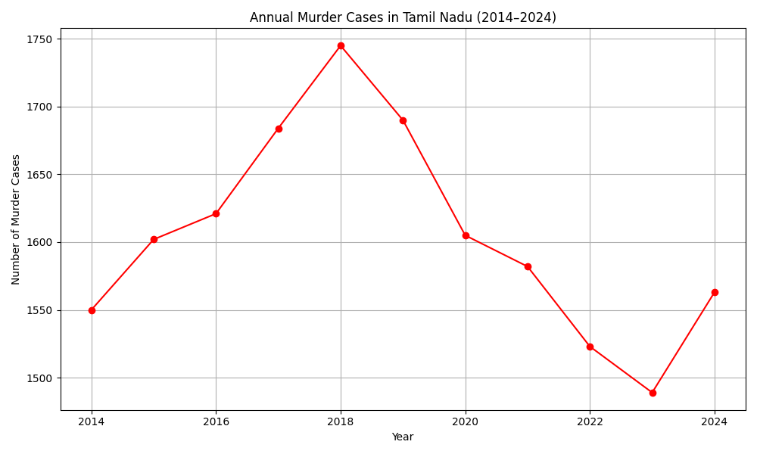

Murder cases peaked in 2019 and have been on a consistent decline since then, reaching the lowest point in a decade by 2024.

# 3. Juvenile Crimes

Figure 2: Juvenile Crime Cases in Tamil Nadu (2014–2024)

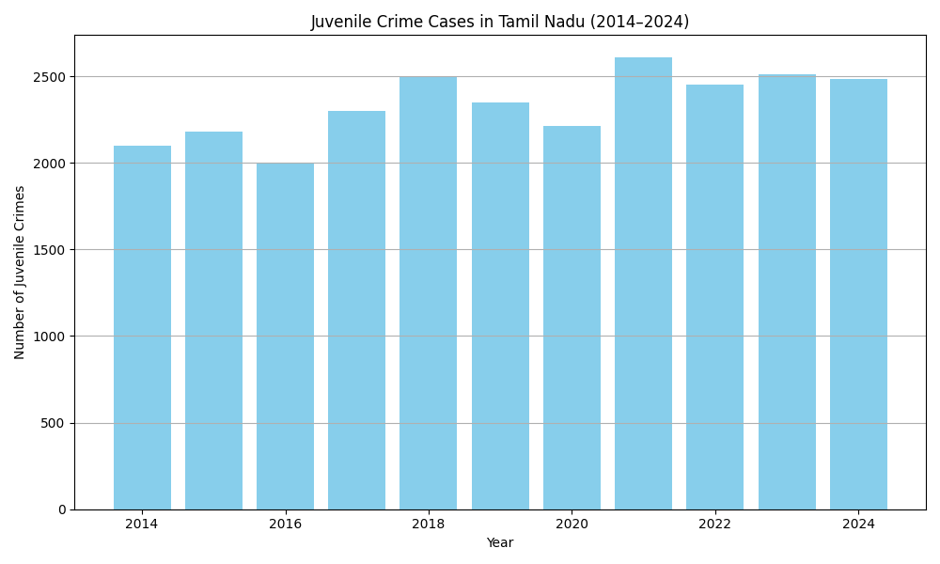

Juvenile crime trends show spikes in 2016, 2019, and 2022. Influencing factors include socio-economic stress, lack of supervision, and substance abuse.

# 4. Crimes Against Women

Figure 3: Crime Rate Against Women in Selected Districts (2020)

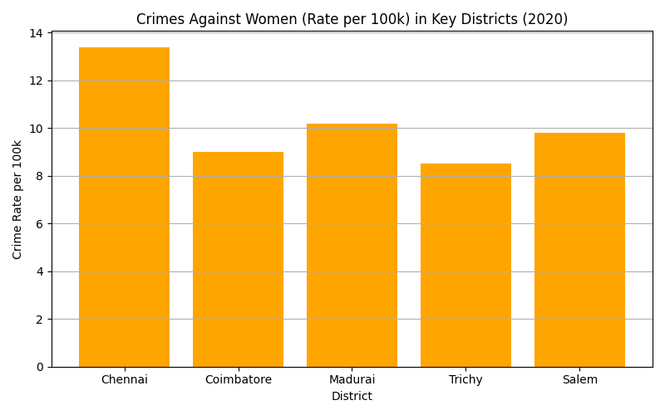

Urban districts like Chennai and Coimbatore show relatively lower crime rates against women. Still, underreporting could mask actual numbers.

# 5. Caste-Based Crimes

Figure 4: Caste-Based Crimes (SC/ST) in Tamil Nadu (2014–2024)

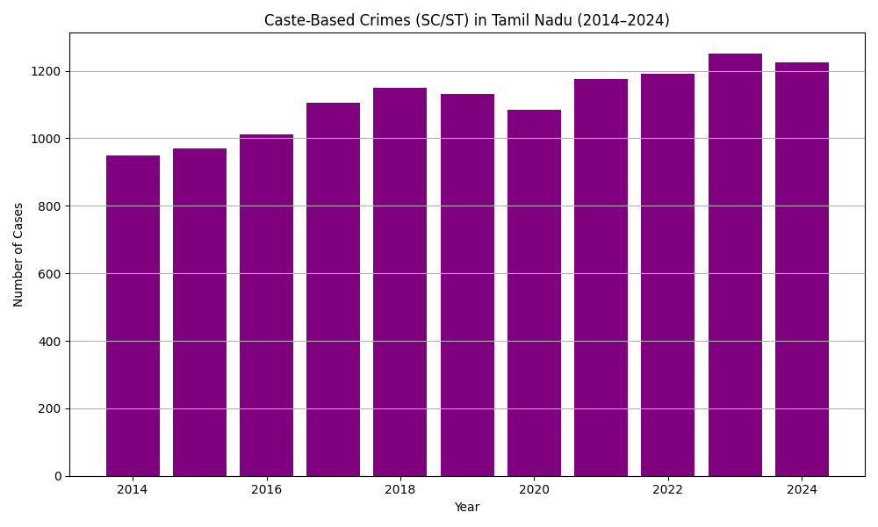

Caste-based crimes have shown an increasing trend, partly due to increased awareness and willingness to report such incidents.

# 6. Correlation Analysis

Figure 5: Correlation Matrix of Crime Categories

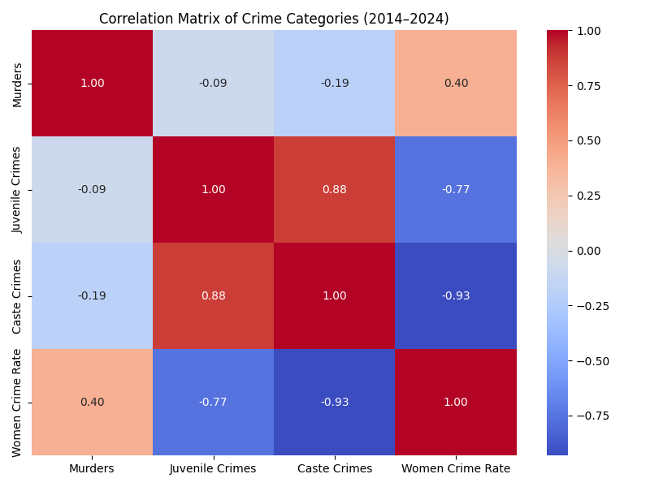

The correlation matrix indicates how different crime categories relate to each other. Juvenile and caste crimes appear moderately correlated with murder trends.

# 7. Conclusion and Recommendations

Tamil Nadu has shown significant improvement in reducing murders and managing crime in urban areas. However, juvenile offenses and caste-based violence are emerging challenges. The following actions are recommended:  
- Expand proactive policing (e.g., OCIU, DARE)  
- Strengthen school counseling and anti-substance programs  
- Improve transparency in reporting women's crimes  
- Enhance rural policing in high-risk caste-conflict zones