

LA GRANDEE INTERNATIONAL COLLEGE

**Simalchaur, Pokhara, Nepal**

A Project Draft

On

**“Parabook”**

**Submitted to:**

**Bachelor of Computer Application (BCA) Program**

In partial fulfilment of the requirements for the degree of BCA under Pokhara University

**Submitted by:**

|  |  |  |  |
| --- | --- | --- | --- |
| Name: | Course | Semester | P.U. Registration Number |
| Sarad Adhikari | BCA | 6th | 2022-1-53-0142 |
| Anish Poudel | BCA | 6th | 2022-1-53-0118 |
| Karun Sunuwar | BCA | 6th | 2022-1-53-0125 |
| Sabin Pandey | BCA | 6th | 2022-1-53-0139 |

Date:July 2, 2025

# Acknowledgement

We express our sincere regard to our project supervisor **Mr. Nabin Pandey**, and Co-Ordinator **Mr. Kundan Chaudhary** for his valuable time, guidance, encouragement, support, and cooperation throughout our project. We would sincerely like to thank the BCA Department for allowing us to work on enhancing our technical skills while undergoing this project.

This is a project draft report on Spa Management System which is carried out as an ingredient of assignment as specified by the faculty member of the degree of BCA, 6th semester.

We are very thankful that you have provided us with an opportunity to show our talent and to sharpen our knowledge.

With Regards,

Anish Poudel (Reg.no: 2022-1-53-0118)

Karun Sunuwar(Reg.no:2022-1-53-0125)

Sabin Pandey (Reg.no: 2022-1-53-0139)

Sarad Adhikari (Reg.no:2022-1-53-0142 )

# Abstract

The proposed project, "Parabook – Paragliding Booking System" is a web-based application designed to streamline and simplify the booking and management process for paragliding activities. Developed using **HTML, CSS, JavaScript, and PHP**, this system serves both customers and administrators by offering a user-friendly interface and essential functionalities to ensure a smooth and efficient booking experience.

For **customers**, the system provides an intuitive platform to browse available flight packages, check real-time availability based on location and weather conditions, book preferred time slots, cancel or reschedule bookings, and receive automated booking confirmations via email. These features empower users to plan their paragliding adventures with confidence and convenience.

For **Company**, the system offers robust tools to manage bookings, track customer details, add or modify available paragliding packages, manage pilots and flight schedules, handle customer queries, and generate daily and monthly reports. The system also includes secure login access, ensuring only authorized personnel can manage sensitive data and operations.

**Administrators** are the central authority in the system. They oversee all platform activities, including managing users, monitoring bookings, and handling system configurations. Most importantly, **only administrators have the authority to approve or reject company registrations**, ensuring service quality, safety, and regulatory compliance.

By integrating all the key features required for running a paragliding business into a dynamic and responsive web application, Parabook enhances customer satisfaction and improves operational efficiency. The system eliminates manual paperwork, reduces the risk of scheduling conflicts, and provides a transparent and organized platform for both users and management. With its scalable architecture and responsive design, the Parabook system is well-suited for expanding adventure tourism businesses aiming to deliver seamless outdoor experiences while maintaining full control over their service operations.

**Declaration for**

**“Paragliding Booking System”**

# Student’s Declaration

This is to certify that Paragliding Booking System embodies the original work done by Anish Paudel, Karun Sunuwar, Sabin Pandey, and Sarad Adhikari , which is submitted to LA GRANDEE International College, under the affiliation of Pokhara University. This project is submitted as a partial fulfillment of the requirement for the system development project of the Bachelor of Computer Application 4th semester, under the supervision of Mr. Kundan Chaudhary. We further state that no resources other than those specifically listed have been utilized in the completion of the project.

Name: Anish Poudel ……….……………….

Exam Roll No: 22530004 **Signature**

Semester: BCA 4th

P.U Registration No: 2022-1-53-0118

Name: Karun Sunuwar ……….……………….

Exam Roll No: 225300 **Signature**

Semester: BCA 4th

P.U Registration No: 2022-1-53-0125

Name: Sabin Pandey ……….……………….

Exam Roll No: 225300011 **Signature**

Semester: BCA 4th

P.U Registration No: 2022-1-53-0139

Name: Sarad Adhikari ……….……………….

Exam Roll No: 225300 **Signature**

Semester: BCA 4th

P.U Registration No: 2022-1-53-0141

# Supervisor’s Declaration

I hereby recommend that his project entitled “**Paragliding Booking System**” is done under my supervision by **Anish Paudel, Karun Sunuwar, Sabin Pandey** and **Sarad Adhikari**  during the 6th semester in partial fulfillment of the requirement of the degree of Bachelor of Computer Application **(BCA)** under **Pokhara University** is completed to my satisfaction and he processed for final evaluation.

_________________

**Mr. Nabin Pandey**

**Date: 01/07/2025**

# Project Summary

The project "Paragliding Booking System" also known as Parabook using HTML, CSS, JS, PHP and MYSQL aims to automate various operational tasks within a company, enhancing efficiency and guest satisfaction. The system provides comprehensive features to manage different possibilities of the company such as booking flights, Customer Relationship Management (CRM), Weather Monitoring, Billing, and Invoicing.

The purpose of this project is to develop an intuitive interface that enhances the regular operations that could held in paragliding companies. For those companies that rely on a file-based system, implementing this application will significantly elevate their daily routines. Besides assistance in daily routines, it also provides statistics on company performance to gain valuable insights.

To conclude, the project Paragliding Booking System. It is specifically aimed to reduce manual tasks and streamline booking processes for both companies and customers.

# Table of Contents

Acknowledgement ii

Abstract iii

Student’s Declaration iv

Supervisor’s Declaration v

Project Summary vi

Table of Contents vii

Abbreviations viii

1.0 Introduction 1

2.0 Problem Statement 2

3.0 Objectives 3

3.1 For Companies: 3

3.2 For Passengers: 3

4.0 Requirement 4

4.1 Functional Requirements: 4

4.2 Non-Functional Requirements: 4

5.0 Methodology 5

6.0 Dataflow Diagram (DFD) 6

Fig 6.1 DFD Level 0 6

Fig 6.2 DFD Level 1 7

7.0 Flowchart 8

Fig 7.1 Flowchart 8

8.0 ER Diagram 9

Fig 8.1 ER Diagram 9

9.0 Tools/System 11

10.0 Gantt Chart 12

Fig: 10.1 Gantt Chart 12

11.0 Deliverables 13

# Abbreviations

|  |  |
| --- | --- |
| Parabook | Paragliding Booking System |
| BCA | Bachelor of Computer Application |
| VS Code | Visual Studio Code |
| MS | Microsoft |
| MySQL | My Structured Query Language |
| HTML | Hyper Text Markup Language |
| ER | Entity Relationship |
| DFD | Dataflow Diagram |
| JS | JavaScript |
| CSS | Cascading Style Sheets |
| PHP | Hypertext Preprocessor |

# 1.0 Introduction

Paragliding is an aerial sport where we can fly using a lightweight, foot-launched glider called a paraglider. It is the only medium through which a pilot and passenger can soar in the sky. Paragliding has been vogue in Nepal since 1995 and the sport is getting even more popular.

To meet the needs of this growing industry, we present **ParaBook**, a user-friendly paragliding booking system developed using HTML, CSS, JS, Mysql and PHP. ParaBook goes beyond traditional booking methods by offering a **centralized, secure data repository.** This repository stores essential information for both company and passengers, including names, addresses, contact details, nationalities and others possible datas. Besides assistance in the database, our application **ParaBook** will also give insightful statistics about a company's performance.

**"ParaBook"** is a comprehensive data management system that simplifies flight procedures for paragliding companies.

# 2.0 Problem Statement

Paragliding companies in Nepal predominantly rely on manual booking methods such as forms and phone calls which results in inefficiency. Additionally, it's hard to keep track of everything because the information is scattered.

Customers face difficulties in making instant bookings which results in inconvenience and poor customer experiences. A time-consuming booking process can discourage potential passengers and create negative impressions, ultimately affecting the company's reputation.

Furthermore, the absence of data analytics capabilities from manual booking methods limits the ability of paragliding companies to make informed decisions regarding pricing strategies, marketing efforts, and operational costs.

To address these challenges and empower paragliding companies, a robust paragliding booking system must be integrated for booking processes and provide valuable data analytics capabilities to drive business growth and overcome existing challenges.

# 3.0 Objectives

The main objective of the project PBS is to transform a physical file-based recording system into a computerized repository. Below are the classified objectives for companies and passengers:

## 3.1 For Companies:

* Automating reservations, and communication with customers.
* A user-friendly platform for employees to easily book flights, access information, and manage bookings.
* Generate statistics on flights, revenue, and company performance.

## 3.2 For Passengers:

* Allow passengers to book, schedule, and shift flights easily.
* Provide clear information about flights.

# 4.0 Requirement

4.1 Functional Requirements: Functional requirements for PBS define the specific actions and functionalities a system or its components must perform. They essentially describe **what** the system should do, outlining the features and functionalities that users will interact with.

* Booking Management
* Account Management
* Information Access
* Reporting and Analytics

By defining functional requirements, we can ensure the system is built to meet user needs and deliver the expected functionalities.

4.2 Non-Functional Requirements: Non-functional requirements define the qualities or characteristics of a system, rather than its specific actions. They essentially describe **how** the system should perform. Here are the non-functional requirements:

* Usability
* Performance
* Availability
* Security
* Maintainability

By defining non-functional requirements, we can ensure the developed system meets the desired quality standards and delivers a positive user experience.

# 5.0 Methodology

For the development of the “Parabook” web application, we’ll be using the Agile methodology, a flexible and iterative approach to software development. Agile focuses on delivering a small, functional pieces of the application through continuous planning, development, and testing. It promotes collaboration, adaptability to change, and frequent delivery of working software.

Agile methodology is particularly well-suited for projects like this that require regular updates evolving features, and client feedback. Development is broken into short cycles known as iterations or sprints (usually 1-3 weeks), where each sprint delivers usable features such as booking modules, admin controls or transaction tracking.

In a nutshell, Agile requires the following key roles and practices:

1. A product Owner defines and prioritizes the features in the Product Backlog.
2. The Development team selects items from the backlog to build each iteration
3. At the end of each sprint, the team reviews and tests the new functionality
4. Repeat

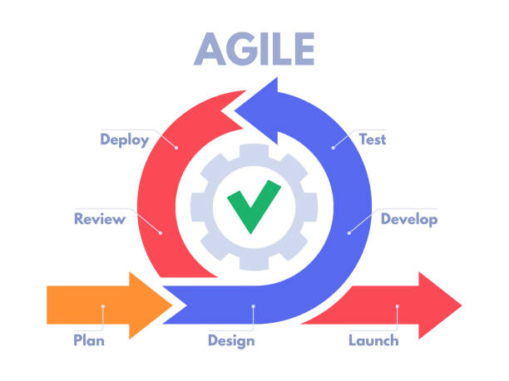

# 01 DFD 06.0 Dataflow Diagram (DFD)

## Fig 6.1 DFD Level 0

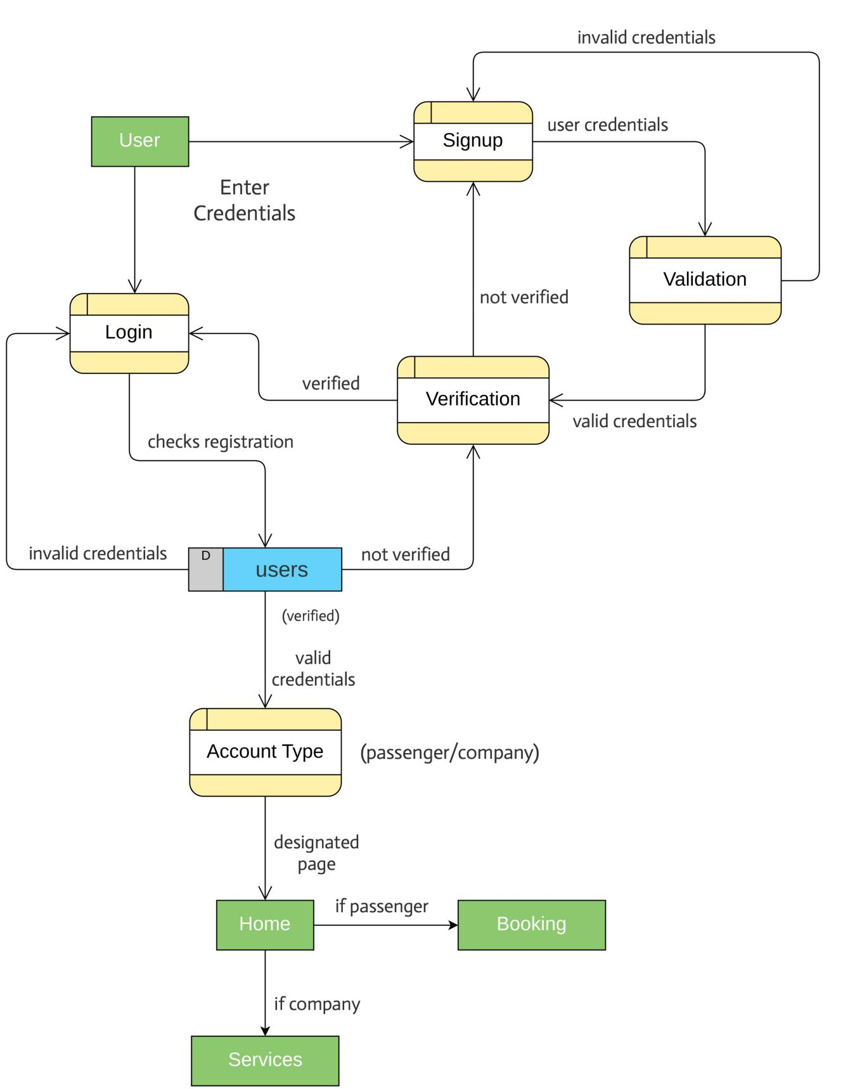

## Fig 6.2 DFD Level 1

# 02 Flowchart7.0 Flowchart

## Fig 7.1 Flowchart

## 

# 03 ParaBook ERD8.0 ER Diagram

## Fig 8.1 ER Diagram

# 9.0 Tools/System

We used **Visual Studio Code (VS Code)** as our primary development environment due to its lightweight nature, user-friendly interface, wide extension support, and seamless compatibility with front-end and back-end web technologies. It facilitated efficient design, development, and debugging throughout the project lifecycle.

For the **front-end development**, we used **HTML, CSS, and JavaScript** to design a responsive and interactive user interface, ensuring a smooth user experience across devices. On the **back-end**, we used **PHP**, which allowed us to handle server-side logic, database interactions, and user authentication processes.

To simulate a local server environment during development, we used **XAMPP**, which includes **Apache** and **MySQL**, enabling us to host and manage the database and run the application locally for testing purposes.

For **version control** and collaborative development, we used **Git** to push, pull, and manage code efficiently across different team members, ensuring secure and organized source code handling.

In addition to development tools, we used several other applications to support planning, documentation, and communication:

* **Draw.io** – Used to design **Data Flow Diagrams (DFD)**, **Flowcharts**, and **Entity-Relationship (E-R) Diagrams**
* **MS Excel** – Used to prepare the **Gantt Chart** for planning and tracking project progress
* **MS PowerPoint** – Used for creating the **project presentation**
* **MS Word** – Used for writing and formatting the complete **project documentation**
* **Discord** – Used for conducting **online meetings** and effective team communication throughout the development phase

.

# GanttChart10.0 Gantt Chart

### Fig: 10.1 Gantt Chart

# 11.0 Deliverables

This project aims to develop a paragliding booking system using HTML, CSS, JS, MySQL and PHP that assists daily operations for companies and enhances the customer experience. Below are the deliverables that we will provide on the completion of this project:

* A fully functional paragliding booking system web application developed using HTML, CSS, JS and PHP, MySQL.
* User registration and login for companies using secure authentication methods.
* Admin dashboard with options to view, add, edit, and cancel bookings, update flight schedules, and generate reports.
* A user-friendly guide explaining how to navigate the booking system, manage bookings, and add pilot's and passenger's information.