Employee Attrition & HR Analytics Dashboard

- Project Overview
This project focuses on analyzing employee attrition patterns using HR data to help organizations understand workforce dynamics, identify key drivers of attrition, and support data-driven HR decision-making. The dashboard provides a comprehensive view of employee distribution, attrition rates, demographic insights, and job satisfaction trends. The analysis is designed for HR managers and business leaders to monitor workforce health and implement effective retention strategies.
- Objectives
  - Analyze overall employee attrition and retention
  - Identify departments and education fields with high attrition
  - Study attrition trends across age groups and gender
  - Evaluate job satisfaction levels across different job roles
  - Provide actionable insights to improve employee retention
3. Tools & Technologies
- Visuals (Cards, Bar Charts, Pie Charts, Matrix, Donut Charts) – Department-wise, age-group, gender, and job satisfaction analysis
- Slicers – Dynamic filtering by education level and employee attributes
- Data Analysis & Visualization: Power BI
- Data Source: HR Employee Dataset (Excel)
- Data Preparation: Power Query
- Calculations & Metrics: DAX

- Dataset Summary
- Total Employees: 1470
- Active Employees: 1233
- Employees Left (Attrition): 237
- Average Employee Age: 37 years
- Key Attributes:
- Employee ID
- Department
- Job Role
- Age & Age Group
- Gender
- Education Level & Education Field
- Job Satisfaction Rating
- Attrition Status
- Key KPIs
- Overall Employees: 1470
- Total Attrition: 237
- Attrition Rate: 16.12%
- Active Employees: 1233
- Average Age: 37
These KPIs provide a high-level summary of workforce stability and attrition risk.

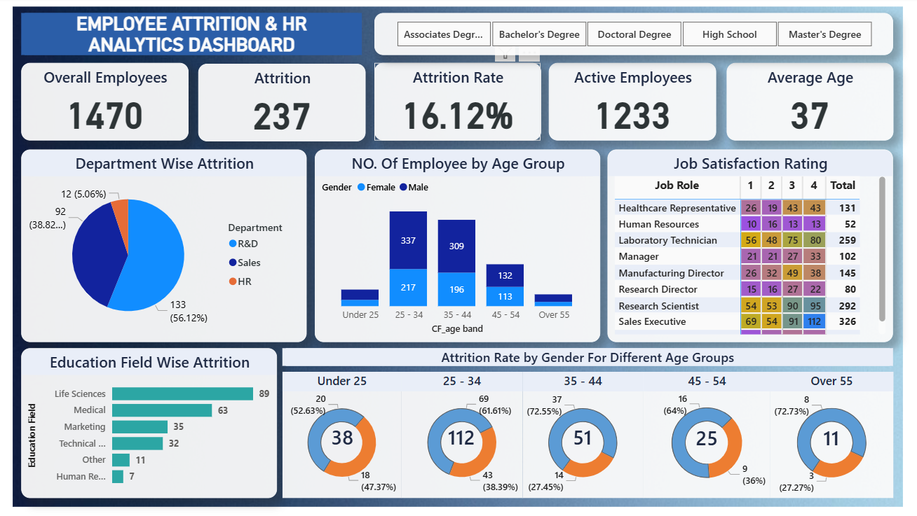
- Dashboard

- Dashboard Insights
- Department-wise Attrition
• R&D Department shows the highest attrition (~56.12%)
• Sales Department contributes ~38.82% of total attrition
• HR Department has minimal attrition (~5.06%)
- Employee Distribution by Age Group
• Highest employee concentration is in the 25–34 and 35–44 age groups
• Attrition is more prominent among mid-career professionals
- Job Satisfaction Analysis
- Sales Executives and Research Scientists show large workforce representation
- Moderate satisfaction levels (ratings 3 and 4) dominate across most roles
- Some roles show low satisfaction ratings, indicating potential attrition risk

- Education Field-wise Attrition
- Life Sciences has the highest attrition
- Followed by Medical and Marketing fields
- HR-related education fields show minimal attrition
- Attrition Rate by Gender & Age Group
- 25–34 age group records the highest attrition count
- Male attrition is slightly higher across most age groups
- Attrition decreases significantly for employees above 45 years
- Business Recommendations
- Implement career development programs for employees aged 25–44
- Improve engagement strategies in R&D and Sales departments
- Conduct regular job satisfaction surveys
- Introduce mentorship and retention incentives for high-risk roles
- Focus on work-life balance and skill development initiatives
- Conclusion
The Employee Attrition & HR Analytics Dashboard successfully highlights key attrition trends and workforce insights. By leveraging these insights, organizations can proactively reduce attrition, improve employee satisfaction, and strengthen overall workforce stability. This project demonstrates practical application of data analytics in HR decision-making and showcases strong analytical and visualization skills.

