Swiggy Sales Data Analysis

- Project Overview

This project presents an interactive Swiggy Sales Data Analysis Dashboard built using Microsoft Excel. The objective of this project is to analyze sales performance, customer behavior, order trends, and regional performance of Swiggy food delivery services across India. The dashboard helps stakeholders make data-driven decisions by providing clear insights through visuals and kpis.

- Objectives
  - Analyze total sales and order performance.
  - Understand monthly, weekly, and daily sales trends.
  - Compare sales by food type (Veg vs Non-Veg).
  - Identify top-performing states and cities.
  - Evaluate customer ratings and order value.
  - Enable filtering by month, restaurant, and category.

- Tools & Technologies
- Microsoft Excel – Data analysis & dashboard creation
- Pivot Tables & Pivot Charts – Aggregations and visual analysis
- Excel Formulas – Calculated metrics and KPIs
- Slicers & Timelines – Interactive filtering
- Dataset – Swiggy sales & order data (cleaned and structured in Excel)

- Dataset Summary
The dataset used in this project represents Swiggy food delivery sales data across multiple cities and states in India. It captures order-level details that help analyze sales performance, customer preferences, and regional trends.

- Dataset Size
- Number of Rows: 197,430
- Number of Columns: 10
- Key Attributes
- Order Date / Month – Used for monthly, weekly, and daily trend analysis.
- Order ID – Unique identifier for each order.
- City – City where the order was placed.
- State – State-wise sales performance analysis.
- Restaurant Name – Identifies partner restaurants.
- Food Category – Cuisine type (Chinese, Pasta, Sweets, etc.)
- Food Type – Veg / Non-Veg classification
- Order Amount – Total value of each order.
- Customer Rating – Rating given by customers.
- Rating Count – Number of ratings received.

- Data Preparation
- Removed duplicate and null values.
- Standardized city and state names.
- Created calculated columns for Quarter, Day, and Week.
- Derived KPIs such as Total Sales, Total Orders, and Average Order Value.

- Key KPIs
- Total Sales: ₹53.01M
- Total Orders: 197.43K
- Average Order Value: ₹268.51
- Average Rating: 4.34
- Rating Count: 5.59M

- Dashboard
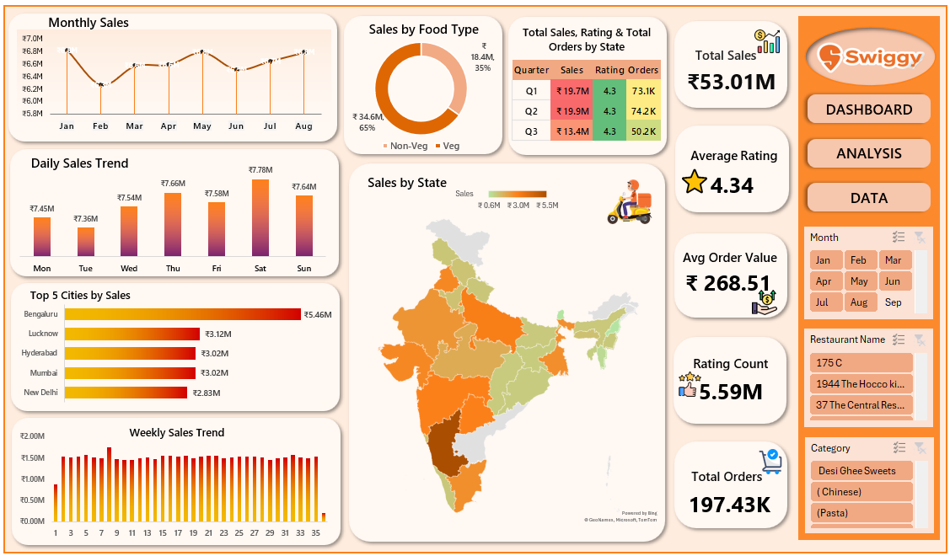
- Dashboard Insights

- Monthly Sales Trend
- Sales show a stable upward trend from January to August.
- Peak sales observed in May and August.
- Slight dip noticed in February and June.

- Daily Sales Trend
- Saturday records the highest sales.
- Tuesday has the lowest sales among weekdays.
- Weekends contribute significantly to total revenue.

- Weekly Sales Trend
- Sales remain consistent throughout the weeks.
- Minor fluctuations indicate steady customer demand.

- Sales by Food Type
- Non-Veg: ₹34.6M (65%)
- Veg: ₹18.4M (35%)
- Non-veg food dominates customer preference.

- Sales by State
- Highest sales contribution from Southern and Western India.
- States like Karnataka, Maharashtra, and Tamil Nadu lead in revenue.
- North-Eastern states show comparatively lower sales.

- Top 5 Cities by Sales
- Bengaluru – ₹5.46M
- Lucknow – ₹3.12M
- Hyderabad – ₹3.02M
- Mumbai – ₹3.02M
- New Delhi – ₹2.83M

- Quarterly Performance

Quarter | Sales |  | Orders
  Avg Rating
Q1 | ₹19.7M | 4.3 | 73.1K
Q2 | ₹19.9M | 4.3 | 74.2K
Q3 | ₹13.4M | 4.3 | 50.2K

- Business Insights
- Focus marketing campaigns on weekends for higher ROI
- Expand Non-Veg menu offerings to match customer demand
- Improve penetration in low-performing states
- Maintain service quality to sustain high customer ratings

