**platform-engineering-assignment**

Name: – A.V.Sarada Vidurangi

Date :- 19/05/2025

IAM setup with screenshot

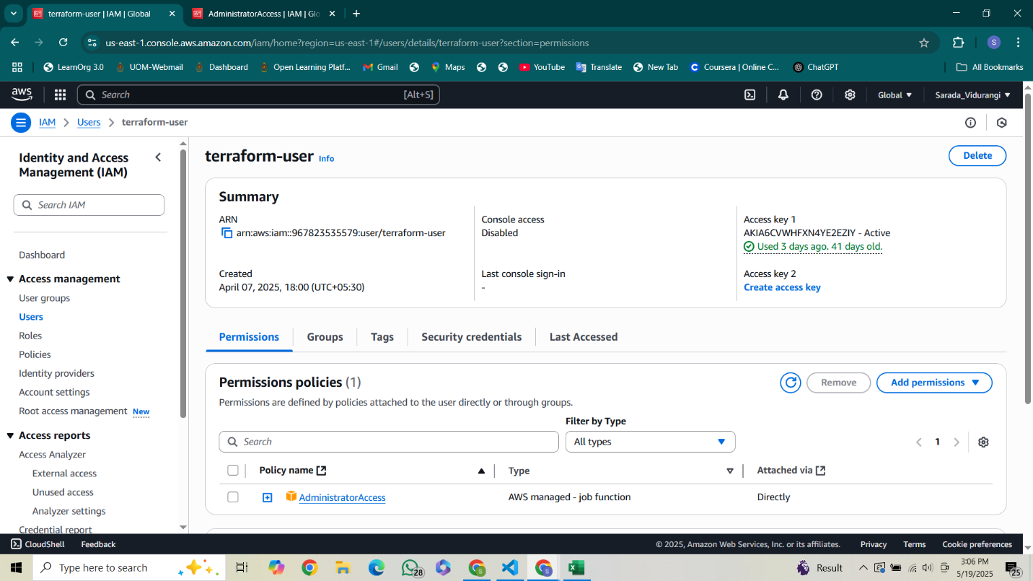

ECR repo with screenshot

Logging via CloudWatch

GitLab variables with screenshot

GitLab pipeline logs (.gitlab-ci.yml file)

