

**Reporting Tool Manual**

Saradha R 02.03.2021

|  |  |  |  |
| --- | --- | --- | --- |
| **Version #** | **Created By** | **Revision**  **Date** | **Reason** |
| 1.0 | Saradha R | 02-03-2021 | Creation of Document |

Contents

1. Introduction 2

2. Request Load Generation 3

3. Deleting Generation Data………………………………………………………………………………..………………………….8

# Introduction

Reporting Package (GATS) used for two functionality.

1. Load the Generation data to production server.
2. Deleting the particular generation data from server.

In that reporting folder have two files

1. requestClient.php
2. deleteGen.php

**Load Generation Link:** <http://localhost/reporting/reportingClient.php>

**Deletion Generation Link:** <http://localhost/reporting/deleteGen.php>

# 2.Load Generation Data

* First copy the load generation link into the browser, the page will be display.

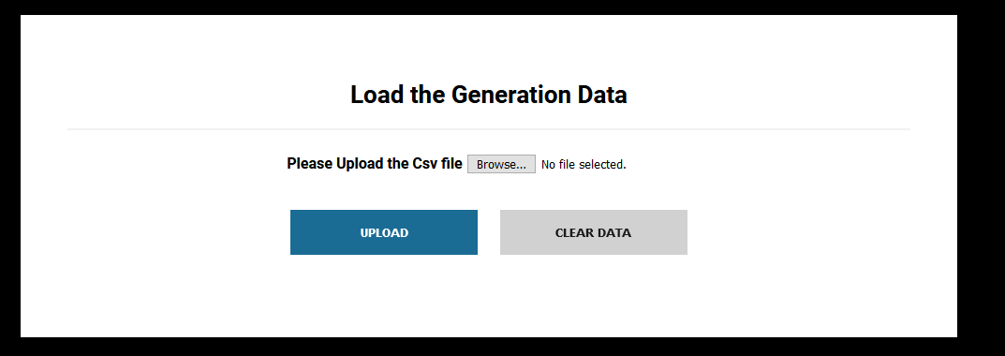

* Click the browse button; select the .CSV file from my computer & uploading the data into server.

**The following instruction updated in the CSV file.**

* Generation Level -> only capital letter **K.**
* Previous Meter Reading -> don’t have any special character in that input. Like 12,256 only you have used **12256** numeric values.
* Current Meter Reading -> don’t have any special character in that input. Like 12,256 only you have used **12256** numeric values.
* CurrentMeterReadingDate-> the following format you have use it like YYYY-MM-DD. **Example: 2021-01-31.**
* MonthYearGeneration ->Date &year you have update like MM-YYYY format. **Example 012021**. Don’t use 12020.
  + Use the below formula, since the CSV or excel file will not take Zero values before a numeric so obtain this we need use this to denote the month in the column Q in the data -1 sheet
  + =IF(ISNUMBER(Q2)=TRUE,"0"&Q2,Q2)
* The following above condition checked in the source code, whether input is not match the condition means showing “Input format is wrong”. Check the below screen.

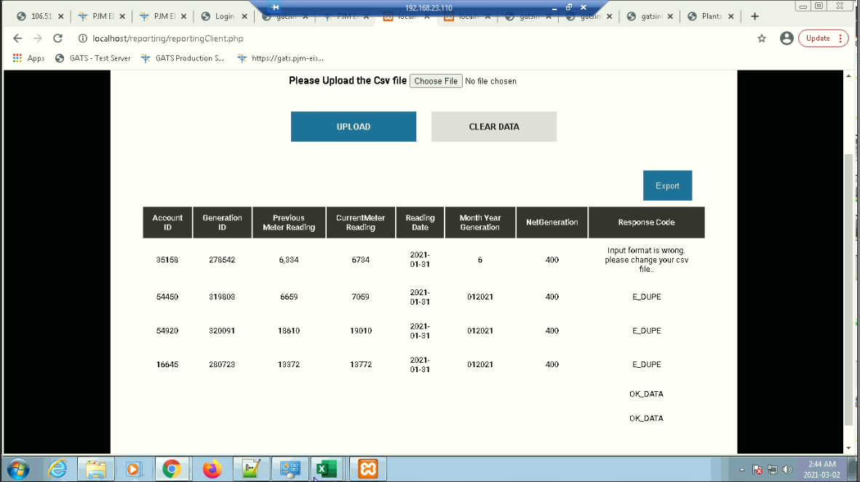

* In that functionality, loading the generation data to production server using WSDL. The wsdl used to sending the data to production server. the server sending corresponding response code whether the data is stored or not. Like OK_DATA,E_DUPE.

Example: This is response coming from server

**Array ( [RequestLoadGenResult] => Array ( [GenerationReturn] => Array ( [RowData] => Array ( [RowID] => 2 [AccountID] => 54450 [GeneratorID] => 319803 [GenerationLevel] => K [PreviousMeterReading] => 6659 [CurrentMeterReading] => 7059 [CurrentMeterReadingDate] => 2021-01-31 [NetGeneration] => 400 [MonthYearGeneration] => 012021 ) [Code] => E_DUPE [RowID] => 2 ) )**

* Above response showing in the table view. Like AccountId,generatoo Id.
* One more instruction, multiple Account Id passing the server means, it showing following response.

**Array ( [RequestLoadGenResult] => Array ( [GenerationReturn] => Array ( [Code] => OK_DATA [RowID] => 0 ) ) )**

Only showing response code. Same procedure we have checked in the SoapUI also same thing happen.

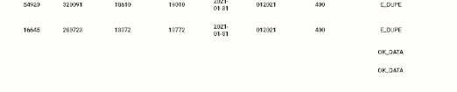

* Export Option also available. Download the data into the excel.
* Click the clear data button; clear the response from table view.

# 2.Deleting Generation Data

* First copy the deleting generation data link into the browser, the page will be display.

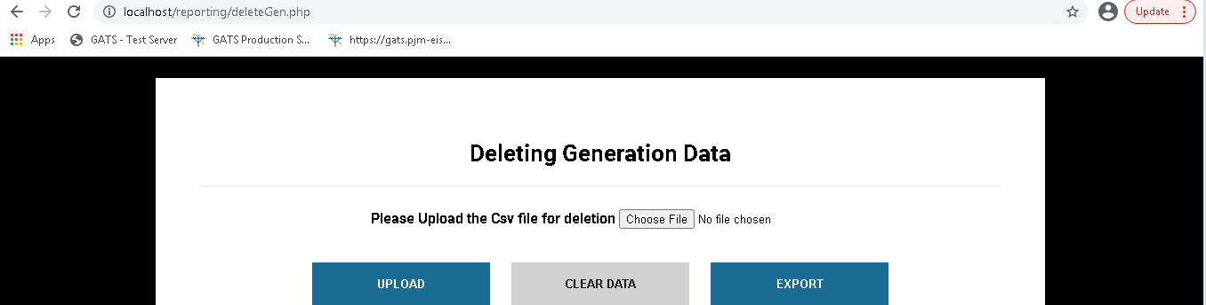

* Click the choose button select the.csv file from your computer. Then click the upload button.csv file data upload into server. Particular data removed from server& send response to client.
* See the following response from server.

**Array ( [DeleteGenerationResult] => Array ( [DeleteGenerationReturn] => Array ( [Code] => E_NOUNPROC [AccountID] => 41769 [GeneratorID] => 302557 [DateRange] => ) ) )**

* The above response showing the table format.

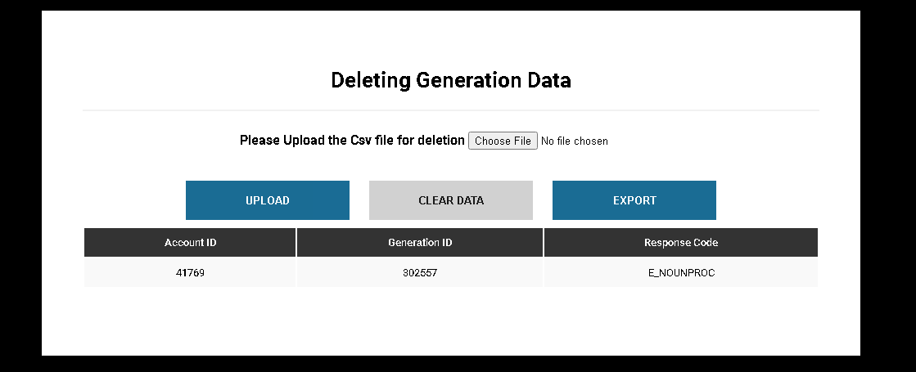

* Click the **Export** button, particular response download into excel format.
* Click the **Clear data** button, Response data removed from the page.