Real Estate Sales and Leads Analytics Platform
Table of Contents
1.0 Introduction
1.1 Project Goals
1.2 Business Requirements
2.0 Data Sources
2.1 Data Collection & Preparation
2.2 Dataset Description
3.0 Data Transformations (ETL)
3.1 ETL Logic
3.2 Data Cleaning Steps
4.0 Data Model (DWH)
4.1 Dimensional Model Diagram
4.2 Dimensions and Facts Explained
5.0 BI Queries
6.0 Dashboard Walkthrough (Key Insights)
6.1 Page 1: Executive Overview (Sales Value)
6.2 Page 2: Sales Volume & Inventory
6.3 Page 3: Lead & Funnel Analysis
6.4 Page 4: Agent Performance Analysis
6.5 Page 5: Marketing & ROI Analysis
7.0 Final Recommendations & Conclusion
8.0 Appendix
8.1 Appendix A: DWH Schema (SQL Scripts)
8.2 Appendix B: BI Query Scripts
8.3 Appendix C: ETL Code (e.g., SSIS Packages)

1.0 Introduction
1.1 Project Goals
The primary goal of this project is to develop a comprehensive "Real Estate Sales and Leads Analytics Platform". This platform is designed for a property company to centralize and analyze data to improve business decisions, optimize marketing efforts, and ultimately increase conversion rates.
1.2 Business Requirements
The core business requirements for this data warehouse and analytics platform are to:
- Centralize and analyze data related to sales, leads, agent performance, and property listings.
- Design and implement a dimensional data model to store this data effectively.
- Enable the tracking of key business processes, including lead-to-sale conversion, agent performance, and property trends.
- Build interactive dashboards for management to visualize performance metrics, identify bottlenecks, and forecast demand.
2.0 Data Sources
2.1 Data Collection & Preparation
This section describes the datasets used for this project and the methods for collecting and preparing them.
- [Dataset 1] Real Estate Listings:
  - Source: This dataset was compiled by performing web scraping on public listings from major real estate portals, specifically Property Finder and OLX.
  - Purpose: Used to analyze property pricing trends, location-based demand, and available inventory features.
- [Dataset 2] Leads & Sales Funnel Data:
  - Source: As proprietary sales data was not publicly available, this dataset was synthetically generated in Excel to model a realistic customer sales funnel (e.g., from initial inquiry to closed sale).
  - Purpose: Used for tracking the simulated sales pipeline and analyzing lead-to-sale conversion rates.
- [Dataset 3] Marketing Campaign Data:
  - Source: Sample campaign performance reports and ad spend data from Google Ads and Facebook Ads.
  - Purpose: Used to measure marketing campaign effectiveness, analyze traffic sources, and calculate key metrics like Customer Acquisition Cost (CAC) and campaign Return on Investment (ROI).
2.2 Dataset Description
The data used includes:
- Lead Datasets: Contained information on lead ID, source, status, and ...
- Sales Datasets: Contained transaction records, final sale price, and property ID...
- Property Datasets: Contained property type, location, list price, and list date...
3.0 Data Transformations (ETL)
3.1 ETL Logic
To move the data from the sources (e.g., Excel files, CSVs) into the final DWH, an ETL (Extract, Transform, Load) process was designed.
- [SSIS]: An SSIS package was created with a Control Flow to manage the full load. A Data Flow task was used for each dimension and fact table, including Lookups to find surrogate keys...
3.2 Data Cleaning Steps
Several data cleaning steps were necessary:
- [Example 1]: Handled NULL values in the Commission_Amount column by replacing them with 0.
- [Example 2]: Standardized the Status column in the property table, as it contained "Sold", "sold", and "SOLD".
- [Example 3]: Calculated new fields, such as Days_to_Sell, by subtracting Listed_Date from Sold_date and loaded this into the Fact_Sales table.
4.0 Data Model (DWH)
4.1 Dimensional Model Diagram
The data warehouse was built using a Galaxy Schema to optimize for analytical queries. The schema consists of two fact tables (Fact_Sales, Fact_Leads) and four primary dimensions.
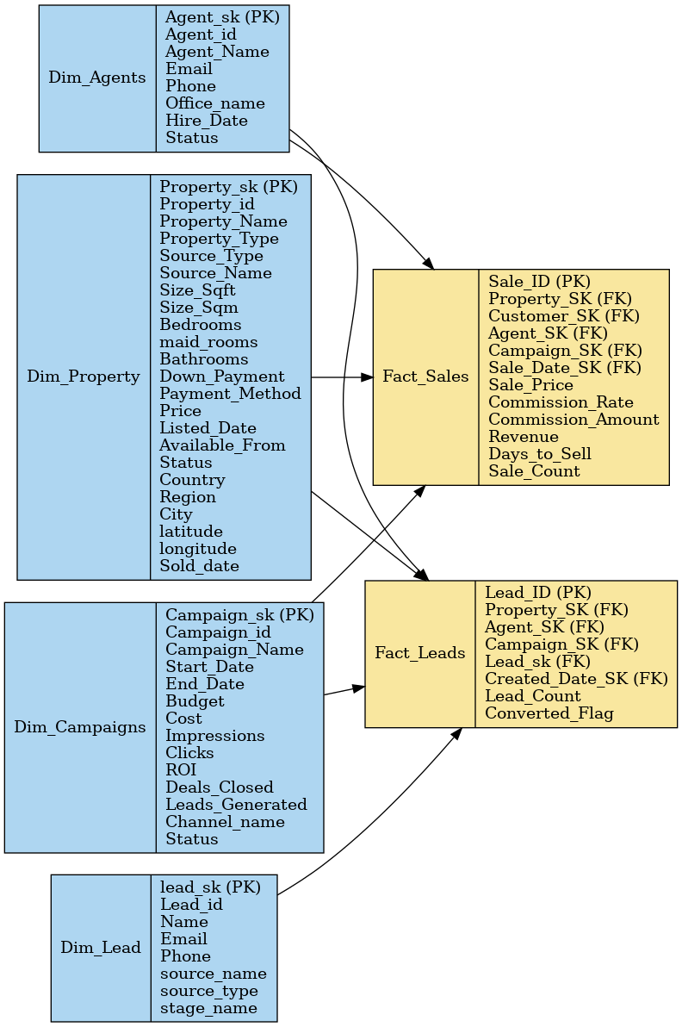
4.2 Dimensions and Facts Explained
- Dimension Tables (The "Who, What, Where, When"):
  - Dim_Agents: Stores information about the sales agents (Name, Office, etc.).
  - Dim_Property: Stores all attributes of the properties (Type, Location, Size, Status).
  - Dim_lead: Stores attributes of the leads (Name, Source, Stage).
  - Dim_Campaigns: Stores attributes of marketing campaigns (Name, Channel, Budget, ROI).
- Fact Tables (The "Numbers" / Events):
  - Fact_Sales: A record of every successful sale, linking agents, properties, and customers to measurable facts like Sale_Price, Commission_Amount, and Revenue.
  - Fact_Leads: A record of every lead generated, linking agents and campaigns to facts like Lead_Count and Converted_Flag.
5.0 BI Queries
To prove the effectiveness of the DWH, several key business questions were translated into SQL queries. These queries are simple and fast due to the star schema design.
Business Question: What are the main KPIs for our properties?
SQL
SELECT * FROM v_Property_KPIs;
Business Question: How many listings of a certain status are in each region?
SQL
EXEC sp_GetListingsStatusByRegion 'Active';
Business Question: Who are my top 5 agents by deals, revenue, and commission for a specific month?
SQL
EXEC sp_GetTopAgentsByClosedDeals 9, 2024;
Business Question: What is the average price, size, and number of sales by region and property type?
SQL
SELECT * FROM v_Market_Insights ORDER BY [Sold Properties] DESC;
Business Question: What are the monthly trends for sales and revenue?
SQL
SELECT * FROM v_SalesTrends ORDER BY [Year], [Month];
Business Question: What is the MoM revenue growth for a given year?
SQL
EXEC sp_GetMOMGrowth 2024;
Business Question: What is the performance of all campaigns?
SQL
SELECT * FROM v_CampaignPerformance;
Business Question: What is the performance of our offices (agents, leads, sales)?
SQL
SELECT TOP 5 * FROM v_OfficesPerformance ORDER BY Sales DESC;
Business Question: What is our total lead count and overall conversion rate?
SQL
SELECT * FROM dbo.fn_GetLeadsAndConversion();
Business Question: What is our average Cost per Lead (CPL)?
SQL
SELECT dbo.fn_GetCostPerLead() AS CostPerLead;
Business Question: How many leads are we getting from each source and channel?
SQL
SELECT * FROM v_LeadSourceEffectiveness;
Business Question: What is the average time between creating a lead and closing a sale?
SQL
SELECT dbo.fn_GetAvgSalesCycleDuration() AS [Average Sales Cycle (Days)];
6.0 Dashboard Walkthrough (Key Insights)
The final data was visualized in a 6-page Tableau Story to present a clear, data-driven narrative.

6.1 Page 1: Executive Overview
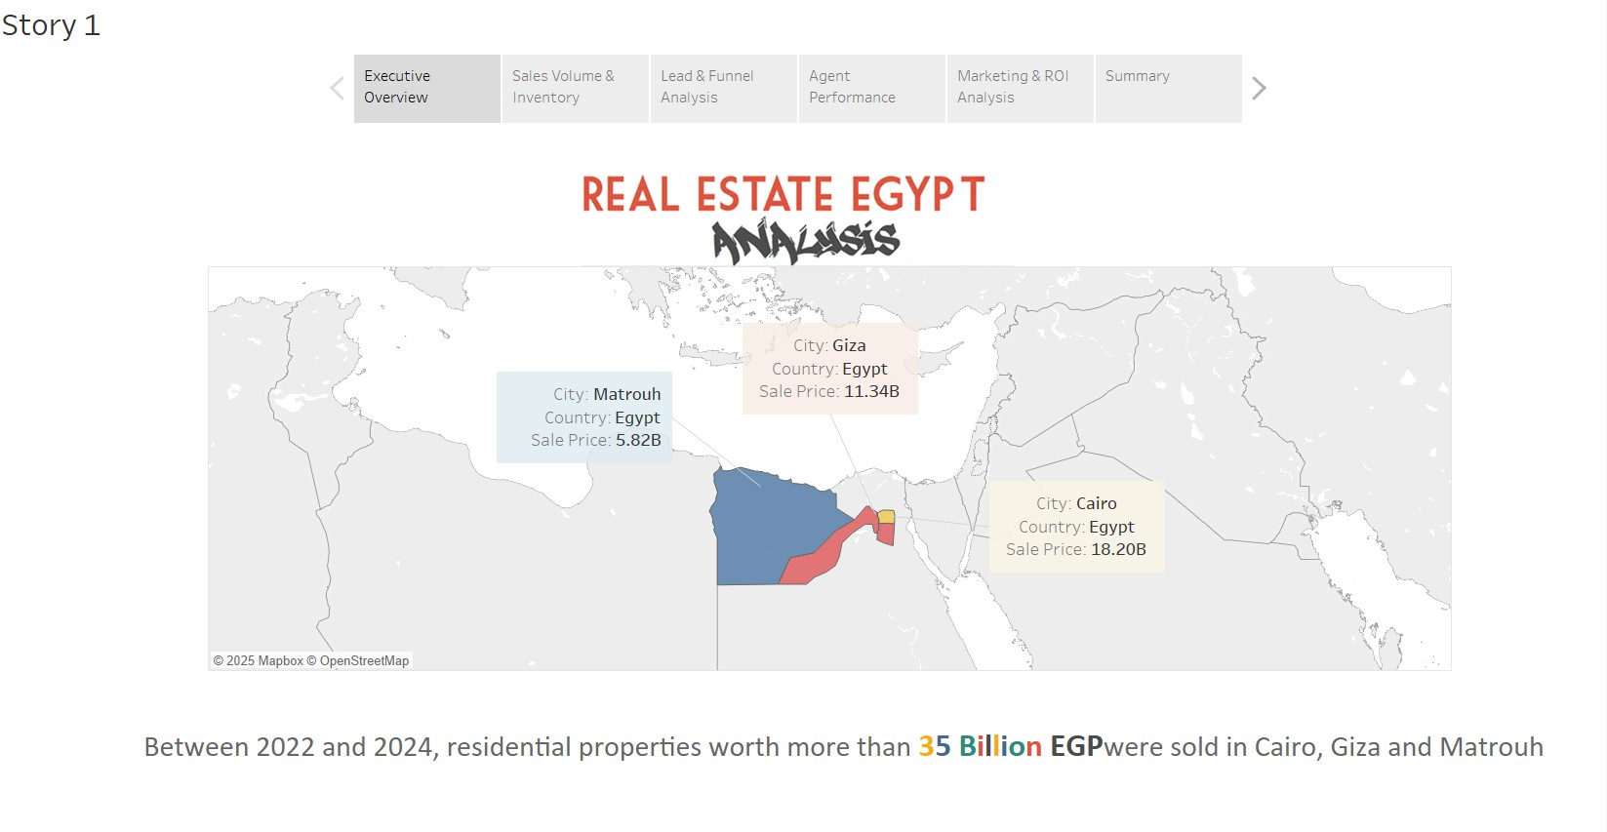
- Description: This page provides the "big picture" overview. It shows that between 2022 and 2024, over 35 Billion EGP in residential properties were sold, with the map clearly indicating that Cairo is the largest market, responsible for over 18.2B EGP of that total.
6.2 Page 2: Sales Volume & Inventory
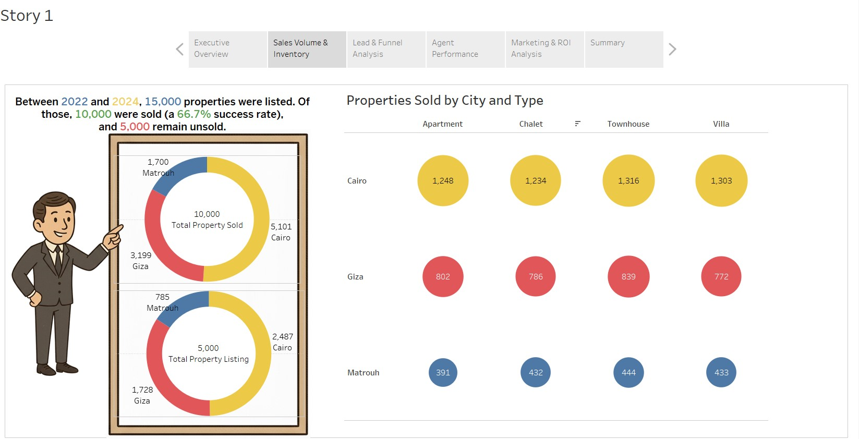
- Description: This page drills down into sales volume. It shows that of 15,000 listed properties, 10,000 were sold (a 66.7% success rate). The "Properties Sold by City and Type" chart clearly shows that "Apartments" are the most popular product across all cities.
6.3 Page 3: Lead & Funnel Analysis
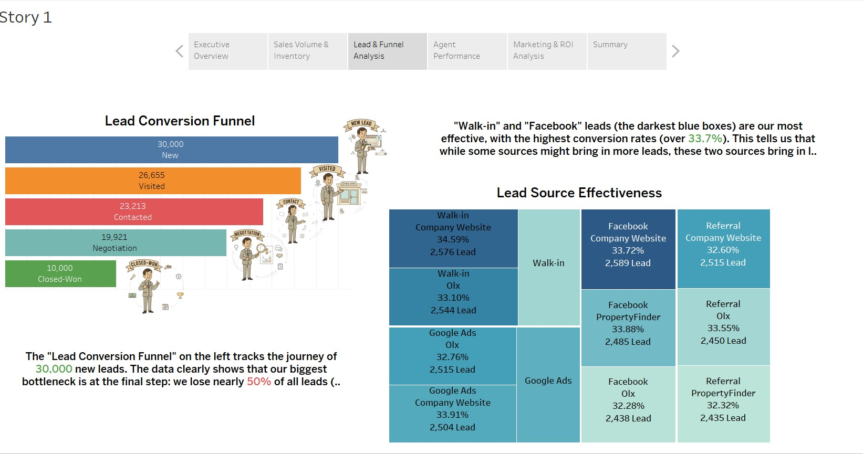
- Description: This dashboard analyzes our sales pipeline. The "Lead Conversion Funnel" shows that to get our 10,000 sales, we started with 30,000 leads. The "Lead Source Effectiveness" treemap shows that "Facebook" and "Walk-in" leads are our highest quality, with the best conversion rates (darkest blue).
6.4 Page 4: Agent Performance Analysis
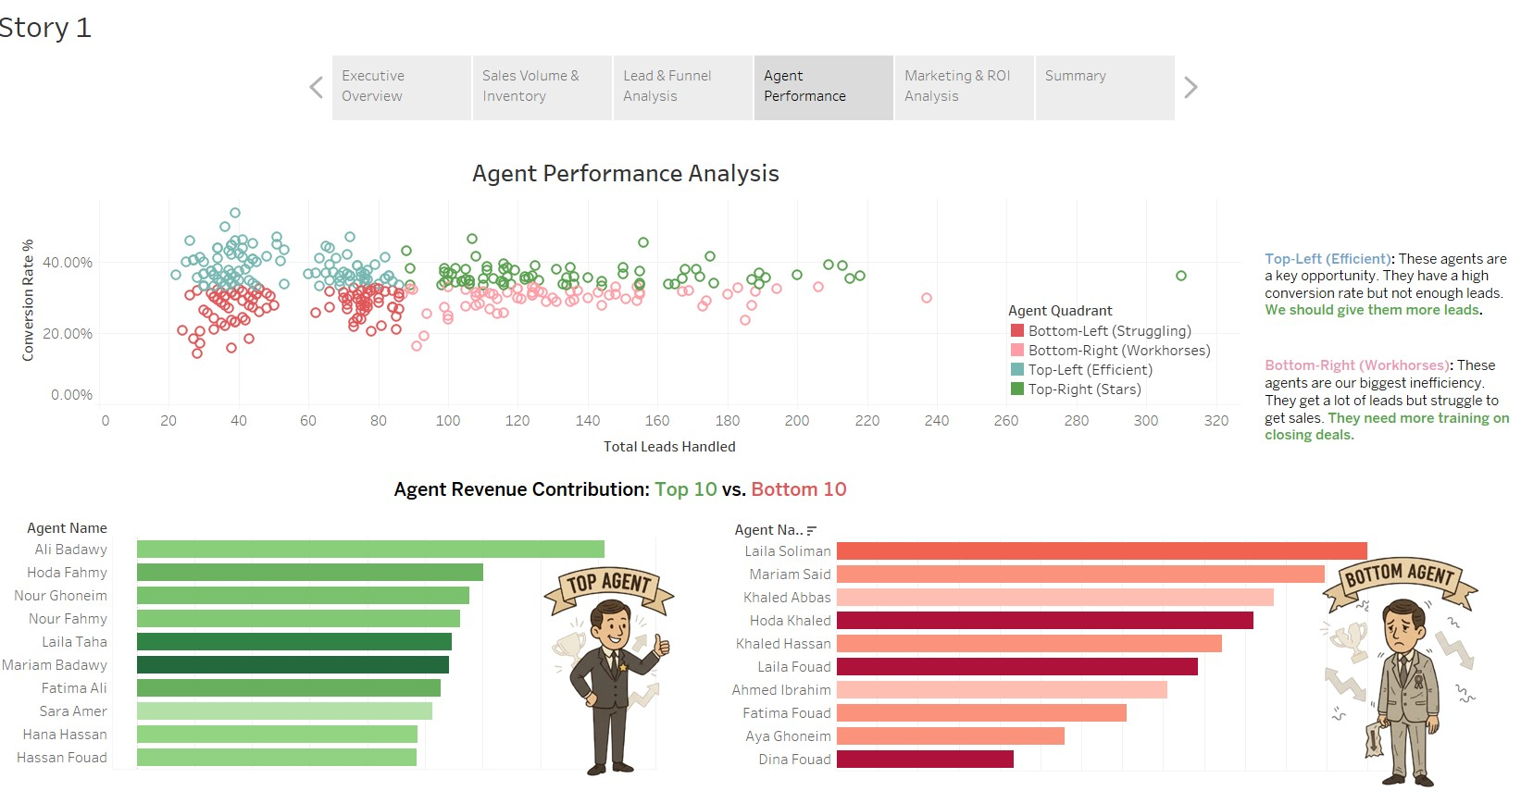
- Description: This page analyzes the sales team. The "Agent Revenue Contribution" charts rank our Top 10 and Bottom 10 agents by revenue. The scatter plot provides a diagnostic, identifying "Efficient" agents (Top-Left) who need more leads and "Workhorse" agents (Bottom-Right) who need more training.
6.5 Page 5: Marketing & ROI Analysis
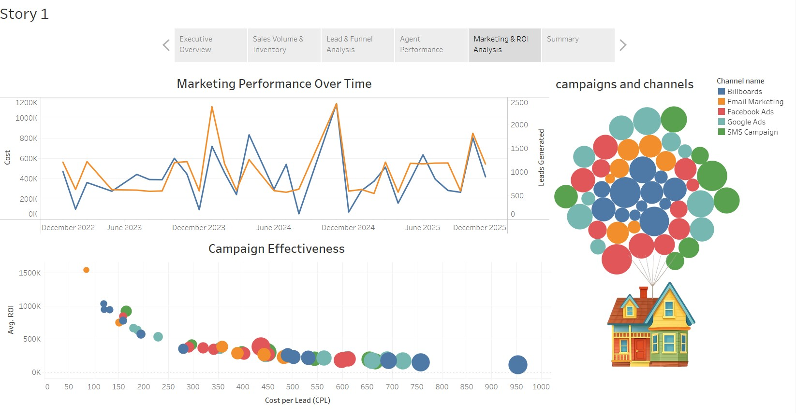
- Description: This page analyzes our marketing spend. The "Marketing Performance Over Time" chart tracks the relationship between cost and leads. The "Campaign Effectiveness" bubble chart identifies our "Gems" (High-ROI, Low-CPL campaigns) and our "Money Pits" (Low-ROI, High-CPL campaigns) at a glance.
7.0 Key Discoveries & Recommendations
This analysis led to three key, data-driven recommendations that can be implemented to increase revenue and reduce costs.
1. The Marketing & Lead Quality Insight
- Discovery: Our marketing budget is not being spent efficiently. Our "Campaign Effectiveness" chart (Page 5) shows...
- Recommendation: Stop the "Money Pit" Google Ads campaigns and re-invest that budget into high-performing "Facebook" and "Referral" programs.
2. The Funnel & Agent Performance Insight
- Discovery: Our biggest problem is closing deals. The "Lead Conversion Funnel" (Page 3) shows our largest bottleneck is at the "Negotiation" stage...
- Recommendation: Implement a "Sales Closing" training program for our "Workhorse" agents and re-assign our best leads to our "Efficient" agents.
3. The Sales & Inventory Insight
- Discovery: Our business is driven by "Apartment" sales in Cairo, but this leaves 5,000 properties unsold in our inventory...
- Recommendation: Run a specific, targeted marketing campaign (using our high-ROI "Facebook" or "Email" channels) for the 5,000 unsold properties to clear old inventory.
8.0 Appendix
8.1 Appendix A: DWH Schema (SQL Scripts)
8.2 Appendix B: BI Query Scripts
8.3 Appendix C: ETL Code

