Spring Core and Maven
Exercise 1: Configuring a Basic Spring Application
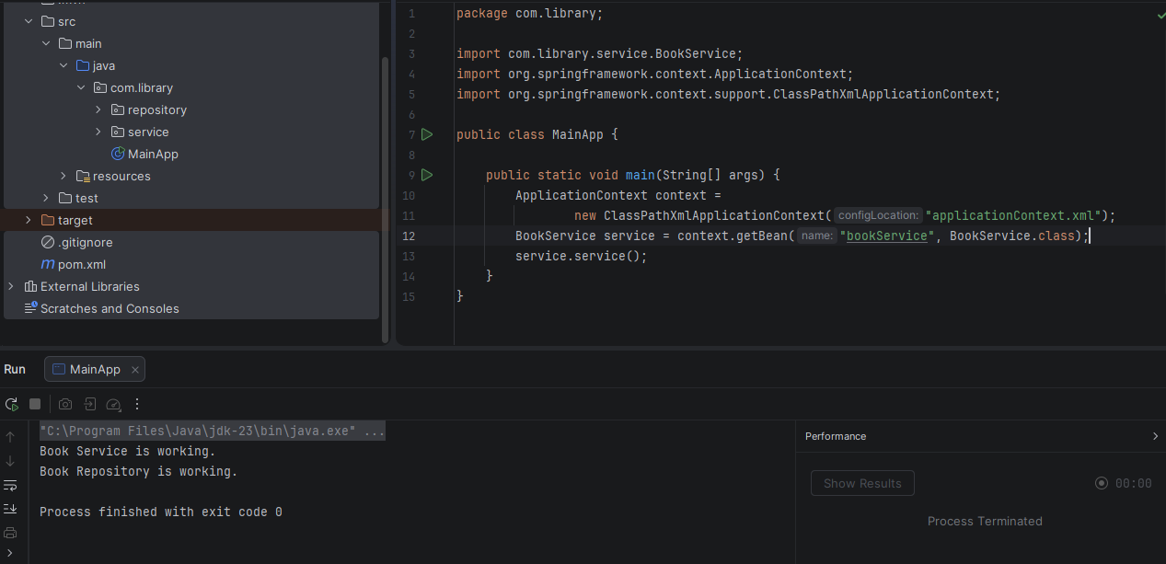
Exercise 2: Implementing Dependency Injection
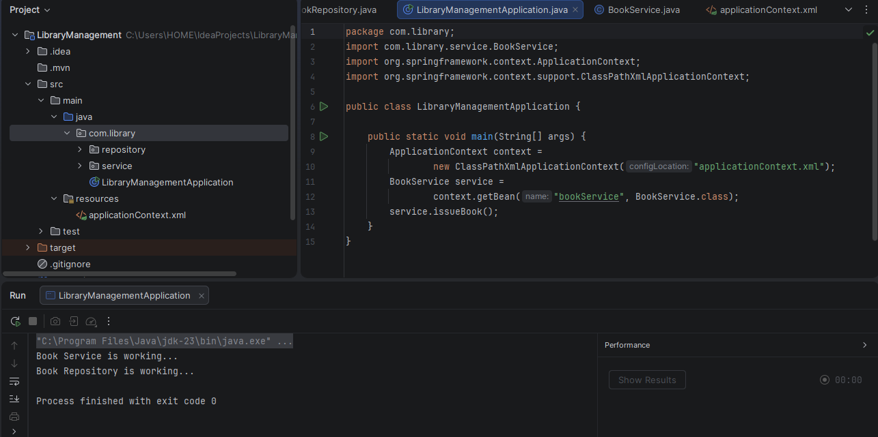
Exercise 4: Creating and Configuring a Maven Project
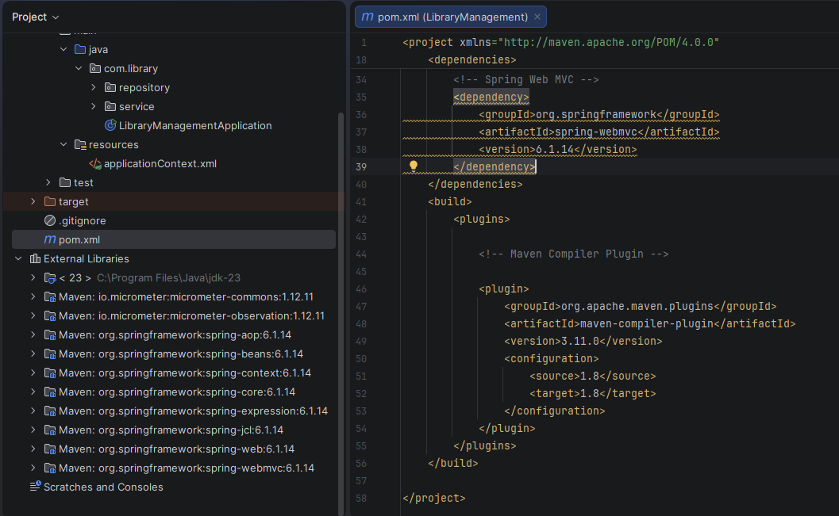
Exercise 5: Configuring the Spring IoC Container
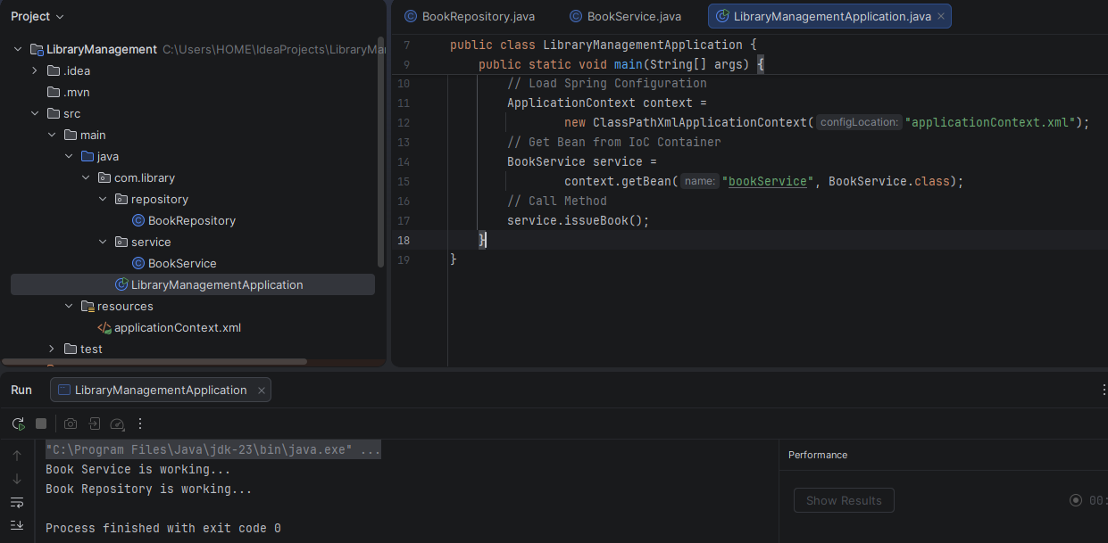
Exercise 7: Implementing Constructor and Setter Injection
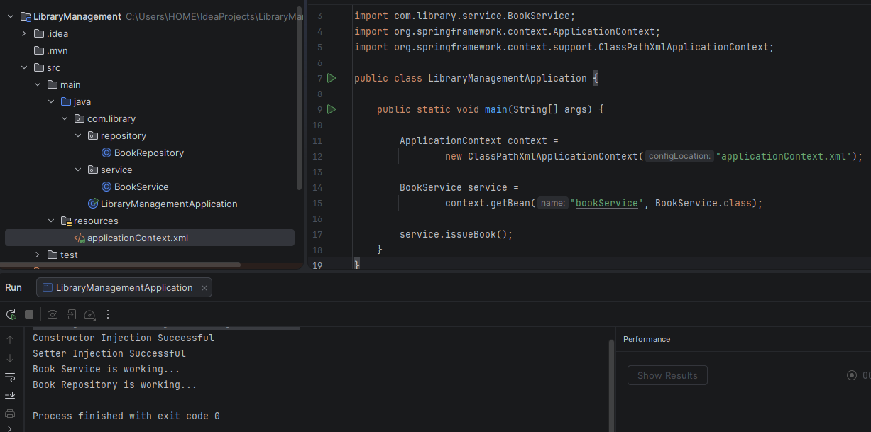
Exercise 9: Creating a Spring Boot Application
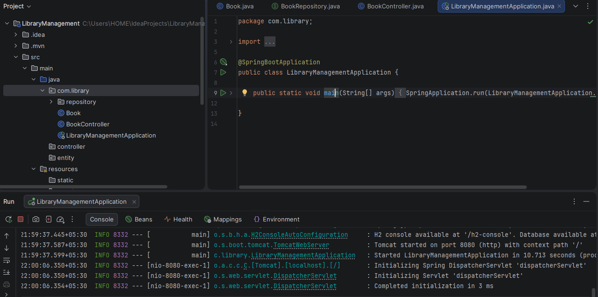
Spring Data JPA with Spring Boot, Hibernate
Spring Data JPA - Quick Example
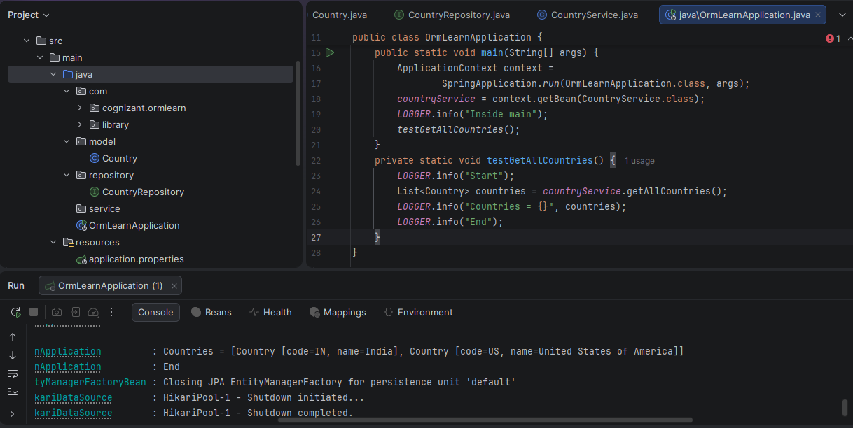
Implement services for managing Country
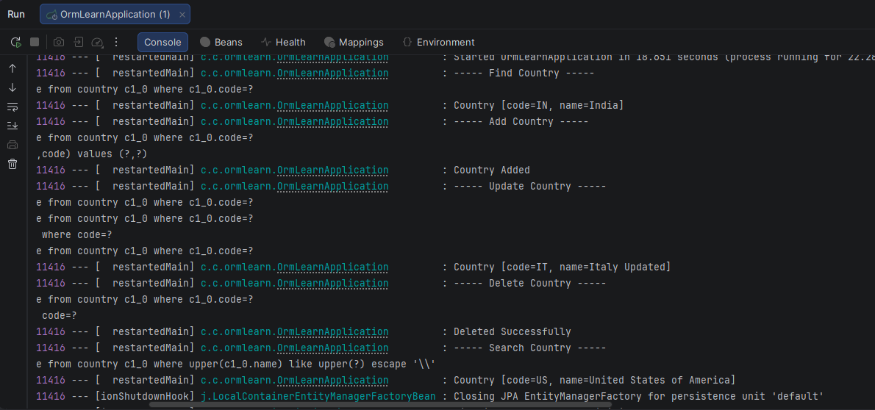
Find a country based on country code
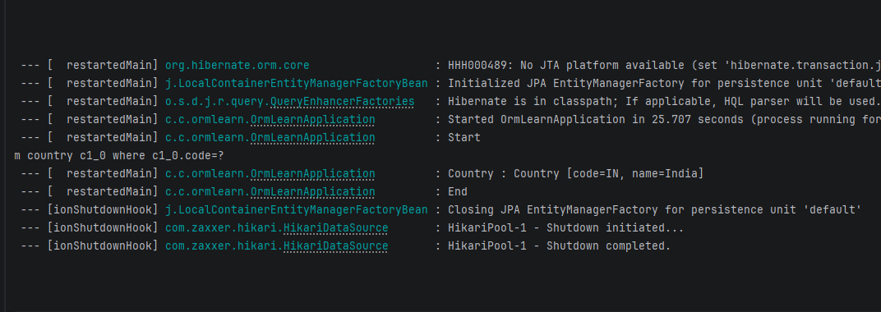

Add a new country
