Spring REST using Spring Boot 3
1.CREATE A SPRING WEB PROJECT USING MAVEN

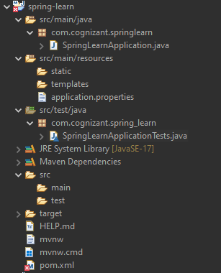
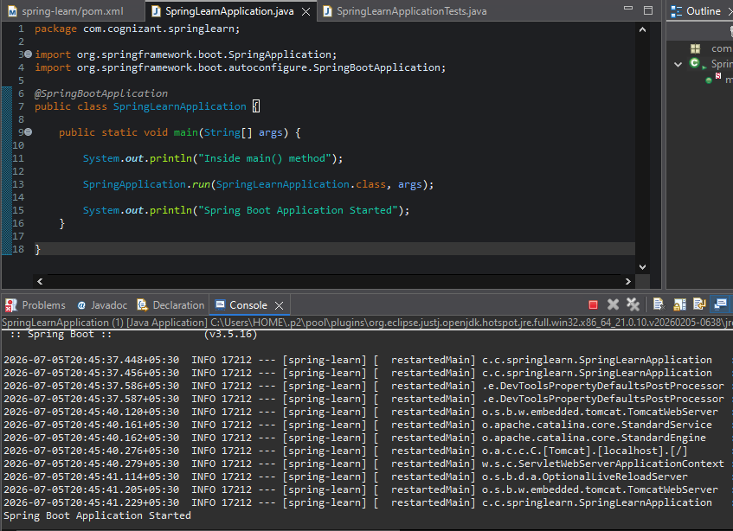

1. src/main/java
Contains the main Java source code of the application.

2. src/main/resources
Contains application configuration files, static resources, and templates.

3. src/test/java
Contains test classes used for testing the application.

4. SpringLearnApplication.java
Main class of the Spring Boot application. It contains the main() method that starts the application.

5. Purpose of @SpringBootApplication
It combines:
- @Configuration
- @EnableAutoConfiguration
- @ComponentScan
It enables auto-configuration and starts the Spring Boot application.

6. main() Method
public static void main(String[] args) {
SpringApplication.run(SpringLearnApplication.class, args);
}
Starts the Spring Boot application.

pom.xml

<parent>
Provides Spring Boot dependency management and default configurations.

<groupId>
Identifies the organization or group.
Example:
com.cognizant

<artifactId>
Specifies the project name.
Example:
spring-learn

<version>
Specifies the project version.
Example:
0.0.1-SNAPSHOT

<properties>
Specifies project properties such as Java version.
<java.version>17</java.version>

Dependencies
spring-boot-starter-web
- Adds Spring MVC and embedded Tomcat for web applications.
spring-boot-devtools
- Provides automatic restart during development.
2.SPRING CORE – LOAD COUNTRY FROM SPRING CONFIGURATION XML
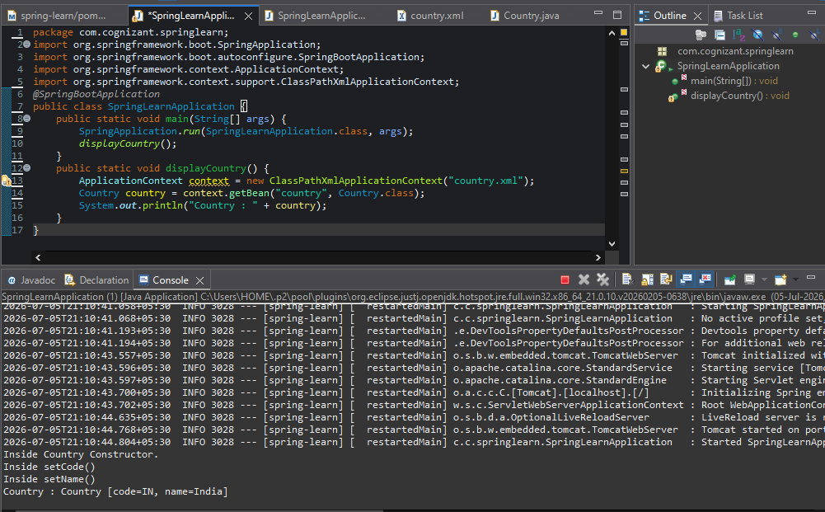

1. Bean Tag
Defines an object (bean) that is managed by the Spring container.

2. id Attribute
Specifies the unique name of the bean.
Example:
<bean id="country" ...>

3. class Attribute
Specifies the fully qualified class name of the bean.
Example:
class="com.cognizant.springlearn.Country"

4. Property Tag
Used to set values for the bean's properties.
Example:
<property name="code" value="IN"/>

5. name Attribute
Specifies the property (instance variable) of the bean to set.
Example:
name="code"

6. value Attribute
Specifies the value assigned to the property.
Example:
value="India"

ApplicationContext
The Spring container that creates, configures, and manages beans.

ClassPathXmlApplicationContext
An implementation of ApplicationContext that loads bean definitions from an XML configuration file in the classpath.
Example:
ApplicationContext context = new ClassPathXmlApplicationContext("country.xml");

What happens when context.getBean() is invoked?
- Spring loads the bean from the XML configuration.
- Creates the bean object (if not already created).
- Calls the constructor.
- Injects the property values using setter methods.
- Returns the fully initialized bean object.
Example:
Country country = context.getBean("country", Country.class);
This retrieves the country bean from country.xml as a Country object.

2. SPRING-REST-HANDSON
1.HELLO WORLD RESTFUL WEB SERVICE
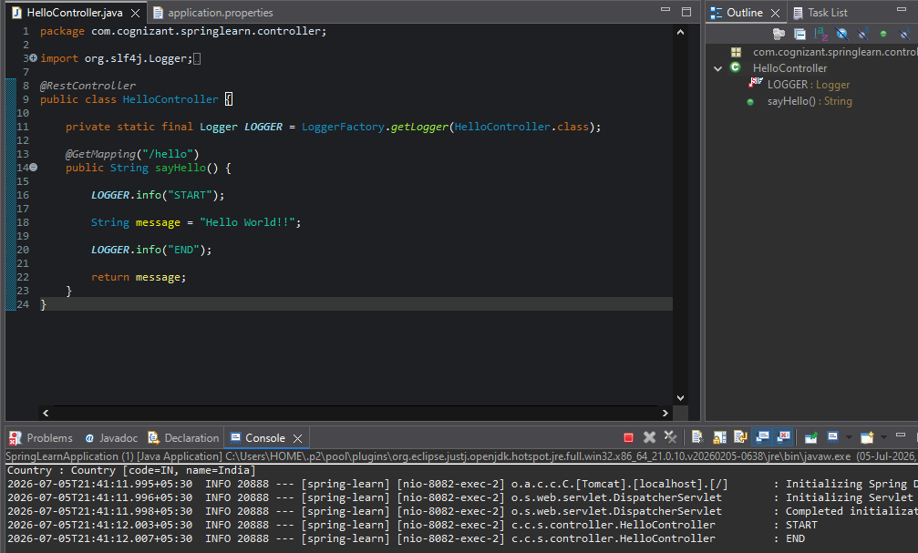
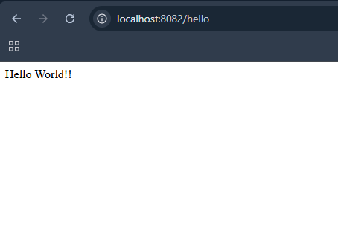

1. Network Tab (Developer Tools)
Shows the HTTP request and response details, including headers, status code, request method, and response body.

2. Headers Tab in Postman
Displays the HTTP request headers and response headers exchanged between the client and the server.
2.REST - COUNTRY WEB SERVICE
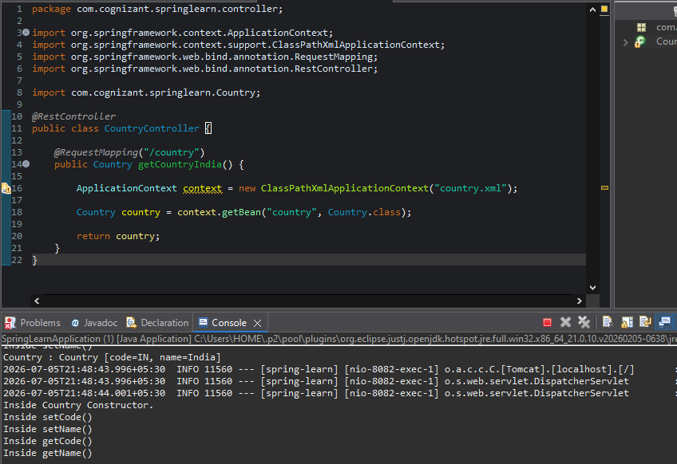
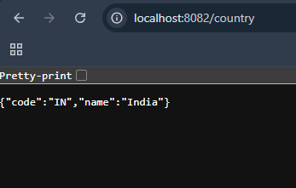

1. What happens in the controller method?
- Loads the Spring XML configuration.
- Retrieves the country bean.
- Returns the Country object.

2. How is the bean converted into JSON?
Spring Boot automatically uses the Jackson library to convert the Country object into a JSON response.

3. Network Tab (Developer Tools)
Shows the HTTP request and response details, including:
- Request URL
- Request Method
- Status Code
- Request Headers
- Response Headers
- Response Body

4. Headers Tab in Postman
Displays the HTTP request headers and response headers exchanged between the client and the server.

3.REST - GET COUNTRY BASED ON COUNTRY CODE
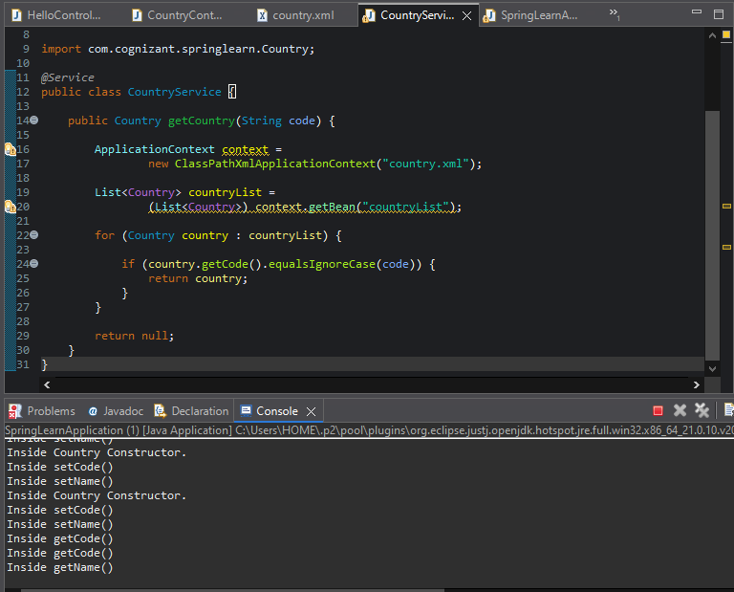
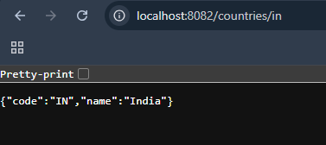

@PathVariable
Used to read values from the URL.

@GetMapping
Maps HTTP GET requests to a controller method.

@Autowired
Automatically injects the required bean.

@Service
Marks a class as the service layer bean.

equalsIgnoreCase()
Compares two strings without considering uppercase or lowercase letters.

5. JWT-HANDSON
1.CREATING MICROSERVICES FOR ACCOUNT AND LOAN
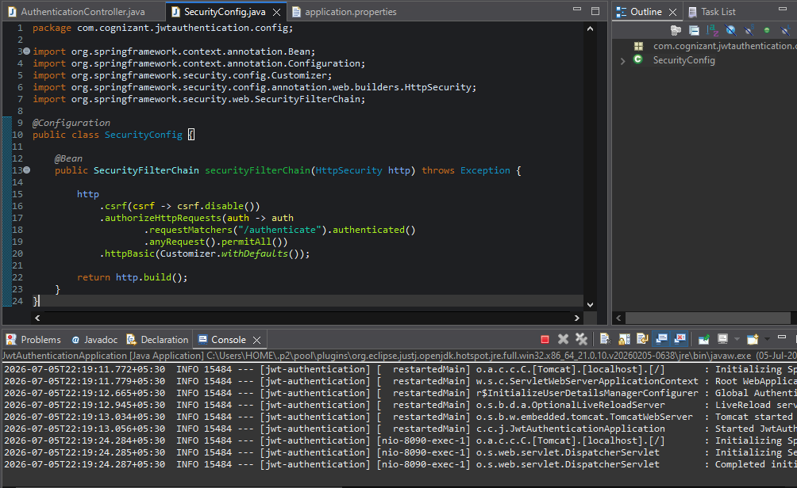
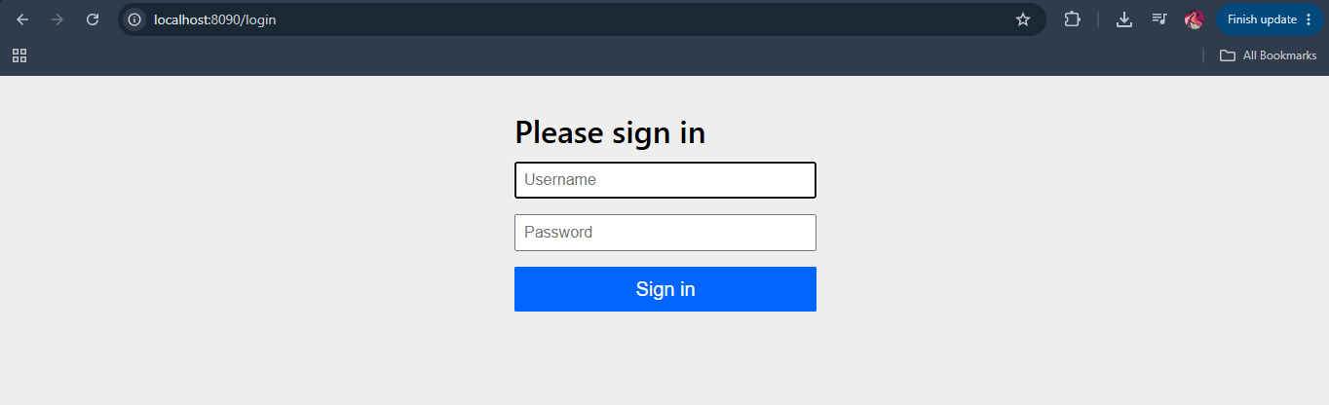
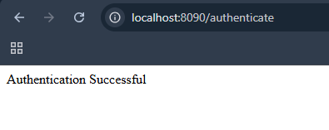
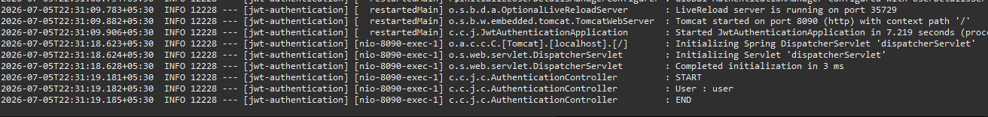
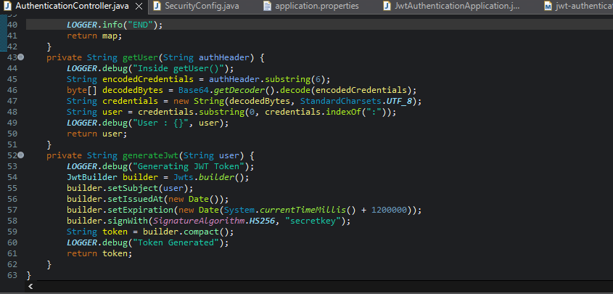
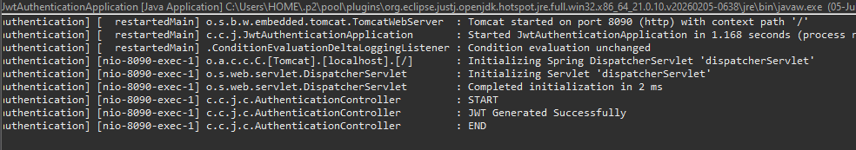
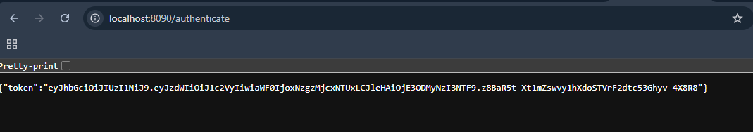

Top of Form

