**Ain Shams University**

**Faculty of Engineering**

**Computer and Systems Engineering Department**

**CSE 412: Digital Verification**

**4th Year CSE**

**2nd Semester 2021/2022**

**Assignment 2**

**Submitted by:**

Sarah Mohamed Ahmed Ahmed

Code: 1700593

Section: 2

**Submitted to:**

Dr. Ayman Wahba

Github link: <https://github.com/Sarah-56/Digital-Verification/tree/main/latest>

Table of Contents

Design: 3

Interface: 3

Counter Module: 3

Test bench: 5

Assertion output: 7

Top module: 8

Output: 9

# Design:

## Interface:

interface Counter_Interface #(

 parameter COUNTER_SIZE = 4

)(

   input bit clk

   );

    bit [1:0] ctrl, WHO;

   bit INIT, LOSER, WINNER, GAMEOVER, rst_l;

   bit [COUNTER_SIZE - 1:0] loadValue;

   clocking cb @(posedge clk);

     default input #0ns output #1ns;

     output rst_l, ctrl, INIT, loadValue;

     input WHO, LOSER, WINNER, GAMEOVER;

   endclocking

   modport dut(

       output GAMEOVER, WHO, LOSER, WINNER,

       input clk, rst_l, ctrl, INIT, loadValue

       );

   modport tb

   (

     clocking cb,

     output rst_l

   );

endinterface

## Counter Module:

module counter #(

   parameter COUNTER_SIZE = 4          // number of bits in counter

   )(

   Counter_Interface.dut sig

   );

   /*********************************************************************

       PARAMETERS

   *********************************************************************/

   parameter cycle = 2;         // clock cycle = 2 msec.

   parameter whoValue = 2'b00;  //start value

   parameter upOne = 2'b00;     //00 count up by 1

   parameter upTwo = 2'b01;     //01 count up by 2

   parameter downOne = 2'b10;   //10 count down by 1

   parameter downTwo = 2'b11;   //11 count down by 2

    /********************************************************************

       REGISTERS & WIRES

   **********************************************************************/

   reg LOSER;

   reg WINNER;

   reg GAMEOVER;

   reg [1:0] WHO;

   reg [1:0] ctrl;

   reg [COUNTER_SIZE - 1:0] m_counter;

   reg [COUNTER_SIZE - 1:0] loser_count;

   reg [COUNTER_SIZE - 1:0] win_count;

   wire [COUNTER_SIZE - 1:0] loadValue;

   /*********************************************************************

       ALWAYS BLOCK

   *********************************************************************/

   always @(posedge sig.clk) begin

       if (sig.INIT) begin

           m_counter = sig.loadValue;

           sig.WHO = whoValue;

           loser_count = 0;

           win_count = 0;

           sig.LOSER = 0;

           sig.WINNER = 0;

           sig.GAMEOVER = 0;

       end

       else begin

           /*************************

           SYNCHRONOUS RESET

           *************************/

           if (sig.rst_l || sig.GAMEOVER) begin

           m_counter <= 4'b0000;

           sig.LOSER <= 0;

           sig.WINNER <= 0;

           sig.WHO <= 2'b00;

           loser_count <= 0;

           win_count <= 0;

           sig.GAMEOVER <= 0;

           end

           /*************************

           INITIALIZATION

           *************************/

           else if (sig.INIT) begin

           m_counter <= sig.loadValue;

           loser_count <= 0;

           win_count <= 0;

           sig.WHO <= 2'b00;

           sig.WINNER <= 0;

           sig.LOSER <= 0;

           sig.GAMEOVER <= 0;

           end

           else begin

           case (sig.ctrl)

               upOne:  m_counter <= m_counter + 1;

               upTwo:  m_counter <= m_counter + 2;

               downOne:  m_counter <= m_counter - 1;

               downTwo:  m_counter <= m_counter - 2;

           endcase

           /*************************************************************************

               set LOSER signal to 1 for 1 clock cycle then clear it and increase

               loser counter by 1 if counter reaches 0

           *************************************************************************/

           if(m_counter == 0) begin

               sig.LOSER <= 1;

               sig.WINNER <= 0;

               loser_count = loser_count + 1;

           end

           /**********************************************************

               set WINNER signal to 1 for 1 clock cycle then clear

it and increase

               winner counter by 1 if counter reaches 15

           ***********************************************************/

           else if(m_counter == 15) begin

               sig.WINNER <= 1;

               sig.LOSER <= 0;

               win_count = win_count + 1;

           end

           else begin

               sig.LOSER <= 0;

               sig.WINNER <= 0;

           end

           // raise gameover signal if loser or winner counter reaches 15

           if(loser_count == 15 || win_count == 15) begin

               sig.GAMEOVER <= 1;

               if(loser_count == 15) sig.WHO <= 2'b01;

               else sig.WHO <= 2'b10;

           end

           end

       end

   end

endmodule

## Test bench:

program tb_counter(Counter_Interface.tb sig);

   /********************************************************************************

       PARAMETERS

   ********************************************************************************/

   parameter cycle = 2;

   parameter COUNTER_SIZE = 4;

   /********************************************************************************

       INITIAL BLOCK

   ********************************************************************************/

   initial begin

       sig.cb.loadValue <= 4'b0000;

       sig.cb.ctrl <= 2'b00;

       sig.cb.rst_l <= 0;

       sig.cb.INIT <= 1;

       for (int ctrl_c = 0; ctrl_c <= 3; ctrl_c = ctrl_c + 1) begin

           for(int loadValue_c = 0; loadValue_c < 3; loadValue_c = loadValue_c + 1) begin

               assertion_1: assert (sig.cb.WINNER == 0)

                   $display("WINNER = %d asserted correctly", sig.cb.WINNER);

               else

                   $fatal("WINNER = %d not asserted correctly", sig.cb.WINNER);

               sig.cb.ctrl <= ctrl_c;

               if(loadValue_c == 2) sig.cb.loadValue <= {COUNTER_SIZE{1'b1}};

               else sig.cb.loadValue <= loadValue_c;

               sig.cb.INIT <= 0;

               #2

               sig.cb.rst_l <= 0;

               #2

               sig.cb.INIT <= 1;

               #1

               sig.cb.INIT <= 0;

               #481

               sig.cb.rst_l <= 1;

           end

       end

   end

   /****************************

       Assign BLOCK

   ****************************/

   assign WHO = sig.cb.WHO;

   assign LOSER = sig.cb.LOSER;

   assign WINNER = sig.cb.WINNER;

   assign GAMEOVER = sig.cb.GAMEOVER;

   /****************************

       Properties

   ****************************/

   property signals_cleared;

     @(sig.cb) disable iff(!($fell(sig.rst_l) )) (WHO ==0 || LOSER == 0 ||

GAMEOVER == 0 || WINNER ==0);

   endproperty

   property winner;

     @(sig.cb)

     if($fell(sig.rst_l)) ##[100:200] GAMEOVER ==1;

   endproperty

   /****************************

       Asserions

   ****************************/

   assert_winner: assert property(winner)$display("[%0t] ----- Assertion GameOver passed", $time);

   assert_signals_cleared: assert property (signals_cleared) $display("[%0t] ----- Assertion Reseting_signals passed", $time);

endprogram

## Assertion output:

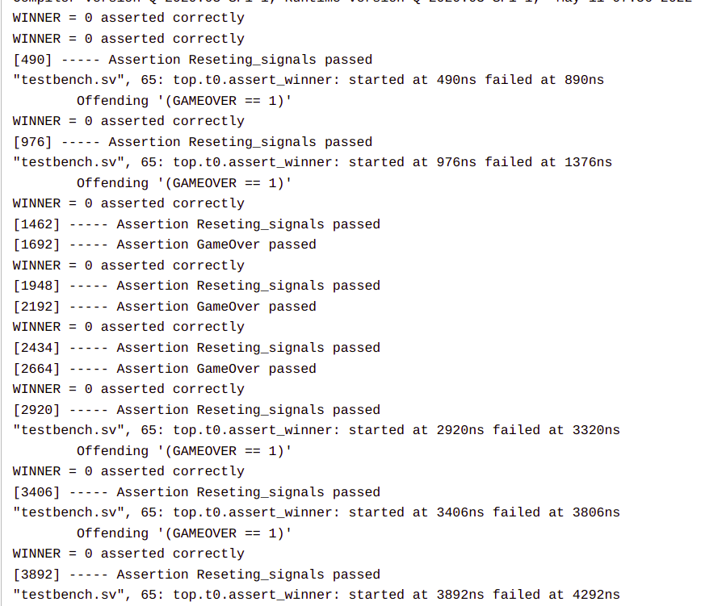

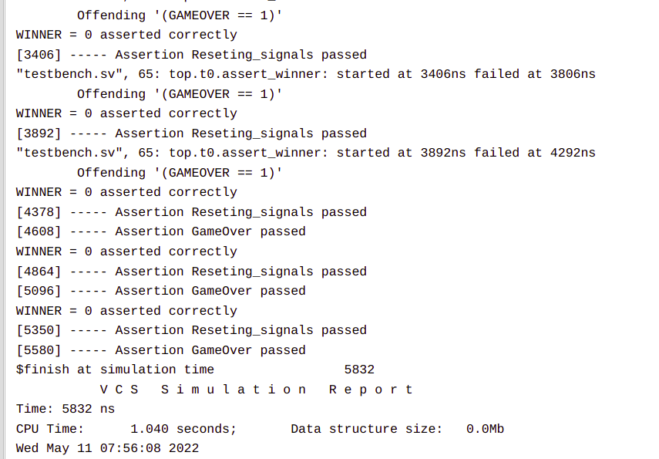

## Top module:

module top (output bit clk);

   initial clk = 1;

   initial forever #1 clk = ~clk;

   Counter_Interface iface(clk);

   tb_counter t0(iface.tb);

   counter G0(iface.dut);

   /******************************

       DUMP VARIABLES

   ******************************/

   initial begin

       $dumpfile("wave.vcd");

       $dumpvars;

   end

endmodule

# 

# Output:

Control signal = 2’b00 (count up by 1)

Load value = 4’b0000

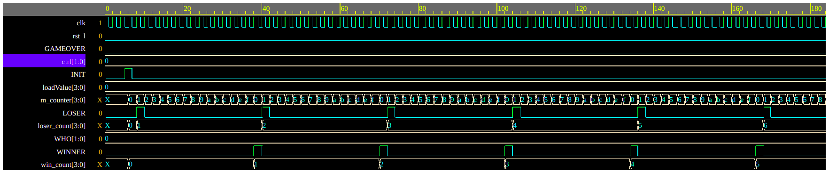

*Figure 1*

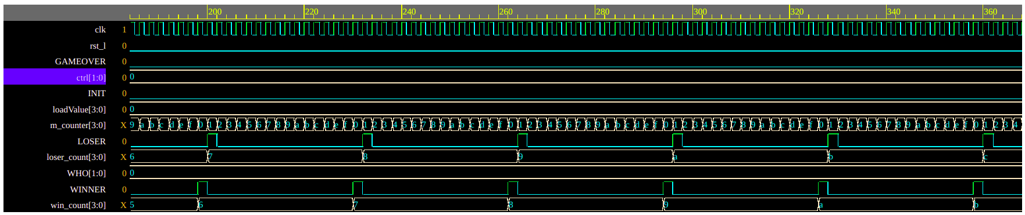

*Figure 3*

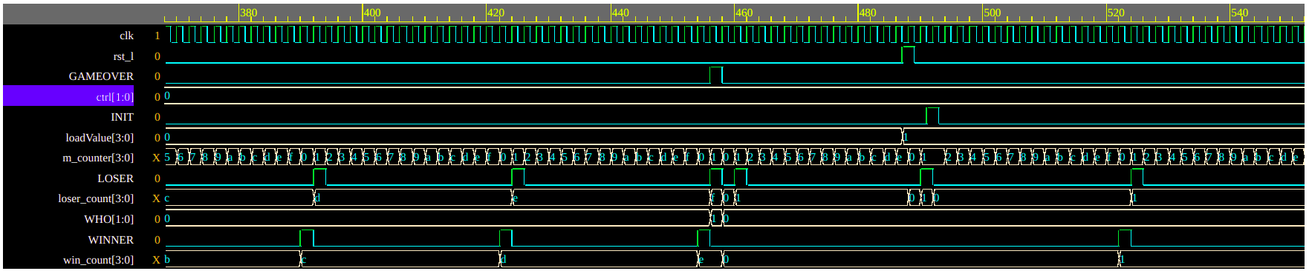

*Figure 4*

Control signal = 2’b00 (count up by 1)

Load value = 4’b0001

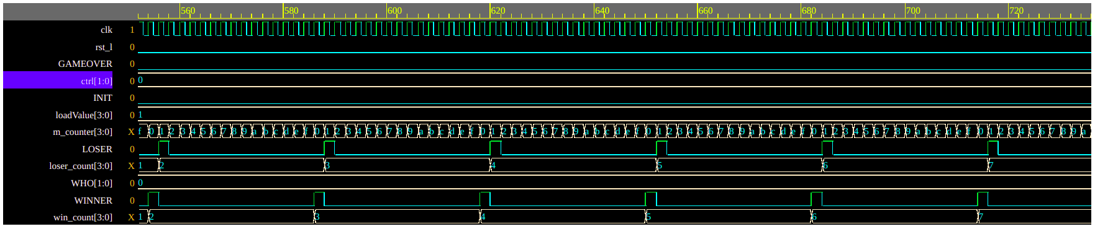

*Figure 5*

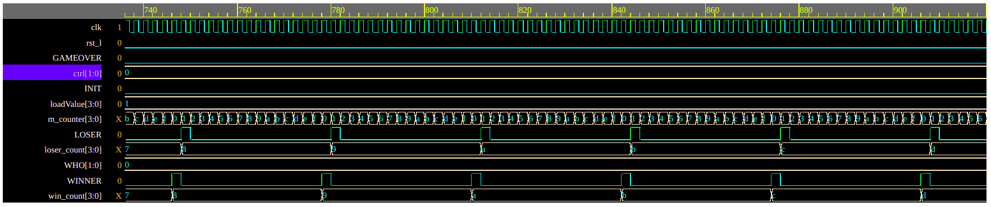

*Figure 6*

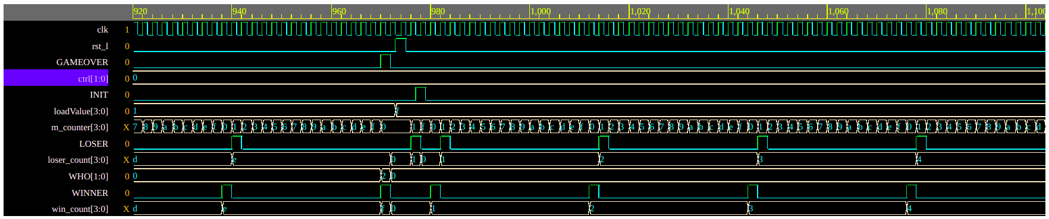

*Figure 7*

Control signal = 2’b00 (count up by 1)

Load value = 4’b1111

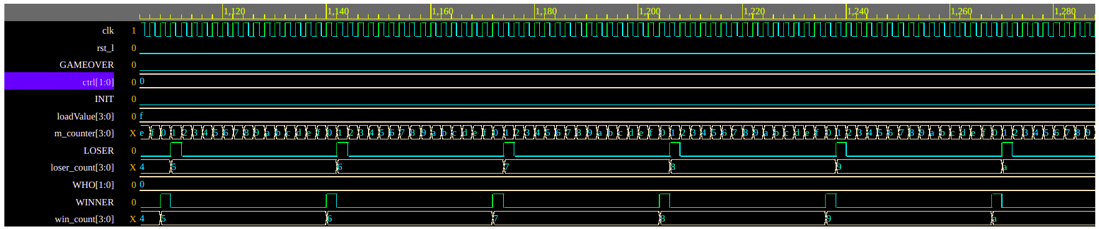

*Figure 8*

Control signal = 2’b00 (count up by 1)

Load value = 4’b1111

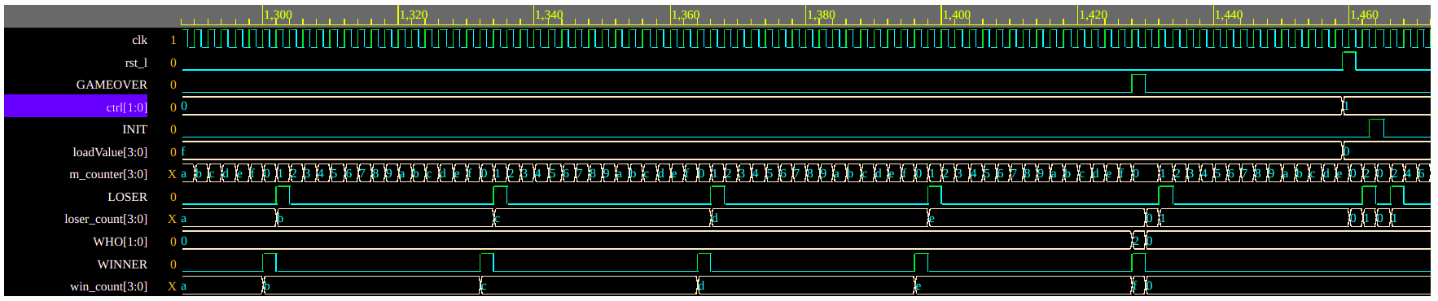

*Figure 9*

Control signal = 2’b01 (count up by 2)

Load value = 4’b0000

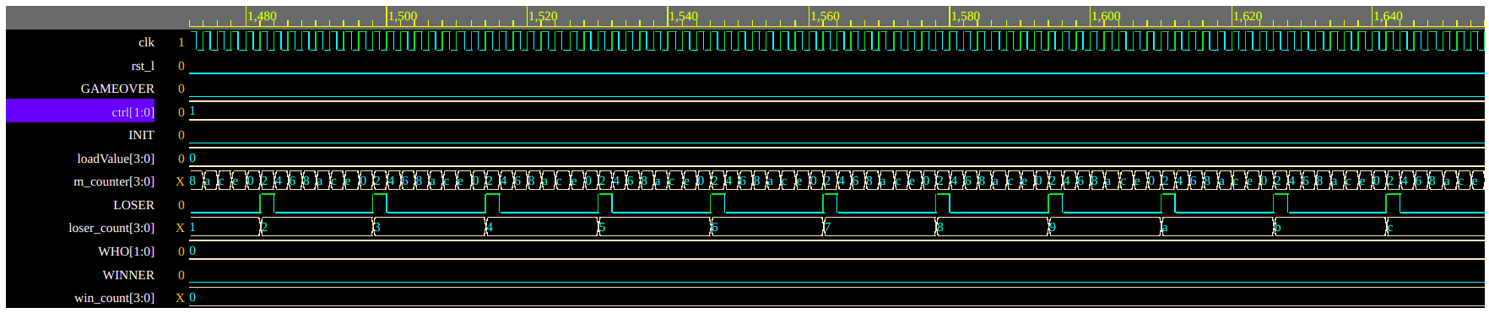

*Figure 10*

Control signal = 2’b01 (count up by 2)

Load value = 4’b0000

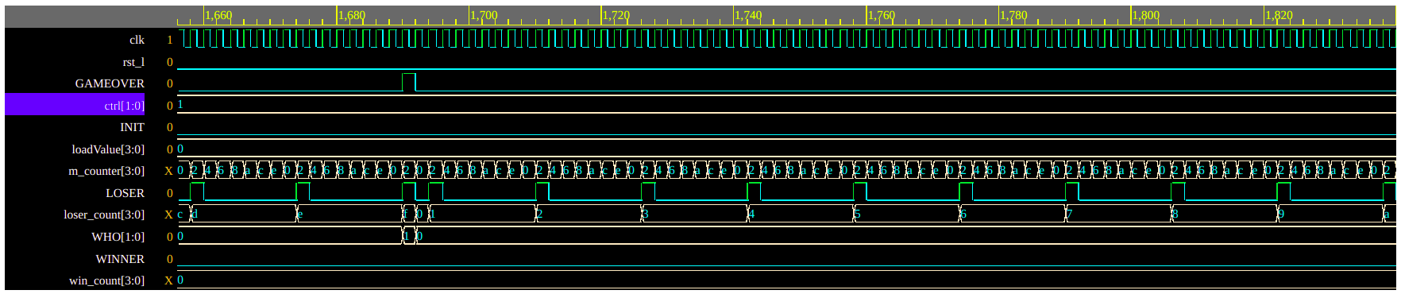

*Figure 11*

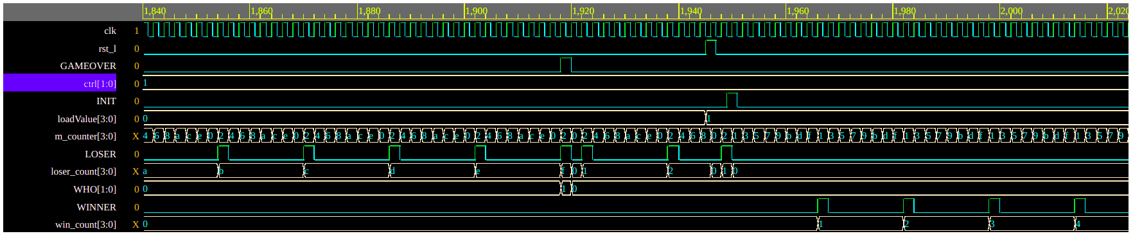

*Figure 12*

Control signal = 2’b01 (count up by 2)

Load value = 4’b0001

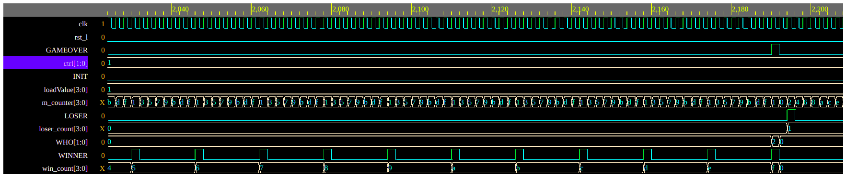

*Figure 13*

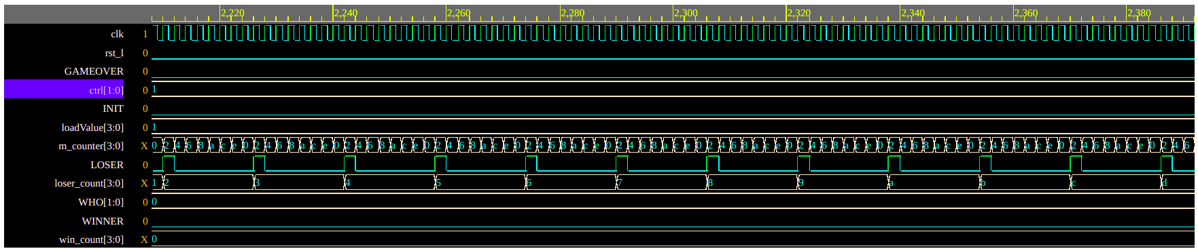

*Figure 14*

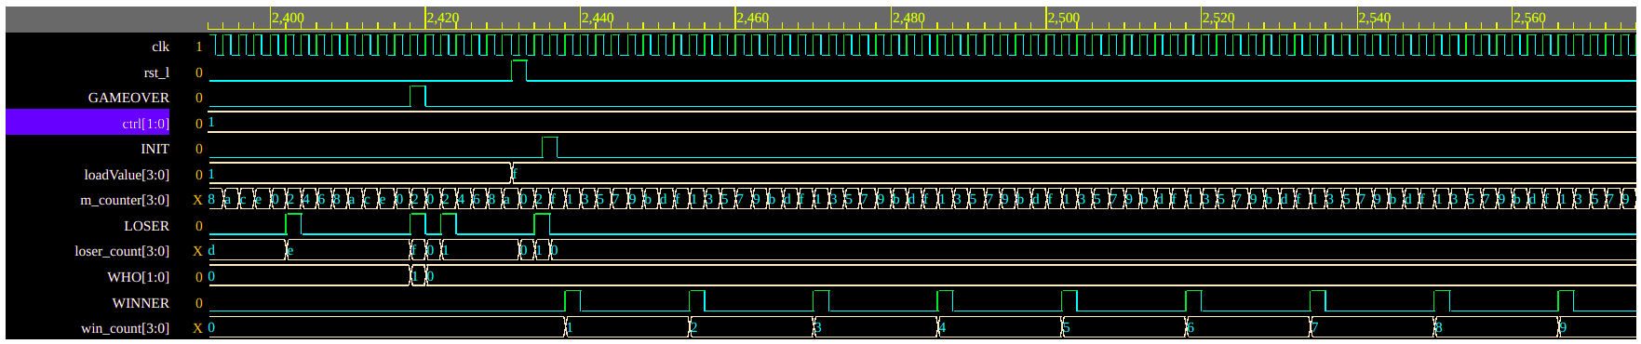

*Figure 15*

Control signal = 2’b01 (count up by 2)

Load value = 4’b1111

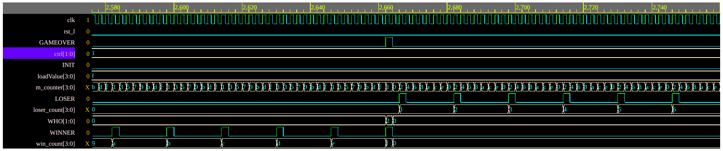

*Figure 16*

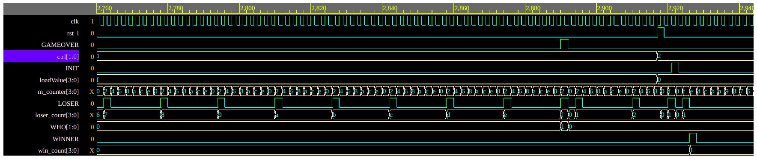

*Figure 17*

Control signal = 2’b10 (count down by 1)

Load value = 4’b0000

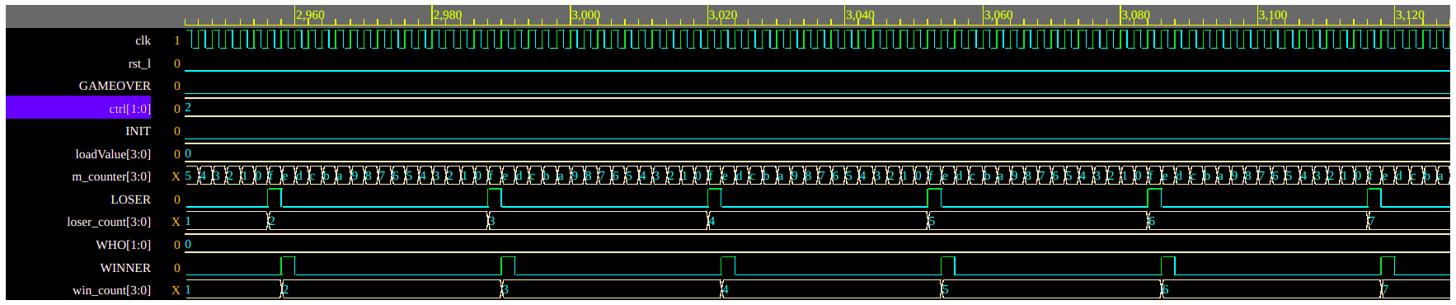

*Figure 18*

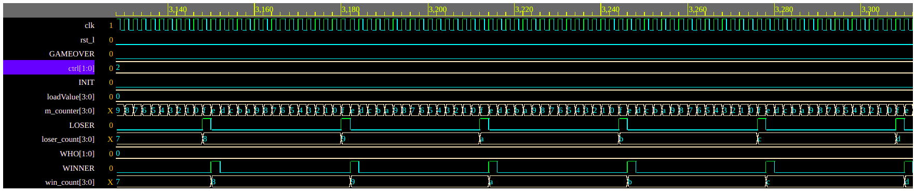

*Figure 19*

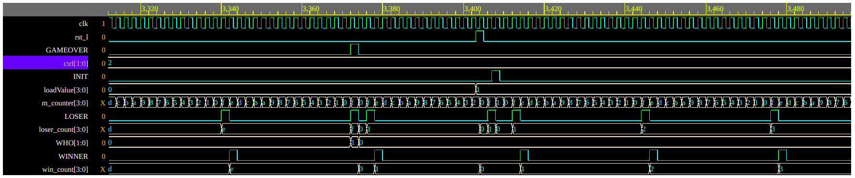

*Figure 20*

Control signal = 2’b10 (count down by 1)

Load value = 4’b0001

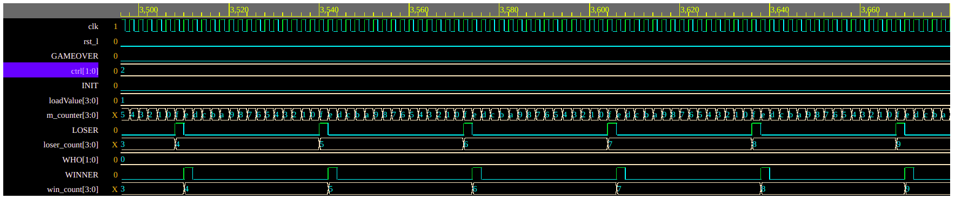

*Figure 21*

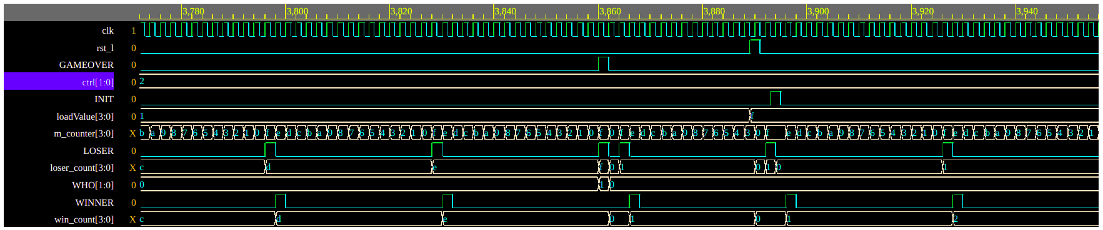

*Figure 22*

Control signal = 2’b10 (count down by 1)

Load value = 4’b1111

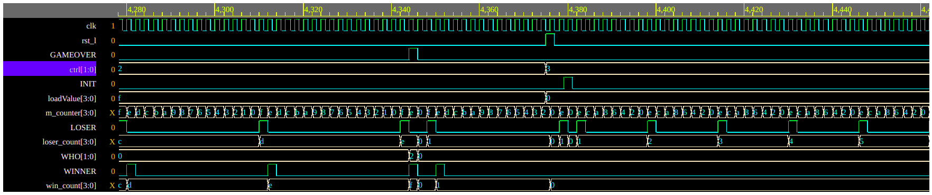

*Figure 23*

Control signal = 2’b11 (count down by 2)

Load value = 4’b0000

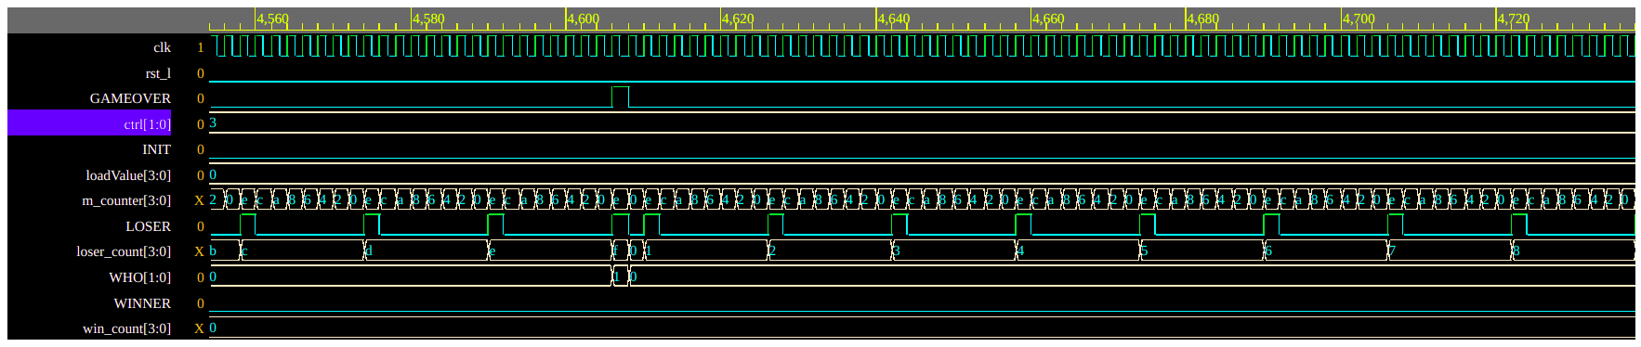

*Figure 24*

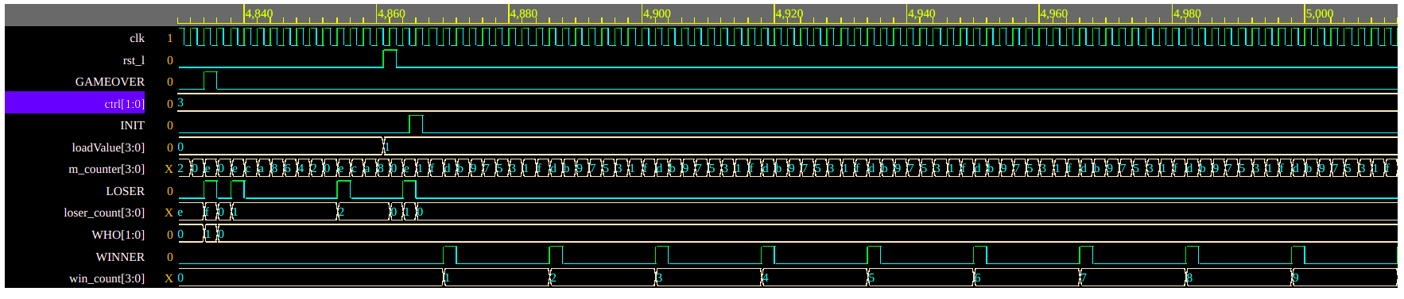

*Figure 25*

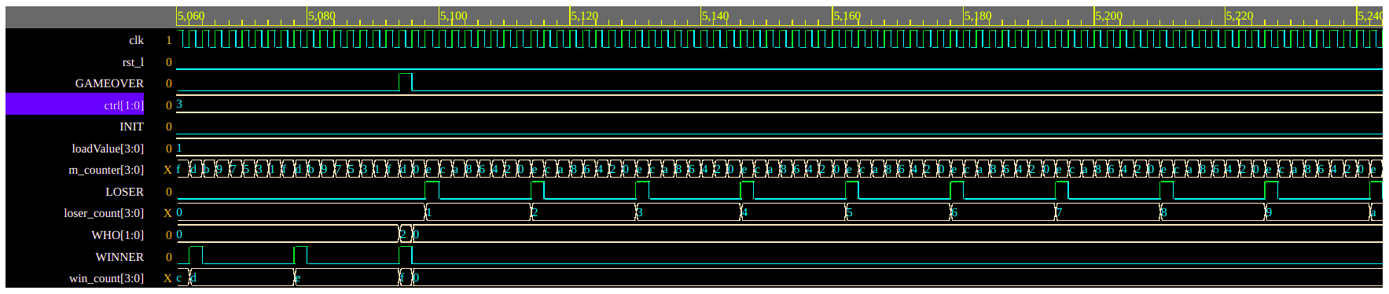

*Figure 26*

Control signal = 2’b11 (count down by 2)

Load value = 4’b0001

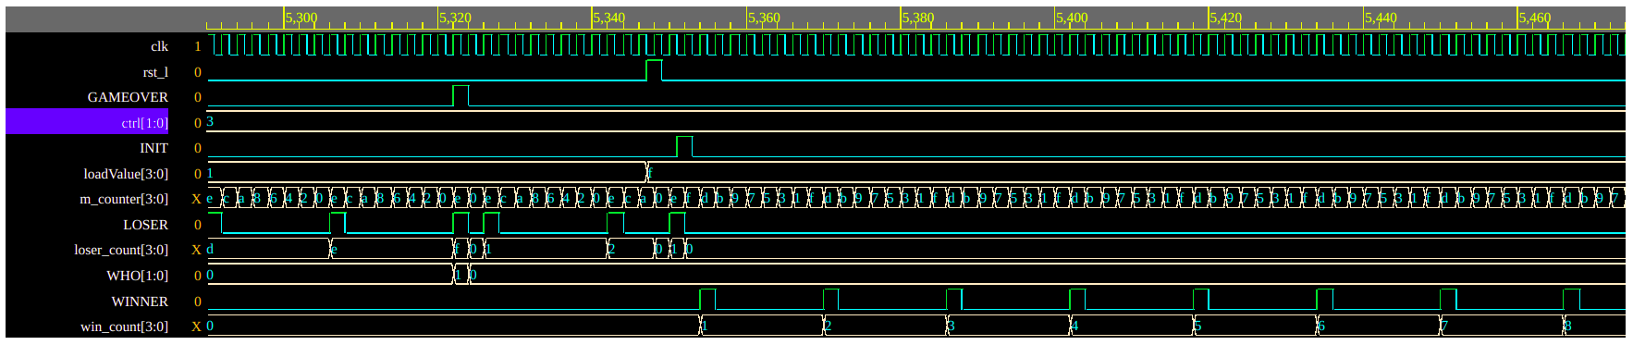

*Figure 27*

Control signal = 2’b11 (count down by21)

Load value = 4’b1111

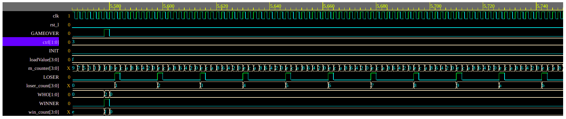

*Figure 28*