|  |  |
| --- | --- |
| Shortcut | Description |
| Cmd+/ | Show Slack shortcuts |

* + Cmd+K - search
* https://w.amazon.com/bin/view/AmazonUC/SIGNAL/OPUS/KB/CommunityTools/
* Workspaces are hierarchical

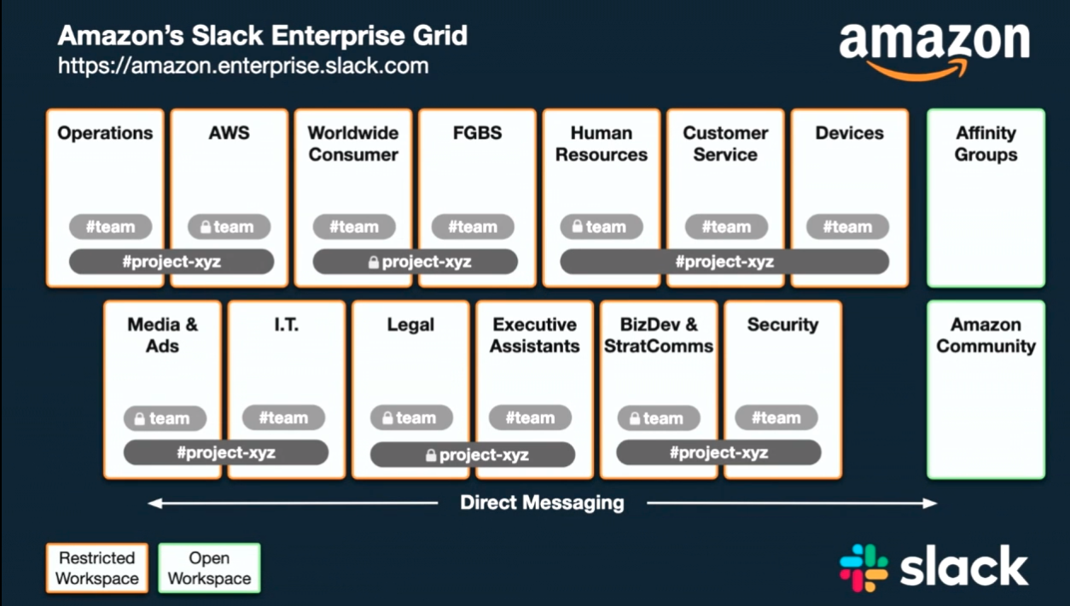

* Direct messaging is available regardless of workspaces
  + Direct messaging is private and can’t be shared. In order to share direct messaging, you must start a direct messaging with all members.
* Channels can span multiple workspaces.
  + Public channel – is within my current workspace. People from other workspaces will not be able to find this channel.
  + Any file classified as confidential, shouldn’t be shared on public channels!!
  + You can’t manually change a public to a private channel. In order to do this, you’ll need to contact IT.
  + You can NEVER turn a private channel into a public channel.
  + If I need to add a channel to different workspaces: In my channel -> Details -> More -> Additional options -> Add channel to additional workspaces.   
    Note: you don’t want usually to add a channel to all workspaces (create too much noise). Only add them to where they’re needed.  
    To know if a channel is on multiple workspaces – see the circles next to its name
* 80% of our conversations should be in channels and 20% in direct messages.
* Pin to channel – to pin important information etc. (see pin next to channel name + floating menu in message)
* Save message – through floating menu in message
* New message – to create a draft before sending (button next to workspace name)
* You can * every direct messages and channels so they all appear at the head of the page and you can easily review if you missed anything.
* @mention – to mention other people in channel (public) or direct messaging (private). In private – it clarify who you’re talking about. In public, it notifies them.
* Effective communication:
  + Emoji to let the other person to know that you’ve seen their message: eyes, checkmark, +1 etc.
    - Priority marking: white-blue-red circles.
  + Threads
    - You can follow/unfollow threads.
* Our Slack set up currently has a file retention policy of 180 days, meaning that any/all files uploaded to Slack will be removed after six months.