CSS
When designing - use ‘*{outline: 1px solid red !important; }’ in CSS to see the boxes.
CSS Validator: https://jigsaw.w3.org/css-validator/#validate_by_input
Web Platform.org also has some pretty complete tutorials on CSS.
Style Guide for CSS: http://getbem.com/introduction/ - BEM: Blocks-Elements-Modifiers

Style
Cascading Style Sheets (CSS) allow you to define an element's appearance by hooking into the attributes that you apply to that element. These attributes can be either and ID or a class and, like all attributes, they add helpful information to the elements that they are attached to. Depending on which attribute you add to an element, you can write a CSS selector to apply the necessary visual styles that are needed to achieve the look and feel for that element and the website as a whole.
While either IDs or classes work for the purpose of hooking into them with CSS rules, modern web design methods favor classes over IDs, in part, because they are less specific and easier to work with overall.
In most cases you would assign a single class attribute to an element, but you actually aren't limited to just one class they way you are with IDs. While an element can only have a single ID attribute, you can absolutely give an element multiple classes and, in some cases, doing so will make your page easier to style and much more flexible!
If you need to assign multiple classes to an element, you can add the additional classes and simply separate them with a space in your attribute.
For example, this paragraph has three classes:
<p class="pullquote featured left">This would be the text of the paragraph</p>
This sets the following three classes on the paragraph tag:
- pullquote
- featured
- left
Notice the spaces between each one of these class values. Those spaces is what sets them up as different, individual classes. This is also why class names cannot have spaces in them, because doing so would set them as separate classes.
For example, if you used "pullquote-featured-left" without a space, it would be one class value, but the example above, where these three words are separated with a space, sets them as individual values. It is important to understand this concept as you decide on which class values to use on your webpages.
Once you have your class values in HTML, you can then assign these as classes in your CSS and apply the styles you would want to add. For example.
.pullquote { ... }
.featured { ... }
p.left { ... }
In these examples, the CSS declarations and values pairs would be inside the curly braces, which is how those styles would be applied to the appropriate selector.

CSS in HTML
Usually, you will want to have a separate CSS file with all your page formatting instructions. However, if you need to add the style directly into your html, there are two ways to do it:

Inline CSS
If you need to inline CSS (very rare) in the html element itself:
<h2 style="color: blue;">CatPhotoApp</h2>

Style Block
In the html:
<style>
h2 {color: blue;}
…
</style>

CSS Selectors
https://www.w3schools.com/cssref/css_selectors.asp
- :root – matches the document’s root element (in HTML this is the <html> tag)
- <element-type> {} will operate on all elements of <element-type>:
h2 {…}
- .<class-type> - will operate on all elements of class <class-type>:
In CSS: .red-text {}
In html: <p class=”red-text”>….</p>
- #<id> - will operate on the single element with id <id>:
In CSS: #cat-photo-element {}
In html: <img id=”cat-photo-element” …>
- Class within a class:
.outerclass<space>.innerclass {}
Will act on all elements of class innerclass that are decendents of the element with the class outerclass
The same works with ids and combinations of ids, elements and classes:
p #innerId .innermostclass {}
- Elements with multiple classes:
.class1.class2 {}
Will act on all the elements that are of class1 and class2
The same works with id: #id1.#id2
- All elements of type x of parent y:
div>p – Selects all <p> elements where the parent is a <div> element
- element+element: div + p
Select all <p> elements that are placed immediately after <div> elements.
- selector1,selector2 – will apply to all selector1 and all selector2 elements.
- [attribute=’value’] – will operate on all elements with this attribute:
[type=’radio’]{}
NOTE: You can set multiple styles to the same element by giving it multiple selectors, for example:
<div class="balls" id="ball1"></div>
<div class="balls" id="ball2"></div>
Both elements will have the same “balls” properties but different properties in “ball1” and “ball2”

Pseudo Class
A pseudo-class is a keyword that can be added to selectors, in order to select a specific state of the element.
For example, the styling of an anchor tag can be changed for its hover state using the :hover pseudo-class selector. Here's the CSS to change the color of the anchor tag to red during its hover state:
a:hover {
color: red;
}

Pseudo Elements
::before
::after
These pseudo-elements are used to add something before or after a selected element. In the following example, a ::before pseudo-element is used to add a rectangle to an element with the class heart:
.heart::before {…}
- The ::before and ::after pseudo element must have a content property. The content property is usually used to add things like a photo or text to the selected element. When the ::before and ::after pseudo-elements are used to make shapes, the content property is still required, but it's set to an empty string.

*property
*property: value is a browser specific CSS hack for versions 7 or below of Internet Explorer.
Although Internet Explorer 7 corrected its behavior when a property name is prefixed with an underscore or a hyphen, other non-alphanumeric character prefixes are treated as they were in IE6. Therefore, if you add a non-alphanumeric character such as an asterisk (*) immediately before a property name, the property will be applied in IE and not in other browsers. Unlike with the hyphen and underscore method, the CSS specification makes no reservations for the asterisk as a prefix, so use of this hack could result in unexpected behavior as the CSS specifications evolve.
*property: value applies the property value in IE 7 and below. It may or may not work in future versions. Warning: this uses invalid CSS.

Cascading
When you create a variable (or set property), it becomes available for you to use inside the element in which you create it. It also becomes available within any elements nested within it. This effect is known as cascading.
You can think of the :root element as a container for your entire HTML document, in the same way that an html element is a container for the body element.

Priorities
The general rule is that specific overrides generic rule and for rules with similar specificity, the last rule overrides the previous ones. CSS attributes in order of priority from high to low:
- Inline style within the element (style=”…”)
- #id
- .class
- element-type (e.g. body)
Notes:
- For attributes with the same priorities (e.g. class): in the event of a conflict, the browser will use whichever CSS declaration came last and will override the previous ones. This is because browsers read CSS from top to bottom.
- To make sure nothing overrides a specific attribute, add !important to it:
…
color: red !important;
…

Classes Name Conventions
- js-<function-name> - for classes that are only linked to javascript code and don’t effect the presentation of the element

Properties
This is the list of all CSS properties:
https://www.w3.org/community/webed/wiki/CSS/Properties

Size Units
CSS has several different units for expressing a length.
Many CSS properties take "length" values, such as width, margin, padding, font-size, border-width, etc.
Length is a number followed by a length unit, such as 10px, 2em, etc.
A whitespace cannot appear between the number and the unit. However, if the value is 0, the unit can be omitted.
For some CSS properties, negative lengths are allowed.
There are two types of length units: absolute and relative.
    - px – pixels (absolute).
    - em - Relative to the font-size of the element (2em means 2 times the size of the current font)
    - vw - Relative to 1% of the width of the viewport*
    - vh - Relative to 1% of the height of the viewport*
    - vmin - Relative to 1% of the viewport’s* smaller dimention
    - vmax - Relative to 1% of the viewport’s* larger dimention
    - % - Relative to the parent element
    - calc(100% - 100px);

Tip: The em and rem units are practical in creating perfectly scalable layout!
* Viewport = the browser window size. If the viewport is 50cm wide, 1vw = 0.5cm.
Note: the viewport doesn’t take the scrollbar into accounts. In order to take them into account do one of the following:
- overflow-y: scroll;
- width: calc(100vw - (100%-100vw));

Text
https://www.w3schools.com/css/css_text.asp
- color
- text-align
- text-decoration: underline, overline, line-through
- text-transform: uppercase, lowercase, capitalize
- text-indent – indent the 1st line of text

Border
border: <width> <style> <color>

- box-shadow:
Create shadow effect around a box. Example:
Here's an example of the CSS to create multiple shadows with some blur, at mostly-transparent black colors:
box-shadow: 0 10px 20px rgba(0,0,0,0.19), 0 6px 6px rgba(0,0,0,0.23);
- opacity:
A value of 1 is opaque, which isn't transparent at all.
A value of 0.5 is half see-through.
A value of 0 is completely transparent.
- text-transform:
capitalization options
- font-weight:
how thick (bold) the text is.
- line-height:
controls the amount of vertical space for each line.

Clockwise Notation
Many properties (e.g. margin or padding) can be specified for the different sides by using a clockwise notation starting with 12:00:
padding: <top> <right> <bottom> <left>;

Shapes
- To create a circle:
border-radius: 50%;
- To create a moon:
border-radius: 50%;
background-color: transparent;
border-radius: 25px 10px 0px 0px blue;
- To create a heart:

Colors

Colors Schemes
Recommended: https://color.adobe.com

RGB Colors:
- 3 hex-bytes: <Red><Green><Blue> - gives 16 million colors. For example: #00FF00 is green.
- 3 hex-nibbles: to shorten: 3 hex nibbles: <red><green><blue> - gives 4,000 colors. However, the difference is not visible in browsers. So #0F0 will give the same kind of green as #00FF00.
- RGB Values: rgb(red,green,blue). Each of them is 0 – none and 255 – full.

RGBA colors:
r = red (0-255)
g = green (0-255)
b = blue (0-255)
a = alpha/level of opacity (0-1, where 0 is fully transparent and 1 is full opaque)
rgba are a great option since the opacity means that you don't have to completely block out the background.
For example: background-color: rgba(45, 45, 45, 0.1);

hsl colors:
hsl(hue, saturation, lightness)
Colors have several characteristics including hue, saturation, and lightness. CSS3 introduced the hsl() property as an alternative way to pick a color by directly stating these characteristics.
Hue is what people generally think of as 'color'. If you picture a spectrum of colors starting with red on the left, moving through green in the middle, and blue on right, the hue is where a color fits along this line. In hsl(), hue uses a color wheel concept instead of the spectrum, where the angle of the color on the circle is given as a value between 0 and 360.
Saturation is the amount of gray in a color. A fully saturated color has no gray in it, and a minimally saturated color is almost completely gray. This is given as a percentage with 100% being fully saturated.
Lightness is the amount of white or black in a color. A percentage is given ranging from 0% (black) to 100% (white), where 50% is the normal color.
Here are a few examples of using hsl() with fully-saturated, normal lightness colors:
Color | HSL
red | hsl(0, 100%, 50%)
yellow | hsl(60, 100%, 50%)
green | hsl(120, 100%, 50%)
cyan | hsl(180, 100%, 50%)
blue | hsl(240, 100%, 50%)
magenta | hsl(300, 100%, 50%)
The hsl() option in CSS also makes it easy to adjust the tone of a color. Mixing white with a pure hue creates a tint of that color, and adding black will make a shade. Alternatively, a tone is produced by adding gray or by both tinting and shading. Recall that the 's' and 'l' of hsl() stand for saturation and lightness, respectively. The saturation percent changes the amount of gray and the lightness percent determines how much white or black is in the color. This is useful when you have a base hue you like, but need different variations of it.

Color Gradient
Applying a color on HTML elements is not limited to one flat hue. CSS provides the ability to use color transitions, otherwise known as gradients, on elements. This is accessed through the background property's linear-gradient() function. Here is the general syntax:
background: linear-gradient(gradient_direction, color 1, color 2, color 3, ...);
The first argument specifies the direction from which color transition starts - it can be stated as a degree, where 90deg makes a vertical gradient and 45deg is angled like a backslash. The following arguments specify the order of colors used in the gradient.
Example:
background: linear-gradient(45deg, red, yellow, rgb(204, 204, 255));
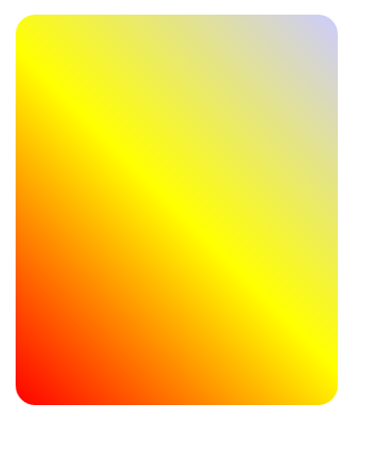

repeating-linear-gradient
The repeating-linear-gradient() function is very similar to linear-gradient() with the major difference that it repeats the specified gradient pattern. repeating-linear-gradient() accepts a variety of values, but for simplicity, you'll work with an angle value and color stop values in this challenge.
The angle value is the direction of the gradient. Color stops are like width values that mark where a transition takes place (from the beginning), and are given with a percentage or a number of pixels.
background: repeating-linear-gradient(
90deg,
yellow 0px,
blue 40px,
green 40px,
red 80px
);
In the example demonstrated in the code above, the gradient starts with the color yellow at 0 pixels which blends into the second color blue at 40 pixels away from the start. Since the next color stop is also at 40 pixels, the gradient immediately changes to the third color green, which itself blends into the fourth color value red as that is 80 pixels away from the beginning of the gradient.
For this example, it helps to think about the color stops as pairs where every two colors blend together.
0px [yellow -- blend -- blue] 40px [green -- blend -- red] 80px
If every two color stop values are the same color, the blending isn't noticeable because it's between the same color, followed by a hard transition to the next color, so you end up with stripes.
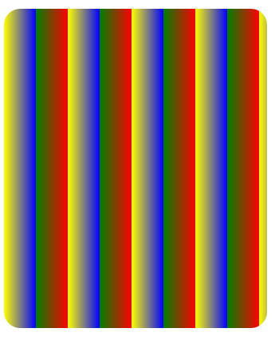

Alignment

text
text-align: justify|center|right|left

Horizontal Alignment
to horizontally center a block element (like <div>), use:
margin: auto;
If you want to align a non-block element (e.g. image or button), you can make it a block element by: display: block; and then you can use the margin: auto; to center it.

Header Alignment
If you want to align the page’s header to be always at the top of the viewport, even when the user scrolls down, add the following to it:
position: fixed;
top: [auto|length|%|initial|inherit];
/* this will hide the content when scrolling: */
background-color :<value>;
/* This will make sure that the header takes up the whole width of the viewport: */
width: 100%;
and add the following to the main element of the page to make sure it doesn’t go over it:
margin-top: 30px;
To be able to use links without them being ‘hidden’ behind the header:
:target:before {
content:"";
display:block;
height:30px; /* fixed header height*/
margin:-30px 0 0; /* negative fixed header height */
}
This will create an empty block-element to “fill in” the space of the header before the actual link.
Issue: there is a small gap between the top of the page and the header;
Solution: if you have the navbar immediately under the body, the gap will disappear. There might be another, better way to do this but this is what I’ve noticed.

Scroll Bar
Use:
overflow: auto;
to add a scroll-bar to a fix-height or max-height block element:
#navbar {
height: 200px;
overflow: auto;
}

Transform
transform: scale(by how much) – allow changing the scale of elements.
The transform property has a variety of functions that lets you scale, move, rotate, skew, etc., your elements. When used with pseudo-classes such as :hover that specify a certain state of an element, the transform property can easily add interactivity to your elements.

Positioning

Full Viewport
Using 100vw on the body/html will not always render the page correctly. If there are scroll bars, it might be wider than the actual view port. In order to fix it, add:
html, body {
width: calc(100vw - (100%-100vw));
}

Normal Flow
CSS treats each HTML element as its own box, which is usually referred to as the CSS Box Model. Block-level items automatically start on a new line (think headings, paragraphs, and divs) while inline items sit within surrounding content (like images or spans). The default layout of elements in this way is called the normal flow of a document, but CSS offers the position property to override it.

Relative Position
When the position of an element is set to relative, it allows you to specify how CSS should move it relative to its current position in the normal flow of the page. It pairs with the CSS offset properties of left or right, and top or bottom. These say how many pixels, percentages, or ems to move the item away from where it is normally positioned (and in the opposite direction). The following example moves the paragraph 10 pixels away from the bottom:
p {
position: relative;
bottom: 10px;
}
Changing an element's position to relative does not remove it from the normal flow - other elements around it still behave as if that item were in its default position.
Note
Positioning gives you a lot of flexibility and power over the visual layout of a page. It's good to remember that no matter the position of elements, the underlying HTML markup should be organized and make sense when read from top to bottom. This is how users with visual impairments (who rely on assistive devices like screen readers) access your content.

Absolute Position
position: absolute;
Absolute position locks the element in place relative to its parent container. Unlike the relative position, this removes the element from the normal flow of the document, so surrounding items ignore it. The CSS offset properties (top or bottom and left or right) are used to adjust the position.
One nuance with absolute positioning is that it will be locked relative to its closest positioned ancestor. If you forget to add a position rule to the parent item, (this is typically done using position: relative;), the browser will keep looking up the chain and ultimately default to the body tag.

Fixed Position
position: fixed;
Fixed position is a type of absolute positioning that locks an element relative to the browser window. Similar to absolute positioning, it's used with the CSS offset properties and also removes the element from the normal flow of the document. Other items no longer "realize" where it is positioned, which may require some layout adjustments elsewhere.
One key difference between the fixed and absolute positions is that an element with a fixed position won't move when the user scrolls. For this reason, navigation bars are sometimes defines with fixed position.

Float
float: left|right;
width: 50%;
Floating elements are removed from the normal flow of a document and pushed to either the left or right of their containing parent element. It's commonly used with the width property to specify how much horizontal space the floated element requires.

Z-Index
z-index: 2;
When elements are positioned to overlap, the element coming later in the HTML markup will, by default, appear on the top of the other elements. However, the z-index property can specify the order of how elements are stacked on top of one another. It must be an integer (i.e. a whole number and not a decimal), and higher values for the z-index property of an element move it higher in the stack (to the front) than those with lower values.

Centre an Element
To centre a block element horizontally:
- Set its margin to a value of auto:
margin: auto;
- To centre inline elements (like images):
display: block:
margin: auto;

Animation
By default, the animation runs one time and then disappear, leaving the original element as it was before the animation ran.
For example, if I have a blue element and I turn it green during the animation – when the animation ends, the element will turn back to being blue.

animation-name
set the name of the animation, which is later used by @keyframes to tell CSS which rules go with which animations.

animation-duration
sets the total length of time for the animation.

animation-fill-mode
Specifies the style applied to an element when the animation has finished:
forwards – the element will remain looking like the animation 100% after it’s finished.

animation-iteration-count
allows you to control how many times you would like to loop through the animation before it stops. If you want the animation to run continuously, use infinite keyword instead of times.

animation-timing-function
controls how quickly an animated element changes over the duration of the animation. If the animation is a car moving from point A to point B in a given time (your animation-duration), the animation-timing-function says how the car accelerates and decelerates over the course of the drive.
There are a number of predefined keywords available for popular options. For example, the default value is ease, which starts slow, speeds up in the middle, and then slows down again in the end. Other options include ease-out, which is quick in the beginning then slows down, ease-in, which is slow in the beginning, then speeds up at the end, or linear, which applies a constant animation speed throughout.

Bezier Curves
In CSS animations, Bezier curves are used with the cubic-bezier function. The shape of the curve represents how the animation plays out. The curve lives on a 1 by 1 coordinate system. The X-axis of this coordinate system is the duration of the animation (think of it as a time scale), and the Y-axis is the change in the animation.
The cubic-bezier function consists of four main points that sit on this 1 by 1 grid: p0, p1, p2, and p3. p0 and p3 are set for you - they are the beginning and end points which are always located respectively at the origin (0, 0) and (1, 1). You set the x and y values for the other two points, and where you place them in the grid dictates the shape of the curve for the animation to follow. This is done in CSS by declaring the x and y values of the p1 and p2 "anchor" points in the form: (x1, y1, x2, y2). Pulling it all together, here's an example of a Bezier curve in CSS code:
animation-timing-function: cubic-bezier(0.25, 0.25, 0.75, 0.75);
In the example above, the x and y values are equivalent for each point (x1 = 0.25 = y1 and x2 = 0.75 = y2), which if you remember from geometry class, results in a line that extends from the origin to point (1, 1). This animation is a linear change of an element during the length of an animation, and is the same as using the linear keyword. In other words, it changes at a constant speed.

The following cubic Bezier curve simulates a juggling movement:
cubic-bezier(0.3, 0.4, 0.5, 1.6);
Notice that the value of y2 is larger than 1. Although the cubic Bezier curve is mapped on an 1 by 1 coordinate system, and it can only accept x values from 0 to 1, the y value can be set to numbers larger than one. This results in a bouncing movement that is ideal for simulating the juggling ball.

@keyframes
s how to specify exactly what happens within the animation over the duration. This is done by giving CSS properties for specific "frames" during the animation, with percentages ranging from 0% to 100%. If you compare this to a movie, the CSS properties for 0% is how the element displays in the opening scene. The CSS properties for 100% is how the element appears at the end, right before the credits roll. Then CSS applies the magic to transition the element over the given duration to act out the scene. Here's an example to illustrate the usage of @keyframes and the animation properties:
#anim { - this can be any CSS selector
(class/id/pseudo class/element etc)
animation-name: colorful;
animation-duration: 3s;
}
@keyframes colorful {
0% {
background-color: blue;
}
100% {
background-color: yellow;
}
}

Variables
Declare a new variable:
--<variable name>: <variable value>;
For example:
--penguin-skin: gray;

Use a variable:
var(--<name of variable>)
For example:
background: var(--penguin-skin);

Fall-back:
When using your variable as a CSS property value, you can attach a fallback value that your browser will revert to if the given variable is invalid.
Note: This fallback is not used to increase browser compatibilty, and it will not work on IE browsers. Rather, it is used so that the browser has a color to display if it cannot find your variable.
var(--<name of variable>,<fallback value>)
for example:
background: var(--penguin-skin, black);

:root
Because of cascading, CSS variables are often defined in the :root element.
By creating your variables in :root, they will be available throughout the whole web page.
Note: if you need to override the variable value, you can override it in more specific classes/ids/elements like according to the CCS priorities.

Accessibility

Hide Screen-Readers Only Content
Improve accessibility on your page when you want to visually hide content meant only for screen readers. This happens when information is in a visual format (like a chart), but screen reader users need an alternative presentation (like a table) to access the data. CSS is used to position the screen reader-only elements off the visual area of the browser window.
Here's an example of the CSS rules that accomplish this:
.sr-only {
position: absolute;
left: -10000px;
width: 1px;
height: 1px;
top: auto;
overflow: hidden;
}
Note
The following CSS approaches will NOT do the same thing:
• display: none; or visibility: hidden; hides content for everyone, including screen reader users
• Zero values for pixel sizes, such as width: 0px; height: 0px; removes that element from the flow of your document, meaning screen readers will ignore it

Colours

Contrast
Low contrast between the foreground and background colors can make text difficult to read. Sufficient contrast improves the readability of your content, but what exactly does "sufficient" mean?
The Web Content Accessibility Guidelines (WCAG) recommend at least a 4.5 to 1 contrast ratio for normal text. The ratio is calculated by comparing the relative luminance values of two colors. This ranges from 1:1 for the same color, or no contrast, to 21:1 for white against black, the strongest contrast. There are many contrast checking tools available online that calculate this ratio for you.
In practice, the 4.5:1 ratio can be reached by darkening the darker color and lightening the lighter one with the aid of a color contrast checker. Darker colors on the color wheel are considered to be blues, violets, magentas, and reds, whereas lighter colors are oranges, yellows, greens, and blue-greens.

Text alternative
Color alone should not be used as the only way to convey important information because screen reader users won't see it and color blind people can’t see it. Use text alternative to address this.

Browser Compatibility
When working with CSS you will likely run into browser compatibility issues at some point. This is why it's important to provide browser fallbacks to avoid potential problems.
When your browser parses the CSS of a webpage, it ignores any properties that it doesn't recognize or support. For example, if you use a CSS variable to assign a background color on a site, Internet Explorer will ignore the background color because it does not support CSS variables. In that case, the browser will use whatever value it has for that property. If it can't find any other value set for that property, it will revert to the default value, which is typically not ideal.
This means that if you do want to provide a browser fallback, it's as easy as providing another more widely supported value immediately before your declaration. That way an older browser will have something to fall back on, while a newer browser will just interpret whatever declaration comes later in the cascade.
For example:
background: red; //widely supported value
background: var(--red-color); // var supported only on
// modern browsers

Responsive Web Design
Today, there are many types of devices that can access the web. They range from large desktop computers to small mobile phones. These devices have different screen sizes, resolutions, and processing power. Responsive Web Design is an approach to designing web content that responds to the constraints of different devices. The page structure and CSS rules should be flexible to accommodate these differences. In general, design the page's CSS to your target audience. If you expect most of your traffic to be from mobile users, take a 'mobile-first' approach. Then add conditional rules for larger screen sizes. If your visitors are desktop users, then design for larger screens with conditional rules for smaller sizes. CSS gives you the tools to write different style rules, then apply them depending on the device displaying the page.

HW Pixels and DIPs
Hardware Pixels: the physical dots of light in the display.
Device Independent Pixels (DIP): a unit of measurement that relates HW pixels to actual distance in the display, regardless of the pixels density of the display.
This means that a DIP of 980 will look the same whether the user choses to work with 1280px or 2560px.
CSS Pixel:
The pixels we use in CSS sheets (e.g. width: 300px).
If we want the CSS pixel to have a 1:1 ratio with DIPs, we should add the following to the HTML:
<meta name=”viewport” content=”width=device-width,initial-scale=1.0”>
This also tells the browser not to scale the content automatically (which sometimes causes a mess)
Device-Pixel Ratio(DPR): how many HW pixels cover the same length as 1 dip?
you can read this value from: window.devicePixelRatio

View Port
https://developer.mozilla.org/en-US/docs/Mozilla/Mobile/Viewport_meta_tag
The browser's viewport is the area of the window in which web content can be seen. This is often not the same size as the rendered page, in which case the browser provides scrollbars for the user to scroll around and access all the content.

Size and Typography
Instead of using em or px to size text, you can use viewport units for responsive typography. Viewport units, like percentages, are relative units, but they are based off different items. Viewport units are relative to the viewport dimensions (width or height) of a device, and percentages are relative to the size of the parent container element.
The four different viewport units are:
- vw: 10vw would be 10% of the viewport's width.
- vh: 3vh would be 3% of the viewport's height.
- vmin: 70vmin would be 70% of the viewport's smaller dimension (height vs. width).
- vmax: 100vmax would be 100% of the viewport's bigger dimension (height vs. width).

Sizing Percentage:
The CSS height property, when used with a percentage value, is calculated with respect to the element's containing block.
Let's say your body element has height: 1000px. Then a child with height: 90% would get 900px.
If you have not set an explicit height to the containing block (and the child is not absolutely positioned), then your child element with percentage height will have nothing to go on and height will be determined by content and other properties.
Therefore, in order to have the percentages sizes work correctly, you must set the size of all the containing blocks, starting with the html and body:
html, body {
min-height: 100vh !important;
height: 100vh;
}
When possible, using the view port unites (vh/vw) will work around this issue completely!

Tap Targets
Every element that users might need to press with their fingers (e.g. buttons, links) is called a tap targets.
Tap targets have to be at least 48x48 CSS pixels so that they will be big enough to tap even on small devices.

Media Queries
Media Queries are a new technique introduced in CSS3 that change the presentation of content based on different viewport sizes. The viewport is a user's visible area of a web page, and is different depending on the device used to access the site.
Media Queries consist of a media type, and if that media type matches the type of device the document is displayed on, the styles are applied. You can have as many selectors and styles inside your media query as you want.
Here's an example of a media query that returns the content when the device's width is less than or equal to 100px:
@media (max-width: 100px) { /* CSS Rules */ }
and the following media query returns the content when the device's height is more than or equal to 350px:
@media (min-height: 350px) { /* CSS Rules */ }
Remember, the CSS inside the media query is applied only if the media type matches that of the device being used.

You can use different CSS sheet for different screen sizes/types using media queries.
In order to do this, add different start sheets for different media characteristics:
<link rel=”stylesheet” media=”screen and (min-width:500px)” href=”over500.css”>
In media types, only use screen and print (if you want your page to be printable).
The other media types queries never really took off and you shouldn’t use them.
You can also use one of the following ways to apply media queries:
- Embed them in the CSS file with media tags:
@media screen and (min-width: 500px){ screen specific configuration…..}
- Or embed them using @import tag. However, for performance reasons – you don’t want to use this method!!
The most common queries used here are:
- Max-width: to specify properties for screen smaller than X
- Min-width: to specify properties for screen bigger than X
There is also the possibility to use min(max)-device-width but this is a bad idea because it takes into account the device width and not the browser’s window width.
The media tag can contain all the regular CSS selectors for the defined media. For Example:
@media (max-width: 350px) {
:root {
background: black;
}
h1 {..}
}

Breakpoints:
The point in which the pages changes its layout based on a media query.
Important: don’t use specific devices to define your breakpoints, use your data as a guide and think which breakpoints it needs e.g. when should I enlarge my fonts, when is my screen big enough to add a video etc.

Responsive Image
Making images responsive with CSS is actually very simple. Instead of applying an absolute width to an element:
img { width: 720px; }
You can use:
img {
max-width: 100%;
display: block;
height: auto;
}
The max-width property of 100% scales the image to fit the width of its container, but the image won't stretch wider than its original width. Setting the display property to block changes the image from an inline element (its default), to a block element on its own line. The height property of auto keeps the original aspect ratio of the image.

Retina Image
The simplest way to make your images appear "retina" (and optimize them for retina displays) is to define their width and height values as only half of what the original file is.
Here is an example of an image that is only using half of the original height and width:
<style>
img { height: 250px; width: 250px; }
</style>
<img src="coolPic500x500" alt="A most excellent picture">

CSS Frameworks for Flexible Design

Display: flex – cause
CSS frameworks are pre-prepared software frameworks that are meant to allow for easier, more standards-compliant web design using the Cascading Style Sheets language. Most of these frameworks contain at least a grid.
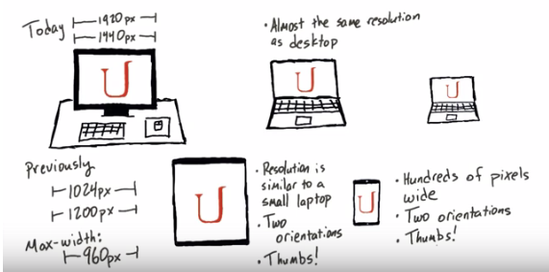
It’s recommended to create:
- .row – 100% of the page’s width
- .col-1…col-12 – columns of width 1/12-12/12 of the row’s width:
- 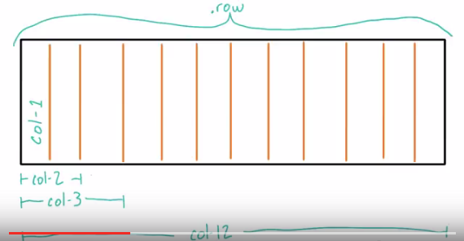

Flexbox vs. Grid
From: https://hackernoon.com/the-ultimate-css-battle-grid-vs-flexbox-d40da0449faf:
- Grid
  - Is made for two dimensional layouts.
  - Where you want to specify the exact cells each div will occupy.
- Flexbox
  - Is made for one dimensional layout.
  - Where you want the cell allocation to happen dynamically depending on the content, without having to specify it yourself.
- Grid will many times be the high-level page layout, with the Flexbox used to layout specific rows dynamically.
This means that if you’re laying out items in one direction (for example three buttons inside a header), then you should use Flexbox:
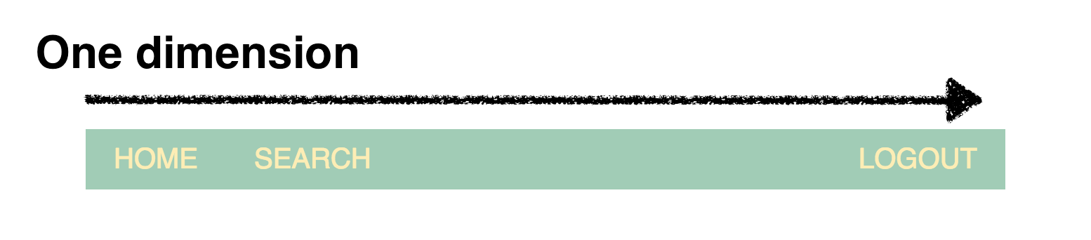
It’ll will give you more flexibility than CSS Grid. It’ll also be easier to maintain and require less code.
However if you’re going to create an entire layout in two dimensions — with both rows and columns — then you should use CSS Grid:
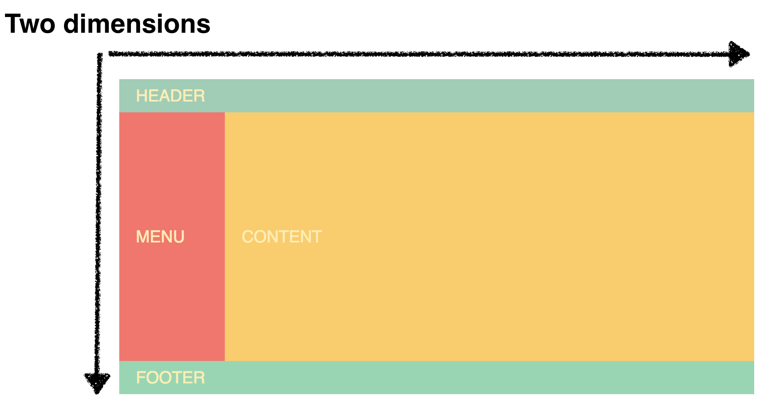
In this case CSS Grid will give you more flexibility, make your markup simpler and the code will be easier to maintain.
Now you can of course combine the two. In the example above it would be perfect to use Grid for the page layout, and then Flexbox to align the content inside the header. This’ll give you the best of both worlds.

Flexbox Layout
https://css-tricks.com/snippets/css/a-guide-to-flexbox/
https://developer.mozilla.org/en-US/docs/Web/CSS/flex
The Flexbox Layout (Flexible Box) module (CSS3) aims at providing a more efficient way to lay out, align and distribute space among items in a container, even when their size is unknown and/or dynamic (thus the word "flex").
Note: Flexbox layout is most appropriate to the components of an application, and small-scale layouts, while the Grid layout is intended for larger scale layouts.
CSS3 introduced Flexible Boxes, or flexbox, to create page layouts for a dynamic UI. It is a layout mode that arranges elements in a predictable way for different screen sizes and browsers.

Flex Container
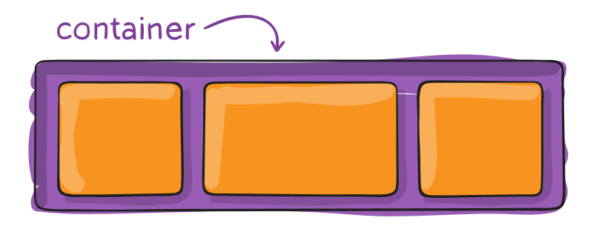

Display: flex/inline-flex
This defines a flex container; inline-flex or block depending on the given value. It enables a flex context for all its direct children.
To use flexbox on an element, set it’s parent display to flex:
display: flex;
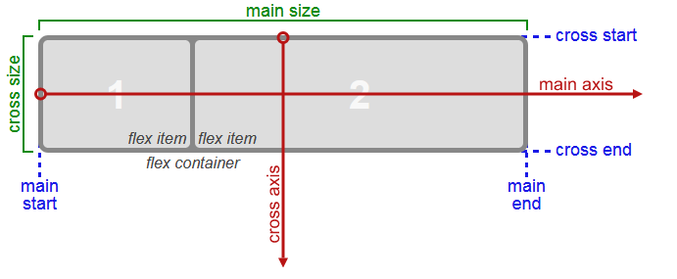
Adding display: flex to an element turns it into a flex container. This makes it possible to align any children of that element into rows or columns.

flex-direction
You do this by adding the flex-direction property to the parent item and setting it to row or column. Creating a row will align the children horizontally, and creating a column will align the children vertically.
Other options for flex-direction are row-reverse and column-reverse.
Note
The default value for the flex-direction property is row.

justify-content
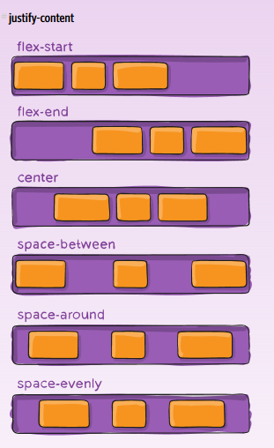
Sometimes the flex items within a flex container do not fill all the space in the container. It is common to want to tell CSS how to align and space out the flex items a certain way. Fortunately, the justify-content property has several options to do this. But first, there is some important terminology to understand before reviewing those options.
Setting a flex container as a row places the flex items side-by-side from left-to-right. A flex container set as a column places the flex items in a vertical stack from top-to-bottom. For each, the direction the flex items are arranged is called the main axis. For a row, this is a horizontal line that cuts through each item. And for a column, the main axis is a vertical line through the items.
There are several options for how to space the flex items along the line that is the main axis. One of the most commonly used is justify-content: center;, which aligns all the flex items to the center inside the flex container. Others options include:
- flex-start: aligns items to the start of the flex container. For a row, this pushes the items to the left of the container. For a column, this pushes the items to the top of the container.
- flex-end: aligns items to the end of the flex container. For a row, this pushes the items to the right of the container. For a column, this pushes the items to the bottom of the container.
- space-between: aligns items to the center of the main axis, with extra space placed between the items. The first and last items are pushed to the very edge of the flex container. For example, in a row the first item is against the left side of the container, the last item is against the right side of the container, then the other items between them are spaced evenly.
- space-around: similar to space-between but the first and last items are not locked to the edges of the container, the space is distributed around all the items

align-items
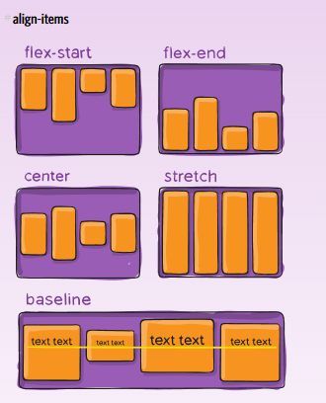
The align-items property is similar to justify-content for a single line/column. Recall that the justify-content property aligned flex items along the main axis. For rows, the main axis is a horizontal line and for columns it is a vertical line.
Flex containers also have a cross axis which is the opposite of the main axis. For rows, the cross axis is vertical and for columns, the cross axis is horizontal.
CSS offers the align-items property to align flex items along the cross axis. For a row, it tells CSS how to push the items in the entire row up or down within the container. And for a column, how to push all the items left or right within the container.
The different values available for align-items include:
- flex-start: aligns items to the start of the flex container. For rows, this aligns items to the top of the container. For columns, this aligns items to the left of the container.
- flex-end: aligns items to the end of the flex container. For rows, this aligns items to the bottom of the container. For columns, this aligns items to the right of the container.
- center: align items to the center. For rows, this vertically aligns items (equal space above and below the items). For columns, this horizontally aligns them (equal space to the left and right of the items).
- stretch: stretch the items to fill the flex container. For example, rows items are stretched to fill the flex container top-to-bottom.
- baseline: align items to their baselines. Baseline is a text concept, think of it as the line that the letters sit on.

align-content
align the whole content on multiple lines/columns:
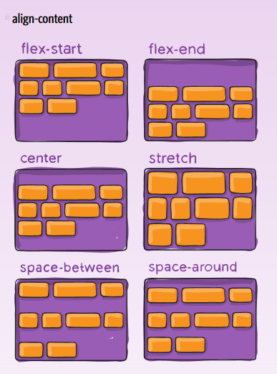

Flex-wrap
CSS flexbox has a feature to split a flex item into multiple rows (or columns). By default, a flex container will fit all flex items together. For example, a row will all be on one line.
However, using the flex-wrap property, it tells CSS to wrap items. This means extra items move into a new row or column. The break point of where the wrapping happens depends on the size of the items and the size of the container.
CSS also has options for the direction of the wrap:
- nowrap: this is the default setting, and does not wrap items.
- wrap: wraps items from left-to-right if they are in a row, or top-to-bottom if they are in a column.
- wrap-reverse: wraps items from bottom-to-top if they are in a row, or right-to-left if they are in a column.

Flex Items
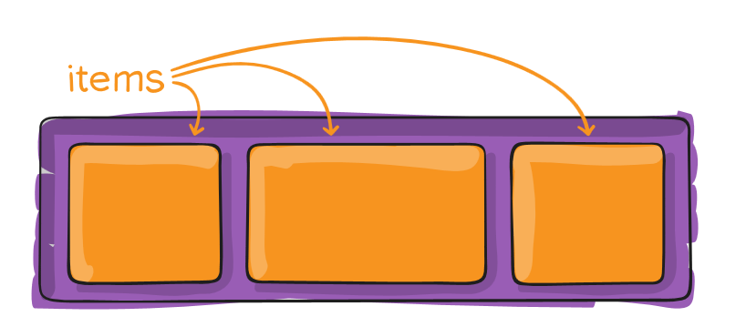

align-self
This property allows you to adjust each item's alignment individually, instead of setting them all at once. This is useful since other common adjustment techniques using the CSS properties float, clear, and vertical-align do not work on flex items.
align-self accepts the same values as align-items and will override any value set by the align-items property.

margin: auto
https://github.com/ohansemmanuel/Understanding-Flexbox/blob/master/05.%20Auto%20margin%20alignment/auto_margin.md
When you use margin:auto on a flex-item, the direction (left, right or both) that has the value auto will take up any empty spaces available.
ul {
display: flex;
}
li {
flex: 0 0 auto;
}
Here's what we've got:
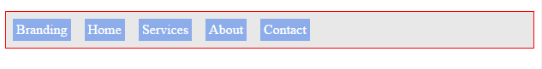
There are a couple of things to note here. So listen up!
- The flex-grow value is set to zero. This explains why the list items don't grow
- The flex-items are aligned to the start of the main-axis (the default behavior)
- Owing to the items being aligned to the start of the main-axis, some extra space is left on the right. You see that?
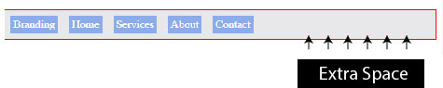
Now use margin: auto on the first list item (branding) and see what happens.
li:nth-child(1) {
margin-right: auto; /*applied only to the right*/
}
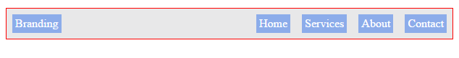
What just happened? The extra space that existed has now been distributed to the right of the first flex-item.
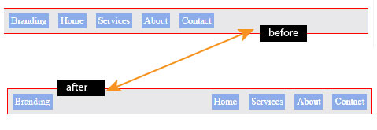
Remember what I said earlier? When you use margin:auto on a flex-item, the direction (left, right or both) that has the value auto will take up any empty spaces available. It doesn't end with just one side. What if you wanted a margin auto alignment on both sides of a flex-item?
/*you may use the margin shorthand to set both sides of you wish*/
li:nth-child(1) {
margin-left: auto;
margin-right: auto
}
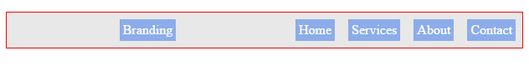
Now the space is distributed across both sides of the flex-item.
So, is there a trade off with the cool auto-margin alignment? It appears there's one. It can be a source of frustration if you don't pay attention too.
When you use the auto-margin alignment on a flex-item, the justify-content property no longer works on the flex-items. It just doesn't work.

order

The order property is used to tell CSS the order of how flex items appear in the flex container. By default, items will appear in the same order they come in the source HTML. The property takes numbers as values, and negative numbers can be used.

Flex-shrink
When it's used, it allows an item to shrink if the flex container is too small. Items shrink when the width of the parent container is smaller than the combined widths of all the flex items within it.
The flex-shrink property takes numbers as values. The higher the number, the more it will shrink compared to the other items in the container. For example, if one item has a flex-shrink value of 1 and the other has a flex-shrink value of 3, the one with the value of 3 will shrink three times as much as the other.

flex-grow
The flex-grow property controls the size of items when the parent container expands.
Using a similar example from the last challenge, if one item has a flex-grow value of 1 and the other has a flex-grow value of 3, the one with the value of 3 will grow three times as much as the other.

flex-basis
The flex-basis property specifies the initial size of the item before CSS makes adjustments with flex-shrink or flex-grow.
The units used by the flex-basis property are the same as other size properties (px, em, %, etc.). The value auto sizes items based on the content.

Flex shorthand
There is a shortcut available to set several flex properties at once. The flex-grow, flex-shrink, and flex-basis properties can all be set together by using the flex property.
For example, flex: 1 0 10px; will set the item to flex-grow: 1;, flex-shrink: 0;, and flex-basis: 10px;.
The default property settings are flex: 0 1 auto;

CSS Grid
Turn any HTML element into a grid container by setting its display property to grid. This gives you the ability to use all the other properties associated with CSS Grid:
<element> {
display: grid;
}
Note
In CSS Grid, the parent element is referred to as the container and its children are called items.

Containers
The following properties defines the whole container and all the elements within it:

grid-template-columns
Simply creating a grid element doesn't get you very far. You need to define the structure of the grid as well. To add some columns to the grid, use the grid-template-columns property on a grid container as demonstrated below:
.container {
display: grid;
grid-template-columns: 50px 50px;
}
This will give your grid two columns that are 50px wide each.
The number of parameters given to the grid-template-columns property indicates the number of columns in the grid, and the value of each parameter indicates the width of each column.

grid-template-rows
The grid you created in the last challenge will set the number of rows automatically. To adjust the rows manually, use the grid-template-rows property in the same way you used grid-template-columns in previous challenge.

Reduce repetition using the repeat function
When you used grid-template-columns and grid-template-rows to define the structure of a grid, you entered a value for each row or column you created.
Lets say you want a grid with 100 rows of the same height. It isn't very practical to insert 100 values individually. Fortunately, there's a better way - by using the repeat function to specify the number of times you want your column or row to be repeated, followed by a comma and the value you want to repeat.
Here's an example that would create the 100 row grid, each row at 50px tall.
grid-template-rows: repeat(100, 50px);
You can also repeat multiple values with the repeat function, and insert the function amongst other values when defining a grid structure. Here's what I mean:
grid-template-columns: repeat(2, 1fr 50px) 20px;
This translates to:
grid-template-columns: 1fr 50px 1fr 50px 20px;
Note
1fr 50px is repeated twice followed by 20px.

Minmax
There's another built-in function to use with grid-template-columns and grid-template-rows called minmax. It's used to limit the size of items when the grid container changes size. To do this you need to specify the acceptable size range for your item. Here is an example:
grid-template-columns: 100px minmax(50px, 200px);
In the code above, grid-template-columns is set to create two columns; the first is 100px wide, and the second has the minimum width of 50px and the maximum width of 200px.

auto-fill
The repeat function comes with an option called auto-fill. This allows you to automatically insert as many rows or columns of your desired size as possible depending on the size of the container. You can create flexible layouts when combining auto-fill with minmax.
In the preview, grid-template-columns is set to
repeat(auto-fill, minmax(60px, 1fr));
When the container changes size, this setup keeps inserting 60px columns and stretching them until it can insert another one.
Note
If your container can't fit all your items on one row, it will move them down to a new one.

auto-fit
auto-fit works almost identically to auto-fill. The only difference is that when the container's size exceeds the size of all the items combined, auto-fill keeps inserting empty rows or columns and pushes your items to the side, while auto-fit collapses those empty rows or columns and stretches your items to fit the size of the container.
Note
If your container can't fit all your items on one row, it will move them down to a new one.

CSS Grid Units
You can use absolute and relative units like px and em in CSS Grid to define the size of rows and columns. You can use these as well:
- fr: sets the column or row to a fraction of the available space,
- auto: sets the column or row to the width or height of its content automatically,
- %: adjusts the column or row to the percent width of its container.
Here's an example:
grid-template-columns: auto 50px 10% 2fr 1fr;
This snippet creates five columns. The first column is as wide as its content, the second column is 50px, the third column is 10% of its container, and for the last two columns; the remaining space is divided into three sections, two are allocated for the fourth column, and one for the fifth.

grid-gap, Grid-column-gap and grid-row-gap
Sometimes you want a gap in between the columns/rows. To add a gap between the columns, use the grid-column-gap or grid-row-gap property like this:
grid-column-gap: 10px;
This creates 10px of empty space between all of our columns.
grid-gap is a shorthand property for grid-row-gap and grid-column-gap from the previous two challenges that's more convenient to use. If grid-gap has one value, it will create a gap between all rows and columns. However, if there are two values, it will use the first one to set the gap between the rows and the second value for the columns.

Grids within Grids
Turning an element into a grid only affects the behavior of its direct descendants. So by turning a direct descendant into a grid, you have a grid within a grid.
For example, by setting the display and grid-template-columns properties of the element with the item3 class, you create a grid within your grid.

Example:
.container {
font-size: 1.5em;
min-height: 300px;
width: 100%;
background: LightGray;
display: grid;
grid-template-columns: auto 1fr;
grid-template-rows: auto 1fr auto;
grid-gap: 10px;
grid-template-areas:
"advert header"
"advert content"
"advert footer";
}
.item1 {
background: LightSkyBlue;
grid-area: header;
}
…
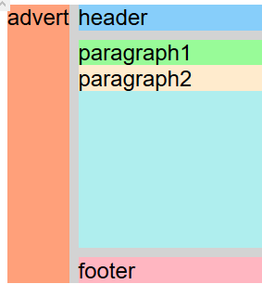

Elements
The following properties are for individual elements within the grid container:

grid-column and grid-row
The hypothetical horizontal and vertical lines that create the grid are referred to as lines. These lines are numbered starting with 1 at the top left corner of the grid and move right for columns and down for rows, counting upward.
This is what the lines look like for a 3x3 grid:
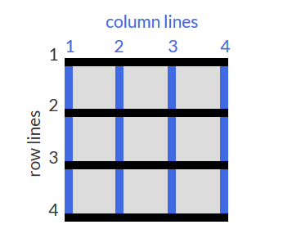
To control the amount of columns an item will consume, you can use the grid-column property in conjunction with the line numbers you want the item to start and stop at.
Here's an example:
grid-column: 1 / 3;
This will make the item start at the first vertical line of the grid on the left and span to the 3rd line of the grid, consuming two columns.
The same goes for grid-row as well.

justify-self and align-self
In CSS Grid, the content of each item is located in a box which is referred to as a cell. You can align the content's position within its cell horizontally using the justify-self property on a grid item. By default, this property has a value of stretch, which will make the content fill the whole width of the cell. This CSS Grid property accepts other values as well:
- start: aligns the content at the left of the cell,
- center: aligns the content in the center of the cell,
- end: aligns the content at the right of the cell.
Just as you can align an item horizontally, there's a way to align an item vertically as well. To do this, you use the align-self property on an item. This property accepts all of the same values as justify-self from the last challenge.

justify-items and align-items
Sometimes you want all the items in your CSS Grid to share the same alignment. You can use the previously learned properties and align them individually, or you can align them all at once horizontally by using justify-items on your grid container. This property can accept all the same values you learned about in the previous two challenges, the difference being that it will move all the items in our grid to the desired alignment.

Grid-template-areas and grid-area
You can group cells of your grid together into an area and give the area a custom name. Do this by using grid-template-areas on the container like this:
grid-template-areas:
"header header header"
"advert content content"
"footer footer .";
The code above merges the top three cells together into an area named header, the bottom three cells into a footer area, and it makes two areas in the middle row; advert and content.
Note
Every word in the code represents a cell and every pair of quotation marks represent a row.
In addition to custom labels, you can use a period (.) to designate an empty cell in the grid.
After creating an areas template for your grid container, you can place an item in your custom area by referencing the name you gave it. To do this, you use the grid-area property on an item like this:
.item1 { grid-area: header; }
This lets the grid know that you want the item1 class to go in the area named header. In this case, the item will use the entire top row because that whole row is named as the header area.

grid-area without areas template
The grid-area property you learned in the last challenge can be used in another way. If your grid doesn't have an areas template to reference, you can create an area on the fly for an item to be placed like this:
item1 { grid-area: 1/1/2/4; }
This is using the line numbers you learned about earlier to define where the area for this item will be. The numbers in the example above represent these values:
grid-area: horizontal line to start at / vertical line to start at / horizontal line to end at / vertical line to end at;
So the item in the example will consume the rows between lines 1 and 2, and the columns between lines 1 and 4.

Design Concepts

Spacing
Negative space – a space that doesn’t contain anything – separate between elements that makes them more readable.
Ways to create negative space:
Padding – inside an element
Margins – outside an element
overflow – used to contain a lot of text in a small area
:
Used to dynamically change the display of the page depending on the type of display (screen/print
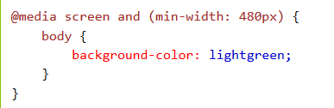
@media not|only mediatype and (media feature) {
CSS-Code;
}
You can also have different stylesheets for different media:
<link rel="stylesheet" media="mediatype and|not|only (media feature)" href="mystylesheet.css">

Normalizing:
To make sure our design looks the same on all browsers – link to the normalize.css stylesheet on googlecode:
<link rel="stylesheet" src="//normalize-css.googlecode.com/svn/trunk/normalize.css">
Testing:
To test the page on different devices and with different network conditions – use chrome emulation tools:
https://developer.chrome.com/devtools/docs/device-mode

Background
One way to add texture and interest to a background and have it stand out more is to add a subtle pattern. The key is balance, as you don't want the background to stand out too much, and take away from the foreground. The background property supports the url() function in order to link to an image of the chosen texture or pattern. The link address is wrapped in quotes inside the parentheses:
background: url("https://i.imgur.com/MJAkxbh.png");

Complementary Colors – 2 Colors for Strong Visual Impact
Color theory and its impact on design is a deep topic and only the basics are covered in the following challenges. On a website, color can draw attention to content, evoke emotions, or create visual harmony. Using different combinations of colors can really change the look of a website, and a lot of thought can go into picking a color palette that works with your content.
The color wheel is a useful tool to visualize how colors relate to each other - it's a circle where similar hues are neighbors and different hues are farther apart. When two colors are opposite each other on the wheel, they are called complementary colors. They have the characteristic that if they are combined, they "cancel" each other out and create a gray color. However, when placed side-by-side, these colors appear more vibrant and produce a strong visual contrast.
Some examples of complementary colors with their hex codes are:
red (#FF0000) and cyan (#00FFFF)
green (#00FF00) and magenta (#FF00FF)
blue (#0000FF) and yellow (#FFFF00)
This is different than the outdated RYB color model that many of us were taught in school, which has different primary and complementary colors. Modern color theory uses the additive RGB model (like on a computer screen) and the subtractive CMY(K) model (like in printing). Read here for more information on this complex subject.
There are many color picking tools available online that have an option to find the complement of a color.

Split-Complement Scheme – 3 Colours for Strong Visual Impact.
Computer monitors and device screens create different colors by combining amounts of red, green, and blue light. This is known as the RGB additive color model in modern color theory. Red (R), green (G), and blue (B) are called primary colors. Mixing two primary colors creates the secondary colors cyan (G + B), magenta (R + B) and yellow (R + G). You saw these colors in the Complementary Colors challenge. These secondary colors happen to be the complement to the primary color not used in their creation, and are opposite to that primary color on the color wheel. For example, magenta is made with red and blue, and is the complement to green.
Tertiary colors are the result of combining a primary color with one of its secondary color neighbors. For example, red (primary) and yellow (secondary) make orange. This adds six more colors to a simple color wheel for a total of twelve.
There are various methods of selecting different colors that result in a harmonious combination in design. One example that can use tertiary colors is called the split-complementary color scheme. This scheme starts with a base color, then pairs it with the two colors that are adjacent to its complement. The three colors provide strong visual contrast in a design, but are more subtle than using two complementary colors.
Here are three colors created using the split-complement scheme:
Color | Hex Code
orange | #FF7D00
cyan | #00FFFF
raspberry | #FF007D

Colouring Scheme
- Header, footer and heading – in the same colour (e.g. teal (#09A7A1))

Placeholders for images
http://placehold.it/<dimention>x<dimention>
http://placepuppy.it/<dimention>/<dimention>
http://placekitten.com/<dimention>/<dimention>

Elements Paddings
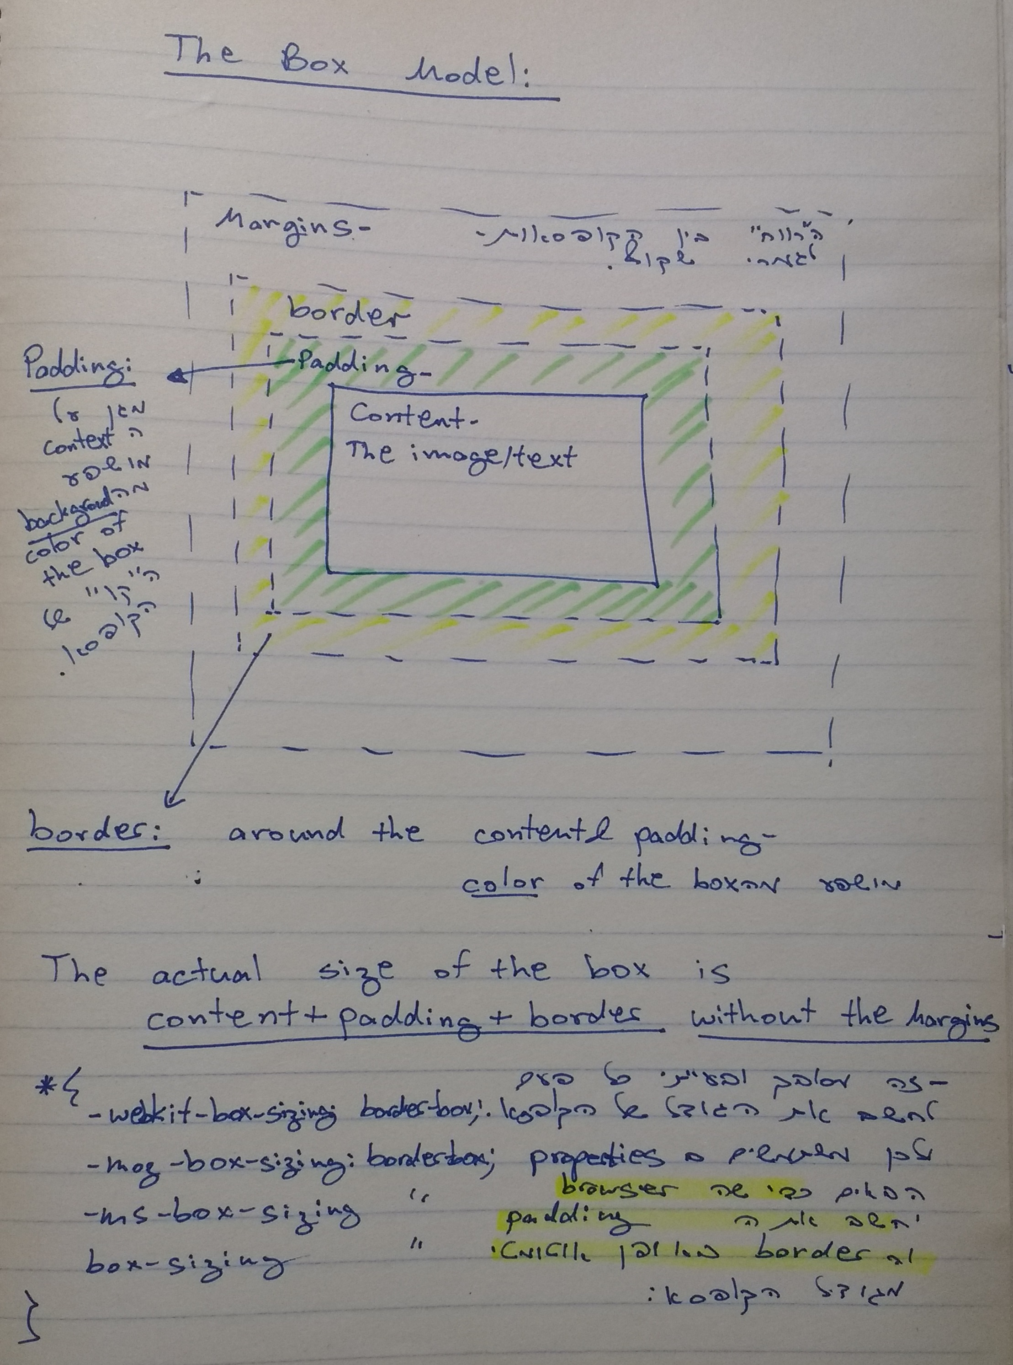
- An element’s padding controls the amount of space between an element’s contents (e.g. text) and its border
- An element's margin controls the amount of space between an element's border and surrounding elements.
If you set an element's margin to a negative value, the element will grow larger than its surrounding element.
NOTE: if the element width is 100%, every padding/boarder will be in addition to the 100% and therefore, will make the width more than 100%!!
To avoid this issue, set: box-sizing: border-box; in order to include the passing/border in the size of the box.

Fonts:

Fallback
There are several default fonts that are available in all browsers. These generic font families include monospace, serif and sans-serif
When one font isn't available, you can tell the browser to "degrade" to another font.
For example, if you wanted an element to use the Helvetica font, but degrade to the sans-serif font when Helvetica wasn't available, you will specify it as follows:
p {
font-family: Helvetica, sans-serif;
}
Generic font family names are not case-sensitive. Also, they do not need quotes because they are CSS keywords.

Fonts Libraries

Google Fonts is a free library of web fonts that you can use in your CSS by referencing the font's URL.
www.google.com/fonts

<link href="https://fonts.googleapis.com/css?family=Lobster" rel="stylesheet" type="text/css">
Now you can use the Lobster font in your CSS by using Lobster as the FAMILY_NAME as in the following example:
font-family: FAMILY_NAME, GENERIC_NAME;
The GENERIC_NAME is optional, and is a fallback font in case the other specified font is not available.
Family names are case-sensitive and need to be wrapped in quotes if there is a space in the name. For example, you need quotes to use the "Open Sans" font, but not to use the Lobster font.

Sizes:
Pixels (px), points (pt) – not scalable to mobile and visually impaired and therefore should not be used.
Em(em) – becoming the standard in web-dev. 1em == the current web browser font size. Scalable and mobile user-friendly. However, it scales a bit too abruptly making its smallest size not readable and its largest size too big.
Percent (%) – 100% == the current web browser font size. Similar to em and also scalable.

The Verdict
In theory, the em unit is the new and upcoming standard for font sizes on the web, but in practice, the percent unit seems to provide a more consistent and accessible display for users. When client settings have changed, percent text scales at a reasonable rate, allowing designers to preserve readability, accessibility, and visual design.
The winner: percent (%).
I will use percent on the body element (body { font-size: 62.5%; }), and then use the em unit to size it from there. As long as the body is set using the percent unit, you may choose to use either percent or ems on any other CSS rules and selectors and still retain the benefits of using percent as your base font size. Over the past couple of years, this has really become the standard in design.

Build Tools
- The best tool to use in 2018 is Webpack. In the past there were gulp and grunt. But now, you should only learn Webpack: https://www.youtube.com/watch?v=9kJVYpOqcVU

Debugging

Chrome
- To inspect an element:
  - Right-click on the element and choose inspect from the popup menu
- Filters:
  - In the developer tools under Elements->Styles->Filter. Can filter both states (e.g. hover) or specific properties.
  - element.style is the style that is defined directly on the element’s html with style=”…”.

Pre-Compilers

Css vs SASS vs SCSS
CSS is the styling language that any browser understands to style webpages.
SASS/LESS/Stylus are the most common CSS pre-compilers.
SCSS is a special type of file for SASS, a program written in Ruby that assembles CSS style sheets for a browser, and for information SASS adds lots of additional functionality to CSS like variables, nesting and more which can make writing CSS easier and faster. SCSS files are processed by the server running a web app to output a traditional CSS that your browser can understand.

CSS
In CSS we write code as depicted bellow, in full length.
body{
width: 800px;
color: #ffffff;
}
body content{
width:750px;
background:#ffffff;
}

SCSS
In SCSS we can shorten this code using a @mixin so we don’t have to write color and width properties again and again. We can define this through a function, similarly to PHP or other languages.
$color: #ffffff;
$width: 800px;

@mixin body{
width: $width;
color: $color;

content{
width: $width;
background:$color;
}
}

SASS
In SASS however, the whole structure is visually quicker and cleaner than SCSS.
It is sensitive to white space when you are using copy and paste,
It seems that it doesn't support inline CSS currently.
$color: #ffffff
$width: 800px
$stack: Helvetica, sans-serif

body
width: $width
color: $color
font: 100% $stack

content
width: $width
background:$color

Compilation
Unfortunately, you can’t directly insert an SCSS (Sassy CSS) file into your HTML. That’s because SASS is a superset (or so-called preprocessor or extension) of CSS3's syntax, which is NOT supported by web browsers. While SCSS offers many handy features for developers that do not exist in native CSS such as inheritance, nesting, logic statements, mixins, and more, it also limits you from having a link to the .scss file in your HTML page.
So to take full advantage of all the incredible features offered by SCSS in your HTML page, you’ll first have to compile it down to CSS. To convert your SCSS to CSS, you can try these tools:
- SCSS to CSS Converter
- SCSS Compiler
- Scout App
- Gulp.js – Learn How to Use Gulp to Generate CSS from Sass/SCSS
Once your SCSS is converted to CSS, you can easily insert the newly converted CSS file into your HTML code with the following line of code:
<link rel="stylesheet" type="text/css" href="file.css">

SASS – Syntactically Awesome StyleSheets
Sass, or "Syntactically Awesome StyleSheets", is a language extension of CSS. It adds features that aren't available using basic CSS syntax. Sass makes it easier for developers to simplify and maintain the style sheets for their projects.
Sass can extend the CSS language because it is a preprocessor. It takes code written using Sass syntax, and converts it into basic CSS. This allows you to create variables, nest CSS rules into others, and import other Sass files, among other things. The result is more compact, easier to read code.
There are two syntaxes available for Sass:
- The first, known as SCSS (Sassy CSS) and used throughout these challenges, is an extension of the syntax of CSS. This means that every valid CSS stylesheet is a valid SCSS file with the same meaning. Files using this syntax have the .scss extension.
- The second and older syntax, known as the indented syntax (or sometimes just "Sass"), uses indentation rather than brackets to indicate nesting of selectors, and newlines rather than semicolons to separate properties. Files using this syntax have the .sass extension.

Variables
To define:
$<variable name>: <variable value>;
To use:
$<variable name>
For example:
$main-fonts: Arial, sans-serif;
$headings-color: green;
//To use variables:
h1 {
font-family: $main-fonts;
color: $headings-color;
}

Nesting
Sass allows nesting of CSS rules which makes the CSS much more readable.
Normally, each element is targeted on a different line to style it, like so:
nav {
background-color: red;
}
nav ul {
list-style: none;
}
nav ul li {
display: inline-block;
}
For a large project, the CSS file will have many lines and rules. This is where nesting can help organize your code by placing child style rules within the respective parent elements:
nav {
background-color: red;
ul {
list-style: none;
li {
display: inline-block;
}
}
}

Mixins
In Sass, a mixin is a group of CSS declarations that can be reused throughout the style sheet.
Newer CSS features take time before they are fully adopted and ready to use in all browsers. As features are added to browsers, CSS rules using them may need vendor prefixes. Consider "box-shadow":
div {
-webkit-box-shadow: 0px 0px 4px #fff;
-moz-box-shadow: 0px 0px 4px #fff;
-ms-box-shadow: 0px 0px 4px #fff;
box-shadow: 0px 0px 4px #fff;
}
It's a lot of typing to re-write this rule for all the elements that have a box-shadow, or to change each value to test different effects.
Mixins are like functions for CSS. Here is how to write one:
@mixin box-shadow($x, $y, $blur, $c){
-webkit-box-shadow: $x, $y, $blur, $c;
-moz-box-shadow: $x, $y, $blur, $c;
-ms-box-shadow: $x, $y, $blur, $c;
box-shadow: $x, $y, $blur, $c;
}
The definition starts with @mixin followed by a custom name. The parameters (the $x, $y, $blur, and $c in the example above) are optional.
Now any time a box-shadow rule is needed, only a single line calling the mixin replaces having to type all the vendor prefixes. A mixin is called with the @include directive:
div {
@include box-shadow(0px, 0px, 4px, #fff);
}

Flow Control

If/Else
@mixin text-effect($val) {
@if $val == danger {
color: red;
}
@else if $val == alert {
color: yellow;
}
@else if $val == success {
color: green;
}
@else {
color: black;
}
}

For Loop

Strat through end
Includes the end number:
@for $i from 1 through 12 {
.col-#{$i} { width: 100%/12 * $i; }
}
The #{$i} part is the syntax to combine a variable (i) with text to make a string. When the Sass file is converted to CSS, it looks like this:
.col-1 {
width: 8.33333%;
}
.col-2 {
width: 16.66667%;
}
...
.col-12 {
width: 100%;
}

Start to end
Excludes the end number:
@for $i from 1 to 13 {
.col-#{$i} { width: 100%/12 * $i; }
}

Each
@each directive which loops over each item in a list or map.
On each iteration, the variable gets assigned to the current value from the list or map.
@each $color in blue, red, green {
.#{$color}-text {color: $color;}
}
A map has slightly different syntax. Here's an example:
$colors: (color1: blue, color2: red, color3: green);
@each $key, $color in $colors {
.#{$color}-text {color: $color;}
}
Note that the $key variable is needed to reference the keys in the map. Otherwise, the compiled CSS would have color1, color2... in it.
Both of the above code examples are converted into the following CSS:
.blue-text {
color: blue;
}
.red-text {
color: red;
}
.green-text {
color: green;
}

While
The @while directive is an option with similar functionality to the JavaScript while loop. It creates CSS rules until a condition is met.
The @for challenge gave an example to create a simple grid system. This can also work with @while.
$x: 1;
@while $x < 13 {
.col-#{$x} { width: 100%/12 * $x;}
$x: $x + 1;
}

Extend Styles
Sass has a feature called extend that makes it easy to borrow the CSS rules from one element and build upon them in another.
For example, the below block of CSS rules style a .panel class. It has a background-color, height and border.
.panel{
background-color: red;
height: 70px;
border: 2px solid green;
}
Now you want another panel called .big-panel. It has the same base properties as .panel, but also needs a width and font-size.
It's possible to copy and paste the initial CSS rules from .panel, but the code becomes repetitive as you add more types of panels.
The extend directive is a simple way to reuse the rules written for one element, then add more for another:
.big-panel{
@extend .panel;
width: 150px;
font-size: 2em;
}
The .big-panel will have the same properties as .panel in addition to the new styles.

Partials
Partials in Sass are separate files that hold segments of CSS code. These are imported and used in other Sass files. This is a great way to group similar code into a module to keep it organized.
Names for partials start with the underscore (_) character, which tells Sass it is a small segment of CSS and not to convert it into a CSS file. Also, Sass files end with the .scss file extension. To bring the code in the partial into another Sass file, use the @import directive.
For example, if all your mixins are saved in a partial named "_mixins.scss", and they are needed in the "main.scss" file, this is how to use them in the main file:
// In the main.scss file
@import 'mixins'
Note that the underscore is not needed in the import statement - Sass understands it is a partial. Once a partial is imported into a file, all variables, mixins, and other code are available to use.

SASS in VS Code

Install
npm install -g node-sass

Compile
node-sass <scss file name> <output css file name>

