- Emmet is built into VSCode – no plugin required.

Bootstrap
How to customize Bootstrap:
https://uxplanet.org/how-to-customize-bootstrap-b8078a011203

General
http://getbootstrap.com/css/
Bootstrap will figure out how wide your screen is and respond by resizing your HTML elements - hence the name Responsive Design.
With responsive design, there is no need to design a mobile version of your website. It will look good on devices with screens of any width.
You can add Bootstrap to any app by adding the following code to the top of your HTML:
<link rel="stylesheet" href="https://maxcdn.bootstrapcdn.com/bootstrap/3.3.7/css/bootstrap.min.css" integrity="sha384-BVYiiSIFeK1dGmJRAkycuHAHRg32OmUcww7on3RYdg4Va+PmSTsz/K68vbdEjh4u" crossorigin="anonymous"/>

You can also download the css and js folders from bootstrap and copy them to your project folder. Don't forget to include the files in your head element:
<link rel="stylesheet" href="css/bootstrap.min.css"> <script src="js/bootstrap.min.js"></script>

Minified Files:

Every .js and .css has a minified version of the file (<name>.min). This file is identical in content to the regular full file but has all the spaces taken out of it to make it smaller and faster to download.
When you’re putting .css and/or .js files in your project, make sure to include the minified versions of the files.
NOTE: CSS minification does not happen automatically by default, therefore if you edit your unminified CSS file, but include the minified version in your HTML, the page will not use the updated CSS by default.
You can manually minify your CSS using a site like http://cssminifier.com/.
You can also use a more advanced and automated workflow where CSS files get minimized automatically, for example using a plugin for your code editor or a build system like Gruntjs.
If you have a problem that you need to debug, you can use the unminified files, debug the problem and then go back to using the minified files.

HTML
Rows and Columns:
All the content should be inside rows (class=”row”) and inside columns. If we want to use the full row, we’ll use col-md-12. There are up to 12 columns in every row.
<link rel="stylesheet" href="css/bootstrap.min.css">
<script src="js/bootstrap.min.js"></script>
…
<div class="container-fluid">
<div class="row">
<div class=”col-xs-12 col-md-6”> --< can define different sizes to different display sizes >
...
</div>
</div>
</div>

.col-md-offset-* - Move columns to the right using .col-md-offset-* classes. These classes increase the left margin of a column by * columns. For example, .col-md-offset-4 moves .col-md-4 over four columns.

class="img-responsive" – will make your images resize automatically.

Java Script
The Bootstrap JavaScript file is dependent on JQuery version 1.9 or higher. JQuery can be downloaded here: http://jquery.com/download
Once downloaded, place the JQuery file in the 'js' directory in the Bootstrap file structure.
Modals:
You can read more about this topic in Bootstrap's JavaScript Documentation.

Containers
Bootstrap requires a containing element to wrap site contents and house our grid system. You may choose one of two containers to use in your projects. Note that, due to padding and more, neither container is nestable.
Use .container for a responsive fixed width container.
<div class="container">
...
</div>
Use .container-fluid for a full width container, spanning the entire width of your viewport.
<div class="container-fluid">
...
</div>

Images
Classes:
img-responsive – to set the image size to perfectly fit the width of your page.

Text
- text-center
- text-muted

Font Awesome – with <i> or <span>
Font Awesome is a convenient library of icons. These icons are vector graphics, stored in the .svg file format. These icons are treated just like fonts. You can specify their size using pixels, and they will assume the font size of their parent HTML elements.
You can include Font Awesome in any app by adding the following code to the top of your HTML:
<link rel="stylesheet" href="https://maxcdn.bootstrapcdn.com/font-awesome/4.5.0/css/font-awesome.min.css" integrity="sha384-XdYbMnZ/QjLh6iI4ogqCTaIjrFk87ip+ekIjefZch0Y+PvJ8CDYtEs1ipDmPorQ+" crossorigin="anonymous">
The i element was originally used to make other elements italic, but is now commonly used for icons. You can add the Font Awesome classes to the i element to turn it into an icon, for example:
<i class="fa fa-info-circle"></i>
Note that the span element is also acceptable for use with icons.
Use Font Awesome to add a thumbs-up icon to your like button by giving it an i element with the classes fa and fa-thumbs-up; make sure to keep the text "Like" next to the icon:
<button class="btn btn-block btn-primary"><i class="fa fa-thumbs-up">Like</i></button>

Button
https://www.w3schools.com/bootstrap/bootstrap_buttons.asp
- Bootstrap has its own styles for button elements, which look much better than the plain HTML ones.
- Add “btn” and “btn-default” classes to any button element to use this button style.
- btn-block – will turn the button to block element.

Form
- You can use Bootstrap's col-xs-* classes on form elements, too! This way, our radio buttons will be evenly spread out across the page, regardless of how wide the screen resolution is.
- All textual <input>, <textarea>, and <select> elements with the class .form-control have a width of 100%.

Bootstrap Grid
Bootstrap uses a responsive 12-column grid system, which makes it easy to put elements into rows and specify each element's relative width. Most of Bootstrap's classes can be applied to a div element.
Bootstrap has different column width attributes that it uses depending on how wide the user's screen is. For example, phones have narrow screens, and laptops have wider screens.
Take for example Bootstrap's col-md-* class. Here, md means medium, and * is a number specifying how many columns wide the element should be. In this case, the column width of an element on a medium-sized screen, such as a laptop, is being specified.
In the Cat Photo App that we're building, we'll use col-xs-*, where xs means extra small (like an extra-small mobile phone screen), and * is the number of columns specifying how many columns wide the element should be.
Put the Like, Info and Delete buttons side-by-side by nesting all three of them within one <div class="row"> element, then each of them within a <div class="col-xs-4"> element.
The row class is applied to a div, and the buttons themselves can be nested within it:
<div class="row">
<div class="col-xs-4">
<button class="btn btn-block btn-primary">Like</button>
</div>
<div class="col-xs-4">
<button class="btn btn-block btn-info">Info</button>
</div>
<div class="col-xs-4">
<button class="btn btn-block btn-danger">Delete</button>
</div>
</div>

Sizes
col-<size>-xx
xx – the number of columns
<size>: xl(big PC screen)/lg(PC screen)/md(tablet)/sm(cell phone)/<none>

Offset
Allow specifying empty columns before this class.
For example:
<div class=”col-2 offset-3”>…
Will leave 3 columns empty from start this div with width = 2 columns

Well
<div class="col-xs-6">
<div class="well">
…
</div>
</div>
Will create a visual sense of depth for your columns.

Graphic Design
CARP:
- Contrast
- Alignment
- Repetition
- Proximity

Bootstrap Native Colors

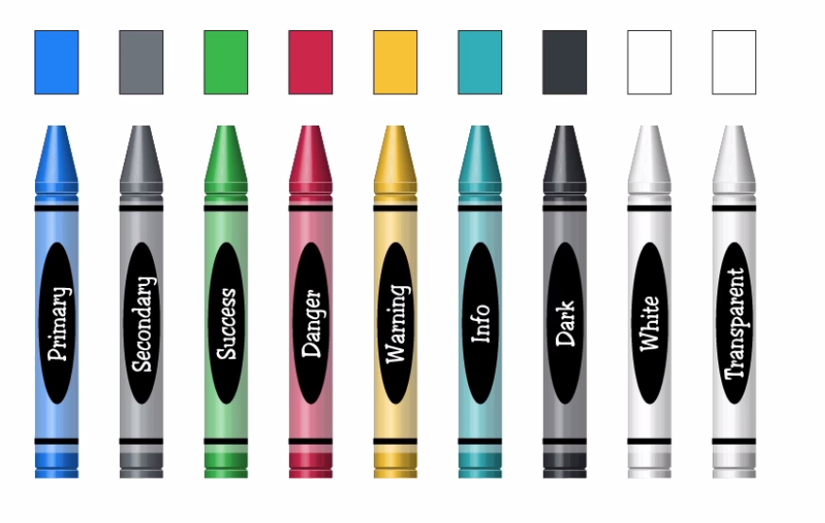
Bootstrap background colors:
Classes: bg-<name> for example:
class = “bg-primary”

Containers
class=”container” – add automatic margins and paddings to the div. When we resize the page, the size of the content will jump at bs4 breakpoints. To make the transition smoother, we can use instead: class=”container-fluid”

Rows
Bootstrap 4 support 12 columns layout. In order to use it, put your content inside a “row” and “col”. This will automatically set three and two columns:
<div class="container">
<div class="row">
<div class="myRow col bg-success"></div>
<div class="myRow col bg-warning"></div>
<div class="myRow col bg-danger"></div>
</div>
<div class="row">
<div class="myRow col bg-primary"></div>
<div class="myRow col bg-info"></div>
</div>
</div>

Media Breakpoints:
The main, basic layouts are:
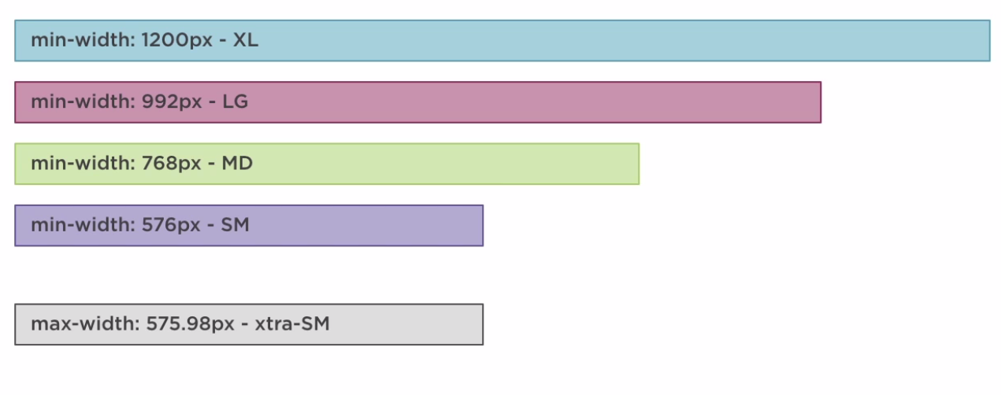
Different properties (e.g. margins) can use the media breakpoints. Usually, you can set the default property e.g. mx-2 and then the different property that will take effect whenever the screen’s size is equal or bigger than the breakpoint.
For example:
class=”mx-2 mx-lg-5” will use mx-2 for all screen sizes upto (but not including) large and for large and XL screens, it will use the mx-5 instead.

Grid System
- class=”col-<number of columns>” – the element will have the width of <number of columns> out of 12. For example: class=”col-2” will take 2/12 columns of the row.
- class-“w-100” – will take the full size of the parent container row (100%).
- col-sm – will automatically stack the columns when the viewport reaches BS4 small breakpoint.
- col-<size>-<columns> - will change the number of columns depending on the BS4 breakpoints. For example:
<div class="col-sm-6 col-md-10 col-lg-4 col-xl-8 bg-warning">Column</div>
- order-<num> - will reorder your columns.

Alignments and Offsets

In the Container (e.g. Row):
- Align-items-<center|start|end> – align the columns in the row (vertically). This also cancel the stretching of the content.
- Justify-contect-<start|end|center|around|between> - justify the columns in the row (horizontally)

In the Elements (e.g. Column):
- Align-self-<center|start|end> - align the specific element in the row (vertically). This also cancel the stretching of the content.
- offset-<columns> - add an offset before the column. Examples: offset-4 offset-sm-2
- ml-auto – margin left auto – will push all the columns to the far right. mr-auto.

Padding, Display and Margin

https://getbootstrap.com/docs/4.0/utilities/spacing/

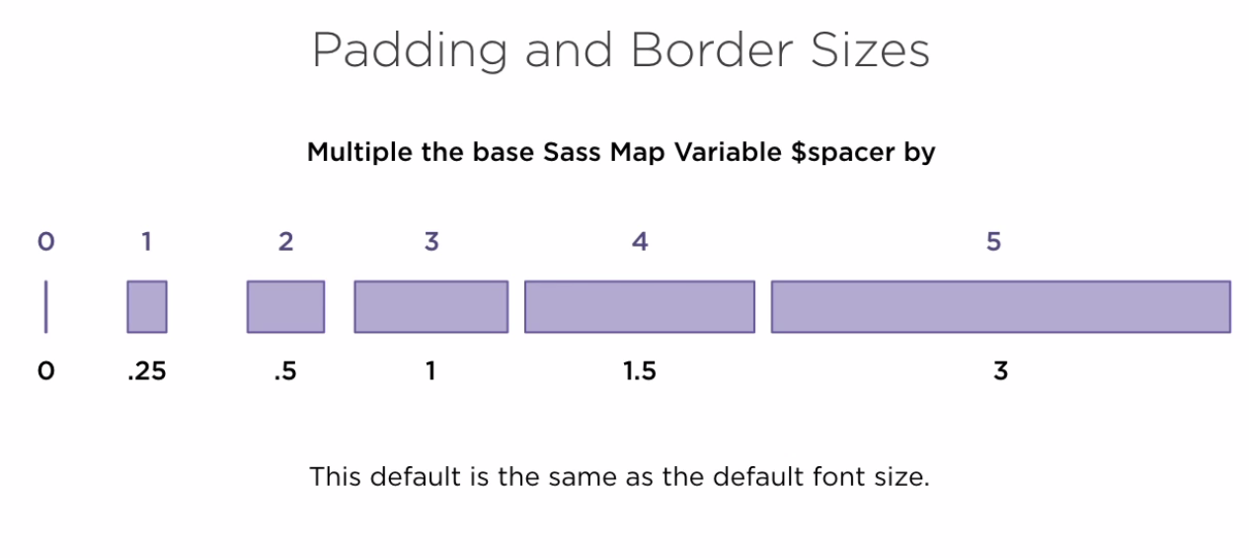
- mt-<size> according to the SASS $space size. So, for example:
class=”mt-1” will set the margin-top to 0.25 of the $spacer size.
- d-block – change an inline element (e.g. span) to display: block;
- d-inline – change a block element (e.g. div) to inline element

Flexbox
https://getbootstrap.com/docs/4.0/utilities/flex/
- d-flex – will set the element to display:flex
- flex-row – will set a flex-direction: row.
- flex-row – will set a flex-direction: column.

Navigation
https://getbootstrap.com/docs/4.1/components/navs

Nav
To build a basic navigation bar with BS4:
<ul class="nav">
<li class="nav-item">
<a class="nav-link active" href="#">Active</a>
</li>
<li class="nav-item">
<a class="nav-link" href="#">Link</a>
</li>
<li class="nav-item">
<a class="nav-link" href="#">Link</a>
</li>
<li class="nav-item">
<a class="nav-link disabled" href="#">Disabled</a>
</li>
</ul>
- You can also remove the list items and just use:
<nav class="nav">
<a class="nav-item nav-link active" href="#">Active</a>
<a class="nav-item nav-link" href="#">Link</a>
<a class="nav-item nav-link" href="#">Link</a>
<a class="nav-item nav-link disabled" href="#">Disabled</a>
</nav>

Navbar
<nav class="navbar navbar-expand-lg navbar-dark fixed-top" id="mainNav">
<div class="container">
<a class="navbar-brand js-scroll-trigger" href="#top">Navbar</a>
<button class="navbar-toggler navbar-toggler-right" type="button" data-toggle="collapse" data-target="#navbarResponsive" aria-controls="navbarResponsive" aria-expanded="false" aria-label="Toggle Navigation">Menu <i class="fa fa-bars"></i></button>
<div class="collapse navbar-collapse" id="navbarResponsive">
<ul class="navbar-nav text-uppercase ml-auto" >
<li class="nav-item"><a class="nav-link js-scroll-trigger" href="#link1">Link1</a></li>
<li class="nav-item"><a class="nav-link js-scroll-trigger" href="#link2">Link2</a></li>
<li class="nav-item"><a class="nav-link js-scroll-trigger" href="#link3">Link3</a></li>
<li class="nav-item"><a class="nav-link js-scroll-trigger" href="#link4">Link4</a></li>
<li class="nav-item"><a class="nav-link js-scroll-trigger" href="#link5">Link5</a></li>
</ul>
</div>
</div>
</nav>
- navbar-brand – the logo of our web page.

data-* attributes
- data-* attributes allow us to store extra information on standard, semantic HTML elements without other hacks such as non-standard attributes, extra properties on DOM or Nost.setUserData().
- data-toggle=”collapse” – trigger the JS that allows our elements to collapse at a smaller screen-size.
- data-target=”#id” – defines which elements (id) will be collapsed.

Aria
Accessible Rich Internet Applications is a set of attributes that define ways to make Web content and Web applications (especially those developed with Ajax, JS and more recent web technologies like Bootstrap) more accessible to people with disabilities.
It supplements HTML so that interactions and widgets commonly used in applications can be passed to Assistive Technologies when there is not otherwise a mechanism. For example, ARIA enables accessible navigation landmarks in HTML4, JavaScript widgets, form hints and error messages, live content updates, and more.
Many of these widgets were later incorporated into HTML5, and developers should prefer using the correct semantic HTML element over using ARIA, if such an element exists. For instance, native elements have built-in keyboard accessibility, roles and states. However, if you choose to use ARIA, you are responsible for mimicking (the equivalent) browser behaviour in script.

- sr-only – hidden tags for screen readers only

Dropdown Menu
<li class="nav-item dropdown">
<a class="nav-link dropdown-toggle" href="#" id="navbarDropdown" role="button" data-toggle="dropdown" aria-haspopup="true" aria-expanded="false">
Dropdown
</a>
<div class="dropdown-menu" aria-labelledby="navbarDropdown">
<a class="dropdown-item" href="#">Sub-Link 1</a>
<a class="dropdown-item" href="#">Sub-Link 2</a>
<div class="dropdown-divider"></div>
<a class="dropdown-item" href="#">Sub-Link 3</a>
</div>
</li>
Result:

- Set one of the menu items to be a dropdown list with class dropdown

Navbar styles
- nav-tabs – will created tabbed interface:
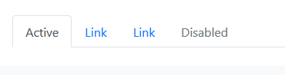
- nav-pills:
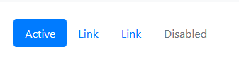
- nav-fill – will fill the full available width.
- Nav-justified - All horizontal space will be occupied by nav links, but unlike the .nav-fill above, every nav item will be the same width.

Search box
Inside the navbar:
<form class="form-inline my-2 my-lg-0">
<input class="form-control mr-sm-2" type="text" placeholder="Search">
<button class="btn btn-outline-success my-2 my-sm-0">Search</button>
</form>

Breadcrumbs
<nav aria-label="breadcrumb">
<ol class="breadcrumb">
<li class="breadcrumb-item"><a href="#">Home</a></li>
<li class="breadcrumb-item"><a href="#">Alice in Wonderland</a></li>
<li class="breadcrumb-item"><a href="#">All Chapters</a></li>
<li class="breadcrumb-item active"><a href="#">Chapter 7: A Mad Tea-Party</a></li>
</ol>
</nav>

Pagination
<nav aria-label="Chapter Link">
<ul class="pagination">
<li class="page-item disabled">
<a class="page-link" href="#" aria-label="Previous">
<span aria-hidden="true">&laquo;</span>
<span class="sr-only">Previous</span>
</a>
</li>
<li class="page-item active"><a class="page-link" href="#">1</a></li>
<li class="page-item"><a class="page-link" href="#">2</a></li>
<li class="page-item"><a class="page-link" href="#">3</a></li>
<li class="page-item">
<a class="page-link" href="#" aria-label="Next">
<span aria-hidden="true">&raquo;</span>
<span class="sr-only">Next</span>
</a>
</li>
</ul>
</nav>
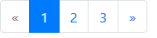
NOTE: If we remove the list items and use only the <nav> and <a> tags, the disabled and active classes will not work!

Typography

Headlines
- h<i> e.g. h1,h2
- text-lowercase|uppercase|capitalize
- Fancy display heading with fading secondary class:
<h3>H3 - Man Bites Dog
<small class="text-muted">Dog Bites Man</small>
</h3>
- display-<i> – new font sizes for BS4

Text Colors
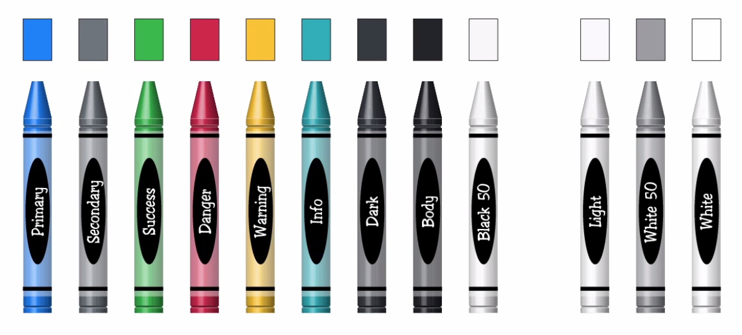
- text-<color>
- in order to overwrite these colors in CSS, you need to add to your CSS:
.text-danger{
color: <new-color-value> !important;
}

Paragraphs and Blockquotes
- lead – set a paragraph as a lead paragraph with a slightly bigger and more spaced-out font.
- Quotes:
<hr>
<blockquote class="blockquote p-3 text-muted text-right">
Why, Mary Ann, what are you doing out here? Run home this moment, and fetch me a pair of gloves and a fan! Quick, now!
<footer class="blockquote-footer">The White Rabbit from <cite title="Alice in Wonderland">Alice in Wonderland</cite></footer>
</blockquote>
<hr>

Inline elements
<ul>
<li><mark>with: mark element</mark></li>
<li><del>with: del element</del></li>
<li><s>with: s element</s></li>
<li><ins>with: ins element</ins></li>
<li><u>with: u element</u></li>
<li><small>with: small element</small></li>
<li><strong>with: strong element</strong></li>
<li><em>with: em element</em></li>
</ul>
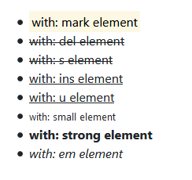

Box elements
- shadow|-none|-sm|-lg – will add a shadow-effect to the box.
- Borders:
  - rounded|-top|-bottom|-circle|-0
  - border|-top|….|-<colors>

Badges

Any element type can have a badge added to it:
<p>Some text with a <span class="badge badge-primary">badge</span></p>
<button type="button" class="btn btn-block btn-success">Some button with a <span class="badge badge-dark">badge</span></button>
Will result in:
Can be used also in <a> tag
- Badge-pill – will make the badge looks like a pill.

Lists
- list-group
- list-group-item
- list-group-item-action –
- list-group-item-<color> - will set the background and font colors according to the following scheme:
- 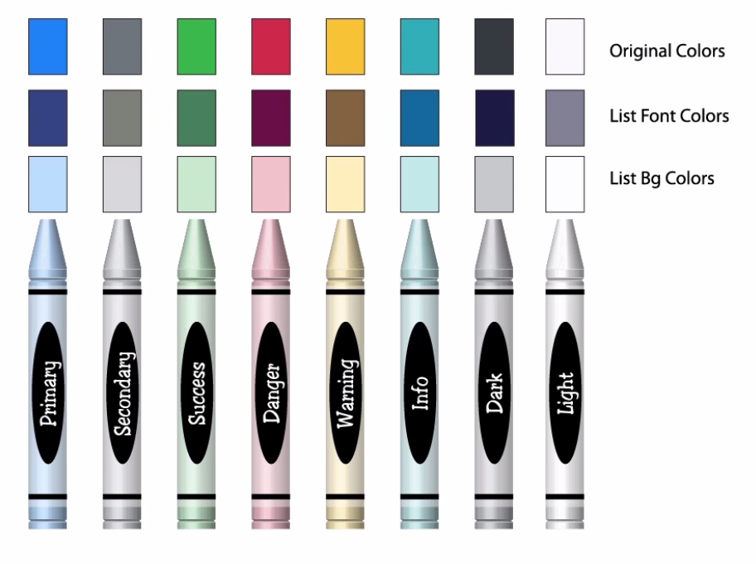
- list-unstyled – remove all styling from the list.
- list-inline and list-inline-item – makes the list inline.
- Description List (<dl>):
<hr class="mt-5">
<dl class="row">
<dt class="col-sm-3">Coffee</dt>
<dd class="col-sm-9">Black hot drink</dd>
<dt class="col-sm-3">Milk</dt>
<dd class="col-sm-9">White cold drink</dd>
</dl>

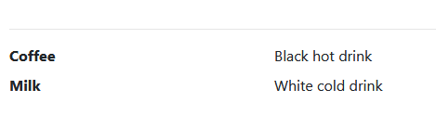

List-group with JS Behavior
- list-group
- list-group-item , list-group-item-action

Responsive Floats
- float-right
- float-sm-right
- clearfix – whenever you use float classes, you should also use ‘clearfix’ which will make sure that the other elements in the page will not overwrite the float elements and it will keep the flow of the elements as you would expect.

Fixed Elements and Justified Types
- Text-justify
- fixed-top|buttom – will fix the element to the top/buttom of the page.
- sticky-top – the element will be in its usually place but when it gets to the top, it will stick there.

Buttons
- btn – a must for every button type
- btn-lg|sm
- btn-block – will make the button a block element that takes the whole width of the parent element.
- data-toggle=”button” – makes the button into a toggle-button.
- active
- disabled

Colors
- btn-<color>
- btn-link – will look like a regular anchor-tag link
- btn-ouline-<color>

Button Groups
See Bootstrap\bootstrap_sandbox.html

Images
- Img-fluid – will make the image fluid
- Float-right|left – will float a smaller image
- d-block mx-auto – will center the image
- rounded – will round the edges of the image
- visible(default)|invisible – make the image visible/invisible.

Tables
- *table
- table-dark
- table-striped ; table-bordered
- table-hover – will show the hover when we scroll over the table
- Each row: <tr scope=”row”>
- <thead class=”thead-dark|light”> - to have a dark header row.
- Table-<colors e.g. primary,success etc>

Media
- *media ; media-body

Forms
See bootstrap\bootstrap_forms.html
- form-group – for every form field (div)
- form-control – for every input field e.g. input, select, textarea etc.
- form-control-file for file uploads:
<input class="form-control-file" type="file" id="file">
- form-text for paragraphs
- form-check – for checkboxes and radio buttons. When used, add form-check-label to their label and form-check-input to their checkbox/radio input
- form-inline – to create an inline-form
- form-row and col-<size>-<num> can be used to compact the form to multiple columns.
- is-valid|is-invalid will color the border green/red to mark validity of fields (works with JS).
invalid-feedback will color text with red to return feedback on invalid input.
- Prepend/append buttons/text/icon to input fields using input-group and input-group-prepend|append inside the input-group.
- In select tag: use multiple to allow choosing multiple inputs.

Jumbotron
A lightweight, flexible component that can optionally extend the entire viewport to showcase key marketing messages on your site.

<div class="jumbotron">
<h1 class="display-4">Hello, world!</h1>
<p class="lead">This is a simple hero unit, a simple jumbotron-style component for calling extra attention to featured content or information.</p>
<hr class="my-4">
<p>It uses utility classes for typography and spacing to space content out within the larger container.</p>
<a class="btn btn-primary btn-lg" href="#" role="button">Learn more</a>
</div>
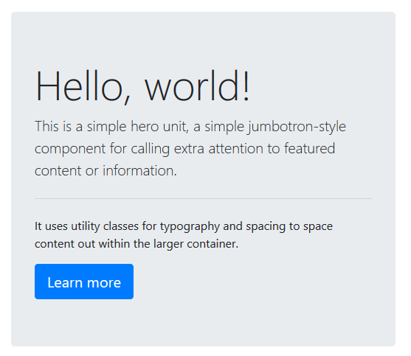
- To make the jumbotron full width, and without rounded corners, move the jumbotron outside of the container and have the container or the container-fluid inside the jumbotron class.
- jumbotron-fluid will make the jumbotron class fluid so that it will re-size continuously and not just at the size checkpoints.

Tooltips
Using:
- data-toggle=”tooltip”
- data-placement=<”top|right|left|buttom”>
- data-html=”true|false”
- title=”tooltip information goes here”
and the following JS:
<script>
$(function(){
$('[data-toggle="tooltip"]').tooltip();
})

</script>

Popup Modals
- data-toggle=”modal”
- data-target=”#id”

Bootstrap Libraries

Bootbox.js
An open source javascript library to create dialog boxes using bootstrap.

Install – Visual Studio
- Install bootbox package:
PM> install-package bootbox
- Add it to the project’s bundles in BundleConfig.cs. You can add it to the bootstrap js bundles.

Functions

Confirm
Create a dialog box
bootbox.confirm(“<question to user>”,
callbackFunction(result) {
if(result) { handle truethy result }
}

JQuery Libraries

Toastr
To display non-blocking messages to the user on the front end
- Install: PM> install-package toastr
- Add ~/content/toastr.css and ~/Scripts/toastr.js to our bundles.

Use
toastr.success(“<message to display>”);
toastr.error(“<message to display>”);

Data Tables

Install – Visual Sudio
- Install JQuery-DataTables:
PM> install-package jquery.datatables
- The main scripts to add to the BundleConfig are:
  - datatables/jquery.dataTables.js
  - datatables/dataTables.bootstrap.js
There are many other scripts in the datatables folder that you might want to include depending on your needs but these are the core ones.
- Include the datatables css files to the css bundle:
  - datatables/css/jquery.dataTables.css
  - datatables/css/dataTables.bootstrap.css

Usage
On $(document).ready – call:
$(<selector for the table tag>).DataTable();
On all data tables DOM elements.
Notes:
- You must make sure that your table structure is correct and that you have the same number of header tags (th) and columns (td).
- DataTables uses JSON objects to search and sort the tables. Therefore, if we send it an already rendered html (rendered on the server side by ASP.Net for example), the DataTables library will have to parse it in order to create the JSON that it can work with.
Therefore, it is more efficient to send a serialized JSON object instead, like we do with RESTful API.

DataTable with Ajax
$(<selector>).DataTable( {
ajax: {
url: <the path to the web api call>,
dataSrc: <the property in the returned JSON that hold the array. If the returned is an array – should be “”>

}
columns: [
{
data: < the name of the property for object or index for array>,
render: [optional] – can be:
- a callback rendering function that returns the html to render: function(data, type, row (== the object of each row), meta){…} or
- an expression that return all the required fields as JSON object or
- if not included – will render the data in ‘data’ field as is.
},
{
…
}
]
});

Limitations
Client-side storage of the JSON table and sorting/searching etc on the client side is ok for small-medium size data sets. However, if we have more than around a thousand of records returned by the server, it is more efficient to do the ‘heavy lifting’ of searching and sorting on the server side and not on the client side.
In order to do this, we’ll need to enable server-side processing on DataTables.

Type Ahead
A javascript jquery library that provides autocomplete search functionality.
The typeahead.js library consists of 2 components:
- The suggestion engine, Bloodhound, that is responsible for computing suggestions for a given query and
- The UI view, Typeahead. That is responsible for rendering suggestions and handling DOM interactions.

- PM>install-package Twitter.Typeahead
- Add: ~/scripts/typeahead.bundle.js to our lib bundle
- Create a new content/typeahead.css stylesheet for the typeahead and add it to your css bundle.
- Go to https://twitter.github.io/typeahead.js/examples/ - from there you can:
  - Copy the styles from the ../css/examples.css into your newly created typeahead.css
  - Go to Remote and copy the JS

JQuery
is designed to simplify scripting done on the client side. It provides a unified api for working with the DOM object, hiding the implementation details of the different browsers. jQuery's most recognizable characteristic is its dollar sign ($) syntax. With it, you can easily manipulate elements, create animations and handle input events.
- Inside the html, JQuery should run inside <script></script> tag since it’s a JS library.
- All jQuery functions start with a $, usually referred to as a dollar sign operator, or as bling, which is an alias for the JQuery object.
- jQuery often selects an HTML element with a selector, then does something to that element.
For example, let's make all of your button elements bounce. Just add this code inside your document ready function:
$("button").addClass("animated bounce");

Naming
Convention: call your JQuery selector elements starting with $ so you can immediately see that they are jquery elements as opposed to javascript variables:
let $popupForm = $(“.popup-form”);

Life Cycle
- $(document).ready(function() {…}); will run as soon as your browser finished loading your page. This is important because without your document.ready function, your code may run before your HTML is rendered, which would cause bugs.
- Every javascript file that needs to run immediately when loaded, should be wrapped with the:
$(document).ready( function() {
… all file contents.
});
In order to make sure that it:
  - Only run once the document is ready
  - Protect its internal variables from leaking into the global scope!
- If the js is just a library, it will need to be wrapped in an anonymous function to prevent its internal variable from leaking into the global scope:
(function () {
// all the file’s contents…
})();

Find Elements

Elements Selectors
In JQuery, you select elements in the same way you would in CSS. For example:
$(“button”) – will select all elements of type button.
$(“.text-primary”) – will select all elements with the class “text-primary”
$(“#target3”) – will select the element with the id taget3.
This call always returns a collection. This collection can contain zero, one or more elements.

DOM Tree
- parent() – will return the parent of the chose elements. For example:
$("#left-well").parent().css("background-color", "blue")
- parents(<opt: selector>) – will return all the parents of the chosen elements that matches the selector.
- children() – will target all children of the element.

HTML attribute vs. DOM property

Attributes are defined by HTML. Properties are defined by the DOM (Document Object Model).
- A few HTML attributes have 1:1 mapping to properties. id is one example.
- Some HTML attributes don't have corresponding properties. colspan is one example.
- Some DOM properties don't have corresponding attributes. textContent is one example.
- Many HTML attributes appear to map to properties ... but not in the way you might think!
That last category is confusing until you grasp this general rule:
Attributes initialize DOM properties and then they are done. Property values can change; attribute values can't.
For example, when the browser renders <input type="text" value="Bob">, it creates a corresponding DOM node with a value property initialized to "Bob".
When the user enters "Sally" into the input box, the DOM element value property becomes "Sally". But the HTML value attribute remains unchanged as you discover if you ask the input element about that attribute: input.getAttribute('value') returns "Bob".
The HTML attribute value specifies the initial value; the DOM value property is the current value.

The disabled attribute is another peculiar example. A button's disabled property is false by default so the button is enabled. When you add the disabled attribute, its presence alone initializes the button's disabled property to true so the button is disabled.
Adding and removing the disabled attribute disables and enables the button. The value of the attribute is irrelevant, which is why you cannot enable a button by writing <button disabled="false">Still Disabled</button>.
Setting the button's disabled property disables or enables the button. The value of the property matters.
The HTML attribute and the DOM property are not the same thing, even when they have the same name.
So, from W3:
- The .prop() method should be used for boolean attributes/properties and for properties which do not exist in html (such as window.location).
- The .attr() should be used to read the default value of attributes that exist in the html.

Register Event Handlers
$( element chooser ).on(“<event type>”,<function to call on event>)
For example:
$(‘#button-3’).on(“click”, function() {
onButton3(with parameters….);
}
Notes:
- If you have a lot of buttons, it might be more efficient to register just one handle on the parent and use the children as selectors:
$("#customers").on("click",".js-delete", function() {…}
This way, there is only one handler but it will call the callback function only if the triggering button matches the selector (2nd parameter).
- Inside the event handler, you can use $(this) to receive the element that the event triggered on.
For example:
$("#test-button").on("click", function () {
console.log(`You clicked on: ${$(this).text()}`);
});

Query/Set Elements
For all the functions below: elem will be:
let elem = $(“some elements chooser”);
- elem.text() – the text of the element
- elem.toggle/slideToggle/fadeToggle(<time>) – will make the element appear/disappear with time for the animation.

Change Elements

Add/Remove Classes
addClass – adds the indicated class(es) to the selected element. For example:
$("button").addClass("animated bounce");
Will add both “animated” and “bounce” classes to all buttons elements.
removeClass – removes the indicated class from the chosen element.

Manipulate Elements

Move Element
$(“<element selector>”).appendTo(“<to element selector>”);
For example:
$("#target4").appendTo("#left-well");
Will move target4 element to your #left-well element.

Clone Element
For example:
$(“<element selector>”).clone().appendTo(“<to element selector>”);
Will clone the element and then append the cloned element to the “to element selector”.

Remove Element
$(“<element selector>”).remove();

Change CSS Properties
To change the CSS of an element:
$(“<css selector>”).css(“<property>”,”<value>”);
For example:
$(“#target1”).css(“color”, “blue”);

Change HTML Properties
$(“<element selector>”).prop(“<property name>”, <value>);
For example:
$(“button”).prop(“disabled”, true);
Will disable all buttons.

Change HTML Tags
- $(“<element selector>”).html(“<new html>”);
Lets you add HTML tags and text within an element. Any content previously within the element will be completely replaced with the content you provide using this function.
For example:
$("h3").html("<em>jQuery Playground</em>");
- $(“<element selector>”).text(“<new text>”);
Lets you change the content of the element with the supplied text without any HTML tags parsing. Note: Any content previously within the element will be completely replaced with the content you provide using this function.
For example:
$("h3").text("jQuery Playground");

Custom Validators
If we need to support more complex validators than the ones supplied by the HTML (e.g. required), we can use JQuery to run additional customer validators on the input fields. In order to do this:
Plug in the validation functionality into the form:
let validator = $("#newRental").validate({
submitHandler: function () {…}
});
- Create the custom validation function:

$.validator.addMethod("<validator function name>",
function () {
// Return true if valid
// and false otherwise
},
“error message if validation failed”);
- Add a special JQuery validation attribute to the required fields to run the validator on them. For each field, add:
data-rule-<validator function>="true"
And:
name=”<field name>”
This will cause JQuery to run the validator function automatically whenever this field change.
For example:
<input type="text" id="customer"
name=”customer”
data-rule-validCustomer="true">
…
$.validator.addMethod("validCustomer",function () { return vm.customerId && vm.customerId != 0;
},
"Please select a valid customer.");

D3.JS – Data Driven Documents
D3 is a JS library to create dynamic and interactive data visualizations in the browser.
It's built to work with common web standards, namely HTML, CSS, and Scalable Vector Graphics (SVG).
D3 takes input data and maps it into a visual representation of that data. It supports many different data formats. D3 lets you bind (or attach) the data to the Document Object Model (DOM). You use HTML or SVG elements with D3's built-in methods to transform the data into a visualization.
D3 gives you a lot of control over the presentation of data.

Document Element Methods
- select() - takes an argument for the name of the element you want and returns an HTML node for the first element in the document that matches the name:
const firstAnchor = d3.select(“a”);
- append() - takes an argument for the element you want to add to the document. It appends an HTML node to a selected item, and returns a handle to that node.
- text() - either sets the text of the selected node, or gets the current text. To set the value, you pass a string as an argument inside the parentheses of the method.
Example:
d3.select("ul")
.append("li")
.text("Very important item");
- selectAll() - select a group of elements. It returns an array of HTML nodes for all the items in the document that match the input string:
const anchors = d3.selectAll("a");
- style(<css-property>,<value>) - add inline CSS styles on dynamic elements:
d3.select(“ul”)
.style(“color”,”red”);
- style(<css property>, (d)=> {
/* Logic that returns the property based on a condition */
});

data() and enter()

The D3 library focuses on a data-driven approach. When you have a set of data, you can apply D3 methods to display it on the page. Data comes in many formats, but this challenge uses a simple array of numbers.
The first step is to make D3 aware of the data. The data() method is used on a selection of DOM elements to attach the data to those elements. The data set is passed as an argument to the method.
A common workflow pattern is to create a new element in the document for each piece of data in the set. D3 has the enter() method for this purpose.
When enter() is combined with the data() method, it looks at the selected elements from the page and compares them to the number of data items in the set. If there are fewer elements than data items, it creates the missing elements.
Here is an example that selects a ul element and creates a new list item based on the number of entries in the array:
<body>
<ul></ul>
<script>
const dataset = ["a", "b", "c"];
d3.select("ul").selectAll("li")
.data(dataset) // for each data in the datset
.enter() // do the following:
.append("li") // append(“li”)
.text((d) => d); // .text(“a/b/c”)
</script>
</body>
It may seem confusing to select elements that don't exist yet. This code is telling D3 to first select the ul on the page. Next, select all list items, which returns an empty selection. Then the data() method reviews the dataset and runs the following code three times, once for each item in the array. The enter() method sees there are no li elements on the page, but it needs 3 (one for each piece of data in dataset). New li elements are appended to the ul and have the text "New item".
.text(d) – gets a single entry from the dataset that this selection is bound to.

attr()
add any HTML attribute to an element, including a class name.
The attr() method works the same way that style() does. It takes comma-separated values, and can use a callback function.:
selection.attr("class", "container");

Ajax
AJAX is a way of sending information between browser and server without refreshing page. It can be done with or without library like jQuery
  - In contrast to the traditional HTML forms for posting data to the server, when using AJAX, the user stays on the same page, we call the server in the background, and then refresh the content of the page. This gives a faster and smoother experience to the end user. We can even load an entirely new page in the content area and this gives the user the illusion that they’re on a new page.
  - AJAX is a technique to do an XMLHttpRequest (out of band Http request) from a web page to the server and send/retrieve data to be used on the web page. AJAX stands for Asynchronous Javascript And XML. It uses javascript to construct an XMLHttpRequest, typically using different techniques on various browsers.
  - jQuery (website) is a javascript framework that makes working with the DOM easier by building lots of high level functionality that can be used to search and interact with the DOM. Part of the functionality of jQuery implements a high-level interface to do AJAX requests. jQuery implements this interface abstractly, shielding the developer from the complexity of multi-browser support in making the request.
Examples:
- Google suggestions in search
- Likes and comments in sites like Facebook etc.
- Background checking of forms while you type
- Updating social media/email etc home page, without having to refresh the page to see new data.

Ajax with JQuery
Most jQuery applications don't in fact use XML, despite the name "Ajax"; instead, they transport data as plain HTML or JSON (JavaScript Object Notation).

$.ajax()
jQuery’s core $.ajax() method is a powerful and straightforward way of creating Ajax requests. It takes a configuration object that contains all the instructions jQuery requires to complete the request. The $.ajax() method is particularly valuable because it offers the ability to specify both success and failure callbacks. Also, its ability to take a configuration object that can be defined separately makes it easier to write reusable code:

// Using the core $.ajax() method
$.ajax({
// The URL for the request
url: "post.php",
// The method (GET/POST/PUT/DELETE etc) to call
method: "GET",
// The data to send (will be converted to a query string)
data: {
id: 123
},
// The type of data we expect back
dataType : "json"
})
// Code to run if the request succeeds (is done);
// The response is passed to the function
.done(function( json ) {
$( "<h1>" ).text( json.title ).appendTo( "body" );
$( "<div class=\"content\">").html( json.html ).appendTo( "body" );
})
// Code to run if the request fails; the raw request and
// status codes are passed to the function
.fail(function( xhr, status, errorThrown ) {
alert( "Sorry, there was a problem!" );
console.log( "Error: " + errorThrown );
console.log( "Status: " + status );
console.dir( xhr );
})
// Code to run regardless of success or failure;
.always(function( xhr, status ) {
alert( "The request is complete!" );
});

Convenience Methods
If you don’t need to extensive configurability of $.ajax() and you don’t need to handle errors, you might want to use one of the convenience methods below. Note that all of these methods actually call .ajax() under the hood:
- $.get
Perform a GET request to the provided URL.
- $.post
Perform a POST request to the provided URL.
- $.getScript
Add a script to the page.
- $.getJSON
Perform a GET request, and expect JSON to be returned.

React
React, popularized by Facebook, is an open-source JavaScript library created and maintained by Facebook for building user interfaces. It is used to create components, handle state and props, utilize event listeners and certain life cycle methods to update data as it changes.
React combines HTML with JavaScript functionality to create its own markup language, JSX.
React is the V and the C in MVC pattern. The Presentational components are the View and the Container Components are the Controllers. See Container-Presentational Pattern.

JSX
React uses a syntax extension of JavaScript called JSX that allows you to write HTML directly within JavaScript. This has several benefits. It lets you use the full programmatic power of JavaScript within HTML, and helps to keep your code readable. For the most part, JSX is similar to the HTML that you have already learned, however there are a few key differences that will be covered throughout these challenges.
For instance, because JSX is a syntactic extension of JavaScript, you can actually write JavaScript directly within JSX. To do this, you simply include the code you want to be treated as JavaScript within curly braces: { 'this is treated as JavaScript code' }. Keep this in mind, since it's used in several future challenges.
However, because JSX is not valid JavaScript, JSX code must be compiled into JavaScript. The transpiler Babel is a popular tool for this process. For your convenience, it's already added behind the scenes for these challenges. If you happen to write syntactically invalid JSX, you will see the first test in these challenges fail.
It's worth noting that under the hood the challenges are calling ReactDOM.render(JSX, document.getElementById('root')). This function call is what places your JSX into React's own lightweight representation of the DOM. React then uses snapshots of its own DOM to optimize updating only specific parts of the actual DOM.

JSX Elements
To create a JSX element:
const JSX = <h1>Hello JSX!</h1>;
Note: every JSX variable should return one element. So for example, the following is a valid JSX element:
const JSX = (
<div>
<p>Paragraph One</p>
<p>Paragraph Two</p>
<p>Paragraph Three</p>
</div>
);
Note: the parenthesis are optional.
But the following isn’t:
const JSX = (
<p>Paragraph One</p>
<p>Paragraph Two</p>
<p>Paragraph Three</p>
);

JSX Elements Syntax
The following are the important changes between JSX syntax and plain HTML syntax:
- class (in html) => className (in JSX)
- all HTML attributes’ names change to be camelCase. So, for example:
  - onclick => onClick
  - onchange => onChange
etc.
- Any hyphenated HTML attribute or CSS style properties are written using camel case in JSX.
- Self-Closing Tags:
Unlike HTML where some tags are always self-closing (e.g. <br> or <br />) and others must always have an opening and a closing tags (e.g. <div></div>),
- In JSX, any JSX element can be written with a self-closing tag, and every element must be closed. The line-break tag, for example, must always be written as <br /> in order to be valid JSX that can be transpiled. A <div>, on the other hand, can be written as <div /> or <div></div>. The difference is that in the first syntax version there is no way to include anything in the <div />
- Comments:
{/*This is a React comment*/}
- Javascript code:
{ Math.round(4.5); }

Conditional markup/properties

Markup on regular condition
Imagine that you are tracking several conditions in a component and you want different elements to render depending on each of these conditions. If you write a lot of else if statements to return slightly different UIs, you may repeat code which leaves room for error. Instead, you can use the && logical operator to perform conditional logic in a more concise way. This is possible because you want to check if a condition is true, and if it is, return some markup. Here's an example:
{regular JS conditional code && <p>markup</p>}
If the condition is true, the markup will be returned. If the condition is false, the operation will immediately return false after evaluating the condition and return nothing. You can include these statements directly in your JSX and string multiple conditions together by writing && after each one. This allows you to handle more complex conditional logic in your render() method without repeating a lot of code.
For example:
render() {
return (
<div>
<button
onClick={this.toggleDisplay}>
Toggle Display
</button>
{this.state.display && <h1>Displayed!</h1>}
</div>
);
}

Markup on Ternary Condition
The same can be done also with ternary expressions:
render() {
const buttonOne = <button onClick={this.submit}>Submit</button>;
const buttonTwo = <button>You May Enter</button>;
const buttonThree = <button>You Shall Not Pass</button>;
return (
<div>
<h3>Enter Your Age to Continue</h3>
<input
style={inputStyle}
type="number"
value={this.state.input}
onChange={this.handleChange} /><br />
{
this.state.input === "" ?
(buttonOne) :
(this.state.input < 18 ?
(buttonThree) :
(buttonTwo))
}
</div>
);
}

Style on Coditions
You can also render CSS conditionally based on the state of a React component. To do this, you check for a condition, and if that condition is met, you modify the styles object that's assigned to the JSX elements in the render method.
This paradigm is important to understand because it is a dramatic shift from the more traditional approach of applying styles by modifying DOM elements directly (which is very common with jQuery, for example). In that approach, you must keep track of when elements change and also handle the actual manipulation directly. It can become difficult to keep track of changes, potentially making your UI unpredictable. When you set a style object based on a condition, you describe how the UI should look as a function of the application's state. There is a clear flow of information that only moves in one direction. This is the preferred method when writing applications with React.
render() {
let inputStyle = {
border: '1px solid black'
};
if(this.state.input.length > 15) {
inputStyle.border = "3px solid red";
}
return (
<div>
<h3>Don't Type Too Much:</h3>
<input
type="text"
style={inputStyle}
value={this.state.input}
onChange={this.handleChange} />
</div>
);
}
};

JSX Security – Prevents Injection Attacks
It is safe to embed user input in JSX:
const title = response.potentiallyMaliciousInput;
// This is safe:
const element = <h1>{title}</h1>;
By default, React DOM escapes any values embedded in JSX before rendering them. Thus it ensures that you can never inject anything that’s not explicitly written in your application. Everything is converted to a string before being rendered. This helps prevent XSS (cross-site-scripting) attacks.

Elements Styles
There are two main options for styling the React JSX elements:
- If you import styles from a stylesheet, it isn't much different than regular html+CSS:
You apply a class to your JSX element using the className attribute, and apply styles to the class in your stylesheet.
- Another option is to apply inline styles, which are very common in ReactJS development.
You apply inline styles to JSX elements similar to how you do it in HTML, but with a few JSX differences. Here's an example of an inline style in HTML:
<div style="color: yellow; font-size: 16px">Mellow Yellow</div>
JSX elements use the style attribute, but because of the way JSX is transpiled, you can't set the value to a string. Instead, you set it equal to a JavaScript object. Here's an example:
<div style={{color: "yellow", fontSize: 16}}>Mellow Yellow</div>
Notice how we camelCase the "fontSize" property? This is because React will not accept kebab-case keys in the style object. React will apply the correct property name for us in the HTML.
Note: All property value length units (like height, width, and fontSize) are assumed to be in px unless otherwise specified. If you want to use em, for example, you wrap the value and the units in quotes, like {fontSize: "4em"}. Other than the length values that default to px, all other property values should be wrapped in quotes.

Components
Components are the core of React. Everything in React is a component and here you will learn how to create one.
The main types of components are:

Stateless functional component
A stateless functional component is any function you write which accepts props and returns JSX.

Stateless Component
A stateless component, on the other hand, is a class that extends React.Component, but does not use internal state.

Stateful Component
Finally, a stateful component is any component that does maintain its own internal state. You may see stateful components referred to simply as components or React components.
A common pattern is to try to minimize statefulness and to create stateless functional components wherever possible. This helps contain your state management to a specific area of your application. In turn, this improves development and maintenance of your app by making it easier to follow how changes to state affect its behavior.
There are two ways to create a React component:

Stateless Functional Components
The first way is to use a JavaScript function. Defining a component in this way creates a stateless functional component. Think of a stateless component as one that can receive data and render it, but does not manage or track changes to that data.
To create a component with a function, you simply write a JavaScript function that returns either JSX or null. One important thing to note is that React requires your function name to begin with a capital letter. Here's an example of a stateless functional component that assigns an HTML class in JSX:
// After being transpiled, the <div> will have a CSS class of 'customClass'
const DemoComponent = function() {
return (
<div className='customClass' />
);
};

Because a JSX component represents HTML, you could put several components together to create a more complex HTML page. This is one of the key advantages of the component architecture React provides. It allows you to compose your UI from many separate, isolated components. This makes it easier to build and maintain complex user interfaces.

Extend React Components – ES6 and up
The other way to define a React component is with the ES6 class syntax. In the following example, Kitten extends React.Component:
class Kitten extends React.Component {
constructor(props) {
super(props);
}
{/* This function will be called to return the JSX element to render into the HTML (or null)*/}
render() {
return (
<h1>Hi</h1>
);
}
}
This creates an ES6 class Kitten which extends the React.Component class. So the Kitten class now has access to many useful React features, such as local state and lifecycle hooks. Don't worry if you aren't familiar with these terms yet, they will be covered in greater detail in later challenges.
Also notice the Kitten class has a constructor defined within it that calls super(). It uses super() to call the constructor of the parent class, in this case React.Component. The constructor is a special method used during the initialization of objects that are created with the class keyword. It is best practice to call a component's constructor with super, and pass props to both. This makes sure the component is initialized properly. For now, know that it is standard for this code to be included. Soon you will see other uses for the constructor as well as props.

Stateful Component
One of the most important topics in React is state. State consists of any data your application needs to know about, that can change over time. You want your apps to respond to state changes and present an updated UI when necessary. React offers a nice solution for the state management of modern web applications.
You create state in a React component by declaring a state property on the component class in its constructor. This initializes the component with state when it is created. The state property must be set to a JavaScript object. Declaring it looks like this:
this.state = {
// describe your state here
}
You have access to the state object throughout the life of your component. You can update it, render it in your UI, and pass it as props to child components. The state object can be as complex or as simple as you need it to be. Note that you must create a class component by extending React.Component in order to create state like this.

setState
In order to change the state of your object, you should use the setState method. You call the setState method within your component class like so: this.setState(), passing in an object with key-value pairs. The keys are your state properties and the values are the updated state data. For instance, if we were storing a username in state and wanted to update it, it would look like this:
this.setState({
username: 'Lewis'
});
React expects you to never modify state directly, instead always use this.setState() when state changes occur. Also, you should note that React may batch multiple state updates in order to improve performance. What this means is that state updates through the setState method can be asynchronous. There is an alternative syntax for the setState method which provides a way around this problem. This is rarely needed but it's good to keep it in mind!

Automatic Re-Rendering
State is one of the most powerful features of components in React. It allows you to track important data in your app and render a UI in response to changes in this data. If your data changes, your UI will change. React uses what is called a virtual DOM, to keep track of changes behind the scenes. When state data updates, it triggers a re-render of the components using that data - including child components that received the data as a prop. React updates the actual DOM, but only where necessary. This means you don't have to worry about changing the DOM. You simply declare what the UI should look like.

Encapsulation
Note that if you make a component stateful, no other components are aware of its state. Its state is completely encapsulated, or local to that component, unless you pass state data to a child component as props. This notion of encapsulated state is very important because it allows you to write certain logic, then have that logic contained and isolated in one place in your code.

Controlled Form
Your application may have more complex interactions between state and the rendered UI. For example, form control elements for text input, such as input and textarea, maintain their own state in the DOM as the user types. With React, you can move this mutable state into a React component's state. The user's input becomes part of the application state, so React controls the value of that input field. Typically, if you have React components with input fields the user can type into, it will be a controlled input form.
The same can be done for any form input/output field:
class MyForm extends React.Component {
constructor(props) {
super(props);
this.state = {
input: '',
submit: ''
};
this.handleChange = this.handleChange.bind(this);
this.handleSubmit = this.handleSubmit.bind(this);
}
handleChange(event) {
this.setState({
input: event.target.value
});
}
handleSubmit(event) {
this.setState({
submit: this.state.input
});
event.preventDefault(); // prevent form default behaviour which will refresh the page.
}
render() {
return (
<div>
<form onSubmit={this.handleSubmit}>
<input type="text" value={this.state.input}
onChange={this.handleChange} />
<button type='submit'>Submit!</button>
</form>
<h1>{this.state.submit}</h1>
</div>
);
}
};

Lifecycle Methods
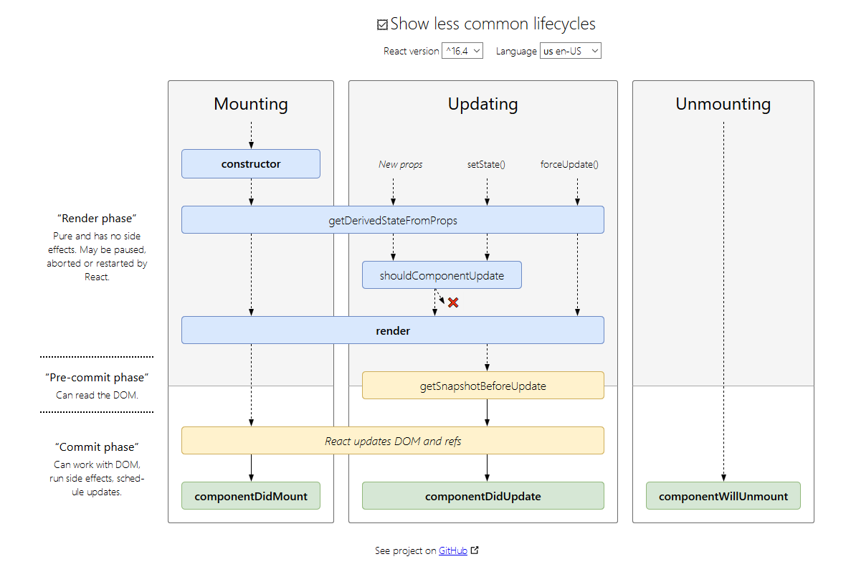
React components have several special methods that provide opportunities to perform actions at specific points in the lifecycle of a component. These are called lifecycle methods, or lifecycle hooks, and allow you to catch components at certain points in time. This can be before they are rendered, before they update, before they receive props, before they unmount, and so on.
In order to use them, you should define them in your React component so that they will be called automatically.
Here is a list of some of the main lifecycle methods:
- componentWillMount()
called before the render() method when a component is being mounted to the DOM.
- componentDidMount()
  - Get Data
Most web developers, at some point, need to call an API endpoint to retrieve data. If you're working with React, it's important to know where to perform this action.
The best practice with React is to place API calls or any calls to your server in the lifecycle method componentDidMount(). This method is called after a component is mounted to the DOM. Any calls to setState() here will trigger a re-rendering of your component. When you call an API in this method, and set your state with the data that the API returns, it will automatically trigger an update once you receive the data.
  - Add Event Listeners
The componentDidMount() method is also the best place to attach any event listeners you need to add for specific functionality. React provides a synthetic event system which wraps the native event system present in browsers. This means that the synthetic event system behaves exactly the same regardless of the user's browser - even if the native events may behave differently between different browsers.
You've already been using some of these synthetic event handlers such as onClick(). React's synthetic event system is great to use for most interactions you'll manage on DOM elements. However, if you want to attach an event handler to the document or window objects, you have to do this directly.
For example:
componentDidMount() {
document.addEventListener("keydown",
this.handleKeyPress);
}
// Note: any event listener that is added in componentDidMount, should be removed in componentWillUnmount:
componentWillUnmount() {
docment.removeEventListener("keydown",
this.handleKeyPress);
}
- componentWillReceiveProps(nextProps)
Another lifecycle method is componentWillReceiveProps() which is called whenever a component is receiving new props. This method receives the new props as an argument, which is usually written as nextProps. You can use this argument and compare with this.props and perform actions before the component updates. For example, you may call setState() locally before the update is processed.
- shouldComponentUpdate()
So far, if any component receives new state or new props, it re-renders itself and all its children. This is usually okay. But React provides a lifecycle method you can call when child components receive new state or props, and declare specifically if the components should update or not. The method is shouldComponentUpdate(), and it takes nextProps and nextState as parameters.
This method is a useful way to optimize performance. For example, the default behavior is that your component re-renders when it receives new props, even if the props haven't changed. You can use shouldComponentUpdate() to prevent this by comparing the props. The method must return a boolean value that tells React whether or not to update the component. You can compare the current props (this.props) to the next props (nextProps) to determine if you need to update or not, and return true or false accordingly.
- componentWillUpdate()
- componentDidUpdate()
called immediately after a component re-renders. Note that rendering and mounting are considered different things in the component lifecycle. When a page first loads, all components are mounted and this is where methods like componentWillMount() and componentDidMount() are called. After this, as state changes, components re-render themselves.
- componentWillUnmount()
Use this lifecycle method to do any clean up on React components before they are unmounted and destroyed. Removing event listeners is an example of one such clean up action.

Properties

Passing Properties
In React, you can pass props, or properties, to child components. Say you have an App component which renders a child component called Welcome that is a stateless functional component. You can pass Welcome a user property by writing:
<App>
<Welcome user='Mark' />
</App>
You use custom HTML attributes that React provides support for to pass the property user to the component Welcome. Since Welcome is a stateless functional component, it has access to this value like so:
const Welcome = (props) => <h1>Hello, {props.user}!</h1>
It is standard to call this value props and when dealing with stateless functional components, you basically consider it as an argument to a function which returns JSX. You can access the value of the argument in the function body. With class components, you will see this is a little different.
Note: when using class components, use {this.props.user} instead since props is a member variable of the class.

Passing Arrays
To pass an array to a JSX element, it must be treated as JavaScript and wrapped in curly braces.
<ParentComponent>
<ChildComponent colors={["green", "blue", "red"]} />
</ParentComponent>
The child component then has access to the array property colors. Array methods such as join() can be used when accessing the property.
const ChildComponent = (props) => <p>{props.colors.join(', ')}</p>
This will join all colors array items into a comma separated string and produce:
<p>green, blue, red</p>

Pass Callback as Props

class MyApp extends React.Component {
constructor(props) {
super(props);
this.state = {
inputValue: ''
}
this.handleChange = this.handleChange.bind(this);
}
handleChange(event) {
this.setState({
inputValue: event.target.value
});
}
render() {
return (
<div>
<GetInput input={this.state.inputValue}
handleChange={this.handleChange} />
<RenderInput input={this.state.inputValue} />
</div>
);
}
};
class GetInput extends React.Component {
constructor(props) {
super(props);
}
render() {
return (
<div>
<h3>Get Input:</h3>
<input
value={this.props.input}
onChange={this.props.handleChange}/>
</div>
);
}
};
class RenderInput extends React.Component {
constructor(props) {
super(props);
}
render() {
return (
<div>
<h3>Input Render:</h3>
<p>{this.props.input}</p>
</div>
);
}
};

Default Properties
To define the default property to pass if the user doesn’t provide any property:
MyComponent.defaultProps = {
location: 'San Francisco'
}

PropTypes
React provides useful type-checking features to verify that components receive props of the correct type. For example, your application makes an API call to retrieve data that you expect to be in an array, which is then passed to a component as a prop. You can set propTypes on your component to require the data to be of type array. This will throw a useful warning when the data is of any other type.
It's considered a best practice to set propTypes when you know the type of a prop ahead of time. You can define a propTypes property for a component in the same way you defined defaultProps. Doing this will check that props of a given key are present with a given type. Here's an example to require the type function for a prop called handleClick:
MyComponent.propTypes = {
handleClick: PropTypes.func.isRequired
}
In the example above, the PropTypes.func part checks that handleClick is a function. Adding isRequired tells React that handleClick is a required property for that component. You will see a warning if that prop isn't provided. Also notice that func represents function. Among the seven JavaScript primitive types, function and boolean (written as bool) are the only two that use unusual spelling. In addition to the primitive types, there are other types available. For example, you can check that a prop is a React element. Please refer to the documentation for all of the options.
Note: As of React v15.5.0, PropTypes is imported independently from React, like this:
import React, { PropTypes } from 'react';

Composition
React strongly recommend against creating your own base component classes. In React components, code reuse is primarily achieved through composition rather than inheritance.
Now we will look at how we can compose multiple React components together. Imagine you are building an App and have created three components, a Navbar, Dashboard, and Footer.
To compose these components together, you could create an App parent component which renders each of these three components as children. To render a component as a child in a React component, you include the component name written as a custom HTML tag in the JSX. For example, in the render method you could write:
return (
<App>
<Navbar />
<Dashboard />
<Footer />
</App>
)
When React encounters a custom HTML tag that references another component (a component name wrapped in < /> like in this example), it renders the markup for that component in the location of the tag. This should illustrate the parent/child relationship between the App component and the Navbar, Dashboard, and Footer.

Design
Component composition is one of React's powerful features. When you work with React, it is important to start thinking about your user interface in terms of components like the App example in the last challenge. You break down your UI into its basic building blocks, and those pieces become the components. This helps to separate the code responsible for the UI from the code responsible for handling your application logic. It can greatly simplify the development and maintenance of complex projects.

Rendering

Render JSX Elements
So far, you've learned that JSX is a convenient tool to write readable HTML within JavaScript. With React, we can render this JSX directly to the HTML DOM using React's rendering API known as ReactDOM.
ReactDOM offers a simple method to render React elements to the DOM which looks like this:
ReactDOM.render(componentToRender, targetNode);
where the first argument is the React element or component that you want to render, and the second argument is the DOM node that you want to render the component to.
As you would expect, ReactDOM.render() must be called after the JSX element declarations, just like how you must declare variables before using them.

Render React Components
ReactDOM.render(<ComponentToRender />, targetNode)
Where <ComponentToRender /> uses the same syntax as in the React components’ compositions.
For example:
ReactDOM.render(<TypesOfFood />,
document.getElementById("challenge-node"));

Dynamic Rendering
You may need your components to render an unknown number of elements. Often in reactive programming, a programmer has no way to know what the state of an application is until runtime, because so much depends on a user's interaction with that program. Programmers need to write their code to correctly handle that unknown state ahead of time. Using Array.map() in React illustrates this concept.
For example, you create a simple "To Do List" app. As the programmer, you have no way of knowing how many items a user might have on their list. You need to set up your component to dynamically render the correct number of list elements long before someone using the program decides that today is laundry day:
render() {
const items = this.state.toDoList.map(item =>
(<li>{item}</li>) );
return (
<div>
<textarea
onChange={this.handleChange}
value={this.state.userInput}
style={textAreaStyles}
placeholder="Separate Items With Commas" /><br />
<button onClick={this.handleSubmit}>
Create List</button>
<h1>My "To Do" List:</h1>
<ul>
{items}
</ul>
</div> );
} }
Note:
- You can use all other collections-manipulating JS functions for dynamically analyzing and rendering content in the same way.
- These function returns JSX elements and not JS strings!!

Inline if
Use <condition> && <html> to render the html if the <condition> is true:
Reder() {
return (
<div>
<h1>Hello!</h1>
{unreadMessages.length > 0 &&
<h2>
You have {unreadMessages.length} unread messages.
</h2>
}
</div>
);
}

Inline if-else
Use ternary operation:
render() {
const isLoggedIn = this.state.isLoggedIn;
return (
<div>
{isLoggedIn ? (
<LogoutButton onClick={this.handleLogoutClick} />
) : (
<LoginButton onClick={this.handleLoginClick} />
)}
</div>
);
}

Prevent Rendering
In rare cases you might want a component to hide itself even though it was rendered by another component. To do this return null instead of its render output.
One important thing to keep in mind when returning null is that even though the component doesn’t show up, its lifecycle methods are still fired.
function WarningBanner(props) {
if (!props.warn) {
return null;
}
return (
<div className="warning">
Warning!
</div>
);
}
class Page extends React.Component {
...
render() {
return (
<div>
<WarningBanner warn={this.state.showWarning} />
</div>
);
}
}

Keys
Each list item should have a unique (in this list) string key that help React identify which items have changed, are added, or are removed. Keys should be given to the elements inside the array to give the elements a stable identity.
The best way to pick a key is to use a string that uniquely identifies a list item among its siblings. Most often you would use IDs from your data as keys:
const todoItems = todos.map((todo) =>
<li key={todo.id}>
{todo.text}
</li>
);
When you don’t have stable IDs for rendered items, you may use the item index as a key as a last resort:
const todoItems = todos.map((todo, index) =>
// Only do this if items have no stable IDs
<li key={index}>
{todo.text}
</li>
);

Rendering on the Server
The biggest advantages of rendering the initial page on the server instead of on the client are:
- Much faster initial load since the HTML is calculated on the server and then sent to the client
- Search Engines can see the HTML’s contents and reference it
Note: React will still be able to recognize your app and manage it after the initial load.
To render the initial page on the server, use ReactDOMServer.renderToString() function:
import ReactDOMServer from 'react-dom/server';

ReactJS on VS Code
https://code.visualstudio.com/docs/nodejs/reactjs-tutorial
- Install create-react-app generator:
$ npm install create-react-app
- Run the generator:
$ create-react-app <name of your app’s directory>
- Run the app:
$ cd <app directory>
$ npm start
Once the app starts (it takes quite a few minutes), You should see "Welcome to React" on http://localhost:3000 in your browser.

React App
A common pattern is to have a stateful component containing the state important to your app, that then renders child components. You want these components to have access to some pieces of that state, which are passed in as props.
For example, maybe you have an App component that renders a Navbar, among other components. In your App, you have state that contains a lot of user information, but the Navbar only needs access to the user's username so it can display it. You pass that piece of state to the Navbar component as a prop.
This pattern illustrates some important paradigms in React:
- The first is unidirectional data flow:
State flows in one direction down the tree of your application's components, from the stateful parent component to child components. The child components only receive the state data they need.
- The second is that complex stateful apps can be broken down into just a few, or maybe a single, stateful component. The rest of your components simply receive state from the parent as props, and render a UI from that state.
- It begins to create a separation where state management is handled in one part of code and UI rendering in another. This principle of separating state logic from UI logic is one of React's key principles. When it's used correctly, it makes the design of complex, stateful applications much easier to manage.

class MyApp extends React.Component {
constructor(props) {
super(props);
this.state = {
name: 'CamperBot'
}
}
render() {
return (
<div>
<Navbar name={this.state.name} />
</div>
);
}
};

class Navbar extends React.Component {
constructor(props) {
super(props);
}
render() {
return (
<div>
<h1>Hello, my name is: {this.props.name}</h1>
</div>
);
}
};

React App Skeleton

HTML
<!DOCTYPE html>
<html>
<head>
…
</head>
<body>
…
<div id="component-to-replace-by-react">
<!—my react application will search for this component and
will replace its content with the rendered ones -->
</div>
<script type="text/javascript" src="main.js"></script>
</body>
</html>

Javascript
// main.js
…
const wrapper = document.getElementById("component-to-replace-by-react");
wrapper ? ReactDOM.render(<MyComponent />, wrapper) : false;
MyComponent is my user-defined React component that renders the element’s contents.

Convention:
The component-replace-by-react id will usually be either “root” or “app”

Container-Presentational Pattern
the Container / Presentational principle is a pattern for React components.

Container
- The container component is the one that carries all the logic: functions for handling state changes, internal component state and so on.
The container connects between the store (redux) and the React view.
- Rule: Minimize view logic in containers by extracting it into dumb components.

Presentational – Component - View
- In contrast a presentational component is merely used for displaying the intended markup. Presentational components are plain JavaScript functions receiving data from the container component as props.
- Note: Presentational components are not connected to the store and don’t need to know about Redux!
- If our presentational components don’t need to have private states, they can be stateless functions components. This reinforces their single responsibility of rendering markup. The syntax is terser. What's more, the React core team recommends using stateless components whenever possible. Because these components are not "dressed up" with any of the capabilities of React component objects, the React team anticipates there will be many performance advantages introduced for stateless components in the near future
- “Dumb” components receive data from their parents through props and may hold local component state. Assume you’re implementing a TextInput component from scratch. The blinking caret position is an excellent example for local component state that should not find its way into your global app state.

React Advice
From Nik:
Happy to have a chat about this. Ultimately, the architecture and understanding when to use patterns is important than coding standards. So I suggest getting a bit of an understanding of:
- What state management library you'll use, how it works, best practices, abstractions
- MobX/Redux are the two most popular, have used both and I find mobx much simpler
- How to use HOCs, Render props, how and when to abstract hooks
- How/when to decouple presentation and container logic
In terms of coding standards:
- Typescript is great
- Functional components are quite convenient
- there are some gotchas with state management in fn components, definitely suggest reading the docs for this one https://reactjs.org/docs/hooks-reference.html
- Create as few ad-hoc elements as is possible (a red-flag may be if you see yourself using the same inline styling in many places), make use of your component lib and use/extend abstractions where reasonable
- Use layout helpers/styling helpers etc.

- +1 to react-testing-library, I think it's default now in create-react-app it's very good+1 to screenshot tests being flaky

From Dave:

huge +1 to hooks and functional components
my 2c regarding state management, is to just use react state, up until the point you can't don't dive headfirst into redux because you heard it works for some cases. It is super valuable for massive amounts of state with complex relationships, but often, a simple state object at different levels is sufficient

Additional Commands

Hooks
https://reactjs.org/docs/hooks-effect.html
- useEffect() – adds the ability to perform side effects from a function component.
  - When you call useEffect, you’re telling React to run your “effect” function after flushing changes to the DOM. Effects are declared inside the component so they have access to its props and state. By default, React runs the effects after every render — including the first render.

Redux

Flux
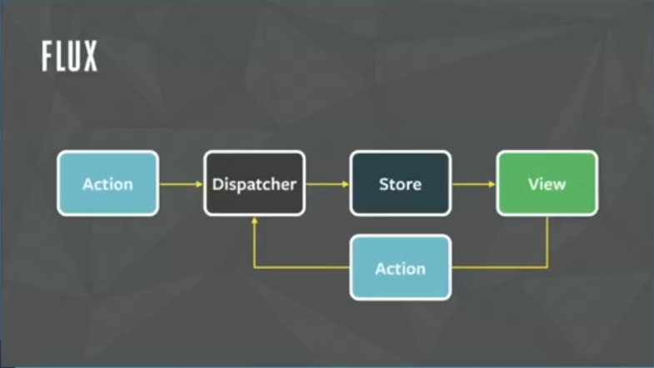

General
Redux is a react.js implementation of the Flux architecture for React apps that comes to replace the MVC model with a more flexible architecture for web apps:
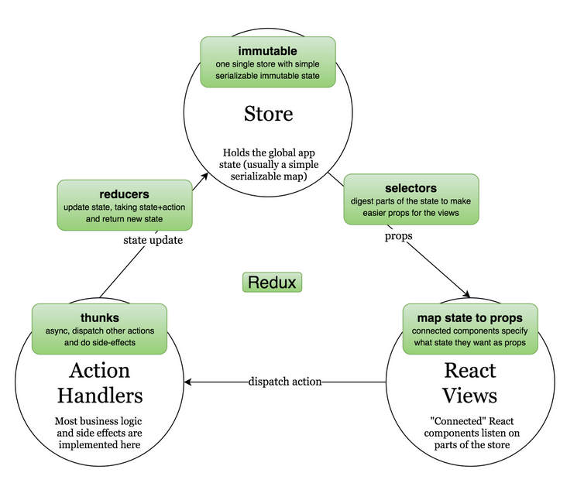
It implements a predictable state container for JavaScript apps.
It helps you write applications that behave consistently, run in different environments (client, server, and native), and are easy to test. On top of that, it provides a great developer experience, such as live code editing combined with a time traveling debugger.
You can use Redux together with React, or with any other view library. It is tiny (2kB, including dependencies), but has a large ecosystem of addons available.
To install:
npm install --save redux

When to use Redux?
What I found is that you should consider using Redux when:
- multiple React components needs to access the same state but do not have any parent/child relationship
- you start to feel awkward passing down the state to multiple components with props
As long as you have just one React component using the state or just passing the state between father and son, Redux might be an overkill for this function.
Redux is framework-agnostic. It can work with pure javascript as well as with React, Angular and other front end frameworks.

Install
npm install redux –save-dev
For working with React:
npm i react-redux --save-dev

Middleware
Middleware is the suggested way to extend Redux with custom functionality. Middleware lets you wrap the store's dispatch method for fun and profit. The key feature of middleware is that it is composable. Multiple middleware can be combined together, where each middleware requires no knowledge of what comes before or after it in the chain.
The most common use case for middleware is to support asynchronous actions without much boilerplate code or a dependency on a library like Rx. It does so by letting you dispatch async actions in addition to normal actions.
For example, redux-thunk lets the action creators invert control by dispatching functions. They would receive dispatch as an argument and may call it asynchronously. Such functions are called thunks. Another example of middleware is redux-promise. It lets you dispatch a Promise async action, and dispatches a normal action when the Promise resolves.
Middleware is not baked into createStore and is not a fundamental part of the Redux architecture, but we consider it useful enough to be supported right in the core. This way, there is a single standard way to extend dispatch in the ecosystem, and different middleware may compete in expressiveness and utility.
To connect the middleware to redux, you use the createStore:
const store = createStore(combineReducers(reducers),
applyMiddleware(thunk));

Redux-Thunk
a middleware that looks at every action that passes through the system, and if it’s a function, it calls that function. That’s all it does.
Redux will pass two arguments to thunk functions: dispatch, so that they can dispatch new actions if they need to; and getState, so they can access the current state. So you can do things like this:
function logOutUser() {
return function(dispatch, getState) {
return axios.post('/logout').then(function() {
// pretend we declared an action creator
// called 'userLoggedOut', and now we can dispatch it
dispatch(userLoggedOut());
});
};
}
This allows us to create asynchronous calls that will dispatch the action only after they finish. For example:
export const fetch_post = () => {
return {
type: "FETCH_USER"
};
};
export const receive_post = post => {
return {
type: "FETCHED_USER",
data: post
};
};
export const receive_error = () => {
return {
type: "RECEIVE_ERROR"
};
};
export const thunk_action_creator = username => {
const user = username.replace(/\s/g, "");
store.dispatch(fetch_post());
return function(dispatch, getState) {
return fetch(`https://api.github.com/users/${user}`)
.then(data => data.json())
.then(data => {
if (data.message === "Not Found") {
throw new Error("No such user found!!");
} else dispatch(receive_post(data));
})
.catch(err => dispatch(receive_error()));
};
};
Note:
When using Thunk middleware, there is no need for mapDispatchToProps since the thunks will get the parameters (dispatch, getState) that will allow the thunks to get the state of the store (use selectors to avoid direct access – see react-redux design!!) and to dispatch the actions.

Redux Store
In Redux, there is a single state object that's responsible for the entire state of your application. This means if you had a React app with ten components, and each component had its own local state, the entire state of your app would be defined by a single state object housed in the Redux store. This is the first important principle to understand when learning Redux: the Redux store is the single source of truth when it comes to application state.
This also means that any time any piece of your app wants to update state, it must do so through the Redux store. The unidirectional data flow makes it easier to track state management in your app.

CreateStore
Creates a Redux store that holds the complete state tree of your app.
There should only be a single store in your app.
const store = createStore(reducer, [preloadedState], [enhancer]);
· Don't create more than one store in an application! Instead, use combineReducers to create a single root reducer out of many.
· It is up to you to choose the state format. You can use plain objects or something like Immutable. If you're not sure, start with plain objects.

reducer
A reducing function that returns the next state tree, given the current state tree and an action to handle.
Some important notes on reducer functions:
- The reduce function should never change the received state tree but instead return a new state tree after the action.
- They must be pure functions—functions that return the exact same output for given inputs. They should also be free of side-effects. This is what enables exciting features like hot reloading and time travel.
- Do not put API calls into reducers.
- If your state is a plain object, make sure you never mutate it! For example, instead of returning something like Object.assign(state, newData) from your reducers, return Object.assign({}, state, newData). This way you don't override the previous state. You can also write return { ...state, ...newData } if you enable the object spread operator proposal.
You can also use the seamless-immutable library to make the state immutability explicit and easy to work with.
- the reducer function must always return a new copy of state and never modify state directly. Redux does not enforce state immutability, however, you are responsible for enforcing it in the code of your reducer functions.
- When a store is created, Redux dispatches a dummy action to your reducer to populate the store with the initial state. You are not meant to handle the dummy action directly. Just remember that your reducer should return some kind of initial state if the state given to it as the first argument is undefined, and you're all set.
Example:
function todosReducer(state = [], action) {
switch (action.type) {
case 'ADD_TODO':
return state.concat([action.text])
default:
return state
}
}
- Another pattern for not mutating the state is by copying it to a temporary object at the start of the function and manipulating the copy instead:
function todosReducer(state = {…}, action) {
let copy = Object.assign({}, state);
switch (action.type) {
case 'ADD_TODO':
… manipulate copy …
return copy;
default:
return state
}
}
Note: Object.assign does only a shallow copy of the object! In order to do a deep copy, you can use JSON.stringify and JSON.parse:
let copy = JSON.parse(JSON.stringify(state);

Actions
An action is a plain object that represents an intention to change the state. Actions are the only way to get data into the store. Any data, whether from UI events, network callbacks, or other sources such as WebSockets needs to eventually be dispatched as actions.
Actions must have a type field that indicates the type of action being performed. Types can be defined as constants and imported from another module. It's better to use strings for type than Symbols because strings are serializable.
Other than type, the structure of an action object is really up to you. If you're interested, check out Flux Standard Action for recommendations on how actions should be constructed.
let action = {
type: 'ADD_TODO',
payload: {
text: 'Do something.'
}
}
Note: use const to define and use action types e.g.
const ADD_TODO = ‘ADD_TODO’;

Action Creators
Functions that create actions. For example:
function addTodo(text) {
return ({
type: “ADD_TODO”,
text
});
}

CombineReducers
When the state of your app begins to grow more complex, it may be tempting to divide state into multiple pieces. Instead, remember the first principle of Redux: all app state is held in a single state object in the store. Therefore, Redux provides reducer composition as a solution for a complex state model. You define multiple reducers to handle different pieces of your application's state, then compose these reducers together into one root reducer. The root reducer is then passed into the Redux createStore() method.
In order to let us combine multiple reducers together, Redux provides the combineReducers() method. This method accepts an object as an argument in which you define properties which associate keys to specific reducer functions. The name you give to the keys will be used by Redux as the name for the associated piece of state.
Typically, it is a good practice to create a reducer for each piece of application state when they are distinct or unique in some way. For example, in a note-taking app with user authentication, one reducer could handle authentication while another handles the text and notes that the user is submitting. For such an application, we might write the combineReducers() method like this:
const rootReducer = Redux.combineReducers({
auth: authenticationReducer,
notes: notesReducer
});
Now, the key notes will contain all of the state associated with our notes and handled by our notesReducer. This is how multiple reducers can be composed to manage more complex application state. In this example, the state held in the Redux store would then be a single object containing auth and notes properties.

Dispatch
Dispatches an action to the store. This is the only way to trigger a state change.
The store's reducing function will be called with the current getState() result and the given action synchronously. Its return value will be considered the next state. It will be returned from getState() from now on, and the change listeners will immediately be notified.

const ADD_TODO = ‘ADD_TODO’;
import { createStore } from 'redux';
const store = createStore(todos, ['Use Redux']);
function addTodo(text) {
return {
type: ADD_TODO,
text
}
}
store.dispatch(addTodo('Read the docs'));
store.dispatch(addTodo('Read about the middleware'));

Subscribe
Adds a change listener. It will be called any time an action is dispatched, and some part of the state tree may potentially have changed. You may then call getState() to read the current state tree inside the callback.
You may call dispatch() from a change listener.
function select(state) {
return state.some.deep.property
}
let currentValue;
function handleChange() {
let previousValue = currentValue;
currentValue = select(store.getState())
if (previousValue !== currentValue) {
console.log(
'Some deep nested property changed from',
previousValue,
'to',
currentValue
)
}
}
const unsubscribe = store.subscribe(handleChange);
…
unsubscribe();

React with Redux
In a React Redux app, you create a single Redux store that manages the state of your entire app. Your React components subscribe to only the pieces of data in the store that are relevant to their role. Then, you dispatch actions directly from React components, which then trigger store updates.
React is a view library that you provide with data, then it renders the view in an efficient, predictable way. Redux is a state management framework that you can use to simplify the management of your application's state. Typically, in a React Redux app, you create a single Redux store that manages the state of your entire app. Your React components subscribe to only the pieces of data in the store that are relevant to their role. Then, you dispatch actions directly from React components, which then trigger store updates.
Although React components can manage their own state locally, when you have a complex app, it's generally better to keep the app state in a single location with Redux. There are exceptions when individual components may have local state specific only to them. Finally, because Redux is not designed to work with React out of the box, you need to use the react-redux package. It provides a way for you to pass Redux state and dispatch to your React components as props.
React Redux provides a small API with two key features: Provider and connect.

Project Directory Structure
We will organize our code according to the following top-level directory structure under /src:
- /src/components (i.e. presentational/views)
“Dumb” React components that have no knowledge of Redux
Each component:
  - Will have a render function
  - Will receive everything they need from the container using them.
- /src/containers
“Smart” React components that are connected to our Redux store
Each container.js:
  - Will extend the React.Component
  - mapStateToProps(state){…}
  - mapDispatchToPops(dispatch){…}
  - export default connect(mapStateToProps, mapDispatchToProps)(<container>);
- /src/services
Abstraction facades for external API (like backend servers).
The benefit of this abstraction layer is that API’s change and we want to decouple our code as much as possible from them.
Rule: Services must be completely stateless.
- /src/store
All Redux-specific code goes here, including all business-logic of our app
- The store directory is organized by domain, each containing:
  - /src/store/{domain}/reducer.js
Reducer as a default export with all selectors as named exports. Will include:
    - The defaultState for this reducer/domain
    - The reducer for this domain
    - The selectors for this domain’s partial state – all the functions required for manipulating this domain’s partial state to re-format or combine its data.
  - /src/store/{domain}/actions.js
All the domain action creators to be used by the dispatch functions defined in the mapDispatchToProps.
  - /src/store/{domain}/actionsTypes.js
All the domain action types (action.type in reducer)
  - /src/store/reducer.js
Combine all the partial reducers into one for the combineReducers call
  - /src/App.js
Contain the root App React.Component that contains all the othem components in the application. Like all other containers, can have its own mapStateToProps, mapDispatchToProps and connect.
  - /src/Index.js:
    - createStore using the combinedResucers in /src/store/reducer.js
    - ReactDOM.reder(<Provider…)- connecting the store to the application.

Design
- Split the app into screens. Every screen will have its own {domain}
- In src/index.js – create the store and connect the reducers (from ./store/reducers.js)
- For each domain:
  - State-first: What app state does this domain needs?
Put the state and reducer code in the store/{domain}/reducer.js
Tips for designing the state:
    - Avoid modelling the state after the server API, or according to specific views – do what is best for your state.
    - Build the smallest state possible.
    - Don’t duplicate data in the state. Test: do you need to update the same data in more than one place?
    - Normalize the data. Example: products list and order.
    - Think of the store as an in-memory database and apply database design modelling on it.
    - State is important! Dedicate the time to design and refactor it!
  - Create the component and container for the domain under \components and \containers
Note: Containers are not allowed to have any logic except dispatching actions.
Rule: Containers should always access state through selectors.
  - Start implementing full user scenarios (from the simplest to the more complex) for this domain.
  - Fill in the reducer for the container. Create any required selectors (pure functions that takes the state as input and returns a transformed part of the state for consumption by a container) in the reducer. The container’s mapStatetoProps will usually call these selectors.

Tips
- Rule: Place all business logic inside action handlers (thunks), selectors and reducers.

React-Redux Full Skeleton

HTML
The main application HTML must contain the same id as we used in the Provider call under the react-redux section. In this example, “root”:
…
<div class="container">
<div id="root">
</div>
</div>
…

React with Container-Presentational (Component) Pattern:

Install
See “SetUpReactWebpackAndBabelOnPC_Tutorial.docx” or the original: https://www.valentinog.com/blog/react-webpack-babel/

Code Skeleton

//--------------------------------------------------------------------
// Containers:
// the components that carries all the logic: functions for handling state changes,
// internal component state and so on.
// The containers connect between the store (redux) and the React view
//--------------------------------------------------------------------

class Container1 extends React.Component {...}
class Container2 extends React.Component {...}

//--------------------------------------------------------------------
// Presentational:
// Components that only render the intended markup.
// Usually, they will:
// ** Be Stateless pure functions
// ** Not contain private states
// ** Receive all required date from their matching container component
// ** The same presentational component can be used by more than one
// Container componenet to display different types of data in a
// standard way
//--------------------------------------------------------------------

function Presentational1(props) {
return (
<html markup using props (both state and fucntions) received from Container1
through the props
>
);
}

//--------------------------------------------------------------------
// App:
// The main React component that contain the rest of the React
// components in the App. This is the same App that we used in the
// react-redux Provider call
//--------------------------------------------------------------------
const App = () => (
...
<Container1 />
<Container2 />
...
);

Redux (central store):

Install:

Code Skeleton:
// Imports:
import { createStore } from "redux";
import { combineReducers } from "redux";

//----------------------------------------------
// Actions Definitions and Creators
//----------------------------------------------
const ACTION_1 = "ACTION_1";
...

function actionCreator1(...) {
return {
type: ACTION_1,
...
};
}

function actionCreator2(...) {...}

//----------------------------------------------
// States and Reducers Definitions:
//----------------------------------------------

let defaultState1 = ...;
function reducer1(state = defaultState1, action) {...}

let defaultState2 = ...;
function reducer2(state = defaultState2, action) {...}

...

const rootReducer = Redux.combineReducers( {
stateProperty1: reducer1,
stateProperty2: reducer2,
...
});
// Note:
// The resulting state will have the structure: {stateProperty1, stateProperty2,...}
// and each property will be sent to the appropriate reducer on change.

//----------------------------------------------
// Create the Store:
//----------------------------------------------
const store = createStore(rootReducer);

// Redux also support the following functions (see below).
// However, in react-redux system, they will be called by the react-redux library
// internally when connecting the mapStateToProps and mapDispatchToProps:
// * subscribe a Change-handler to be called whenever the state changes:
// function handleChange() {...}
// const unsubscribe = store.subscribe(handleChange);
// * dispatch - for dispatching actions to the store to change the state:
// store.dispatch(actionCreator1(...));

React-redux
A library that connects Redux and React together:

Install:
npm install react-redux –save-dev

Code Skeleton:
// imports:
import React, { Component } from "react";
import { render } from "react-dom";
import { Provider } from "react-redux";
import { connect } from "react-redux";

// Connect your React app (App) to your store so you can access it:
render(
<Provider store={store}>
<App />
</Provider>,
// The target element might be either root or app,
// depending on your development environment
// document.getElementById("app")
document.getElementById("root")
);

//--------------------------------------------------------------------
// mapStateToProps:
// For every Container component that need to access the state:
//--------------------------------------------------------------------

function mapStateToProps(state) {
return {componentProperty1: state.stateProperty1, ...};
}

const ConnectedContainer1 = connect(mapStateToProps,
null)(Container1);
// Container1 is a regular React component, define in the React section below
// Container1 will be able to access the properties through:
// this.props.componentProperty1 etc.

//--------------------------------------------------------------------
// mapStateToProps:
// For every Container component that need to dispatch actions:
//--------------------------------------------------------------------

function mapDispatchToProps(dispatch) {
return {
componentFunction1: (actionParameters...) =>
dispatch(actionCreator1(actionParameters...)),
...
};
}

const ConnectedContainer2 = connect(null,
mapDispatchToProps)(Container2);

// Container2 is a regular React component, define in the React section below
// Container2 will be able to access the componentFunctions through:
// this.props.componenetFunction1(actionParameters...);

// Note: different containers can connect to the same mapping functions if they need
// access to the same data/actions.

The Details

Provider
The Provider is a wrapper component from React Redux that wraps your React app. This wrapper then allows you to access the Redux store and dispatch functions throughout your component tree. Provider takes two props, the Redux store and the child components of your app. Defining the Provider for an App component might look like this:
<Provider store={store}>
<App/>
</Provider>
Eample:

import React from 'react'
import ReactDOM from 'react-dom'
import { Provider } from 'react-redux'
import store from './store'
import App from './App'
const rootElement = document.getElementById('root')
ReactDOM.render(
<Provider store={store}>
<App />
</Provider>,
rootElement
)

Map Store<->UI
The Provider component allows you to provide state and dispatch to your React components, but you must specify exactly what state and actions you want. This way, you make sure that each component only has access to the state it needs. You accomplish this by creating two functions: mapStateToProps() and mapDispatchToProps().
In these functions, you declare what pieces of state you want to have access to and which action creators you need to be able to dispatch. Once these functions are in place, you'll see how to use the React Redux connect method to connect them to your components in another challenge.
Note: Behind the scenes, React Redux uses the store.subscribe() method to implement mapStateToProps().

Connect
Now that you've written both the mapStateToProps() and the mapDispatchToProps() functions, you can use them to map state and dispatch to the props of one of your React components. The connect method from React Redux can handle this task. This method takes two optional arguments, mapStateToProps() and mapDispatchToProps(). They are optional because you may have a component that only needs access to state but doesn't need to dispatch any actions, or vice versa.
To use this method, pass in the functions as arguments, and immediately call the result with your component. This syntax is a little unusual and looks like:
connect(mapStateToProps, mapDispatchToProps)(MyComponent)
Note: If you want to omit one of the arguments to the connect method, you pass null in its place.

Container-Presentational Pattern
https://www.thegreatcodeadventure.com/the-react-plus-redux-container-pattern/

React vs JQuery
jQuery script will be vastly smaller, quicker to write, and will work just as well.
The second you need to start adding features (caching, navigation, routing, undo, displaying state in multiple places, needing to manipulate the state, incremental updates, basically anything other than the bare minimum you listed), the jQuery solution will be very difficult to extend (at best) and will more likely be a horrible disaster.
- jQuery is a library for manipulating the DOM;
- React is a library for creating and managing components with internal state which, when rendered, will manipulate the DOM for you.
- The scope of React is a hundred times larger than the scope of jQuery, so it becomes a question of whether you need all the extra stuff React adds.
As a practical matter: Yes, you will need those features.
- One of the features of React is the "virtual DOM" that React uses behind the scenes. Whereas jQuery will just force a re-render of all the elements it's swapping out, React will diff the new virtual DOM with the previous one and do only the changes necessary on the real DOM (often, no changes at all...)
With complex layouts it can be much faster.

Angular
- The successor to Angular.JS (Angular 1.x)
- Open source front-end JS Framework.
- Build by google for its own project
- Supplies basic app services
- Useful for creating rich client-side applications and Single Page Applications (SPA).
- Support different languages, including TypeScript (Angular is built using TypeScript).

Angular 1.8
Hello world:
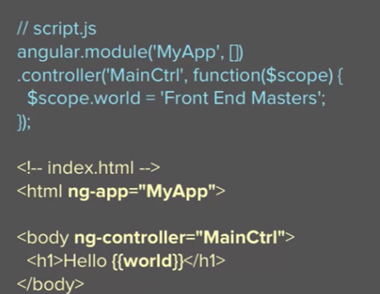
https://github.com/onehungrymind/angular-testing-quick-start

Follow the Bread-crumbs
- In html:
  - ng-app=”nameOfMyApp” – define the name of the app
  - The HTML is your view with direct access to your Angular
- in JS:
  - angular.module(‘nameOfMyApp’..).controller(‘myController’…){}
- defines and connect the controller to the app
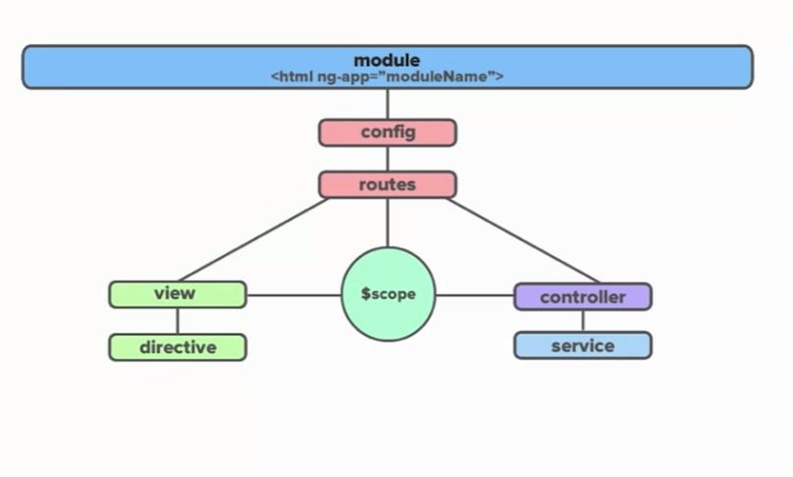
- Module – define the app at a top level
- Config – all the global configuration required by your app before it’s fully loaded. Note: anything that can be accessed only after the app is up and running, can be put in a shared-service.
- Routes – The URLs and their mapping to controller and view.
  - Used for deep linking URLs to Controllers and Views
  - Define routes using $routeProvider
  - Typically used in conjunction with ngView directive and $routeParams service
- @Scope is the js objects with some hooks that allow the view and controller to update (from) it. It provides commands for view to act upon and context
- Controller: behavioural (js)
  - Should not know anything about the view they control
  - Be small and focused
  - Should not talk to other controllers. If you need to share information between controllers, use services.
  - Should NOT own the domain model.
- View: Declerative (html+AngularJS syntax)
  - AngularJS compiled DOM
  - The product of $compile merging the html template with the $scope (dynamic data)
  - DOM is no longer the single source of truth.
- Directives and Services – extend the view and controller respectively
- Services
  - Services carry out common tasks specific to the web application
  - They are consumed via the AngularJS Dependency Injection subsystem
  - They are application singletons
  - They are instantiated lazily (only when needed)
- Routing: allow us to directly navigate to a specific state/functionality within our application. There are different routing libraries we can use:
  - ngRoute is fine for simple routing but ui-router is exponentially more powerful.
  - ui-router actually turns your application into a state machine. It’s much more powerful than ngRoute but takes around the same effort to set up.
- File Structure:
  - Organize your application by feature
  - Your file structure should tell a story. It should clearly convey intention.
  - You need to decide on a structure and stick with it. Consistency over being ‘right’.
  - $digest – processes all of the watchers of the current scope and call the callback functions if something changed.
  - $apply() – used to notify that something has happened outside of the AngularJS domain. Use this whenever you update a value that’s consumed by angularJS so that you’ll be able to recognize and deal with any errors.
$apply forces a $digest cycle.

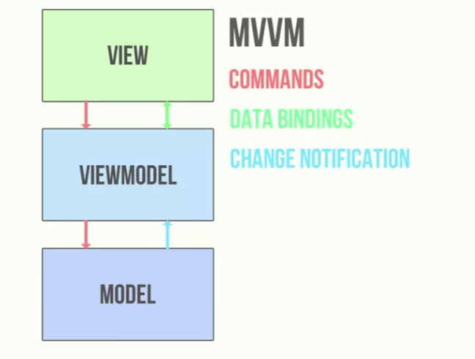
- View – html
- ViewModel – Angular’s scope and controllers
- Model – Angular models – services.

- ng-repeat – cycle in html over a list of objects to display them.

Directive
AngularJS way to extend the HTML with special tags.
AngularJS build-in directives start with ‘ng-’ and include:
- ng-app: initialized an AngularJS app and tells AngularJS that the <div> element is the ‘owner’ of the AngularJS application. For example:
<div ng-app="" ng-init="firstName='John'">
…
</div>
- ng-init: initialized AngularJS’s application data
- ng-model: binds the value of HTML contols (input, select, textarea etc) to application data. For example:
<p>Name: <input type="text" ng-model="firstName"></p>
  - Can also provide type validation, status, css classes etc.
- ng-repeat: html loop: it clones html elements, once for each item in the collection. For example:
<ul>
<li ng-repeat="x in names">
{{ x.name + ', ' + x.country }}
</li>
</ul>

User-Defined Directives
https://www.w3schools.com/angular/angular_directives.asp
To declare your own directive, use
.directive() function to declare it:
app.directive(‘directive-name’,functionToCall);
Note: when declaring directive, you must use camelCaseName but when using it in the html, you must use lower case with ‘-‘ between words:

<body ng-app="myApp">
<w3-test-directive></w3-test-directive>
<script>
var app = angular.module("myApp", []);
app.directive("w3TestDirective", function() {
return {
template : "<h1>Made by a directive!</h1>"
};
});
</script>
</body>
You can invoke a directive in html by using any of the following (will all return the same thing):
- Element name: <w3-test-directive></w3-test-directive>
- Attribute: <div w3-test-directive></div>
- Class: <div class=”w3-test-directive”></div>
- Comment: <!-- directive: w3-test-directive -->

Install
To install Angular CLI: on command-line:
> npm -g install @angular/cli

Command Line Tool - ng
- Check version:
> ng –-version
- Build:
This build is actually a WebPack installation – looking at which files are required and packaging them using WebPack
> ng build
The main resulting files are:
  - main.js – that’s where all our code will be
  - polyfills.js – contains support for older browser
  - runtime.js – some runtime-related code
  - styles.js –
  - vendor.js – the angular code.
- Build and Watch:
Building the whole angular app for every change takes a very long time. This can be reduced by sending:
> ng build –-watch
That will monitor the files for changes after the initial build and will automatically re-build when needed so that builds are quick and automatic.

- Serve the Angular app using the index.html that contained in it:
> ng serve

Create New Project
> ng new <name or project and dir> --skip-git
Additional options:
--dryRun : will only show the commands without doing anything
--inline-template :
--inline-style :
--skip-tests : doesn’t

Project structure
- Src\app – contains our .ts source files.
- Src\app\app.components.ts – contain the main entry point for the Angular ng serve
AppComponent is a TS class that uses the @Component decorator to specify some properties including:
  - selector – the tag in the src/index.html that the ‘template’ property below will replace.
  - template – the html code that will replace the contents of the ‘selector’ tag in the index.html:
template: `
<h1>
Welcome to {{title}}!
</h1>
`
or
  - templateUrl: “<relative path to .html file>”
template: "./app.component.html"
this partial html file will be ‘injected’ into the component’s tag in the final served html.

Angular HTML Syntax

{{}} – Interpolation (data->view)
Allow adding JS code into the markup.
Note: the code inside the {{}} in component.html has direct access to the component.ts class that it’s mapped to (through the @Componenet. templateUrl property) and can access its members directly without needing ‘this’ or ‘model’.

[] – Property Binding (data->view)
In the property binding, a template expression appears in quotes to the right of the = symbol as in [property]="expression".
For example:
<p class=”{{className}}”></p> using the interpolation operator is identical to:
<p [class]=”className”></p>

() – Event Handlers (data<-view)
A template statement responds to an event raised by a binding target such as an element, component, or directive: (event)="statement".
As with expressions, avoid writing complex template statements. A method call or simple property assignment should be the norm.

<button (click)="onSave($event)">Save</button>
<button *ngFor="let hero of heroes" (click)="deleteHero(hero)">{{hero.name}}</button>
<form #heroForm (ngSubmit)="onSubmit(heroForm)"> ... </form>

[()] – Two Way Data Binding
In order to bind data in forms to the TS code, we need:
- Add the FormsModule to your app.module.ts:
import {FormsModule } from '@angular/forms';
…
imports: [
…
FormsModule,
…
- To bind data in the form:
[(ngModel)]=”name of the class member” to bind to. For Example:
<input type="text" class="form-control" name="username"
[(ngModel)]="credentials.username"/>
- In order to monitor the state of a data field, we can ask Angular to create an Angular object for it so that we can check its status. For example:
<input type="text" class="form-control" name="username"
[(ngModel)]="credentials.username"
#username="ngModel" required/>
// create an Angular object named ‘username’ and bind it
// to the ngModel which was previously bind to
// credentials.username through the [(ngModel)] call.
<div class="text-danger"
// check the status of the Angular object ‘username’:
*ngIf="username.invalid && username.errors.required">
Username is required!
</div>
- In order to bind the whole form to an angular object – you can add #<objectName>=”ngForm” in the <form> tag and then you can query the form’s state. For example:
<form (submit)="onLogin()" #theForm="ngForm">
…
<input type="submit" class="btn btn-success" value="Login"
[disabled]="theForm.invalid"/>
</div>
Note: [disabled] will disable the button as long as theForm is invalid.

Form Validation
Apart for the regular html validation attributes (e.g. required), Angular support additional ones:
- min/max-length
If we want the browser to not preform the validation and let us handle the validation ourselves (through Angular), we can add novalidate to the form’s tag:
<form (submit)="onLogin()" novalidate>

*ngFor
To iterate over a collection of items:
<li *ngFor="let p of products">{{ p.title }}</li>
This item (and everything in it) will be added for every item in the collection. IN this case, for every p in products.

*ngIf
To display the markup if the condition is met:
<p *ngIf="heroes.length > 3">There are many heroes!</p>

Pipes
Can be used to format the displayed values. For example:
- Built in pipes:
<p>The hero's birthday is {{ birthday | date }}</p>
See https://angular.io/api?type=pipe for all built-in types.
- Define pipe’s template:
<p>The hero's birthday is {{ birthday | date:"MM/dd/yy" }} </p>
- Chained pipes:
The chained hero's birthday is {{ birthday | date | uppercase}}
- Custom pipes: you can write your own custom pipes:

Angular Components
Allow injecting markup and data into html files.

Add Components
- Add the new component under ClientApp/app/<action>/<name>.component.ts
import { Component } from "@angular/core"

@Component({
selector: "product-list",
templateUrl: "./productList.component.html",
styleUrls: []
})
export class ProductList {
…
}
- Add the new component’s class to the app.modules.ts file under @NgModule - declarations:
…

import { AppComponent } from './app.component';
import { ProductList } from './shop/productList.component';

@NgModule({
declarations: [
AppComponent,
ProductList
],
- Now you can use this new component in any html/cshtml file:
…
<product-list></product-list>

Add Service
You might need to share data or services between different components. In order to add a service:
- Add a new injectable class under ClientApp/app/shared:
import { Injectable } from '@angular/core';
@Injectable()
export class DataService {
…
}
Making our service class Injectible tells Angular that it might have dependencies (in it’s constructor) that needs to be injected whenever this class is injected to another object. Note: making this class injectable when it doesn’t have any dependencies is not required but it’s a good idea in order to avoid problems in the future if/when we add dependencies to it.
- Add this new class to app.module.ts under providers.
- Every other Angular class that needs this service, should receive it through their constructor:
export class ProductList {
constructor(private data: DataService) {
this.products = data.products;
}
public products = [];
}

HttpClient Service
If your service need to send http requests to the server:
- Import HttpClientModule into app.module.ts and add it under imports.
- Inject it to your injectable service:
export class DataService {
constructor(private http: HttpClient) { }
…
}

Get data from server:
return this.http.get("/api/prodcuts")
// http.get returns an observable that clients can subscribe to
// in order to be notified on changes
// pipe – allow running a number of functions in order for
// every change in the data:
.pipe(
// rxjs.map will run map on the observable
// collection and will return an observable
// collection:
map((data: any[]) => { this.products = data; return true;
})
);

Post
http.post(“api path”,
[json object to send in body],
[command configurations e.g. headers parameters] );
for example:

public checkout() {
return this.http.post("/api/orders",
this.order, {
headers: new HttpHeaders()
.set("Authorization", `Bearer ${this.token}`)
})
.pipe(
map((response : any) => {
this.order = new Order();
return true;
})
);
}

Routing
- In app.module.ts:

import { RouterModule } from '@angular/router';
// define the routes of the application.
// path: “” – is the root path.
// each component is an Angular Class that will load for this
// path. Note: don’t include the initial /.
let routes = [
{ path: "", component: Shop },
{ path: "checkout", component: Checkout }
];
@NgModule({
…
imports: [
BrowserModule,
HttpClientModule,
// Initialize and connect the RouterManager to the app:
RouterModule.forRoot(routes, {
// the routes will be in the form:
// http://<...application-root-path>#/
useHash: true,
// set true for debugging of the routes:
enableTracing: false
})
…
- In app.component.html:
<router-outlet></router-outlet>
This will cause the framework to load any component that the routerModule find according to its routes as we defined in RouterModule.forRoot.

Html Links
In order to use the RouterModule in html:
- routerLink="<path as appears in routes>" will create the correct href for the path. for example:
<a routerLink="checkout">Checkout</a>

Routing in Code

import { Router } from '@angular/router';
…
export class Cart {
constructor(private data: DataService,
private router: Router) { }

onCheckout() {
if (this.data.loginRequired) {
this.router.navigate(["login"]);
} else {
this.router.navigate(["checkout"]);
}
}
}
Router.navigate([]) – takes the path as it appears in the routes array in the app.module.ts.

Login
- In our backend connected service (e.g. DataService) – add the parameters required to keep track of the user’s authentication state:
private token: string = "";
private tokenExpiration: Date;
and add methods for:
- Checking if login is required:
public get loginRequired(): boolean {
return (this.token.length == 0 ||
this.tokenExpiration < new Date());
}
- Create a login page (form) that gets the username and password from the user and call a onLogic() method that calls the DataServer.login(credentials) method:
onLogin() {
this.data.login(this.credentials) .subscribe(success => {
if (success) {
this.router.navigate(["success"]); } else {
this.router.navigate(["checkout"]);
}}, err => this.errorMessage = "Failed to login");
}

login(credentials : any): Observable<boolean> {
return this.http
.post("/account/createToken", credentials)
.pipe(
map((data: any) => {
this.token = data.token;
this.tokenExpiration = data.tokenExpiration;
return true;
}));
}
- Call privileged actions that requires authentication:
Include the ‘Authorization’ token with the request packet’s header. For example:
return this.http.post("/api/orders",
this.order, {
headers: new HttpHeaders()
.set("Authorization", `Bearer ${this.token}`) })…

Lifecycle Methods

OnInit
In order to call a function automatically on component initialization:
import { Component, OnInit } from "@angular/core"
…
export class ProductList implements OnInit {
…
ngOnInit(): void {
…
}
}
ngOnInit will be called automatically by the Angular FW when the component is initialized.

