ACCOUNTING AND FINANCE -ACF768 ( 64787 )
CORE ANALYSIS COCA-COLA LIMITED
STUDENT NAME: SARAH EBABHIOSE ABHULIMHEN
STUDENT ID: 20048570
WORD COUNT (EXCLUDING APPENDICES)- 2227

EXECUTIVE SUMMARY
This report presents a trend analysis of the Coca-Cola Company's income statement and balance sheet for the years 2020 through 2023. The purpose is to evaluate the company’s financial performance using historical data and contextual explanations informed by internal company disclosures and external market conditions.
This report evaluates the Coca-Cola Company (2020–2023) to assess its suitability as an investment. The objective was to analyse Coca-Cola’s strategic and financial performance using a trend analysis of the income statement and balance sheet. We used the CORE framework (Context, Overview, Ratios, Evaluation) to interpret internal and external factors, alongside financial ratio analysis for profitability, efficiency, liquidity and solvency.
INTRODUCTION
Coca-Cola is a globally recognized billion dollar company, it is seen as the leader of non-alcoholic beverage industry. It was founded on May 8th, 1886 by Dr. John Stith Pemberton and headquartered in Atlanta, Georgia. The company has grown to become one of the most valuable and iconic brands in the world, with operations in over 200 countries and a diverse portfolio of more than 500 brands.
This report analyses the financial performance of Coca-Cola to see if it will be a suitable investment choice for software solutions. The evaluation is grounded in a comprehensive analysis of strategic and financial performance, it covers the years 2021 to 2024. This report will be conducted by using Context, Overview, Ratios and Evaluation (CORE) framework(Moon and Bates, 1993) to analysis the internal and external environment of Coca-Cola using data found in the companies annual report.

CONTEXT(EXTERNAL)
POTER’S 5 FORCES
Porter’s Five Forces will be used to analyse and examine the external context of the company. (Michael E. Porter, 1979) . It identifies five key elements that determine the intensity of competition and, therefore, the profitability potential of a business environment.
COMPETITIVE RIVARY
The competitive rivalry of Coca-Cola is relatively high. In 2022, Coca-Cola had a market share of roughly 46% (Beverage Digest, 2023), making it the most sort after beverage company in the world. The most notable rivalry for Coca cola is Pepsi, offering very similar products to Coca-Cola. Both Coca cola and Pepsi invest heavily in innovation, advertisements and promotional campaigns (The Coca-Cola Annual Report, 2024, p. 11). Internationally Coca-Cola only have a few competitors that can match them, but in some cases in other countries, competition is notable. For example, in Asian countries, Latin America and Africa, emerging brands disrupt Coca-Cola’s market dominance (The Coca-Cola Annual Report, 2024, p. 11). Generally, it is more reasonable to compete with Coca cola on a small-scale, but it is also quite difficult, and with statistics showing that soda consumption is declining in previous years, as people are opting for healthier options, it intensifies the fight for market share (The Coca-Cola Annual Report, 2024, p. 20).
BARGAINING POWER OF SUPPLIERS
The bargaining power of suppliers is low to moderate. Coca-Cola, being a huge brand, has over the years gathered multiple suppliers, sourcing options, reducing dependency on one supplier. They also have long-term contracts with these companies, and Coca cola being a large company, has the power to negotiate bulk purchases (The Coca-Cola Annual Report, 2024, p. 18). They have also invested in bottling plants, reducing suppliers' influence (The Coca-Cola Company, 2025). Occasionally, global economic fluctuations can increase suppliers' power (The Coca-Cola Annual Report, 2024, p. 18).
BARGARNING POWER OF BUYERS
The bargaining power of buyers is low to moderate. Buyers of the brand include individual consumers, retailers and franchises. Coca-Cola has a huge consumer base and global recognition, which makes it a highly sort after brand (Beverage Digest, 2023; The Coca-Cola Company, 2025 ). And as a result, has strong brand loyalty. This drives consumers to purchase it despite available alternatives and low switching costs, making consumer power low. On the other hand, retailers and franchises such as supermarkets, Mac Donald’s, cinemas and so on have some bargaining power because they buy in large quantity and can demand discounts or better terms (The Coca-Cola Annual Report, 2024, p. 17 - 20).
THREAT OF NEW ENTRANTS
The threat of new entry for Coca cola is moderate. It is the leading beverage brand having a global customer base and worldwide recognition and distribution, and a very prominent brand presence (Beverage Digest, 2023; The Coca-Cola Company, 2025 ). Coca-Cola has built a large brand recognition and strong customer loyalty with a brand value of over $106.45 billion in 2024 (Statista, 2024), making it difficult for new entrants to gain consumer trust and establish a comparable consumer base. Moreover, Coca cola has a massive distribution network reaching over 200 countries (The Coca-Cola Company, 2025), having contracts with restaurants, retailers and vending machines, creating a strong distribution channel. These are factors that make the barrier of entry high. Furthermore, consumers have low switching costs, making it easier to switch to other beverages. Additionally, the rise of health niches and smaller brands specializing in organic, gluten free, sugar free drinks have disrupted the market (Rigik, 2014, p. 22). Factors such as these lower the barrier of entry.
THREAT OF SUBUBSTITUTE PRODUCTS
Threat of substitution is high. In today’s world there are a countless number of beverages circulating the market, which makes for easy substitution. Factors like health concerns and low switching costs can affect consumer preference (The Coca-Cola Annual Report, 2024, p. 20). People are pulling back on sugary drinks because of obesity and diabetes risks also, with brands like Monster, Red Bull and Gatorade attracting the younger consumers (The Coca-Cola Annual Report, 2024, p. 20). Also, in places like Nigeria where fake Coca cola products have become an issue, people prefer to substitute for other products rather than exposing themselves to the risk of buying a counterfeit with ingredients that might be detrimental to their health (The Coca-Cola Annual Report, 2024, p. 21).

CONTEXT(INTERNAL)
Coca-Cola’s business model has evolved from a single‐product soft drink to a “total beverage company” spanning over 500 brands, yet its core activities still revolve around three pillars: concentrate production, brand marketing, and a franchised bottling system. Strategically, Coca-Cola pursues portfolio diversification, optimization, and sustainability leadership to drive growth amid shifting consumer preferences and regulatory pressures. In recent years, it has executed major changes including streamlining its brand portfolio, acquiring then scaling health and wellness brands, and setting aggressive environmental targets to future-proof its global beverage empire.
SWOT ANALYSIS
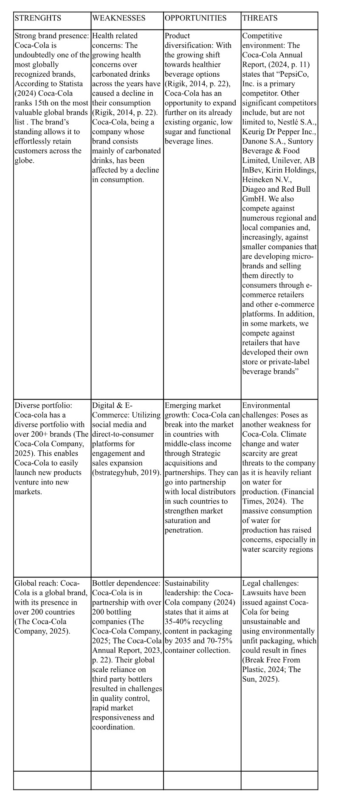

OVERVIEW
Income statement
 | 2020 | 2021 | % change | 2022 | % change | 2023 | % change
Revenue | 33014 | 38655 | 17.09% | 43004 | 11.25% | 45754 | 6.39%
Operating profit | 8997 | 10308 | 14.57% | 10909 | 5.83% | 11311 | 3.69%
Financial costs | 1437 | 1597 | 11.13% | 882 | -44.77% | 1527 | 73.13%
net profit | 9804 | 7768 | -20.77% | 9571 | 23.21% | 10703 | 11.83%
Cost of sales | 13433 | 15357 | 14.32% | 18000 | 17.21% | 18520 | 2.89%

Balance sheet
 | 2020 | 2021 | % change | 2022 | % change | 2023 | % change
Current assets | 19240 | 22545 | 17.18% | 22591 | 0.20% | 26732 | 18.33%
Non-current assets | 68054 | 71809 | 5.52% | 70172 | -2.28% | 70971 | 1.14%
current liabilities | 14601 | 19950 | 36.63% | 19724 | -1.13% | 23571 | 19.50%
non current liabilities | 51411 | 49544 | -3.63% | 47213 | -4.70% | 46649 | -1.19%
equity | 21284 | 24860 | 16.80% | 25826 | 3.89% | 27480 | 6.40%

REVENUE GROWTH
Coca-Cola’s revenue grew significantly from $33.01 billion in 2020 to $45.75 in 2023, reflecting an increase of nearly 39% over the four year period. The biggest increase happened between 2020 and 2021, with 17.09% increase. This was due to the company’s recovery from the pandemic, which previously decreased sales as a result of businesses closing during lockdown (The Coca-Cola Company, 2022, p. 60; 2024, p. 61). the growth was also motivated by new product launch and expansion into global markets. However, from 2022 to 2023, growth slowed down to 6.4%, this was the effect of global inflation and changing consumer habits (The Coca-Cola Company, 2023).
PROFITABILITY
Operating profit rose steadily from $8.99 billion in 2020 to $11.31 billion in 2023, a 26% rise, driven by higher gross margins (from $19,581 billion to $27,234 billion) and disciplined SG&A control despite rising input costs (The Coca-Cola Company, 2022, pp. 59–60; 2024, p. 61), Though the growth rate slowed down after 2021. Net profit however, dropped by -20.77% in 2021 due to post pandemic supply chain challenges and higher financial costs but quickly rebounded in 2022 and 2023 (The Coca-Cola Company, 2022, p. 60; 2024, p. 61).

ASSETS
Coca-Cola’s current assets increase from $19.24 billion in 2020 to $26.73 billion in 2023, indicating a growth of 18.33%. the growth was primarily driven by higher receivables and increased cash reserves (The Coca-Cola Company, 2024). non-current assets remained stable, fluctuating between $70 billion and $72 billion over the same period. It’s stability suggests Coca-Cola followed a steady investment approach during this period. The asset growth aligns with Coca-Cola’s modernization of supply chain, sustained investment in digital technologies and reflecting strategic initiative targeted at improving efficiency and innovation (Coca-Cola Company, 2024).
LIABILITIES
Current liabilities increased drastically from $14.60 billion in 2020 to $23.57 billion in 2023, in line with higher payable and short term borrowing. Non-current liabilities has declined over the four year period, from $51 billion in 2020 to $46.65 billion in 2023, showing a deliberate effort to reduce long-term debt exposure (The Coca-Cola Company, 2022, p. 63; 2024, p. 63).

EQUITY
Shareholder’s equity increased from $21.28 billion in 2020 to $27.48 billion in 2023. this shows a rise of roughly $6.2 billion over the period, Indicating that the company’s net worth has grown. The fundamental reason for this increase is strong retained earnings (The Coca-Cola Company, 2022, p. 64; 2024, p. 63).

ACCOUNTING POLICIES CHANGES
Coca-Cola did not adopt any major change in it’s accounting policies between 2020 to 2023. the company maintained it’s compliance to U.S GAAP, there was no indication of restatement or changes in accounting methods(The Coca-Cola Company, 2024).

RATIOS
Summary of ratios | 2020 | 2021 | 2022 | 2023
profitability
ROCE | 12.38% | 13.85% | 14.94% | 15.26%
Operating profit margin | 27.25% | 26.67% | 25.37% | 24.72%
return on assets | 11.23% | 8.23% | 10.32% | 10.95%
Efficiency
Inventory Turnover days | 89 | 81 | 86 | 87
receivable Turnover days | 35 | 33 | 30 | 27
liquidity
Current ratio | 1.32 | 1.13 | 1.15 | 1.13
Quick ratio | 1.09 | 0.96 | 0.93 | 0.95
Gearing Ratio
interest cover | 6.26 | 6.45 | 12.37 | 7.41
gering ratio | 71% | 67% | 65% | 63%
Investment potential ratio
earning per share | 1.39 | 1.10 | 1.36 | 1.52

EVALUATION
PROFITABILITY RATIO
The trajectory of the profitability ratios were mixed through the four years. Between 2020 and 2023 Coca-Cola became more efficient at generating profits from money invested in the business. Its ROCE increased steadily from 12.4% to 15.3%, showing strong performance. However, ROA fell in 2021 due to pandemic impact from closed business but recovered to 10.95% by 2023 (Coca-Cola, 2022, p. 60). Furthermore, operating profit margin shrank slightly each year, from 27.3% to 24.7% because of the rising costs of production and reinvestment in marketing to drive growth in key markets (Coca-Cola, 2024, p. 61). In comparison, Pepsi-Co's 2023 has an operating margin of 21.8% which falls below Coca-Cola’s 24.7%, illustrating Coke’s stronger cost leverage in its concentrate model.

EFFICIENCY RATIO
Coca-Cola’s Inventory turnover days is mixed. The company became more efficient in taking their money from customers between 2020 and 2023. Receivables days improved steadily from 35 days in 2020 to just 27 days in 2023. however, inventory days fell to 81 days in 2021, then rose to 87 days in 2023. the 2021 fall was a result of fewer retail sales during the pandemic and tighter supply planning(Coca-Cola, 2022, pp. 62–63). Restaurants and cinemas fully reopened after the pandemic which resulted in the gradual increase of inventory days from 2022 - 2023 (Coca-Cola, 2024, p. 63). By 2023, Coca-Cola’s 27 receivable days compared favorably to Pepsi-Co’s 36 days, underlining Coke’s disciplined cash collection.

LIQUIDITIY RATIO
Current ratio dropped from 1.32 in 2020 to a trough of 1.13 in 2021, then stayed at 1.14 through 2023. Quick ratio moved from 1.09 to 0.95 over the period. Since both ratios are sill above 1.0, it shows that Coca-Cola can cover its short trem payable but the drop shows it has fewer extra assets like cash or cash equivalents in comparison to what it owes in the short term. Between 2021 to 2022, Coca-Cola’s liquidity ratio went down partly because it had more short term debt to pay and made a decision to buy back its own shares from investors (Coca-Cola, 2024, p. 64). In comparison Industry peers typically target a current ratio around 1.0 - 1.2; Coca-Cola’s stable 1.13 remains in line with sector norms.

GEARING RATIO
Coca-Cola’s gearing ratio fell from 71% to 63% from 2020 to 2023, which indicates the company relied less on debt over time. Its interest cover ratio spiked to 12.4x in 2022 before moderating to 7.4x in 2023, suggesting that the company kept its finances relatively safe and stable, earning enough to cover interest payments and using less debts. Gearing reduction was a results from the company paying off debts faster than it borrowed new ones, also keeping its profits instead of paying them off (Coca-Cola, 2024, p. 63). Robust profits in 2022 lead to a spike in investment cover, while the drop in 2023 was a result of Coca-Cola taking on more debt to fund strategic deals such as purchasing BodyArmor. By 2023, Pepsi-Co’s gearing was 58% with interest cover 9x, placing Coca-Cola broadly in line with its largest competitor.

INVESTMENT RATIO
The trajectory of investment were mixed within the four years period, it fell from $1.39 in 2020 to $1.10 in 2021, then rose to $1.52 in 2023. this mixed trend shows that Coca-Cola’s profits can be affected by rising costs and big changes in the economy, like the Covid-19 pandemic. 2021 EPS slump is a result of a fall in sales volume during the pandemic and restructuring costs (Coca-Cola, 2022, p. 60). The rebound in 2022 - 2023 motivated by raising product prices, sales of more profitable products and slightly reduced number of shares through buybacks (Coca-Cola, 2024, p. 61). Coca-Cola’s EPS CAGR of 4.4% over 2020–23 slightly outpaced Pepsi-Co’s 3.8%, underscoring Coke’s stronger margin leverage in concentrate operations.

CONCLUSION AND RECOMMENDATION
Based on the CORE analysis, Software Solutions plc should consider investing in Coca-Cola as a minority shareholder. Coca-Cola has a strong and stable financial performance. It consists of a coherent revenue growth, solid profitability and a leading maker position. Its ratios show efficient use of capital and healthy core earnings. Although, the company carries moderate debt, it’s interest cover remains high and it has sufficient liquidity. All these factors indicates it is a reasonably sound candidate for investment.

APPENDICES
 |  |  | 2020 | 2021 | 2022 | 2023
Profitability
Return on Capital Employed | Operating Profit (PBIT) x 100  Total Asset - current liabilities | Operating profit (Earnings from Operations) | 8,997 | 10,308 | 10,909 | 11,311
 |  | Total Assets | 87,294 | 94,354 | 92,763 | 97,703
 |  | Current liabilities | 14,601 | 19,950 | 19,724 | 23,571
 |  |  | 12.38% | 13.85% | 14.94% | 15.26%
Operating profit margin | Operating Profit x 100  Total Revenue | Operating profit (Earnings from Operations) | 8,997 | 10,308 | 10,909 | 11,311
 |  | Total Revenue | 33,014 | 38,655 | 43,004 | 45,754
 |  |  | 27.3% | 26.7% | 25.4% | 24.7%
Return on Assets | Net profit (profit for the year) x 100  Total Assets | Net profit/loss | 9,804 | 7,768 | 9,571 | 10,703
 |  | Total Assets | 87,294 | 94,354 | 92,763 | 97,703
 |  |  | 11.23% | 8.23% | 10.32% | 10.95%
Liquidity Ratio
Current Ratio  (expressed as a ratio X:Y) | Current Asset  Current Liabilities | Current Asset | 19,240 | 22,545 | 22,591 | 26,732
 |  | Current Liabilities | 14,601 | 19,950 | 19,724 | 23,571
 |  |  | 1.32 | 1.13 | 1.15 | 1.13
Quick Ratio  (expressed as a ratio X:Y) | (Current Asset - inventories)  Current Liabilities | Current Asset | 19,240 | 22,545 | 22,591 | 26,732
 |  | Inventories | 3,266 | 3,414 | 4,233 | 4,424
 |  | Current Liabilities | 14,601 | 19,950 | 19,724 | 23,571
 |  |  | 1.09 | 0.96 | 0.93 | 0.95
Efficiency Ratios
Inventory Turnover Days | Inventory x 365 days  Cost of sales | inventory | 3,266 | 3,414 | 4,233 | 4,424
 |  | Cost of sales | 13,433 | 15,357 | 18,000 | 18,520
 |  |  | 365 | 365 | 365 | 365
 |  |  | 89 | 81 | 86 | 87
Receivables turnover days | Receivables x 365 days  Total Revenue | Average receivables | 3144 | 3512 | 3487 | 3410
 |  | Total Revenue | 33,014 | 38,655 | 43,004 | 45,754
 |  |  | 365 | 366 | 367 | 368
 |  |  | 35 | 33 | 30 | 27
Gearing Ratios
Interest Coverage (Number of times) | Operating Profit  Interest on Loan (Finance costs) | Operating profit | 8,997 | 10,308 | 10,909 | 11,311
 |  | Interest on loan | 1,437 | 1,597 | 882 | 1,527
 |  |  | 6.26 | 6.45 | 12.37 | 7.41
Gearing Ratio (%) | Non-current liabilities x 100%  Non-current liabilities + total equity | Non-current liabilities | 51,411 | 49,544 | 47,213 | 46,649
 |  | Total equity | 21,284 | 24,860 | 25,826 | 27,480
 |  |  | 71% | 67% | 65% | 63%
Investment Ratio
Earnings per Share | Net income (Profit for the Year) | Net income | 9,804 | 7,768 | 9,571 | 10,703
 | Number of ordinary shares | Number of ordinary shares | 7,040 | 7,040 | 7,040 | 7,040
 |  |  | 1.39 | 1.10 | 1.36 | 1.52

FIG1.1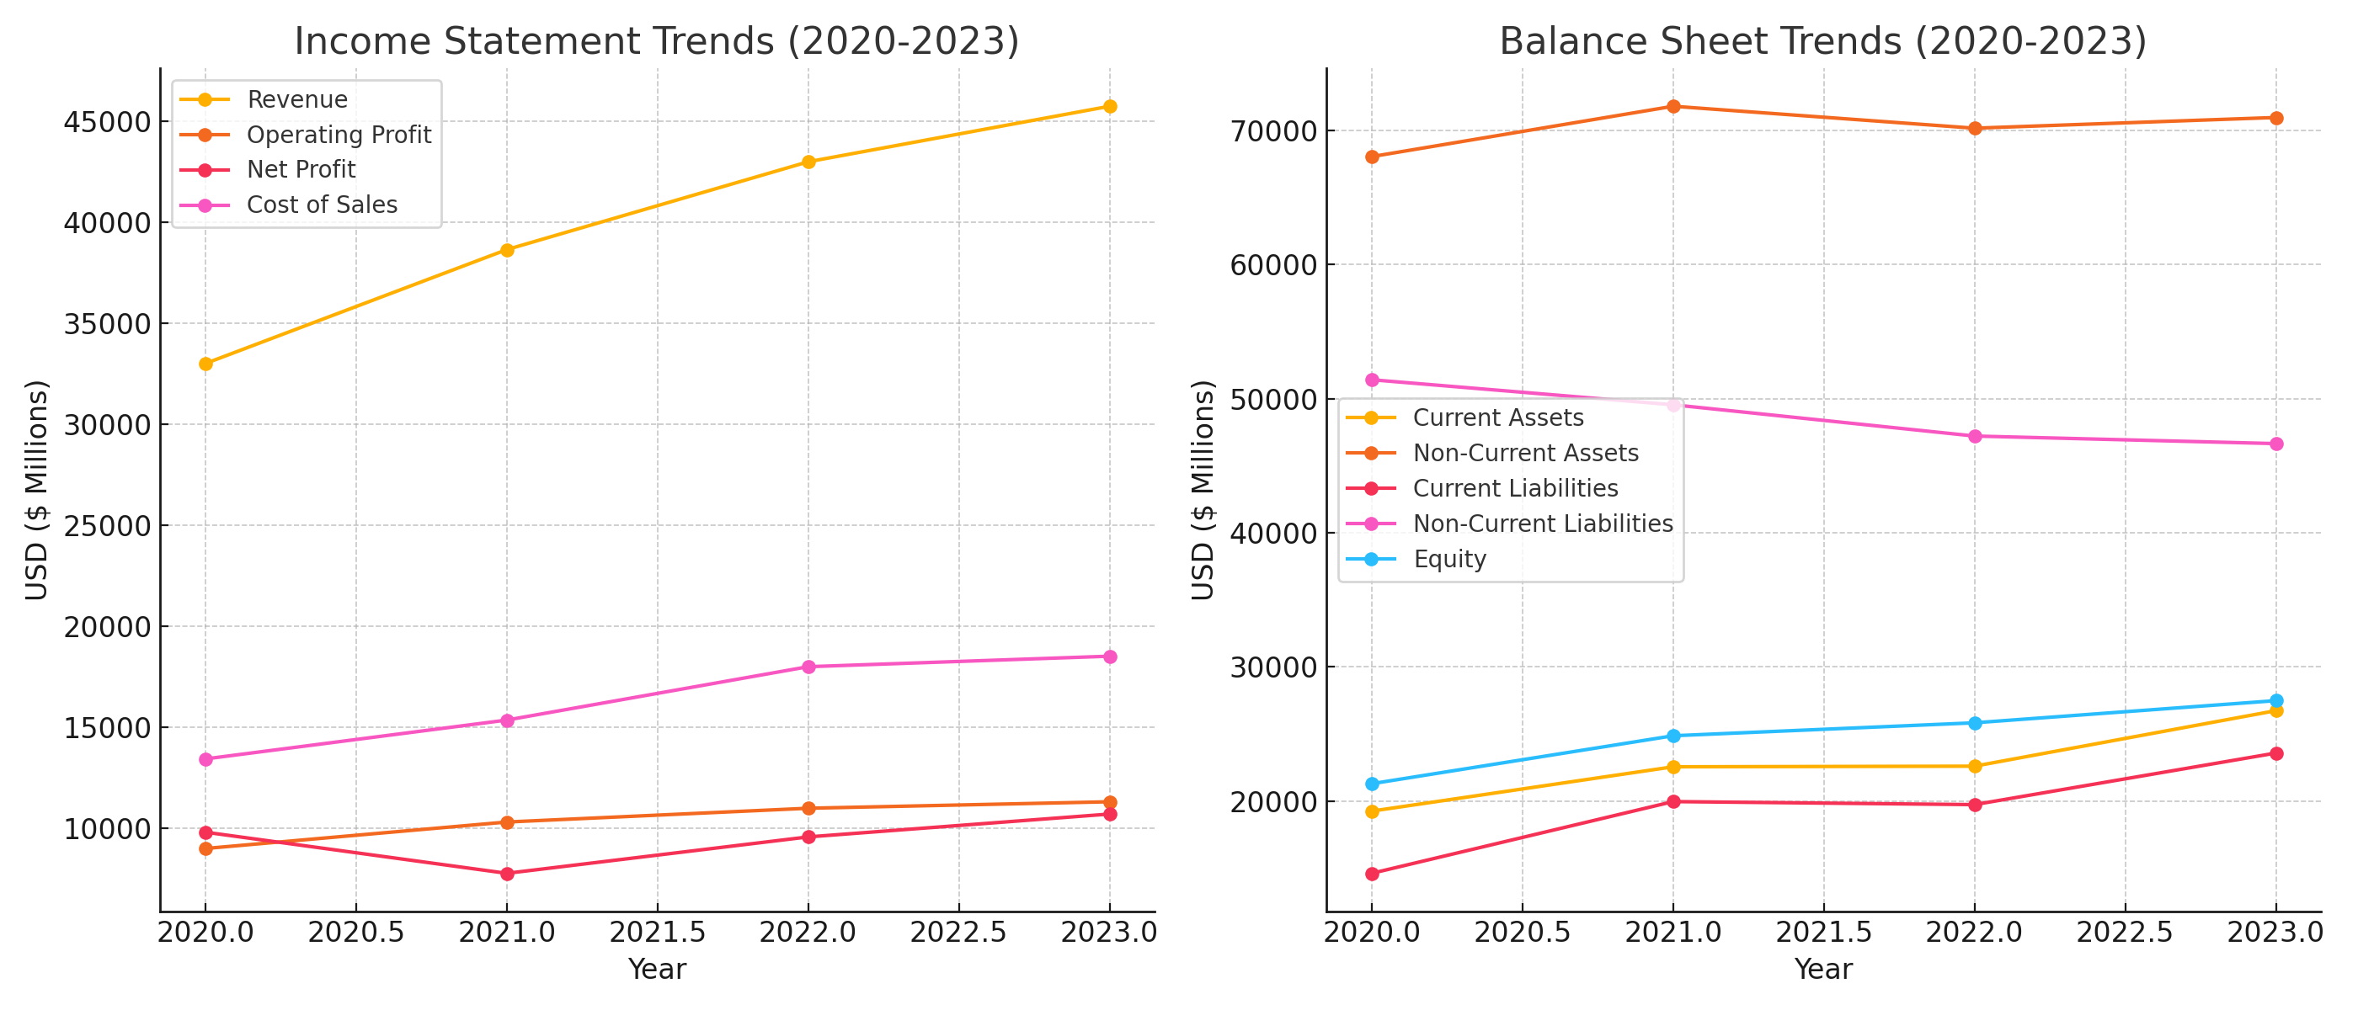

DEFINITION OF TERMS
PROFITABILITY RATIOS: These ratios assess a business's ability to make money in relation to its assets, sales, or capital used. They demonstrate how well a business uses its resources to produce financial returns and how efficient it is at converting profits into revenue.
EFFICIENCY RATIOS: These ratios evaluate how well a business manages its assets and activities. The effectiveness and speed at which resources are converted into cash or income are the main topics of these ratios.
LIQUIDITY RATIOS: Liquidity ratios evaluate a company's ability to settle its short-term debts on time by using its current or near-cash assets. These are quite important for assessing one's present financial status.
INVESTMENT RATIOS: Also known as investor ratios, these metrics provide information on a company's market value and returns from the perspective of its shareholders. These ratios can be used to assess financial success in relation to share value and dividend policy.
GEARING RATIOS: Gearing ratios examine the relationship between debt and equity in a company's capital structure. The extent of the company's reliance on external funding and the financial risk associated with borrowing are reflected.

REFERENCES
- Beverage Digest. (2023) Leading carbonated soft drink (CSD) companies in the United States in 2022, based on volume share. Statista. Available at: https://www.statista.com/statistics/225504/leading-carbonated-soft-drink-companies-in-the-us/ (Accessed: 1 April 2025).
- Break Free From Plastic. (2024) ‘2023 Global Brand Audit: The Coca-Cola Company is once again the top global plastic polluter’, Break Free From Plastic, 7 February. Available at: https://www.breakfreefromplastic.org/2024/02/07/bffp-movement-unveils-2023-global-brand-audit-results/ (Accessed: 1 April 2025).
- bstrategyhub.com, 2019. SWOT Analysis of Coca Cola. Available at: https://bstrategyhub.com/swot-analysis-of-coca-cola-2019-coca-cola-swot-analysis/ (Accessed 3 April 2025).
- Financial Times, 2024. Coca-Cola draws fire after watering down environmental targets. Available at: https://www.ft.com/content/75d5fb6d-2bc8-4621-a955-9c70897541cd (Accessed: 1 May 2025).
- Marketing Week. (2024) Coca-Cola's brand value from 2006 to 2024 (in billion U.S. dollars). Statista. Statista Inc. (Accessed: 1 April 2025).
- Porter, M.E. (1979) ‘How Competitive Forces Shape Strategy’, Harvard Business Review, 57(2), pp. 137–145
- Rigik, E. (2014) ‘Tracking Today’s Retail Beverage Trends’, Convenience Store Decisions, 25(11), p. 22. Available at: https://research.ebsco.com/linkprocessor/plink?id=ca6b6264-eda1-3192-ae51-1c87ace80e41 (Accessed: 22 April 2025).
- The Coca-Cola Company. (2025) Brands. Available at: https://www.coca-colacompany.com/brands (Accessed: 19 April 2025).
- The Coca-Cola Company. (2025) History. Available at: https://www.coca-cola.com/gb/en/about-us/history (Accessed: 9 April 2025).
- The Coca-Cola Company. (2025) Iconic ‘Share a Coke’ is Back for a New Generation. Available at: https://www.coca-colacompany.com/media-center/iconic-share-a-coke-is-back-for-a-new-generation (Accessed: 3 May 2025).
- The Coca-Cola Company. (2025) Sustainability. Available at: https://www.coca-colacompany.com/about-us/sustainability (Accessed: 15 April 2025).
- The Coca-Cola Company. (2025) The Coca-Cola System. Available at: https://www.coca-colacompany.com/about-us/coca-cola-system#:~:text=The%20Coca%E2%80%91Cola%20Company%20does,syrups%20to%20authorized%20bottling%20partners (Accessed: 1 May 2025).
- The Sun. (2025) Coca-Cola cans recalled over 'plastic contamination' in 900 cases. Available at: https://www.thesun.co.uk/news/34807801/coca-cola-coke-cans-recall-plastic-contamination/ (Accessed: 9 April 2025).
- The Coca-Cola Company. (2022) Annual Report 2022. Available at: https://stocklight.com/stocks/us/nyse-ko/the-coca-cola/annual-reports/nyse-ko-2022-10K-22657897.pdf (Accessed: 1 May 2025).
- The Coca-Cola Company. (2024) Annual Report 2024. Available at: https://stocklight.com/stocks/us/nyse-ko/the-coca-cola/annual-reports/nyse-ko-2024-10K-24652148.pdf (Accessed: 9 April 2025).
- Statista. (2024) Coca-Cola brand value from 2006 to 2024. Available at: https://www.statista.com/statistics/326065/coca-cola-brand-value/ (Accessed: 28 April 2025).

