Assignment4 Report
Name: 潘郁婷
Institution (school): NTHU
Student ID: 113078506
Platform (Colab/Kaggle/Local): Colab
Python version: Colab
Operating system: Colab
CPU: None
GPU: T4 GPU
Gen AI Usage: Since I’m a beginner in Python, I used Gen AI to assist with better solution of data cleaning and refine my grammar in this report.
Remark: For ease of grading, you are encouraged to present data in textual form rather than as images.
- Please describe the details of your implementation for the RAG system (please tell us 1. What’s in your RAG system? 2. What’s your prompt? 3. What’s new in your code in comparison with the code from our lab course?) in this assignment. (5%)
Answer:
What’s in my RAG system?
It consists of following components: document preprocessing, vector store, retriever, prompt, QA chain and retrieval chain. It first loaded the dataset and converted each entry into a LangChain Document object with metadata. Then embedded These documents using the provided embedding model and stored in a Chroma vector database. For retrieval, I configured a similarity-based retriever with k = 5. The retrieved documents are then passed into a document-aware generation chain (QA chain), with the specified LLM producing the final answer.
What’s my prompt?
system_prompt = """
You are a retrieval-augmented generation (RAG) assistant.
Use ONLY the information from the retrieved context to answer the user’s question.
Guidelines:
1. Always base your answer strictly on the retrieved documents.
2. Do NOT invent facts or hallucinate.
3. If the context does not contain the answer, reply with: "I cannot find the answer in the provided documents."
4. Keep your answer concise and clear.
5. Your final answer must follow this format:
Answer:
<your short answer>
Supporting Evidence:
- <brief evidence from retrieved docs, cite the document ID from metadata (e.g., [doc 3])>
Context: {context}
"""
I designed a system prompt to guide the LLM and prevent hallucination by:
- Explicitly instructs the model to answer only using the retrieved context
- Respond with “The answer is not in the documents.” when the context does not contain the solution.
- Provide evidence and cite the document when answering questions.
- Answer the questions in a specific format.
What’s new in my code compared with the lab code?
My implementation largely follows the architecture demonstrated in the lab session, in comparison with the lab code, the main new element in my implementation is the custom system prompt, which I redesigned to enforce strict grounding in the retrieved context and to avoid hallucination.
- Please provide analysis for the RAG performance using different prompts in generator model. (10%)
Answer:
 | Short Answer + Citation | Short Answer + Paraphrase | Short Answer + Paraphrase + Citation | Short Answer + Paraphrase + Citation + Number Format
Exact Match | 0.587 | 0.487 | 0.653 | 0.587
Recall@1 | 0.587 | 0.487 | 0.653 | 0.587
Recall@5 | 0.7 | 0.71 | 0.713 | 0.713

The results show that prompt design has a measurable impact on RAG performance. The Short Answer + Citation requirement prompt performs reasonably well because citations encourage grounding in retrieved context. Allowing paraphrasing alone reduces Exact Match and Recall@1, as the model is more likely to drift away from the ground-truth wording. Combining paraphrasing with citations yields the best performance (EM = 0.653), suggesting that grounding constraints help counteract lexical variation. Adding number-format rules maintains strong Recall@5 but does not further improve Exact Match, likely due to increased output variability. Overall, prompts that reinforce grounding (e.g., citations) consistently improve RAG accuracy, while paraphrasing must be paired with such constraints to avoid degrading performance.
- Please analyze the RAG performance under different input data formats provided to the retriever. (10%)
Answer:
 | Original | Paraphrase | Expand
Exact Match | 0.64 | 0.607 | 0.587
Recall@1 | 0.64 | 0.607 | 0.587
Recall@5 | 0.713 | 0.68 | 0.707

This experiment is inspired by the work from Ma, Xinbei, et al. (2023), which shows that query reformulation can improve retrieval-augmented LLM performance, I evaluated three strategies: (1) Original Query, (2) Paraphrased Query using a small Gemma model, and (3) Expanded Query, where the query is rewritten into a longer, search-oriented form. Surprisingly, the results differ from the paper’s findings: the Original Query achieves the highest Exact Match and Recall@1 (0.64), while Paraphrased (0.607) and Expanded (0.587) formats perform worse. This might because the cat-facts collection is too small and concise, so even minor paraphrasing may remove the critical key words which needed for accurate vector retrieval. Expanded queries add additional wording that dilutes key answers, harming the retriever’s relevance scoring. Recall@5 remains relatively stable, suggesting that the retriever still accesses similar document sets, but the ranking and top-1 relevance are impacted by the query rewrite. Overall, while query rewriting has shown benefits in large open-domain QA tasks, my results indicate that in constrained factual datasets, preserving the original short query yields the strongest RAG performance.
- Please provide analysis for the RAG performance using different input order of the retrieved documents to the generator model. (10%)
Answer:
 | Original | Reverse | Random
Exact Match | 0.633 | 0.553 | 0.607
Recall@1 | 0.633 | 0.553 | 0.607
Recall@5 | 0.713 | 0.713 | 0.713

Inspired by findings from Cuconasu, Florin, et al.(2024), which showed that (1) relevant information must appear early in the prompt for the LLM to attend to it, and (2) both irrelevant top-scoring documents and randomly positioned distractors can influence generation quality. Therefore, I tested how different input orders of retrieved documents affect my RAG system’s accuracy. Consistent with the paper, placing the most relevant documents first (Original order), this led to the best Exact Match and Recall@1 (0.633). When I reversed the order, performance dropped noticeably to 0.553, supporting the paper’s claim that the model struggles when relevant information appears late in the prompt. Interestingly, the random order produced a mid-range performance (0.607), aligning with the paper’s observation that randomly positioned content does not necessarily harm accuracy as long as essential evidence remains in the prompt. Recall@5 remained constant across conditions because the retrieved document set was unchanged. Overall, the results actually shows that the document ordering matters, and that positioning high-value evidence earlier actually led to better RAG generation outcomes.
- Please analyze the generation performance of the model when counterfactual information is introduced into the input sequence of the generator. (10%)
Answer:
 | front | middle | end
Exact Match | 0.593 | 0.627 | 0.62
Recall@1 | 0.593 | 0.627 | 0.62
Recall@5 | 0.713 | 0.713 | 0.713

To evaluate how counterfactual information affects the generator model, I injected a fabricated but similar structured document containing incorrect cat facts into the retrieved document set. I generated 3 counterfactual data, and tested in three positions: placing the counterfactual at the front, middle, and end of the input sequence. This design was also motivated by findings from Cuconasu, Florin, et al.(2024), which showed that incorrect or irrelevant documents can strongly influence RAG generation quality, especially when positioned early in the prompt.
The results show that when the counterfactual was placed at the front, the model showed the weakest performance (EM = 0.593), suggesting that early-positioned false information captures the model’s attention and misleads it. On the other hand, performance improved when the counterfactual appeared in the middle (EM = 0.627), and the best results occurred when it was placed at the end (EM = 0.620), indicating that later-positioned distractors led to less influence on the generator. Recall@5 remained constant across all conditions because the underlying retrieved documents did not change. Overall, the experiment confirms that the position of misleading information significantly shapes RAG output quality, and that counterfactuals near the front of the prompt are the most damaging.
- Anything that can strengthen your report. (10%)
Answer:
 | Similarity | mmr | similarity_score_threshold(0.5)
Exact Match | 0.587 | 0.58 | 0.58
Recall@1 | 0.587 | 0.58 | 0.58
Recall@5 | 0.7 | 0.7 | 0.693

To strengthen the report, I also compared different retrieval strategies (similarity, mmr, and similarity_score_threshold). Their performance was similar, with EM and Recall@1 around 0.58, and Recall@5 around 0.69–0.70. Notably, using a stricter threshold such as 0.7 caused the retriever to return ‘no documents’ for most queries. This occurs might because the cat-facts corpus is short and compact, making it difficult for any fact to exceed such a high similarity score. This experiment highlights that retrieval configuration matters: overly strict thresholds can remove all evidence and reduce RAG effectiveness, especially in small datasets.

The screenshot of your testing logs and accuracy. (One Figure only)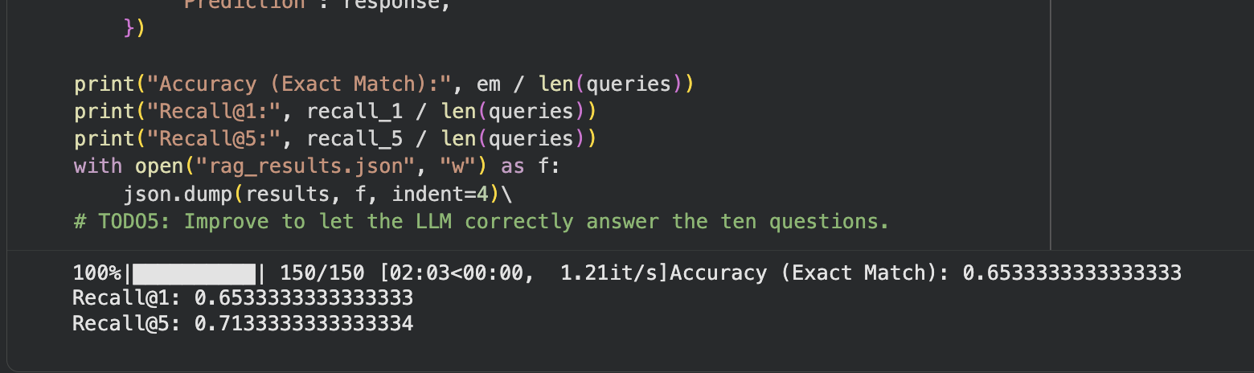

Reference:
Cuconasu, F., Trappolini, G., Siciliano, F., Filice, S., Campagnano, C., Maarek, Y., ... & Silvestri, F. (2024, July). The power of noise: Redefining retrieval for rag systems. In Proceedings of the 47th International ACM SIGIR Conference on Research and Development in Information Retrieval (pp. 719-729).
Ma, X., Gong, Y., He, P., Zhao, H., & Duan, N. (2023, December). Query rewriting in retrieval-augmented large language models. In Proceedings of the 2023 Conference on Empirical Methods in Natural Language Processing (pp. 5303-5315).

