Internship Project

Sarah Philomin V

Chennai

**EXPOSYS DATA LABS**

To create a multi-page responsive website

**EXPOSYS DATA LABS**

Submitted in fulfilment of the requirements for the 35-Days Internship Certification Program through online in Exposys Data Labs from 14th June – 19th July entitled “Pharmacy Management Website“ on the domain “Web Development” by, **SARAH PHILOMIN V** student of Sathyabama Institute of Science and Technology, BTech/IT

**DATE:** 16/07/2021

**PLACE:** Chennai

**ABSTRACT**

Software developers can use responsive design to create a Web page that adapts to the size of the device in real time. This approach to development allows Web pages to be rendered quickly and efficiently, resulting in a positive user experience on mobile, tablet, and desktop platforms.

This project is insight into the design and implementation of a Pharmacy Management System. This is done by creating a database of the available medicines in the shop. The primary aim of pharmacy management system is to improve accuracy and enhance safety and efficiency in the pharmaceutical store. The aim of this project is to develop software for the effective management of a pharmaceutical store.

The biggest drawbacks, on the other hand, are the incompatibility with outdated Web browsers, the longer loading time, and the difficulty in optimising the user experience. Finally, it was discovered that professionals with greater professional expertise in the sector and freelancing developers had different perspectives on the benefits and limitations of responsive design.

**TABLE OF CONTENTS**

|  |  |  |
| --- | --- | --- |
| **CHAPTER NO.** | **TITLE** | **PAGE NO** |
| 1 | INTRODUCTION  GENERAL | 4 |
| 2 | AIM | 5 |
| 3 | SCOPE  FRONT END LANGUAGE   * HTML | 6 |
| 4 | FRONT END LANGUAGE   * CSS   FRONT END FRAMEWORK   * JAVASCRIPT | 7 |
| 5 | MODULES  SYSTEM REQUIREMENTS | 8 |
| 6 | OBJECTIVES | 9 |
| 7 | SOURCE CODE | 10-26 |
| 8 | SCREENSHOTS | 27-31 |

**INTRODUCTION**

We have developed this software for ensuring effective policing by providing statistics of the drugs in stock. The database is then connected to the main program by using interconnection of the Visual Basic program and the database already created. Pharmacy management system is useful to maintain correct database by providing an option to update the drugs in stock. This is pharmacy management system; it is used to manage most pharmacy related activities in the pharmacy.

Pharmacy management system is a management system that is designed to improve accuracy and to enhance safety and efficiency in the pharmaceutical store. This program can be used in any pharmaceutical shops having a database to maintain. It is a computer based system which helps the Pharmacist to improve inventory management, cost, medical safety etc.

The software used can generate reports, as per the user’s requirements. Using this pharmacy management system user is also able to generate report within a specified period of time. The system allows the user to enter a manufacturing and expiry date for a particular product or drug during opening stock and sales transaction.

**GENERAL**

As a result, it's important to look into Web design models and techniques that could help to mitigate some of the challenges mentioned above. One of the most common strategies is responsive Web design, which allows a website to adjust to the device that is being used to access a page (e.g., desktop, laptop, tablet or a smartphone).

The number of scientific studies in the subject of responsive design is currently quite minimal, and most of them simply compare responsive design to adaptive design and the native process of developing an Android or iOS app.

The majority of studies examining the merits and drawbacks of responsive design are opinion-based, based on the personal experiences of Web and mobile developers. The role of responsive Web design is discussed in this study, as well as the primary reasons for its adoption and the limits experienced by web envelopers.\

The main Objectives of the PMS is making the pharmacy organizations computerized by creating neat work through minimizing or eliminating wasting of time as well as removing the resources such as papers for data saving since know a days is paper based, decrease malfunctioned works on the medical usage by giving correct information on each medicine.

This system is also helpful to improve the efficiency of the system by ensuring effective monitoring of services and activities. A summarized list of drugs dispensed to patient can be viewed for monitoring purposes.

**AIM**

The layout is as follows:

* At present, manual system is being utilized in the pharmacy. It requires the pharmacist to manually monitor each drug that is available in the pharmacy. Pharmacy management has kept paper record in filing cabinets.
* Managing a very large pharmacy with records on papers will be tedious and difficult to keep track of inventories with regards to the drugs in the store, expiry date, quantity of drugs available based on the categories and their functions.
* This implies that these services will be manually completed by the pharmacist. This usually leads to mistakes as the workload of the pharmacist increases.

**SCOPE OF THE PROJECT**

The purpose and goals of your website will influence many of the decisions you make throughout this process, from the pages you build to the calls-to-action you include to whether you should establish separate consumer and franchise development websites.

You'll be able to determine what content, design, and user experience you want for your franchise website based on the buyer personas you establish and understand. This strategy can also help you figure out why each of your characters prefers your firm over one of your competitors.

**LANGUAGES USED:**

* HTML – HyperText Markup Language
* CSS – Cascading Style Sheets
* JS – JavaScript

**FRONT END LANGUAGES:**

HTML:

* + HTML (Hypertext Markup Language) is a markup language used to create webpages and apps. Each page has a series of hyperlinks that connect it to other pages.
  + The HTML tags are not displayed by browsers, but they are used to read the page's content.
  + HTML code guarantees that text and graphics are formatted correctly so that they appear as intended in your web browser.
  + A browser would not be able to display text as elements or load images or other elements without HTML.
  + HTML also supplies the page's basic structure, which is then covered with Cascading Style Sheets to customize its appearance.

CSS:

* + CSS (Cascading Style Sheets) is a style sheet language for specifying the appearance of a document written in a markup language. It was created to allow the separation of presentation and content, including layouts, colors, and fonts.
  + This division can improve information accessibility and provide you greater flexibility and control over the presentation qualities you specify.
  + Enables multiple HTML pages to share formatting by specifying the relevant CSS in a separate .css file, and reduce complexity and repetition in the structural content.

**FRONT END FRAMEWORK:**

JAVASCRIPT:

* JavaScript was initially created to “make web pages alive” .The programs in this language are called scripts.
* They can be written right in a web page’s HTML and run automatically as the page loads.
* Scripts are provided and executed as plain text. They don’t need special preparation or compilation to run.
* In this aspect, JavaScript is very different from another language called [Java](https://en.wikipedia.org/wiki/Java_(programming_language)). It is absolutely free to download and use.

It is a front-end framework used for easier and faster web development.

* It includes HTML and CSS based design templates for typography, forms, buttons, tables, navigation, modals, image carousels and many others.
* It can also use JavaScript plug-ins. It facilitates you to create responsive designs.

|  |
| --- |
| **MODULES OF CYBERBLACK WEB:** |
| |  | | --- | | * **HOME** | | * **ABOUT** | | * **SERVICES** | | * **PLACES** | | * **CONTACT US** | |

**SYSTEM REQUIREMENT**

Hardware Requirements:

* Computer with either Intel Pentium processor or AMD processor.
* 128MB DDR RAM or 40GB hard disk drive

Software Requirements:

* Windows 98/2000/XP operating system.
* Microsoft Visual Studio 6.0

### **OBJECTIVES OF PHARMACY SYSTEM**

This will enhance the efficiency of clinical work and ease patient’s convenience, bearing in mind that in Ethiopia is heading towards pharmaceutical care of patients. It deals with the automating tasks of maintaining of Bills.

In addition, Pharmacy management system will be able to process drug prescription with ease. Including safe data store about medicine as well as fast searching, delete and update of medicines.

The pharmacy management system is built for the sake of ensuring effective and clear data saving and manipulating as well as neat work on the pharmacy medical products. The pharmacy management system is easy for use so the user can do pharmacy actions without ambiguities.

This refers the pharmacy management system project highly minimize time and resource by which, searching the medicine data you can get the data in quickest time.

The main Objectives of the PMS is making the pharmacy organizations computerized by creating neat work through minimizing or eliminating wasting of time as well as removing the resources such as papers for data saving since know a days is paper based, decrease malfunctioned works on the medical usage by giving correct information on each medicine.

This system is also helpful to improve the efficiency of the system by ensuring effective monitoring of services and activities. A summarized list of drugs dispensed to patient can be viewed for monitoring purposes.

**SOURCE CODE**

**Index.html,**

<!DOCTYPE html>

<html lang="en">

<head>

<meta charset="UTF-8">

<meta name="viewport" content="width=device-width, initial-scale=1.0">

<!--========== BOX ICONS ==========-->

<link href='https://cdn.jsdelivr.net/npm/boxicons@2.0.5/css/boxicons.min.css' rel='stylesheet'>

<!--========== CSS ==========-->

<link rel="stylesheet" href="assets/css/styles.css">

<title>Vikash Pharmacy</title>

<!--========== TITLE ICON =========-->

<link rel = "icon" href = "assets\img\pharmlogo.png" type = "image/png">

</head>

<body>

<!--========== SCROLL TOP ==========-->

<a href="#" class="scrolltop" id="scroll-top">

<i class='bx bx-chevron-up scrolltop__icon'></i>

</a>

<!--========== HEADER ==========-->

<header class="l-header" id="header">

<nav class="nav bd-container">

<a href="#" class="nav__logo">Welcome to Pharma</a> <div class="nav__menu" id="nav-menu">

<ul class="nav__list">

<li class="nav__item"><a href="#home" class="nav__link active-link">Home</a></li>

<li class="nav__item"><a href="#about" class="nav__link">About</a></li>

<li class="nav__item"><a href="#services" class="nav__link">Services</a></li>

<li class="nav__item"><a href="#menu" class="nav__link">Offerings</a></li>

<li class="nav__item"><a href="#contact" class="nav__link">Contact us</a></li>

<li class="nav__item"><a href="registeration.html" class="nav__link">Register</a></li>

<li><i class='bx bx-moon change-theme' id="theme-button"></i></li>

</ul>

</div>

<div class="nav__toggle" id="nav-toggle">

<i class='bx bx-menu'></i>

</div>

</nav>

</header>

<main class="l-main">

<!--========== HOME ==========-->

<section class="home" id="home">

<div class="home__container bd-container bd-grid">

<div class="home__data">

<h1 class="home__title">Vikash</h1>

<h2 class="home__subtitle">Leading Pharmaceutical<br>Company.</h2>

<a href="registeration.html" class="button">Shop Now</a>

</div>

<img src="assets/img/home.png" alt="" class="home__img">

</div>

</section>

<!--========== ABOUT ==========-->

<section class="about section bd-container" id="about">

<div class="about__container bd-grid">

<div class="about__data">

<span class="section-subtitle about__initial">About us</span>

<h2 class="section-title about__initial">We recommend medicines at <br>affordable prices.</h2>

<p class="about__description">We enable patients to obtain investigational new drugs to treat serious diseases.Our qualified pharmacy staff are always happy to help,whether offering advice on the best product for a specific problem or giving discreet guidance on health-related matters within our private consultation room.</p>

<a href="#" class="button">Explore history</a>

</div>

<img src="assets/img/about.png" alt="" class="about__img">

</div>

</section>

<!--========== SERVICES ==========-->

<section class="services section bd-container" id="services">

<span class="section-subtitle">Offering</span>

<h2 class="section-title">Our Medical Services</h2>

<div class="services__container bd-grid">

<div class="services__content">

<img src="assets/img/temp.png" alt="" class="services__img">

<h3 class="services__title">Temperature Checks</h3>

</div>

<div class="services__content">

<img src="assets/img/sanitizer.png" alt="" class="services__img">

<h3 class="services__title">Regular Sanitization</h3>

</div>

<div class="services__content">

<img src="assets/img/preserved.png" alt="" class="services__img">

<h3 class="services__title">Preserved Safely</h3>

</div>

<div class="services__content">

<img src="assets/img/delivery.png" alt="" class="services__img">

<h3 class="services__title">No Contact Delivery</h3>

</div>

</section>

<!--========== MENU ==========-->

<section class="menu section bd-container" id="menu">

<span class="section-subtitle">Offerings</span>

<h2 class="section-title">Offers Covered</h2>

<div class="menu__container bd-grid">

<div class="menu__content">

<img src="assets/img/Family.png" alt="" class="menu__img">

<h3 class="menu__name">5 LAKH +</h3>

<span class="menu__detail">Families Served</span>

<a href="#" class="button menu__button"><i class='bx bx-cart-alt'></i></a>

</div>

<div class="menu__content">

<img src="assets/img/alliance.png" alt="" class="menu__img">

<h3 class="menu__name">500 more </h3>

<span class="menu__detail">Hospital alliances</span>

<a href="#" class="button menu__button"><i class='bx bx-cart-alt'></i></a>

</div>

<div class="menu__content">

<img src="assets/img/pincode.png" alt="" class="menu__img">

<h3 class="menu__name">25000 +</h3>

<span class="menu__detail">Pincodes Covered</span>

<a href="#" class="button menu__button"><i class='bx bx-cart-alt'></i></a>

</div>

</div>

</section>

<!--===== APP =======-->

<section class="app section bd-container">

<div class="app__container bd-grid">

<div class="app__data">

<span class="section-subtitle app__initial">App</span>

<h2 class="section-title app__initial">App is available</h2>

<p class="app__description">Find our application and download it, you can make reservations, food orders, see your deliveries on the way and much more.</p>

<div class="app__stores">

<a href="#"><img src="assets/img/app1.png" alt="" class="app__store"></a>

<a href="#"><img src="assets/img/app2.png" alt="" class="app__store"></a>

</div>

</div>

<img src="assets/img/movil-app.png" alt="" class="app__img">

</div>

</section>

<!--========== CONTACT US ==========-->

<section class="contact section bd-container" id="contact">

<div class="contact__container bd-grid">

<div class="contact__data">

<span class="section-subtitle contact__initial">Let's talk</span>

<h2 class="section-title contact__initial">Contact us</h2>

<p class="contact__description">If you want to book an order at Vikash, contact us and we will attend you quickly, with our 24/7 virtual-chat service.</p>

</div>

<div class="contact__button">

<a href="#" class="button">Contact us now!!</a>

</div>

</div>

</section>

</main>

<!--========== FOOTER ==========-->

<footer class="footer section bd-container">

<div class="footer__container bd-grid">

<div class="footer__content">

<a href="#" class="footer__logo">Vikash Pharmacy</a>

<span class="footer__description">Pharmaceuticals</span>

<div>

<a href="#" class="footer__social"><i class='bx bxl-facebook'></i></a>

<a href="#" class="footer__social"><i class='bx bxl-instagram'></i></a>

<a href="#" class="footer__social"><i class='bx bxl-twitter'></i></a>

</div>

</div>

<div class="footer__content">

<h3 class="footer__title">Services</h3>

<ul>

<li><a href="#" class="footer__link">Fast Delivery</a></li>

<li><a href="#" class="footer__link">Pricing</a></li>

<li><a href="#" class="footer__link">Hygiene</a></li>

<li><a href="#" class="footer__link">Book an Appointment</a></li>

</ul>

</div>

<div class="footer__content">

<h3 class="footer__title">Information</h3>

<ul>

<li><a href="#" class="footer__link">Event</a></li>

<li><a href="#" class="footer__link">Contact Us</a></li>

<li><a href="#" class="footer__link">Privacy Policy</a></li>

<li><a href="#" class="footer__link">Terms of Services</a></li>

</ul>

</div>

<div class="footer__content">

<h3 class="footer__title">Address</h3>

<ul>

<li>Sarah-Chennai</li>

<li>Perungudi-96</li>

<li>916-785-234</li>

<li><a href="#" class="footer__link">vikashpharm@yahoo.com</a></li>

</ul>

</div>

</div>

<p class="footer__copy">&#169; 2021 Medscode India. All right reserved</p>

</footer>

<!--========== SCROLL REVEAL ==========-->

<script src="https://unpkg.com/scrollreveal"></script>

<!--========== MAIN JS ==========-->

<script src="assets/js/main.js"></script>

</body>

</html>

**Login.html,**

<!DOCTYPE html>

<html>

<head>

<title>Existing account</title>

<link rel = "icon" href = "assets\img\pharmlogo.png" type = "image/png">

<meta name="viewport" content="width=device-width, initial-scale=1">

<style>

body {font-family: Arial, Helvetica, sans-serif;}

form {border: 3px solid #f1f1f1;}

input[type=text], input[type=password] {

width: 50%;

padding: 12px 20px;

text-align: center;

margin: 8px 0;

display: inline-block;

border: 1px solid rgb(108, 5, 168);

box-sizing: border-box;

}

button {

background-color: #037048;

color: white;

padding: 14px 20px;

text-align: center;

margin: 8px 0;

border: none;

cursor: pointer;

width: 50%;

}

button:hover {

opacity: 0.8;

text-align: center;

}

.cancelbtn {

width: auto;

text-align: center;

padding: 10px 18px;

background-color: #f44336;

}

.imgcontainer {

text-align: center;

margin: 24px 0 12px 0;

}

img.avatar {

width: 10%;

text-align: center;

border-radius: 15%;

}

.container {

text-align: center;

padding: 16px;

}

span.psw {

float: right;

text-align: center;

padding-top: 16px;

}

/* Change styles for span and cancel button on extra small screens */

@media screen and (max-width: 300px) {

span.psw {

display: block;

text-align: center;

float: none;

}

.cancelbtn {

width: 100%;

text-align: center;

}

}

</style>

</head>

<body>

<h2 style="text-align: center;">Login Form</h2>

<form action="/action_page.php" method="post">

<div class="imgcontainer">

<img src="assets/img/login.png" alt="Avatar" class="avatar">

</div>

<div class="container">

<label for="uname" ><b>Username</b></label><br>

<input type="text" placeholder="Enter Username" name="uname" required><br>

<label for="psw"><b>Password</b></label><br>

<input type="password" placeholder="Enter Password" name="psw" required><br>

<button type="submit">Login</button><br>

<label>

<input type="checkbox" checked="checked" name="remember"> Remember me<br>

</label>

<label>

<a href="registeration.html">Forgot password?</a><br><br>

</label>

<label>

<button type="button" class="cancelbtn">Cancel</button>

</label>

</div>

</form>

</body>

</html>

**Registeration.html,**

<!DOCTYPE html>

<html>

<head>

<title>To Register</title>

<link rel = "icon" href = "assets\img\pharmlogo.png" type = "image/png">

<meta name="viewport" content="width=device-width, initial-scale=1">

<style>

body {

font-family: Arial, Helvetica, sans-serif;

background-color: purple;

margin: 20px 10 22px 10;

text-align: center;

}

* {

box-sizing: border-box;

text-align: center;

}

.button{

display: inline-block;

background-color: var(--first-color);

color: rgb(44, 91, 247);

padding: .75rem 1rem;

border-radius: .5rem;

transition: .3s;

}

/* Add padding to containers */

.container {

padding: 16px;

text-align: center;

background-color: white;

}

/* Full-width input fields */

input[type=text], input[type=password] {

width: 50%;

padding: 15px;

margin: 5px 0 22px 0;

text-align: center;

display: inline-block;

border: none;

background: #f1f1f1;

}

input[type=text]:focus, input[type=password]:focus {

background-color: #ddd;

outline: none;

text-align: center;

}

/* Overwrite default styles of hr */

hr {

border: 1px solid #f1f1f1;

text-align: center;

margin-bottom: 25px;

}

/* Set a style for the submit button */

.registerbtn {

background-color: #04AA6D;

color: white;

padding: 16px 20px;

margin: 8px 0;

border: none;

cursor: pointer;

width: 50%;

opacity: 0.9;

}

.registerbtn:hover {

text-align: center;

opacity: 1;

}

/* Add a blue text color to links */

a {

text-align: center;

color: dodgerblue;

}

/* Set a grey background color and center the text of the "sign in" section */

.signin {

background-color: #f1f1f1;

text-align: center;

}

</style>

</head>

<body>

<form action="/action_page.php">

<div class="container">

<h1>Create a New Account</h1>

<p>Fill this form to Create an Account in Vikash Pharmacy</p>

<hr>

<label for="email"><b>Email</b></label><br>

<input type="text" placeholder="Enter Email" name="email" id="email" required><br>

<label for="psw"><b>Password</b></label><br>

<input type="password" placeholder="Enter Password" name="psw" id="psw" required><br>

<label for="psw-repeat"><b>Confirm Password</b></label><br>

<input type="password" placeholder="Repeat Password" name="psw-repeat" id="psw-repeat" required><br>

<hr>

<p>By creating an account you agree to our <a href="index.html">Terms & Privacy</a>.</p><br>

<a href="index.html" class="button">Confirm Registration</a>

<p>Already have an account? <a href="login.html">Sign in.</a></p><br>

</div>

</form>

</body>

</html>

**The rest of the JS files and CSS assets are attached to this module!**

**SCREENSHOTS**

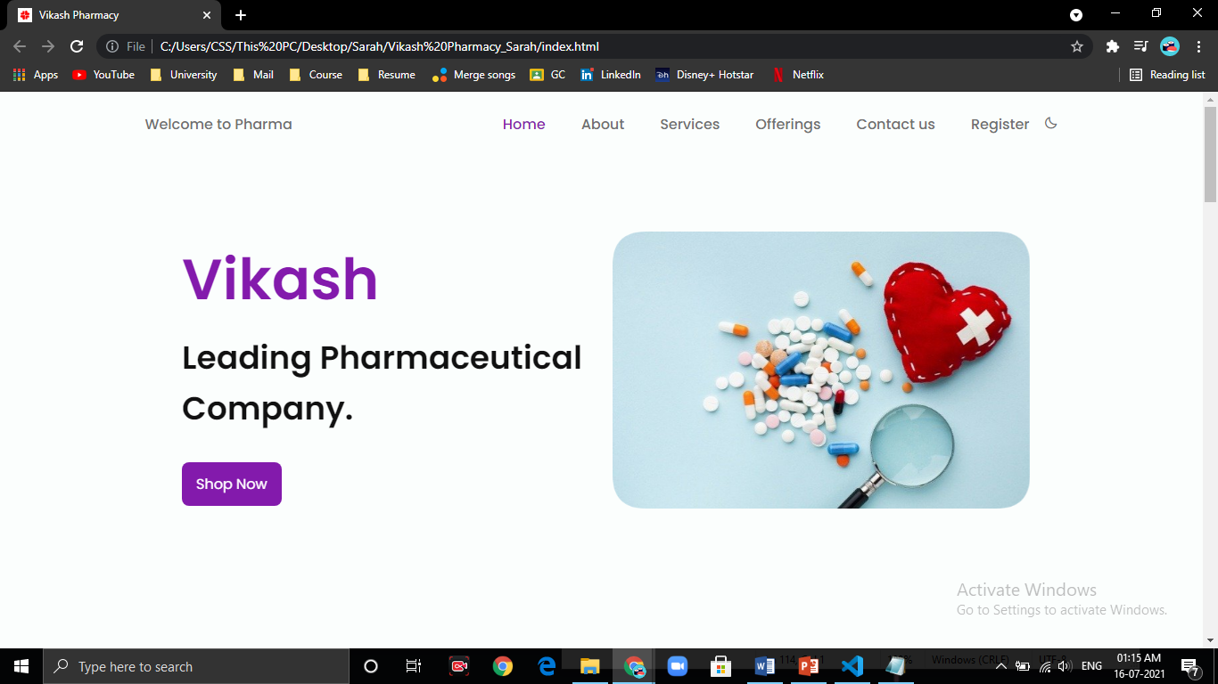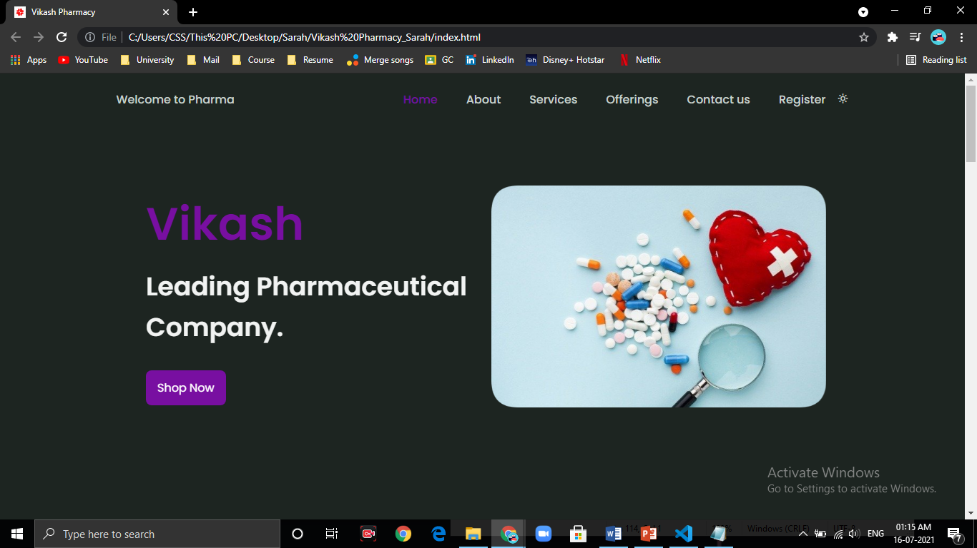

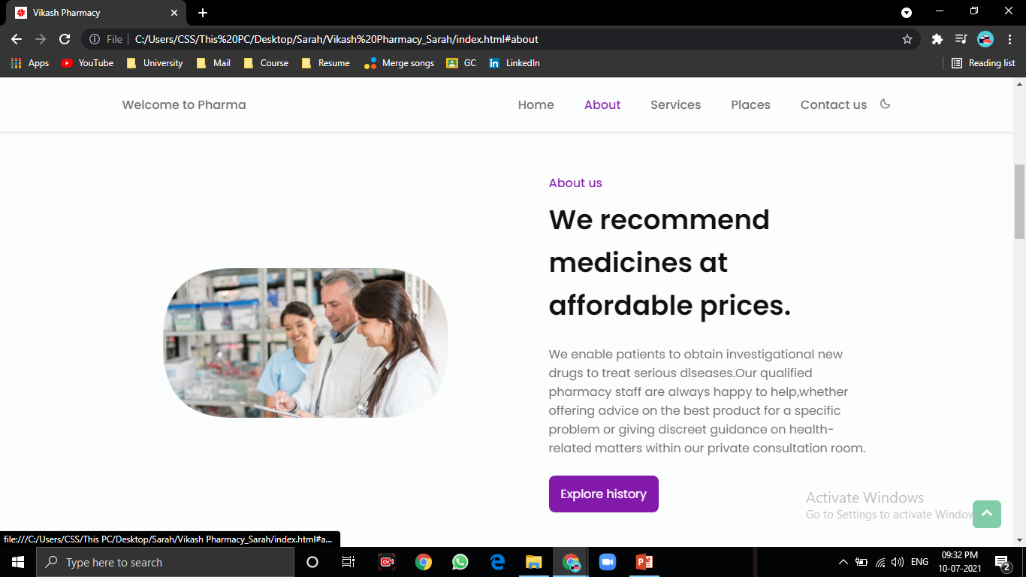**DASHBOARD**

**ABOUT AND SERVICES:**

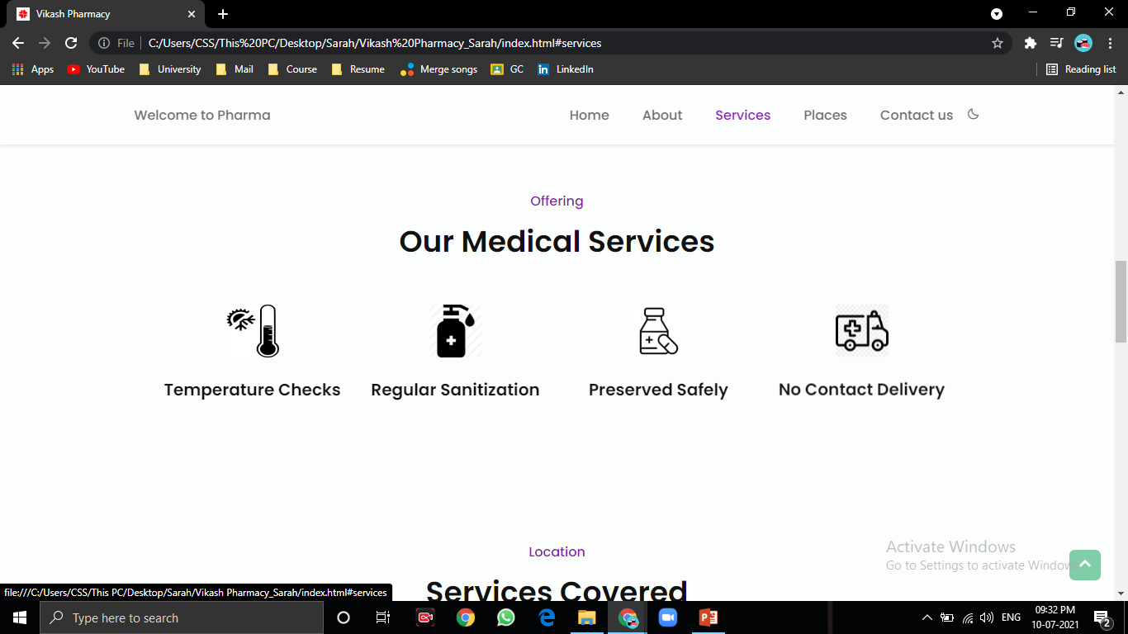

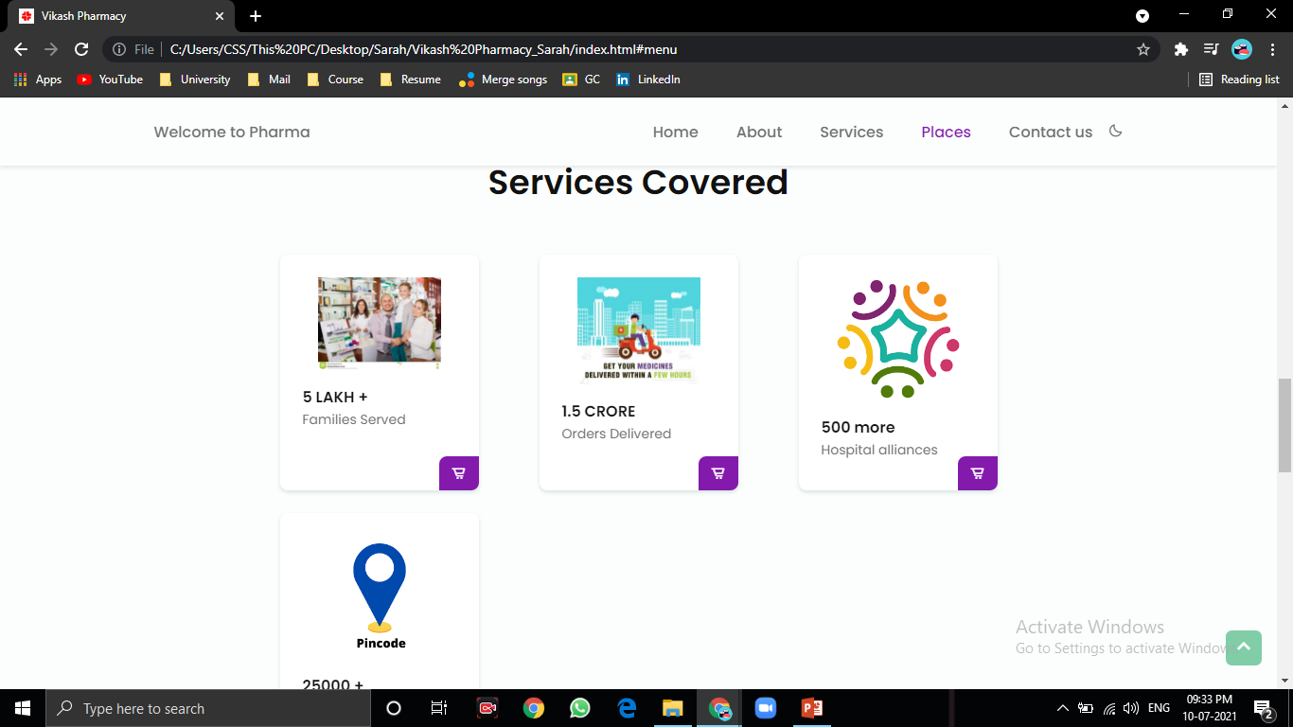

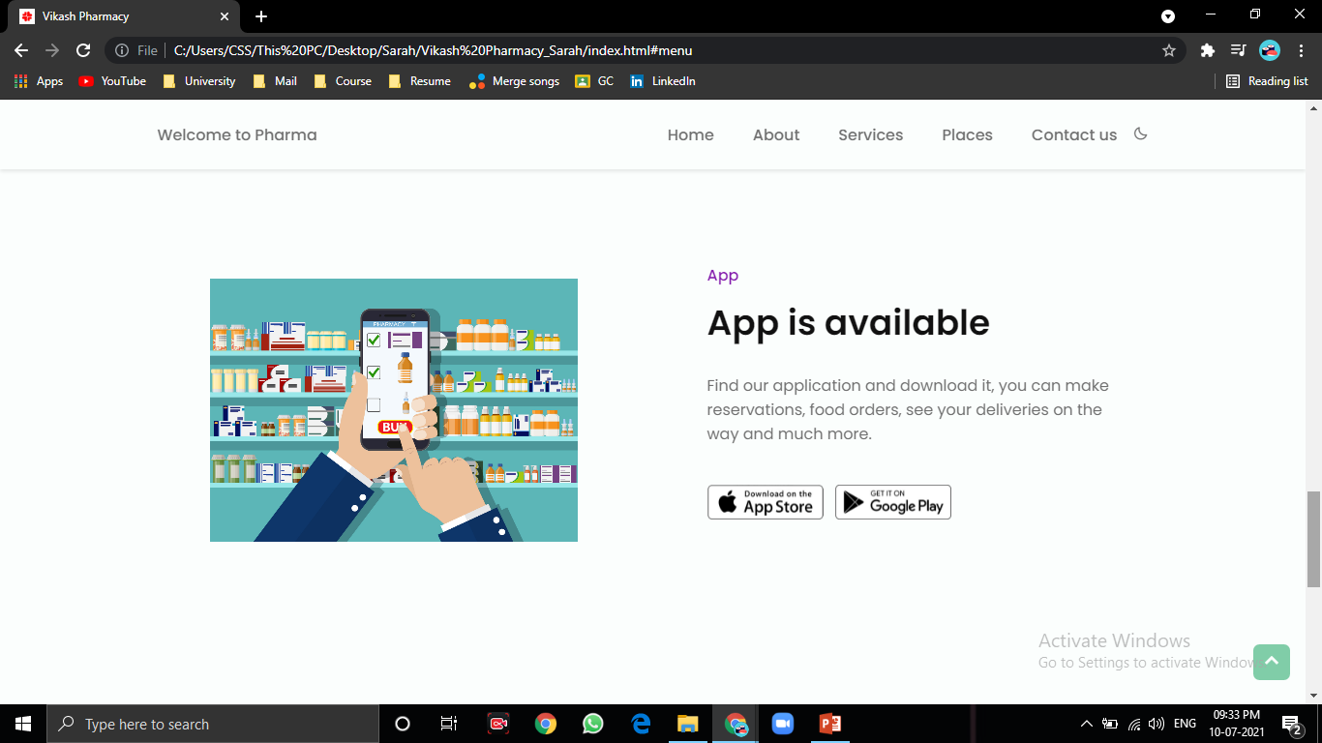

**CONTACT AND REGISTERATION:**

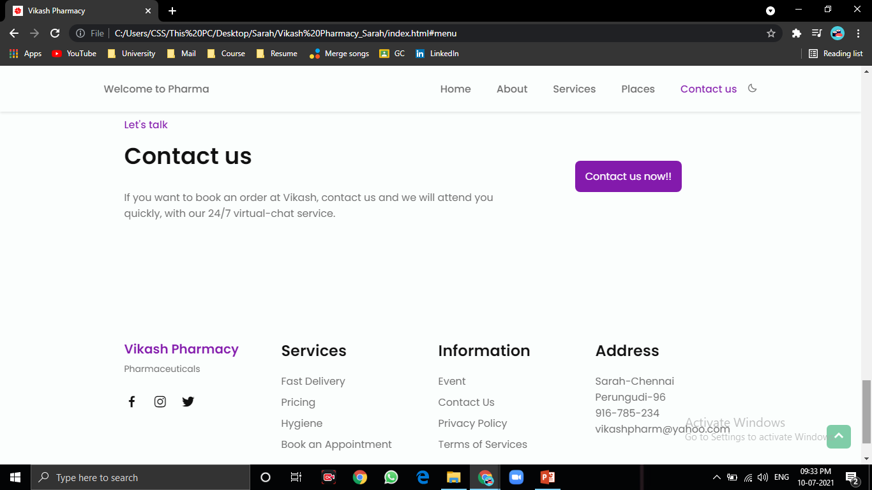

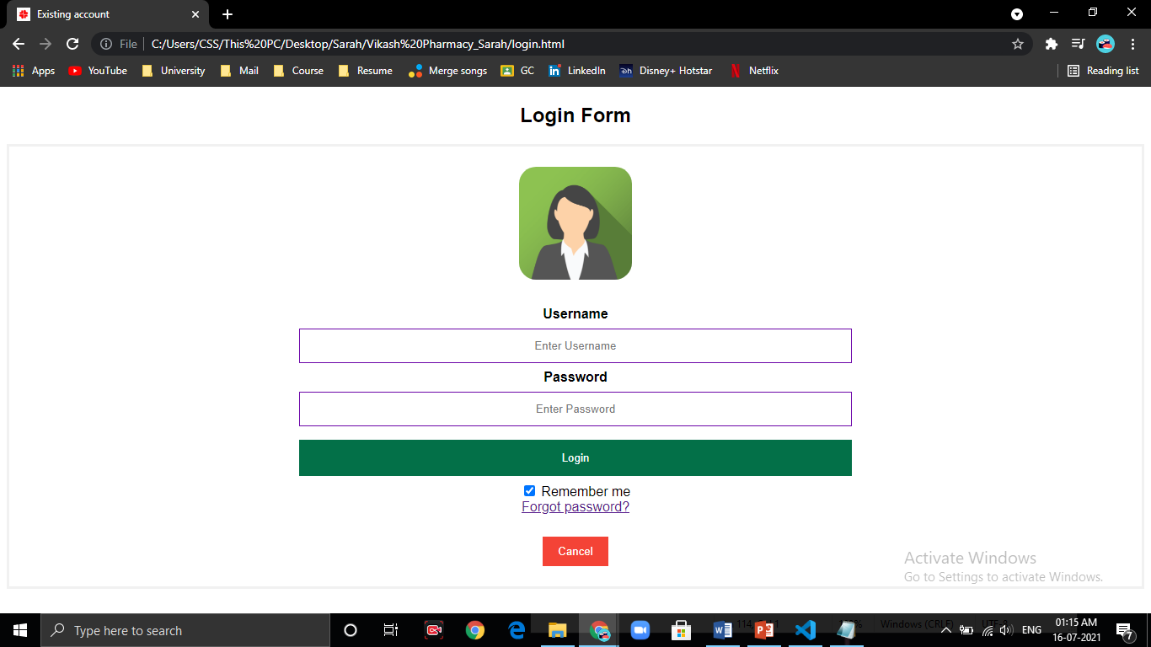

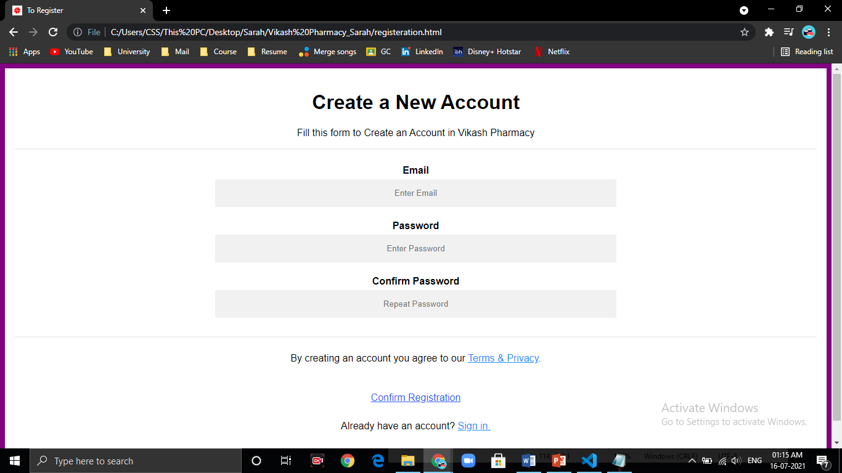

**MULTI PAGE RESPONSIVE:** 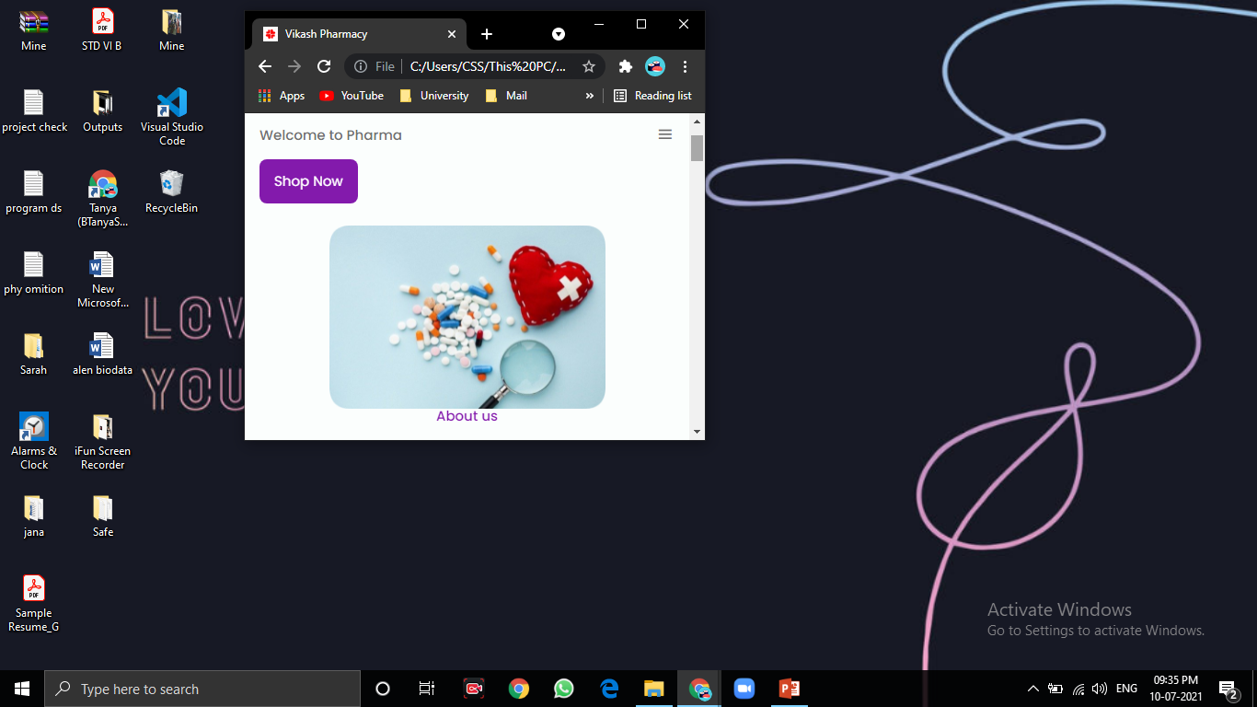

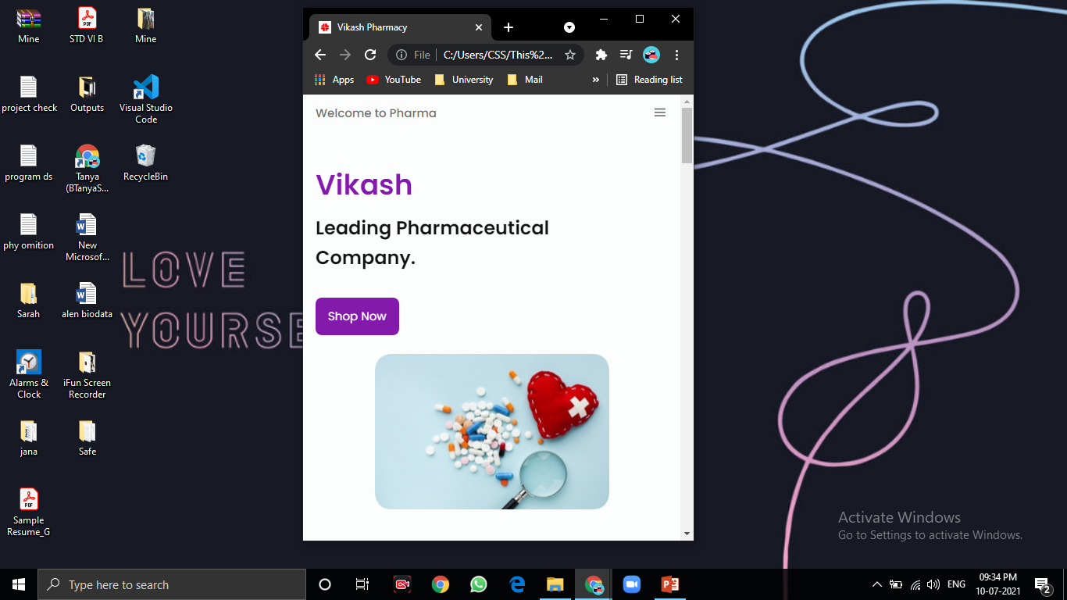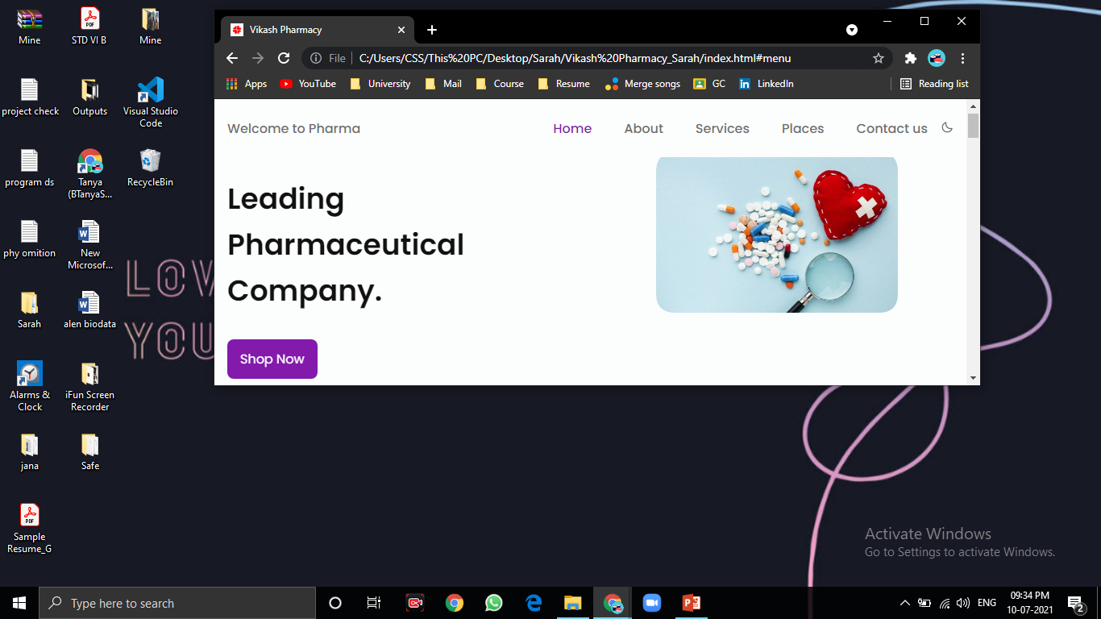

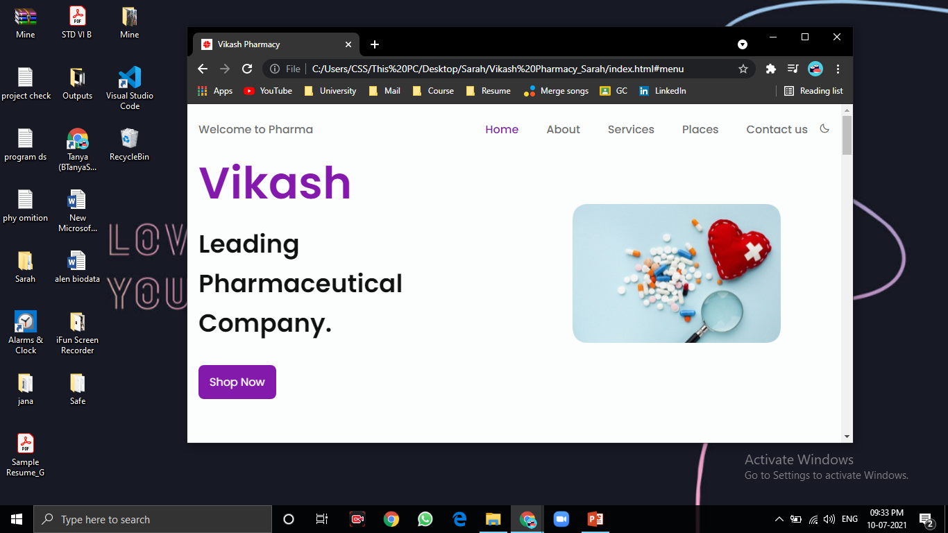

**THANKYOU.**