**SILLY YOU THOUGHT I WOULD HACK YOU???**

Will I don’t need to because I already did hehe…. Anyways sorry not sorry if you get scared, I just liked it the last time so I decided to do it for the last time (good rhyme huh?)

I would like to take the opportunity and say thank you and goodbye since it’s the last coding practice, I guess? (I know we have 3 more weeks but this is a message from the future).

*\*A quick note: you should be thankful that we can’t add auto play sounds*

*And my hacking system is recording you…*

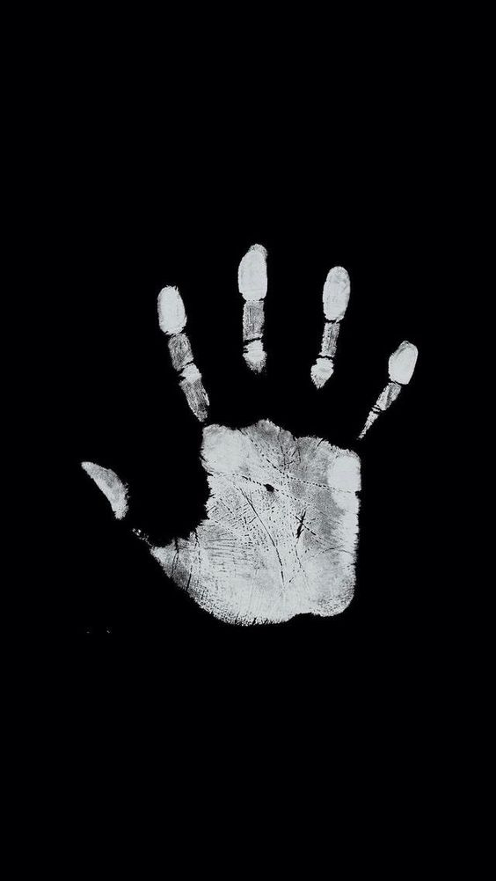

I don’t know why I added it I thought it is cool

