2.b) Accuracy with k=1

88.91

The nearest neighbours:

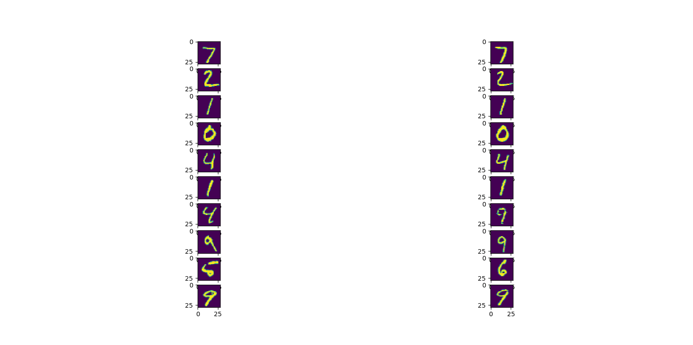

The confusion matrix plot:

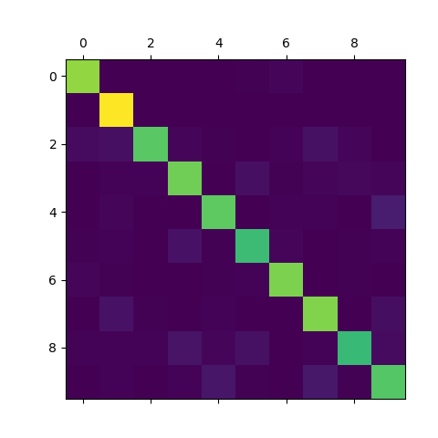

Accuracy with k=5

88.32

Nearest neighbours with k =5

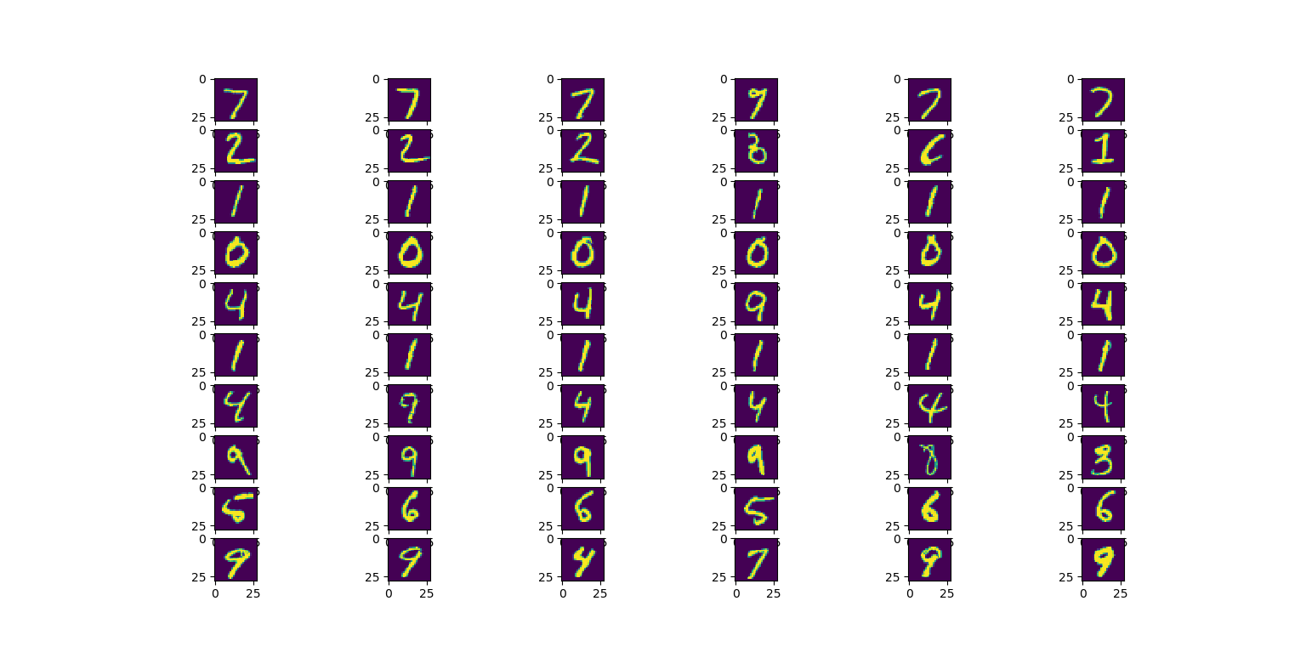

Confusion matrix plot:

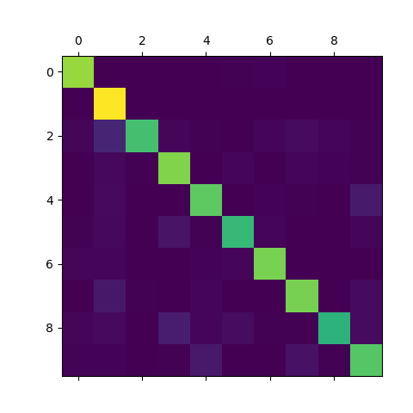

2.d) Plot for all nearest neighbours: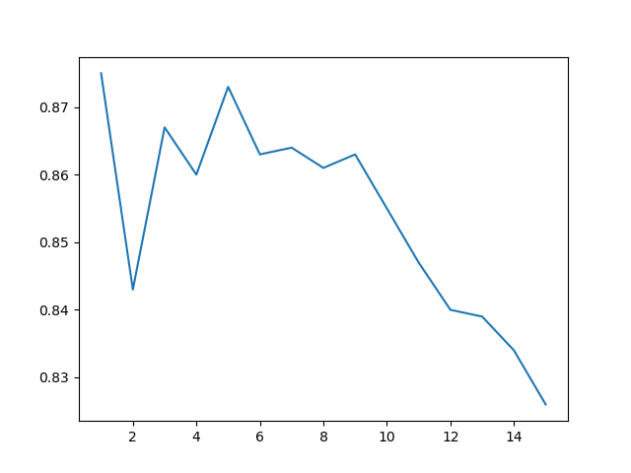

K=1 performed the best

2.d) The accuracy with all training images was 96.91% with k=1 and the best performer in cross validation was k=1.The time to execute increased to around 50 minutes while the previous executions had time executions ranging from 2-4 minutes.