2.1)

With one hidden layer(50 units)

Classification accuracy on test data:97.31%

Training loss curve:

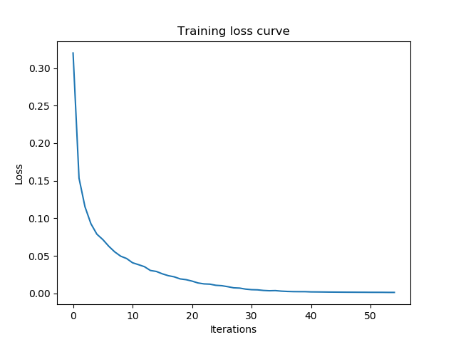

With two hidden layers(100 units):

Classification accuracy on test data:94.77%

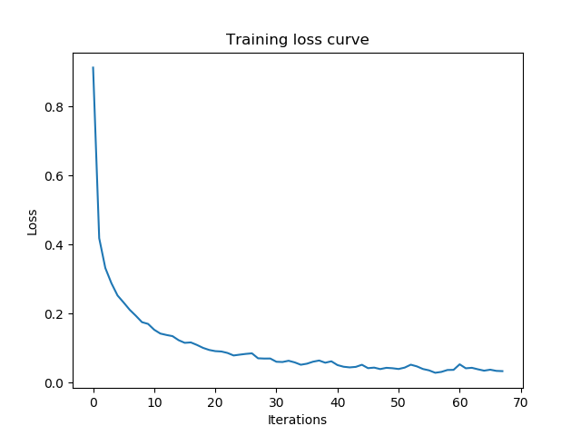

2.2)87.5% Accuracy

