Report

1. This website is created with using the theme of “Entertainers.” This website is designed under personal interest. Therefore, this website is only used as a blog and will not gain any profit. Through this website, the audiences will be introduced to a group of well-known people who still working on retaining the beauty of culture while being innovative in the traditional performing art that called Chinese CrossTalk or also known as “XiangSheng” (相声).

This website is going to introduce the audience of a group of well-known Chinese crosstalk people. The reason why I choose this topic is because in Malaysia, Chinese crosstalk or more known as XiangSheng (相声) is not counted as prosperity or popular comedy so I will like to build a website to promote this Chinese traditional performing art.

My target audience for this web site is those who has the same interest with me who support them and love Chinese crosstalk. Through this web site we can share the same interest and idea towards them. Also, I would like to introduce to the people about this group of people as I believe that not many of people here know them and also know this traditional performing art.

This web site is built also to promote this group of people to the Malaysians as their market in Malaysia or their popularity is not so known by the people here.

In this web site, I think I will include some information of the group of people. I will first introduce what is Chinese crosstalk, what is DeYunShe, how is the founder of it. In the second page, I will include some meaningful video so that the audience can see it clearly and understand what I trying to deliver.

1. In my web site, it contains 4 web pages include Home, Portfolio, About Us and also Contact Us.

In Home, I am using Topnav, content and footer. It contains Header, navigations, content and also footer. I use this way is to make it look more simple.

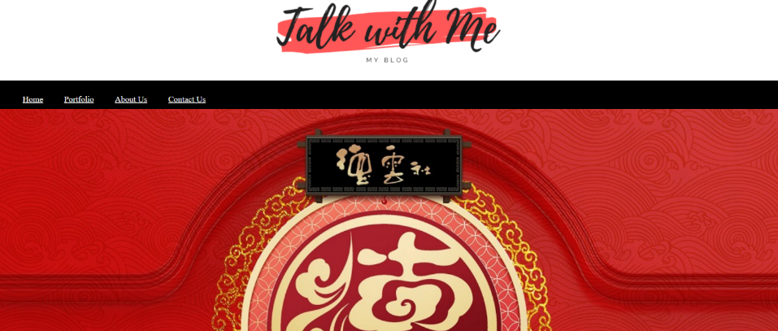

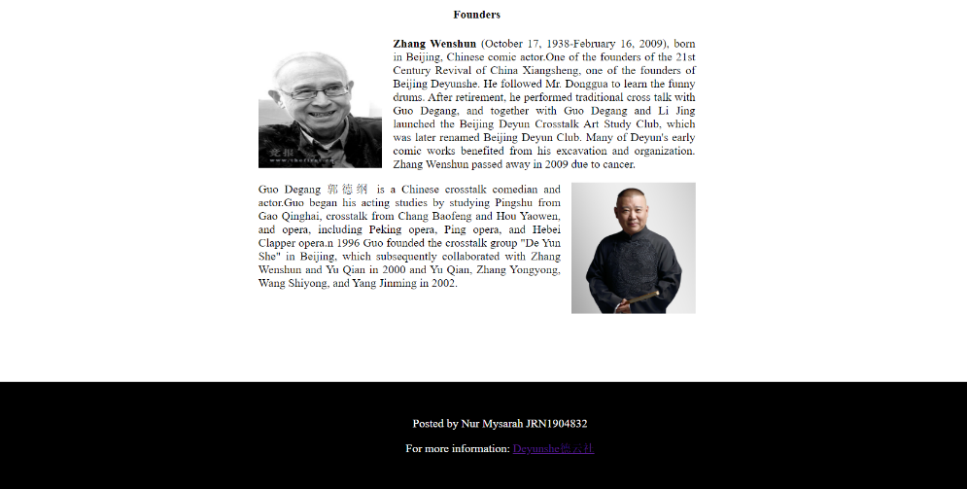

While in Portfolio, I am using the Header, unequal columns and footer layout. In this web page, I will include some video and information to let the audience to see so I decide to use unequal columns because my main content is on the middle,



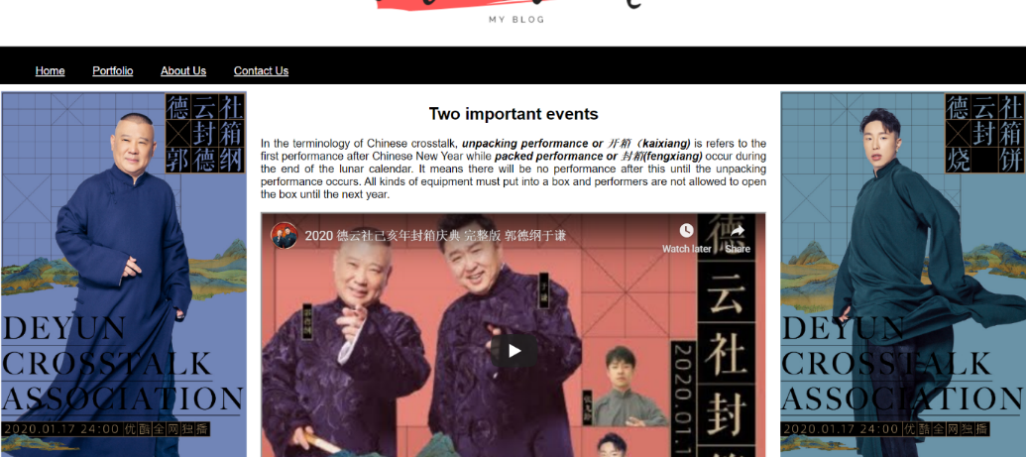

While in the about us web page, I am using Topnav, content and footer layout. It contains Header, navigations, content and also footer. I use this way is to make it look more simple.



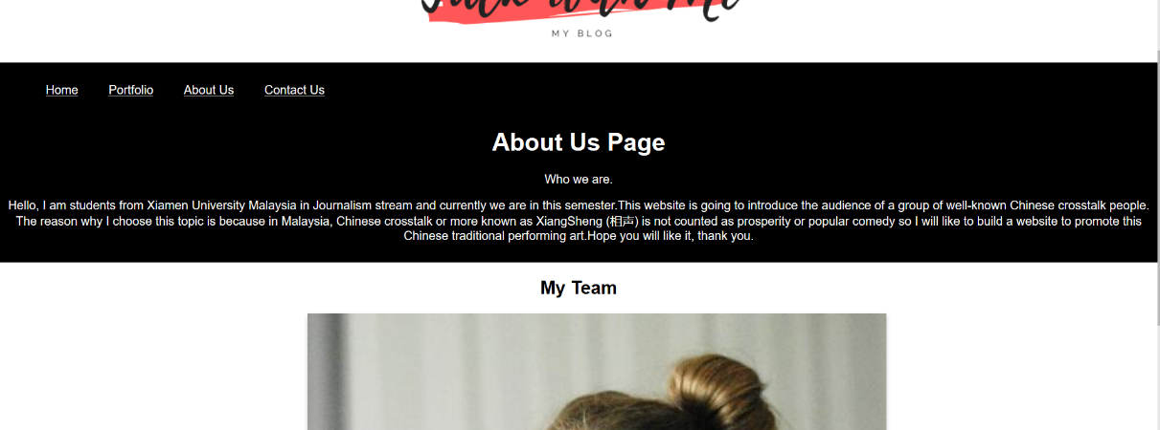

In the last page, contact us, I am using Topnav, content and footer layout. It contains Header, navigations, content and also footer so that it looks more simple.



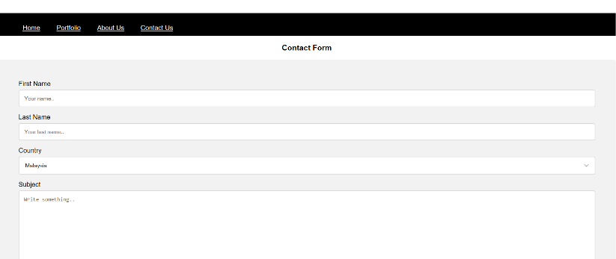

In this web site, most of the color that I am using is black, red, gray and white. The color of the logo that I am using is red. It is to match it to my topic because most of the picture of Deyunshe is using red. While in the navigation part and the footer part I choose to use black. It is because black represents some kind of mysterious feeling. For the gray part, it only applies on contact us web page. The color helps to differentiate the box that can be fill on by the audience. While, I am using the white is because white represents simple. I want to deliver it in simple content.