**Test Suite README**

This test suite is built using Maven, TestNG, Page Object Model (POM), RestAssured, and Selenium

**Prerequisites**

Before running the test suite, ensure you have the following software installed:

* Java Development Kit (JDK) 8 or higher
* Maven
* Chrome or Firefox browser (depending on your WebDriver configuration)

**Setup**

1. Clone the repository to your local machine.
2. Open a terminal or command prompt and navigate to the root directory of the project.
3. Run the tests:
   * Using Intillji Run :
     1. Right click on testng.xml file and choose Run “testing.xml” .
   * 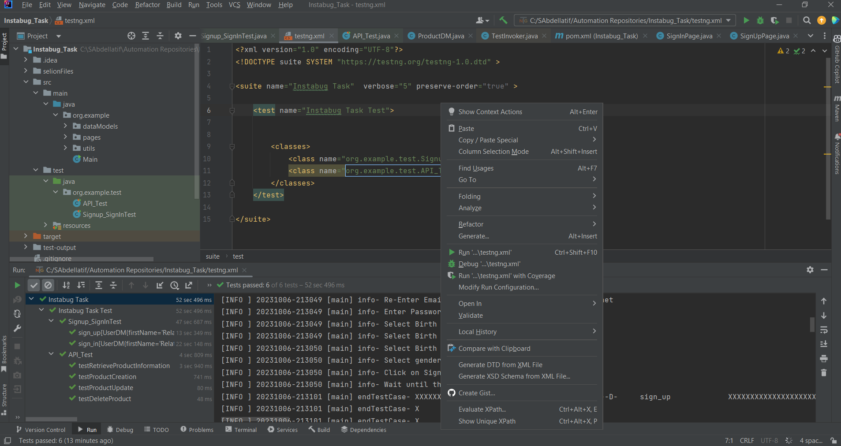
   * Using MAVAN:
     1. Build the project using Maven:
        + mvn clean install
     2. To run all tests, use the following Maven command
        + mvn test
     3. To run specific tests or suites, use the following Maven command:
        + mvn -Dtest=TestClassName test
        + Replace TestClassName with:
          1. org.example.test.Signup_SignInTest **To run UI Automation Test.**
          2. org.example.test.API_Test **To run Rest Assured Test.**

**Project Structure**

The project follows the Page Object Model (POM) design pattern for better test organization and maintenance. Here's an overview of the project structure:

* src/main/java: Contains the main codebase of the framework.
  + pages: Contains page classes that represent the web pages of the application.
  + utils: Contains utility classes for common functionalities.
  + dataModels.
* src/test/java: Contains the test classes and test suites for different scenarios.
* src/test/resources: Contains test configuration files and any required resources.

**Reporting**

1. The test suite generates test reports using the TestNG default reporting mechanism. Once the tests are executed, you can find the HTML reports in the target/surefire-reports directory.
2. The test suite generates test log files using Log4J . Once the tests are executed, you can find it under test-output/Logs directory.