MongoDB Lab2
1 - Download the following json file and import it into a collection named “zips” into “iti” database

2 – find all documents which contains data related to “NY” state

db.zips.find({state:"NY"});

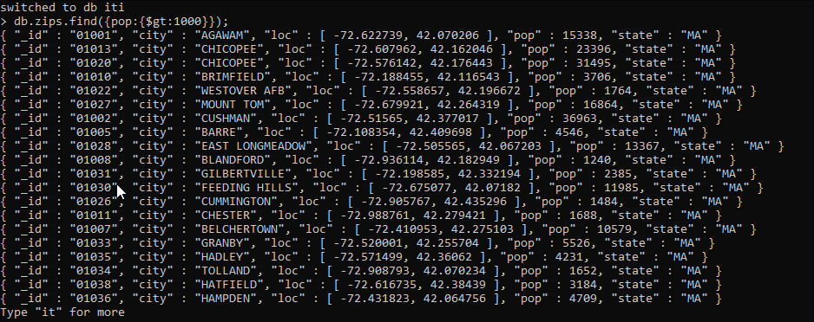
3 – find all zip codes whose population is greater than or equal to 1000

db.zips.find({pop:{$gt:1000}});
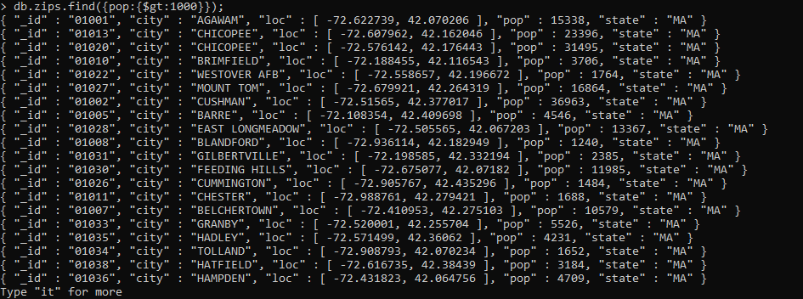

4 – add a new Boolean field called “check” and set its value to true for “PA” and “VA” state

db.umongo.updateMany({$or:[{state: "PA"}, {state: "VA"}]}, {$set: {"check": true}})

5 – using zip codes find all cities whose latitude is between 55 and 65 and show the population only.

db.zips.aggregate(
{ $match: { loc: { $gt: 55, $lt: 65 } } },
{ $project: { _id: 0, pop: 1 } }
);
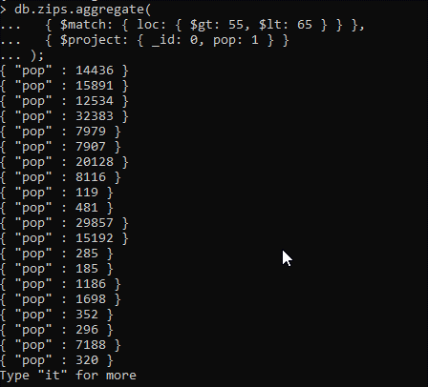
6 – create index for states to be able to select it quickly and check any query explain using the index only.

db.zips.createIndex({state:1});
db.zips.getIndexes();

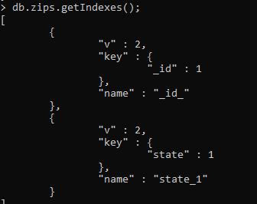

7 – increase the population by 0.2 for all cities which doesn't locate in “AK” nor “NY”

db.zips.updateMany({state:{$ne:["AK","NY"]}}, {$mul:{ pop: 0.2}});

8 – update only one city whose longitude is lower than -71 and is not located in “MA” state, set its population to 0 if zipcode population less than 200.

db.zips.updateOne( { state: { $ne: "MA" }, loc: { $lt: -71 }, pop: { $lt: 200 } }, {$set:{pop:0}} )

9 – update all documents whose city field is a string, rename its city field to be country and if there isn't any, add new document the same as the first document in the database but change the _id to avoid duplications.
Hint: use Variables
*****************************************************************

part2

- Get sum of population that state in PA, AK
db.zips.aggregate([
{ $match: { state: { $in: ["PA", "AK"] } } },
{ $group: { _id: "$state", populationSum: { $sum: "$pop" } } },
]);
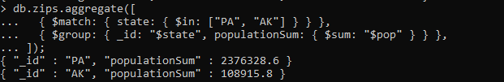
- Get only 5 documents that state not equal to PA, AK
db.zips.find({ state: { $ne: ["PA", "AK"] } } }).limit(5);

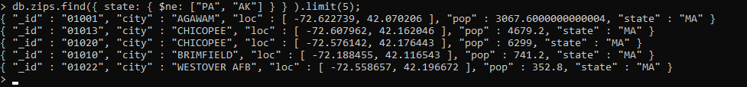

- Get sum of population that state equal to AK and their latitude between 55, 65
db.zips.aggregate([
{ $match: {$and:[{ state: "AK" }, { loc: { $gt: 55, $lt: 65 } }]} },
{ $group: { _id: "$state", populationSum: { $sum: "$pop" } } },
]);

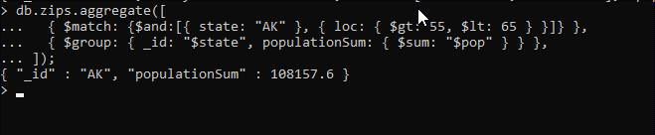
- Sort Population of document that state in AK, PA and skip first 7 document
db.zips.find({ state: { $in: ["PA", "AK"] } }).sort({"pop":1}).skip(7);

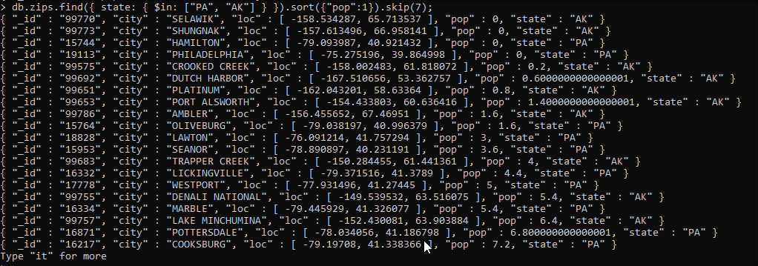

- Get smallest population and greatest population of each state and save the result in collection named "mypop" on your machine colleague
db.umongo.aggregate({$group: {_id: "$state", max: {$max: "$pop"}, min: {$min: "$pop"}}},{$out: {db: "iti", coll: "mypop"}})
- Write an aggregation expression to calculate the average population of a zip code (postal code) by state
db.zips.aggregate({$group: {_id: "$state", pop_sum: {$sum: "$pop"}}});
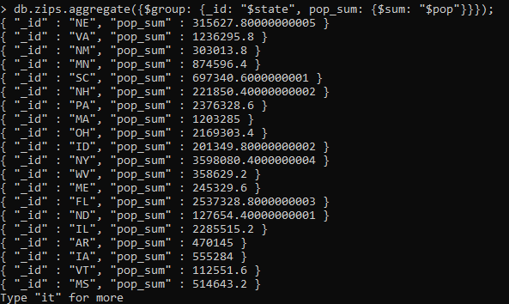

- Write an aggregation query with just a sort stage to sort by (state, city), both ascending
db.zips.aggregate({ $sort: { state: 1, city: 1 } });
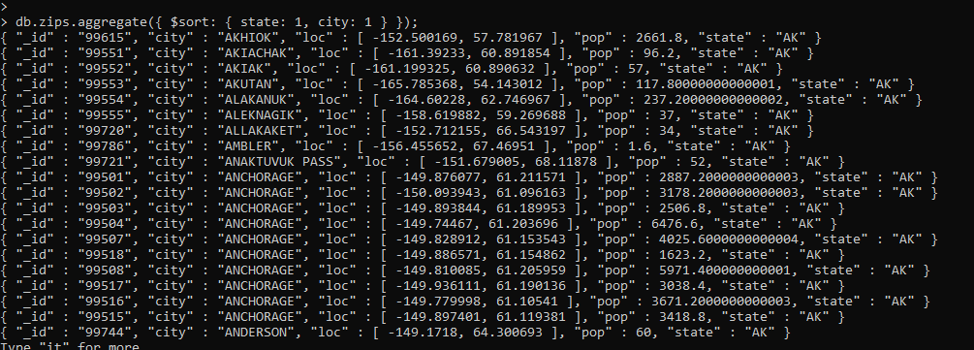

- Write an aggregation query with just a sort stage to sort by (state, city), both descending

db.zips.aggregate({ $sort: { state: -1, city: -1 } });

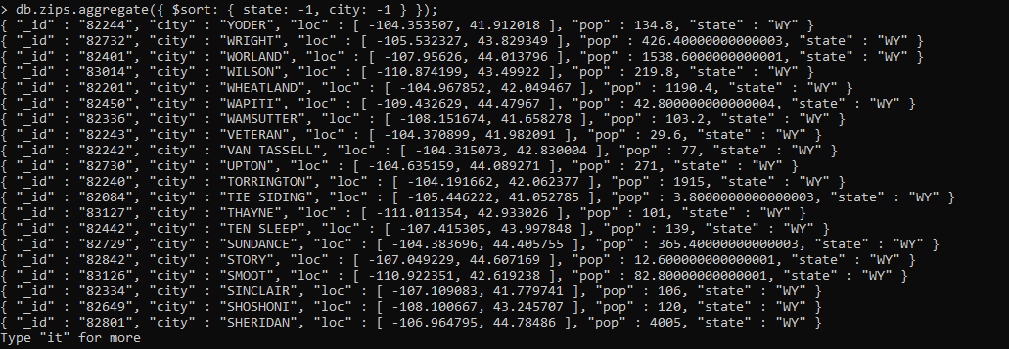
- Calculate the average population of cities in California (abbreviation CA) and New York (NY) (taken together) with populations over 25,000

db.zips.aggregate(
{
$match: {
$and: [{ state: { $in: ["CA", "NY"] } }, { pop: { $gt: 25000 } }],
},
},
{ $group: { _id: null, avg: { $avg: "$pop" } } }
);
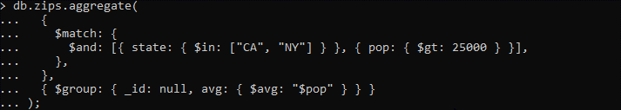
- Return the average populations for cities in each state

db.zips.aggregate({ $group: { _id: "$state", avg: { $avg: "$pop" } } });
