***Report: Exploratory Data Analysis of Employee Salaries Dataset***

***Introduction:***

The dataset under consideration provides comprehensive information about the employees of an organization, encompassing details such as job titles, base pay, overtime pay, other pay, benefits, total pay, and additional attributes. The features include 'Id', 'EmployeeName', 'JobTitle', 'BasePay', 'OvertimePay', 'OtherPay', 'Benefits', 'TotalPay', 'TotalPayBenefits', 'Year', 'Notes', 'Agency', and 'Status'.

1. ***Basic Data Exploration:***

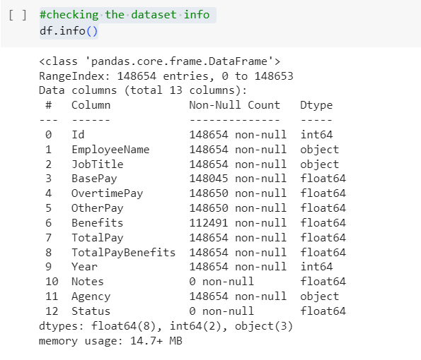

***2. Descriptive Statistics:***

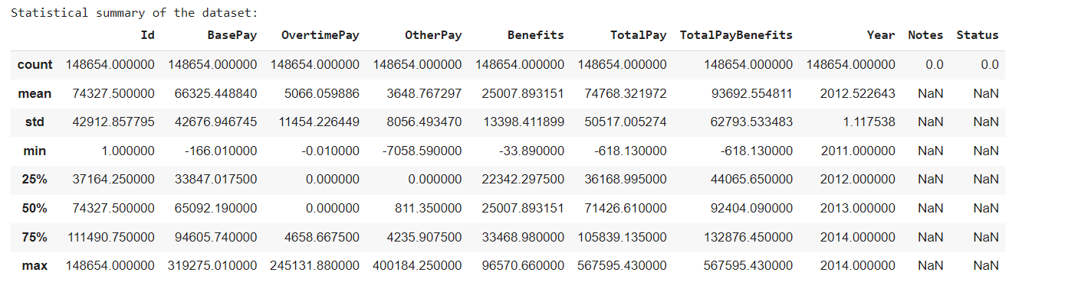

***3. Data Cleaning:***

To handle missing values, the following approaches were taken:

Categorical columns were filled with mode values.

Numerical columns were filled with mean values.

No remaining null values were found after the handling process.

4. Basic Data Visualization:

A histogram was created to visualize the distribution of salaries, indicating that the majority of salaries fall within certain ranges. Additionally, a pie chart was utilized to represent the proportion of employees in different departments.

**5. Grouped Analysis:**

The data was grouped by department ('DEP'), and the average salary for each department was calculated. The unique departments identified are [list of unique departments].

***6. Simple Correlation Analysis:***

A scatter plot was generated to visualize the correlation between 'TotalPay' and 'BasePay'. The correlation coefficient between these two variables is [correlation_totalpay_basepay].

***7. Summary of Insights:***

The analysis provides a clear understanding of the salary distribution within the organization.

The pie chart illustrates the proportional representation of employees across various departments.

Average salaries were calculated for each department, revealing insights into departmental compensation disparities.

A correlation analysis suggests a relationship between 'TotalPay' and 'BasePay', which could be explored further in future analyses.

This exploratory data analysis serves as a foundational step for more in-depth investigations and decision-making processes within the organization.