**Assembly instructions FIPT cell**

# Revision table

|  |  |  |  |
| --- | --- | --- | --- |
| **Date** | **Person** | **Rev#** | **Comment** |
| 191205 | DB | 001 | First version |

Note: create new file for each revision. Increment revision number in file name

Note: save a new file/revision before starting to change stuff

# Summary

**Necessary items:**

* 3x M5x40mm hex socket bolts
* 3d printed parts: (Typically: PLA, 250um layer height, 500um nozzle diameter)
  + 071_0100_Base.stl
  + 071_0101_Top.stl
  + 071_0102_Clamp.stl
  + 071_0105_ScrewCap.stl
* 20mm wide Kapton tape
* >= 20mm wide double sided tape
* 2-3mm thick EVA foam rubber sheet (from arts and crafts store)

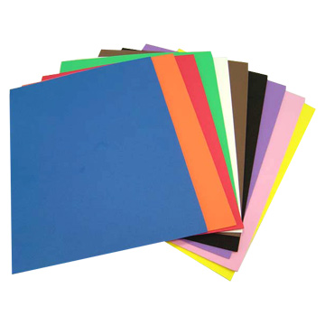

**Assembly steps:**

1. **Print all items**
2. **Add foam to Top part and Base part as in pictures below.**

**These foam parts consists of 3 layers:**

* 1. **Double sided tape**
  2. **Foam sheet**
  3. **Kapton tape**

**Make sure they are 20mm wide and that Kapton covers all foam (such that no electrolyte is absorbed).**

**Note: The foam parts are necessary to avoid touching of the edges of the crossing electrodes. Please follow the order/orientation of the SOP exactly. Otherwise, shorting and other problems can regularly occur!**

# Assembly pictures

