Utilising crowdsourced data to examine urban heat

Combined environmental hazards of the urban heat island and climate change underscores a growing imperative to protect urban residents from the adverse impacts of urban heat. Recent studies recognise the burden of heat is not distributed equally, with income, race, and ethnicity connected to experiencing disproportionately higher temperatures (Hsu et al., 2021). To understand and explore the inequities in this heat burden, dense air temperature sensor networks are required, capable of discerning intra-urban temperature variations.

Recognising this challenge, researchers have turned to innovative solutions, such as crowdsourcing as a means of data generation (Chakraborty et al., 2022; Chapman et al., 2023). One such source is personal weather stations. For 62 UESI cities, data from personal weather stations (Netatmo stations) are investigated over the month of July 2019, during which there was a heatwave in Europe. Comparison of this crowdsourced data with a gridded daily air temperature data (GDAT) (Zhang et al., 2022) shows a strong correlation in daily maximum and minimum temperatures (Figure 1).

Through Figure 1, it is established the crowdsourced data tends to report warmer temperatures. Several factors could contribute to this bias, one such being that the Netatmo stations do not always have radiation shields. In their study of the same period Venter et al (2021) found the station positive bias is reduced during days with cloud cover, indicating the lack of radiation shields is a strong contributor to the observed bias. Given the bias is systematic, this means the data remains highly useful for examining intra-neighbourhood variations in urban air temperatures, as the hotspots will still align.

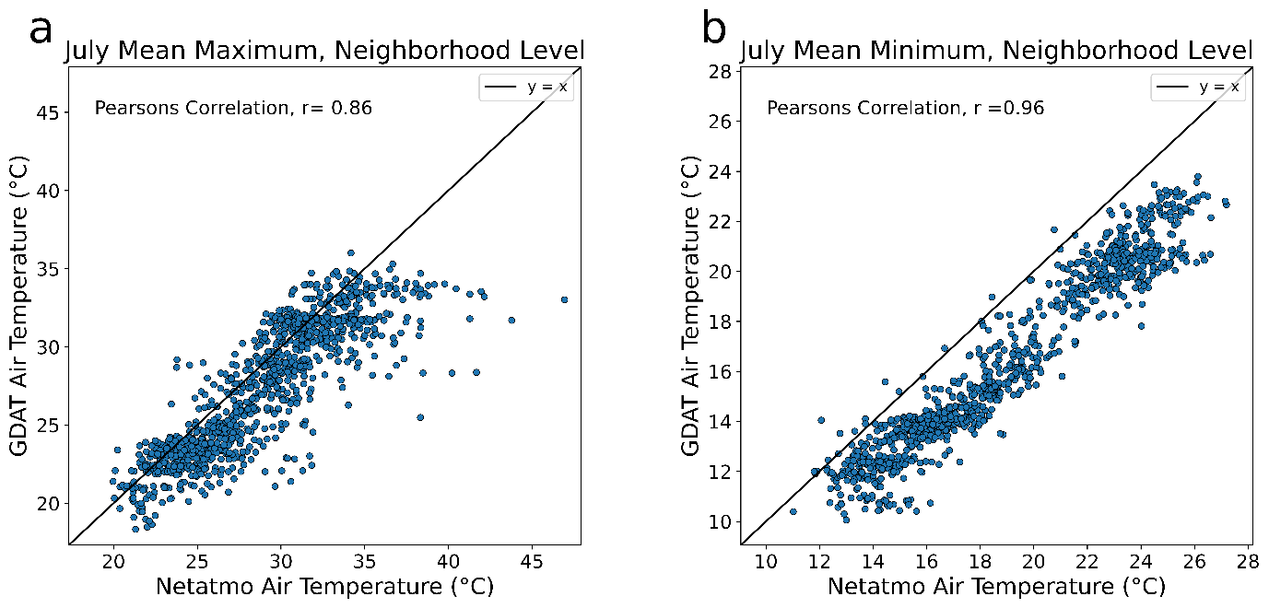

Figure 1 Scatter plot comparison of urban Netatmo air temperature versus the gridded daily air temperature (GDAT) measurements. Each point represents a European UESI neighbourhood.

This case study focuses on Berlin, which contains the highest number of Netatmo stations totalling 215. When categorised based on their surroundings, Netatmo stations located on built-up land on average exhibit higher temperatures in comparison to those situated on non-built-up land across all neighbourhoods, depicted in Figure 2a and Figure 2b, respectively. This non-built-up land is primarily composed of tree cover (Figure 2c), which is known to cool urban surfaces both by providing shade and a process known as evapotranspiration. This involves trees drawing water from the soil and releasing it into the air, where it cools the surroundings through evaporation. This demonstrates how heat disparities extend beyond the neighbourhood level. Within less central neighbourhoods, there can still be pockets of warmer areas. Stations in close proximity show a wide range of air temperature measurements (Figure 2d), demonstrating the extent to which differing urban forms create their own microclimates.

The arrangement shown Figure 2c reflects a typical city configuration, a more built-up centre results in a warmer urban core, with more tree cover in the less central districts leading to lower air temperatures. Consequently, residents and workers in the urban core will have endured a higher burden of heat during this July 2019 heatwave event.

The variability in air temperatures across the city and its sensitivity to landcover types reveals the critical need for high-resolution air temperature data, and its importance for addressing inequities in urban heat.

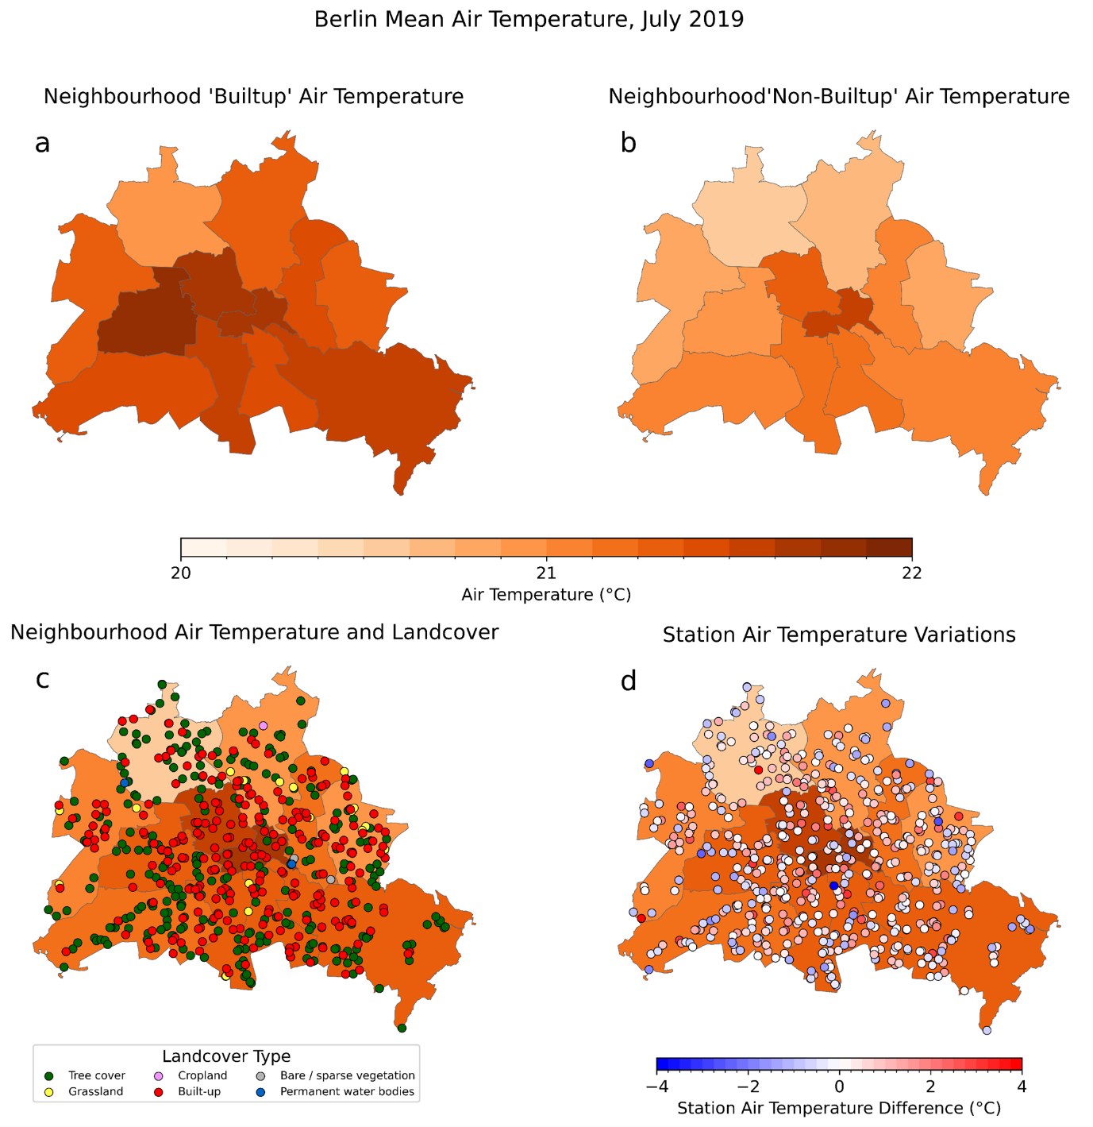

Figure 2 Intra-urban air temperature based on Netatmo station data within Berlin. Neighbourhood means are shown for a) built-up landcover only and b) non-built-up landcover only. Neighbourhood means for all landcover types are shown as a background for c) landcover types and d) differences between each station temperature and its corresponding neighbourhood.

References

Chakraborty, T., Venter, Z. S., Qian, Y., & Lee, X. (2022). Lower Urban Humidity Moderates Outdoor Heat Stress. *AGU Advances*, *3*(5), 1–19. https://doi.org/10.1029/2022AV000729

Chapman, L., Bell, S., & Randall, S. (2023). Can crowdsourcing increase the durability of an urban meteorological network? *Urban Climate*, *49*, 101542. https://doi.org/10.1016/j.uclim.2023.101542

Hsu, A., Sheriff, G., Chakraborty, T., & Manya, D. (2021). Disproportionate exposure to urban heat island intensity across major US cities. *Nature Communications*, *12*(1), 2721. https://doi.org/10.1038/s41467-021-22799-5

Venter, Z. S., Chakraborty, T., & Lee, X. (2021). Crowdsourced air temperatures contrast satellite measures of the urban heat island and its mechanisms. *Science Advances*, *7*(22), 1–10. https://doi.org/10.1126/sciadv.abb9569

Zhang, T., Zhou, Y., Zhao, K., Zhu, Z., Chen, G., Hu, J., & Wang, L. (2022). A global dataset of daily maximum and minimum near-surface air temperature at 1km resolution over land (2003-2020). *Earth System Science Data*, *14*(12), 5637–5649. https://doi.org/10.5194/essd-14-5637-2022