**Homepage**

* With header.ejs and footer.ejs inserted
* Need to keep my blog website with a consistent brand – heading title, and intro section, at the top of the page, to advise users what the blog website is about e.g. funny stories about being a parent.
* Want to include a basic form with blog post title and a free text section to enter the post.
* Will need to install Express, EJS, Node and Body-Parser.
* Will need to use an app.get to res.render the homepage, and an app.post to take the form data and render it on the page. Need to work out how to add it to a blog posts table below the form. Look at my to do list website – should show me how to create and add rows to the table with the content (I already have the Javascript code). I have copied below the JavaScript code from my to do list website.
* Have got the functionality now working to add tasks in to an accordion. Need to add the code to allow deletion and edit of each post.
* Need to include edit and delete buttons on each row. The code above should help. Need a post request to handle edits – and then factor this into the code in the index.ejs. Need to do a bit of google fu and figure out how to do that. Need to also google how to delete using route handlers on index.js.
* **Edits and deletes are now working, but the form goes to a separate edit page which I don’t want to do. Need to look into doing an edit modal instead. Bootstrap has a modals plugin.** [**https://getbootstrap.com/docs/4.0/components/modal/**](https://getbootstrap.com/docs/4.0/components/modal/)

**Header.ejs**

* Header.ejs to link to a contact me page, and the homepage. Need to set up the app.get routes to access those pages in the index.js.
* Must make sure to include the CSS link in the header.
* Use a Bootstrap navbar?

**Footer.ejs**

* Copyright statement with dynamic year.

**CSS Formatting**

* Background colour – there seems to be an emphasis towards blush pinks in parenting blogs. I’m looking at #AA5571 for the header and footer. Could use #BB778D, as a matching colour, for the headers within the actual body of the homepage. The image copied below uses #fffd5f as a general background colour. Form inputs are in #f6f7f1. Button on form is #bb778d.
* Thinking serif heading with sans-serif body.
* If I am going to use images (e.g. from Pexels) lean towards using cartoon image of parents (graphical image, not real people).
* Need a media query, and a dark-mode query, to ensure that it works with dark-mode and to ensure responsiveness on different screen sizes.
* The CSS page needs to be within the static folder.

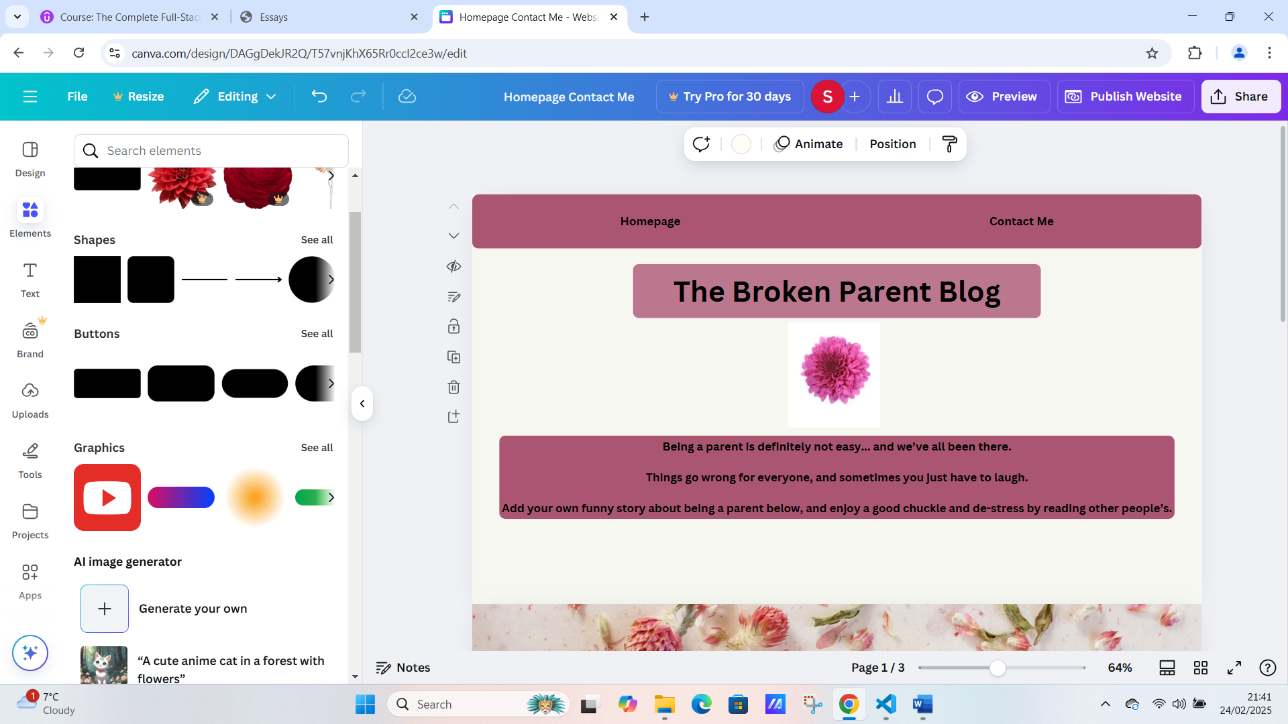

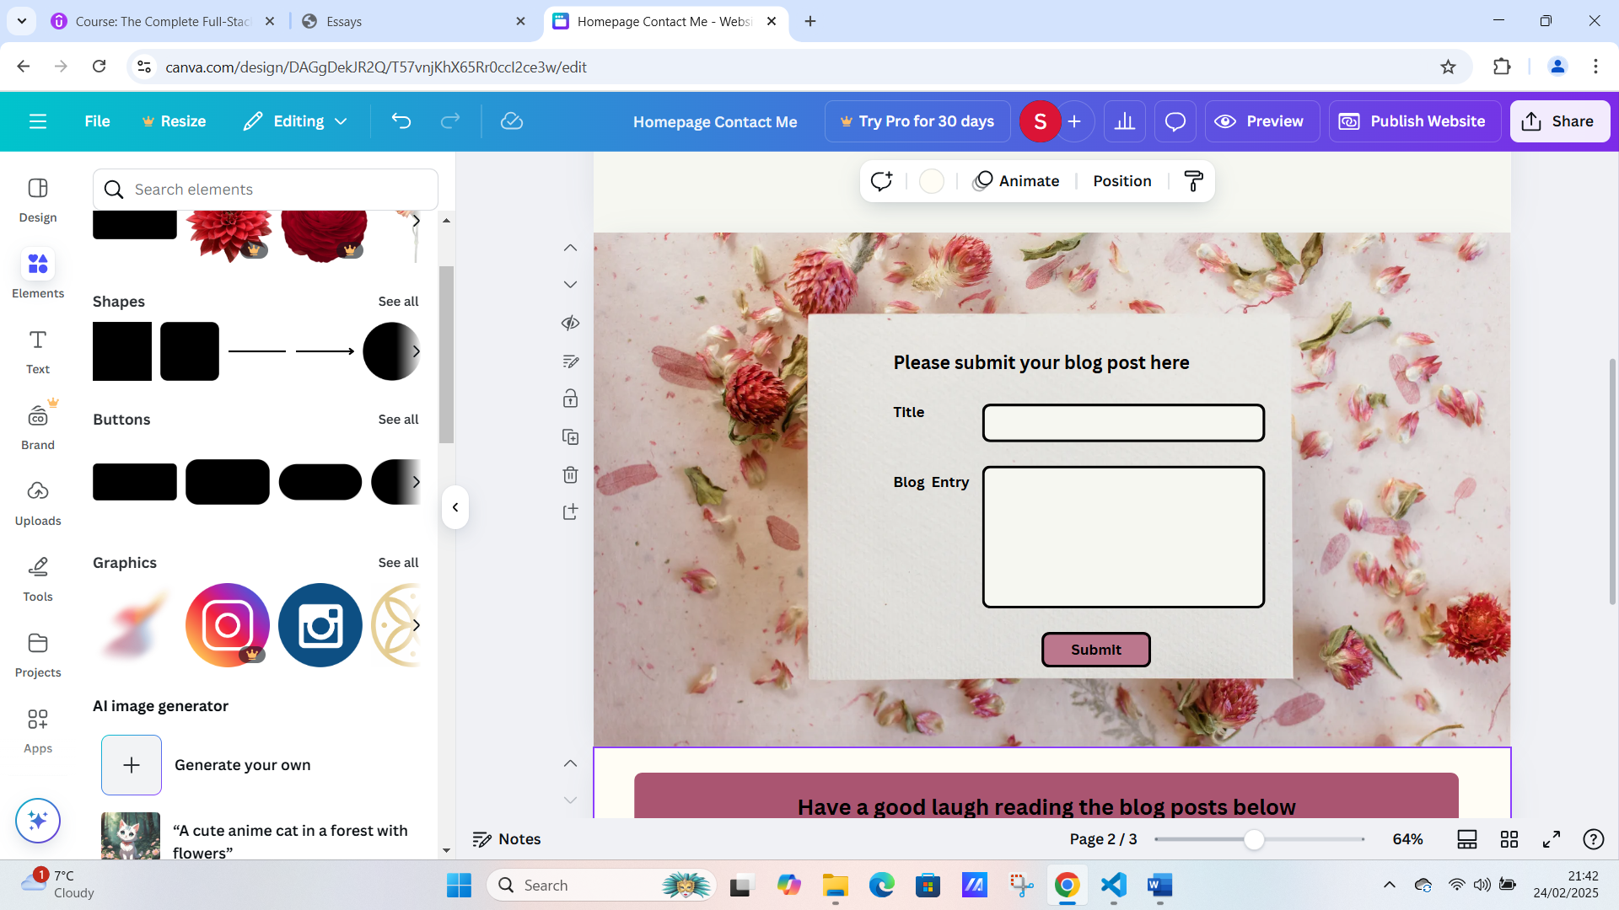

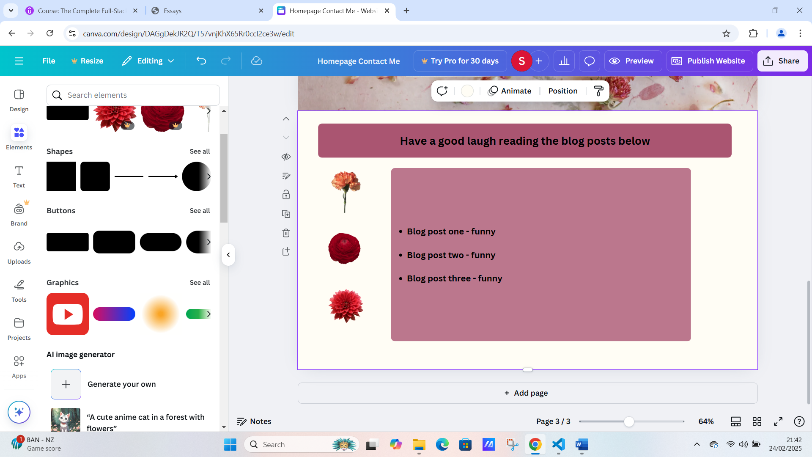

**ADD THIS PROJECT ON CHAT GPT WHEN IT IS FINISHED.**