*Simulating Driving with Analog Computers*

An Electronics Lab Independent Design Report

Sarah Brown

College of Engineering

University of Oklahoma

Norman, OK

*Abstract*— Operational amplifiers (op amps) can be configured in a way that allows them to sum up signals over time resulting in an integration function. With the use of op amps configured as integrators, it is possible to create an analog computer. Analog computers can be used for a variety of purposes by representing “constants and variables with proportional analog voltage levels. These were then processed [sic] by various electronic circuits that performed the mathematical operations in analog form” [1]. By designing a circuit with the use of integrators and a control system with a controllable voltage input, it is possible to simulate games with analog computers. In the 1975 November/December issue of *Elementary Electronics*, an example of this is seen in the article “Project Spaceflight” [2]. This project focused on building a circuit to simulate launching and docking a spaceship. Similarly, it is possible to create other games that are possible to run on an analog computer. Amplified Racing will be a car driving game simulated on an analog computer where you have to avoid slippery spots on an icy road. It will feature a road course created with the use of an integrator circuit that meanders through fields of green circuity. With the use of variable voltage inputs (controlled by potentiometers), a driver can attempt to stay on the generated course. A comparator circuit will be used to analyze the generated and driven course and will create signals to warn if the driver is going to crash. The game is won if the driver can stay on the course for a given amount of time and is lost if the driver veers off of the road and crashes.

Keywords— analog computer, op-amp, 555, circuit, game

# Introduction

From calculating integrals to multiplying constants, analog computers can be used for many different applications. Analog computers of different types operate by using variable quantities to represent a system of some kind. Electronic analog computers use voltage as a variable quantity to represent different operations [3]. These circuits are created with the use of operational amplifiers and other electronic components. Analog computers can not only be used to calculate equations, but also can be used to represent other situations such as a project to simulate flying a spaceship as shown in the 1975 November/December issue of *Elementary Electronics* [2]. Similarly, a circuit can be created to simulate other games, not only space flight. Amplified Racing utilizes an analog computer to simulate driving a car on a winding road.

# Circuit Design

## Block Diagram

Amplified Racing is a car driving game simulated on an analog computer featuring a road course created with an integrator circuit and indicators of whether the car is on the road. To simulate a car driving down a road, four different subcircuits are interconnected as shown in the block diagram in Figure 1.

## 

*Figure 1. A block diagram representation of the circuit.*

## Road

The road subcircuit (Figure 2) of Amplified Racing generates a windy path of voltages that can be shown on the road display subcircuit. This path is created via three different square waves generated with three 555 timer circuits. These signals are summed up into one input signal with a resistor ladder which is then fed into an integrator circuit. The integrator circuit includes a feedback resistor which pulls the signal back towards ground over time. The capacitor value can be adjusted to change the rate at which the road voltage varies. This integrator smooths out the input signal and outputs a windy path. This output signal is fed into an inverting op amp configuration with a gain of 5. This increases the output of the signal allowing it to be more readily detected by the road display circuit. The final generated road can be seen in oscilloscope XSC1 of the simulation.

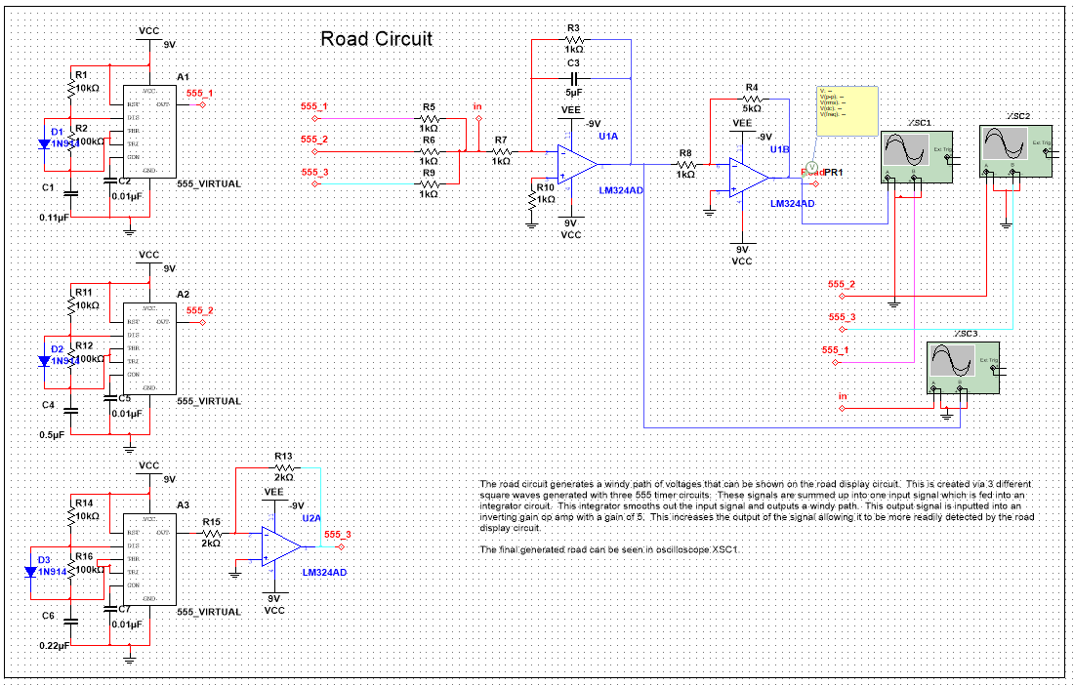

*Figure 2. Road subcircuit.*

## Road Display

The road display subcircuit (Figure 3) serves as a visual indicator of what direction the road goes next. The road display takes a road input from the road subcircuit. This input voltage is sent to multiple comparators with difference reference voltages. This causes the LEDs to turn on in sequence depending on the input voltage. If no LEDs are on, the road is curving to the left, if all seven LEDs are on, the road is curving to the right, and if four out of seven LEDs are on the road is going straight forward. This subcircuit can be used by the driver to tell which direction to steer the car.

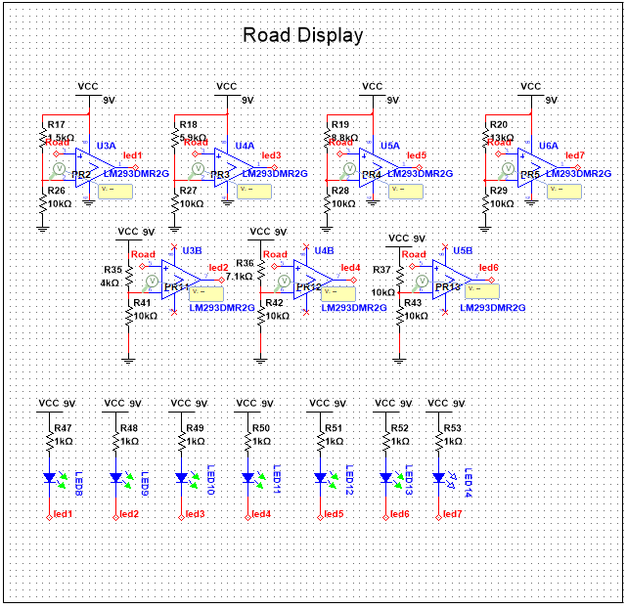

*Figure 3. Road display subcircuit.*

## Steering

The steering subcircuit (Figure 4) serves as a way for the user to control which direction the virtual car is driving. This is implemented by assigning different voltages to different directions. By using a voltage divider circuit and a potentiometer as a “steering wheel,” it is possible to change the voltage and change the direction of the car. The direction of the car is then displayed with the use of seven LEDs, these LEDs are turned on with the use of comparators. Seven different comparators are set to different reference voltages such that the LEDs turn on in an established order. If no LEDs are on, the car is steering left, if all seven LEDs are on, the car is pointing right, and if four of seven LEDs are on the car is driving straight forward. The LEDs are displayed below the comparators in the simulation to better illustrate the steering display. The steering wheel is located below the LEDs and can be changed to change the direction of the car.

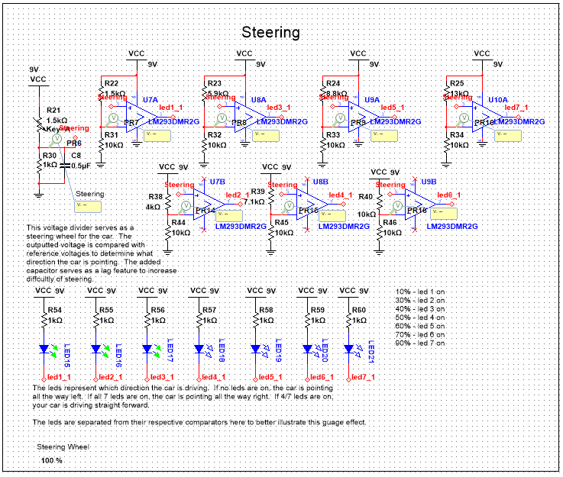

*Figure 4: Steering subcircuit.*

## Status

The status subcircuit (Figure 5) compares voltage outputs from the steering and road subcircuits to determine if the car is currently on the road. This is done by subtracting the steering voltage from the road voltage to compute the difference between the two. This computation is done via a subtractor op amp circuit [4]. However, the output from the subtractor could potentially be negative which would cause complications when trying to display the status. To avoid a negative voltage going into the display section of the status subcircuit, it was modified with an absolute value circuit [5]. The absolute value circuit uses two op amps and diodes to convert the output to the absolute value. The absolute value of the difference between the road and the steering voltages is then input into a series of comparators much like in the steering and road display subcircuits to indicate whether the car is on the road. The more LEDs that are on, the more accurately the car is steering. With this display the user can try to keep their car on the road for as long as possible.

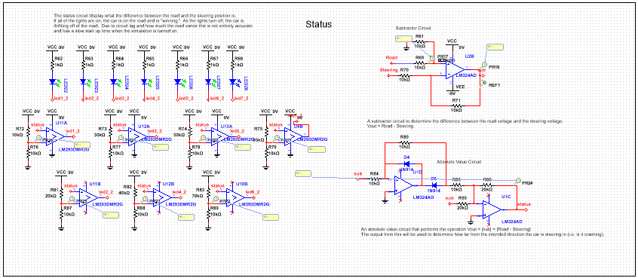

*Figure 5: Status subcircuit.*

# Circuit Reliability

Circuit reliability is an important factor when designing and producing any electronic product, this can be done with different calculations. The Amplified Racing game was tested to determine its reliability rate for a one-year period. These calculations were done by using the reliability rate equation based on information gathered about the parts in the circuit (Table 2). The reliability rate equation is initially in hours and is then converted to time units of years. These calculations show that the reliability rate for a one-year time period for Amplified Racing is 93.22%. This reliability could be improved by removing the potentiometer and lowering the resistor count.

$$R\left(t\right)=ⅇ^{(-\sum_{i=1}^{n}{λ_{i}t})}$$

*Equation 1: Reliability rate equation.*

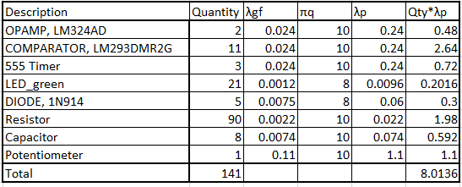

*Table 1: Parts list.*

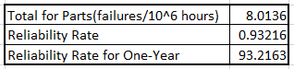

*Table 2: Reliability rate results.*

# Testing and Results

## Testing

Testing for Amplified Racing was done via Multisim simulations, future testing will be performed when a physical circuit is constructed. Testing in Multisim was done by building each subcircuit and testing it to ensure it works before moving on to the next piece. Testing as progress was made ensured that there were no bugs in that component before more designs were based on that work. As the majority of Amplified Racing focuses on physical output of LEDs, testing was straightforward as the LEDs had to turn on in a specific order and it was clear when they did not. When errors occurred, debugging was done with use of the probes and oscilloscope in Multisim. Testing for the road subcircuit focused on developing a smooth and interesting curve output and so focused on output from the different oscilloscopes.

## Results

Amplified Racing successfully implements an analog computer system to simulate a car driving video game. By controlling a “steering wheel” potentiometer, a driver can attempt to stay on a simulated road. Results of the steering wheel can be seen in Figure 6. Shown in Figure 6 is the steering wheel set to 50%, this should result in the car driving straightforward and have four of the seven LEDs show up. Shown in Figure 7 is the final road signal after it has been integrated and scaled. This signal controls which way the voltage road turns. By connecting all four subcircuits together it is possible to tell if the driver is on the road by comparing the different LED displays as shown in Figure 8.

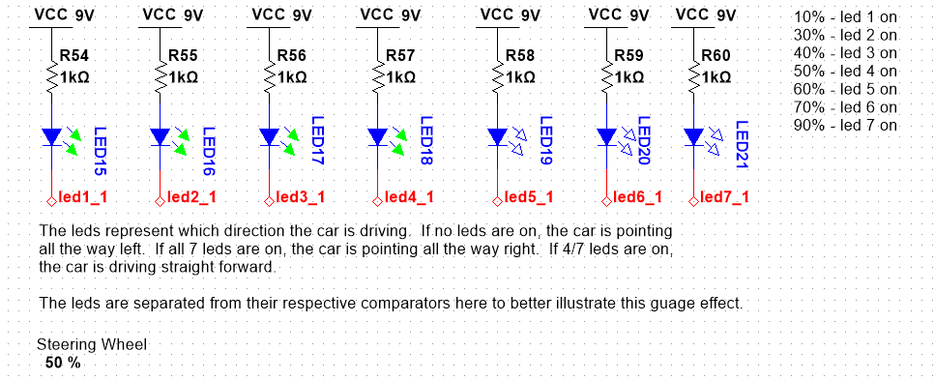

*Figure 6: Steering at 50%*

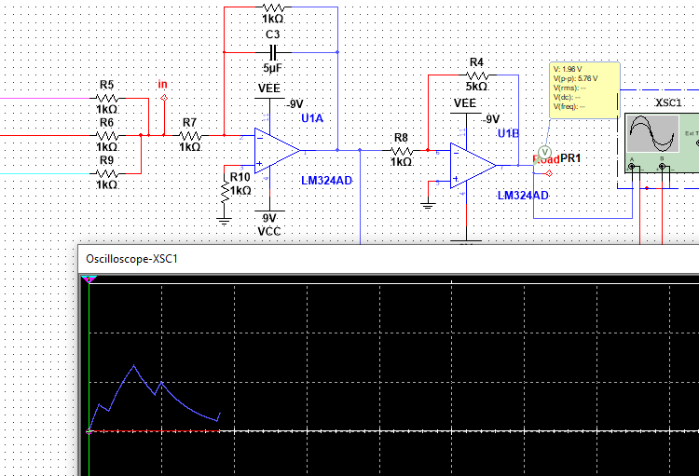

*Figure 7: The final outputted road signal after being integrated and scaled.*

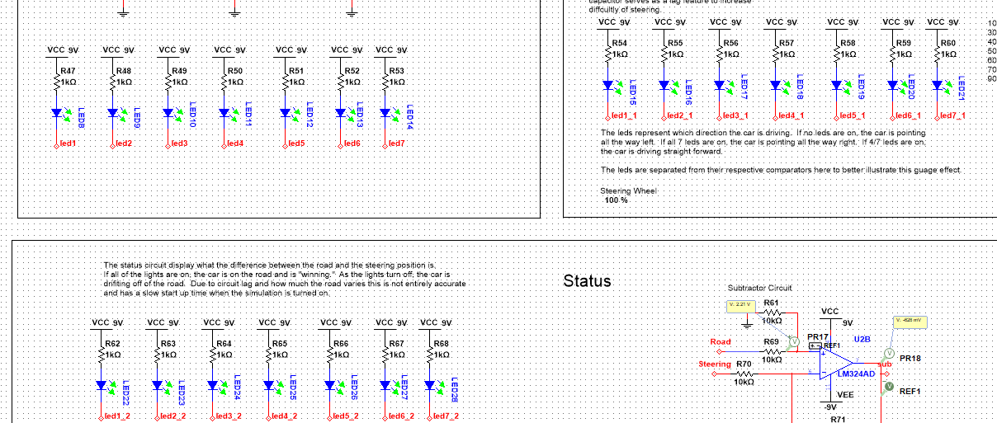

*Figure 8: Image showing the road and the car turning right and the car is staying on the road.*

# Conclusion

## Challenges

The major challenges faced when designing Amplified Racing were mainly due to the road subcircuit. The complexity of the three timer circuits feeding into the integrator resulted in Multisim crashing randomly. This issue was solved by changing the simulation settings for the project. After Multisim’s settings were changed, the other issues due to the road subcircuit were solved via trial and error to get a smooth and interesting road output from the road subcircuit. The status subcircuit also posed challenges on how to best compare the road and steering voltage. The original solution of logic gates made from BS170s became too complicated which resulted in the comparator logic being used again.

## Future Additions

Future developments to Amplified Racing will focus on increasing accuracy of the different display voltages. Specifically, increasing the precision of when the status display LEDs turn on and off. In addition to improving error issues, Amplified Racing 2.0 would feature a timer and damage subcircuit that would control win conditions for the game. These added features would allow the user to win/lose the game and allow the game to be reset afterwards.

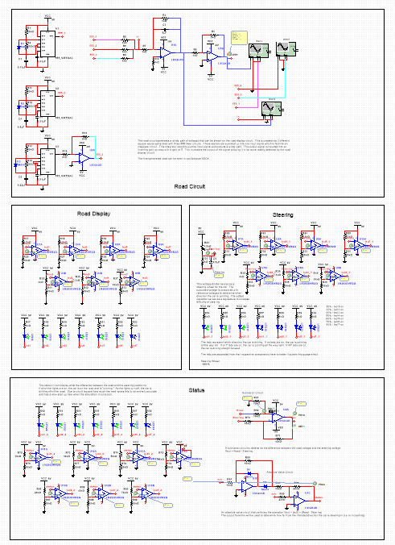*Figure 9: Complete Schematic*

##### References

1. L. Frenzel, “Analog Computers,” Electronic Design, 22-Jan-2007.[Online].Available: https://www.electronicdesign.com/technologies/analog/article/21770561/analog-computers. [Accessed: 25-Mar-2020].
2. M. K. Smith, “Project Spaceflight,” Elementary Electronics, pp. 41–46, 1975.
3. The Editors of Encyclopaedia Britannica, “Analog computer,” Encyclopædia Britannica, 10-Jan-2014. [Online].Available:https://www.britannica.com/technology/analog-computer. [Accessed: 20-Apr-2020].
4. Differential Amplifier or Voltage Subtractor Circuit, 11-Dec-2018. [Online]. Available: https://circuitdigest.com/electronic-circuits/differential-amplifier-or-voltage-subtractor-circuit. [Accessed: 20-Apr-2020].
5. “More Value from Your Absolute Value Circuit-Difference Amplifier Enables Low-Power, High-Performance Absolute Value Circuit,” *More Value from Your Absolute Value Circuit-Difference Amplifier Enables Low-Power, High-Performance Absolute Value Circuit | Analog Devices*. [Online]. Available: https://www.analog.com/en/analog-dialogue/articles/more-value-from-absolute-value-circuit-diff-amp.html. [Accessed: 20-Apr-2020].