Sarah Brown

ELab Independent Project

Amplified Racing Simulation Instructions

1. Open the file named BrownSarah_AmplifiedRacing
2. Start simulation
3. Due to circuit/simulation lag correct values will not be displayed for roughly the first 30 seconds
4. The “steering wheel” to control the “car” is located in the steering subcircuit
   1. The location is shown below
   2. 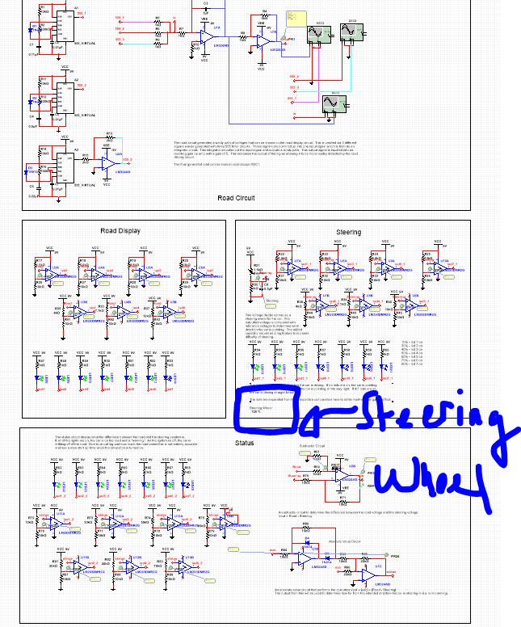
5. By moving the steering wheel position, it is possible to change the direction of the car
   1. Position of car is shown via 7 green LEDs in the steering module
   2. By changing the steering wheel potentiometer to the following settings, the different steering LEDs will turn on. At 90% all seven LEDs should be on. The capacitor attached to the voltage divider in the steering module serves to add lag to steering. This simulates a slippery road condition and it can be changed for different difficulty levels.
      1. 10% - led 1 on
      2. 30% - led 2 on
      3. 40% - led 3 on
      4. 50% - led 4 on
      5. 60% - led 5 on
      6. 70% - led 6 on
      7. 90% - led 7 on
6. The goal of Amplified Racing is to try and match the LEDs in the road display module by steering the car from the steering module. The results are shown in the status module. The more LEDs that are shown as on in the status module, the better the steering!

Trouble Shooting

1. If there are any simulation errors, double check that the simulation/analysis settings are set to the ones shown below

