

OCTO-DE Benefit Tools Crew | Accredited Representation Management

April 29, 2024 | Representative Status Widget

Version 1.0

Revision History

|  |  |  |  |
| --- | --- | --- | --- |
| Date | Version | Description | Author |
| 4/29/2024 | 1.0 | MVP: Minimum Viable Product | Lindsay Li-Smith |
| 7/2/2024 | 1.1 | Updated error state | Lindsay Li-Smith |

Table of Contents

1. Product Overview 4

2. User Access 4

3. Navigation 4

4. Functionality 4

5. Major Issues and Error Messages 6

6. Frequently Asked Questions 6

7. Table of Figures 7

## 1. Product Overview

The Representative Status Widget product is a user-friendly, accessible widget on VA.gov that reflects a Veteran’s current representative status. The different possible widget states are:

1. Unauthenticated
2. Authenticated, no representative
3. Authenticated, represented by a Veteran Service Organization
4. Authenticated, represented by an individual (an attorney or claims agent)
5. Error

## 2. User Access

All users will be able to view the Representative Status Widget.

1. Unauthenticated users will be prompted to sign in
2. Authenticated users will see their representative information, or an error if there was an issue retrieving their information.

## 3. Navigation

Accredited Representative Landing Page

The Representative Status Widget will be at the top of the landing page under a “Check if you already have an accredited representative” header.

The URL for this landing page is <https://va.gov/get-help-from-accredited-representative>.

Find a Representative Product Page

The Representative Status Widget will be at the top of the Find a Representative page, so users can understand if they have representation before beginning a representative search.

The URL for the Find a Representative page is <https://va.gov/get-help-from-accredited-representative/find-rep>.

## 4. Functionality

Different states for the Representative Status Widget

The different possible widget states are:

1. Unauthenticated
2. Authenticated, no representative
3. Authenticated, represented by a Veteran Service Organization
4. Authenticated, represented by an individual (an attorney or claims agent)
5. Error

The “Learn about accredited representatives” link in the authenticated states link to our Accredited Representatives FAQ page: <https://www.va.gov/resources/va-accredited-representative-faqs/>

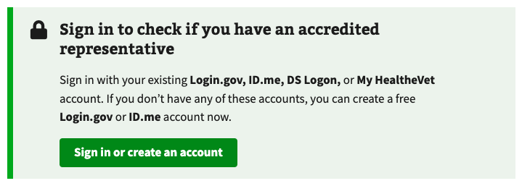

Figure 1. Unauthenticated.



Figure 2. Authenticated, no representative.

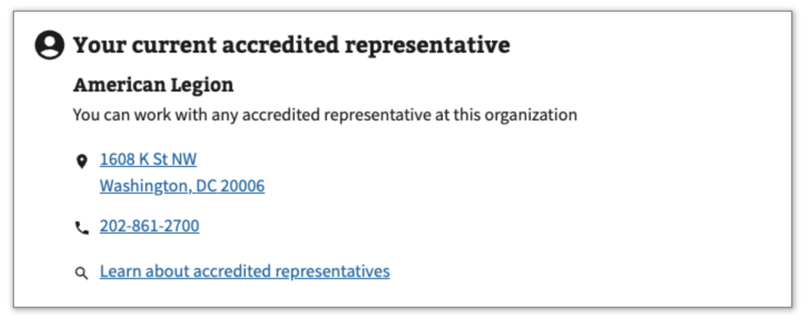

Figure 3. Authenticated, represented by a Veteran Service Organization.

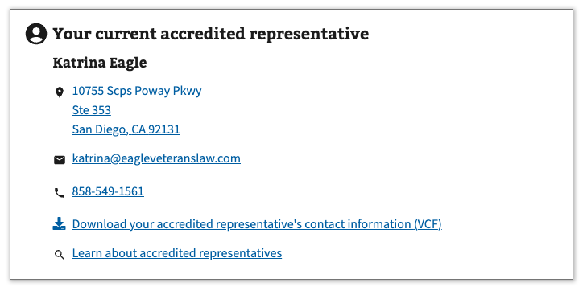

Figure 4. Authenticated, represented by an individual (attorney or claims agent).

## 5. Major Issues and Error Messages

If there is an issue retrieving the active representation for an authenticated user, an error message will be displayed.

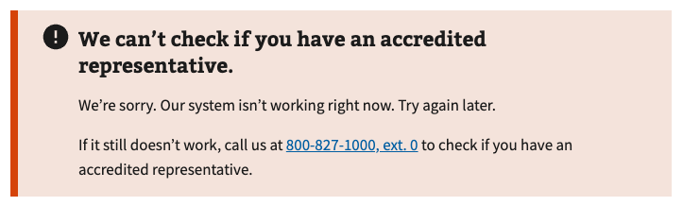

Figure 4. Authenticated, error.

## 6. Frequently Asked Questions

Users may have the following questions, when using this product:

1. What makes a representative accredited?
2. How do I appoint a new accredited representative?
3. How can an accredited representative help me?
4. Does an accredited representative have to help me?
5. Can I work with more than one accredited representative at a time?
6. Can I work with an accredited representative online or over the phone?
7. How do I cancel my representation?

Answers to these questions, and additional information about accredited representatives can be found on:

1. The top of the “Find a Representative” product page includes definitions of each type of accredited representative: <https://va.gov/get-help-from-accredited-representative/find-rep>
2. The “Get help from an accredited representative” landing page includes information on how to find and appoint an accredited representative: <https://va.gov/get-help-from-accredited-representative>.
3. The “FAQ” page includes additional information about accredited representatives: <https://www.va.gov/resources/va-accredited-representative-faqs/>

## 7. Table of Figures

Figure 1. Unauthenticated. 5

Figure 2. Authenticated, no representative. 5

Figure 3. Authenticated, represented by a Veteran Service Organization. 5

Figure 4. Authenticated, represented by an individual (attorney or claims agent). 5

Figure 4. Authenticated, error. 6