Sarah Ewing

03/29/2024

Module 2.3 Assignment

Entity Relationship Diagram (ERD)

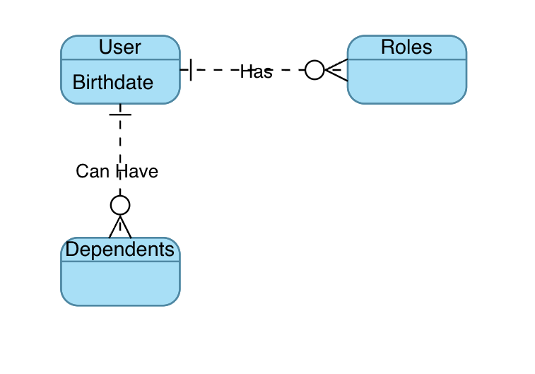

NoSQL Data Structure

