Sarah Ewing

04/13/2024

Module 5.2 Assignment

The CONCAT() function can be used to concatenate two or more strings into a single string. You might use this function when you have a column for first names and a column for last names and you want to concatenate those values into a full name using the alias Full_Name. To test this function, I used the statement:  
SELECT CONCAT(“Sarah”, “ “, “Ewing”) AS Full_Name;

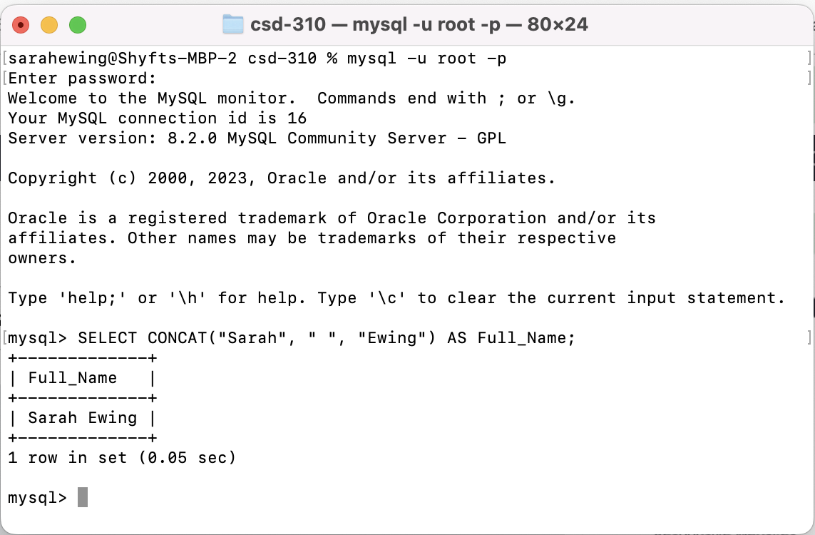

The DATE_FORMAT() function is used to format a date or datetime value based on a specified format. You might use this function when you want to display dates in a particular format, such as “YYYY-MM-DD" or “DD-MM-YYYY". An alias that you could use is formatted_date. To test this function, I used the statement:  
SELECT DATE_FORMAT(CURRENT_DATE(), ‘%m-%d-%Y’) AS formatted_date;  
  
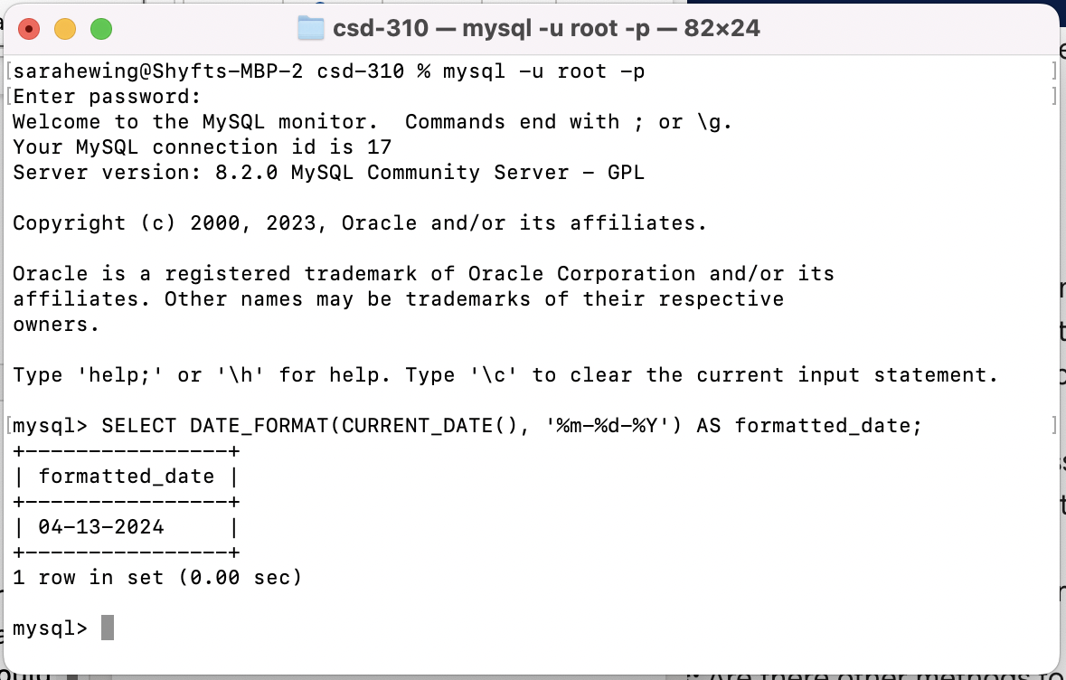

The DATEDIFF() function is used to return the number of days between two date values. You might use this function if you needed to keep track of how many days something takes, like from the date an order is placed until the date the order ships. To test this function, I used the statement:  
SELECT DATEDIFF("2024-04-05", "2024-04-01") AS days_to_ship;

