**Sarah Kenneally**

**Student Number: 10394004**

**Observations from Changes Dataset**

1. Thomas is the most productive member of the team with, with 191 revisions, followed by Jimmy with 152 then there is a steep drop off for the rest of the authors as seen below.

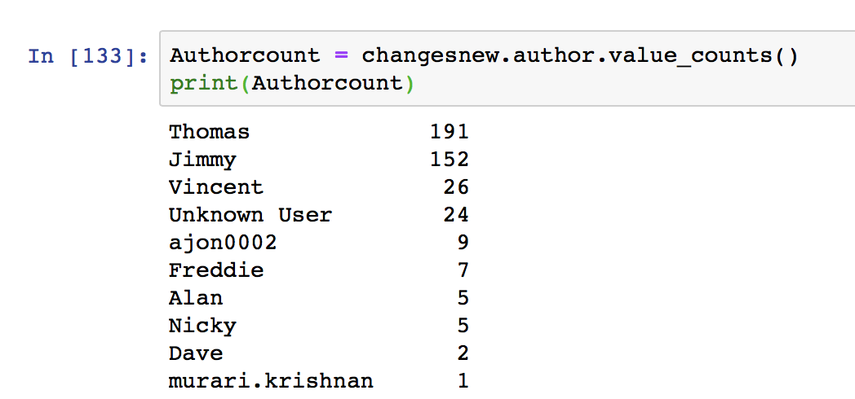

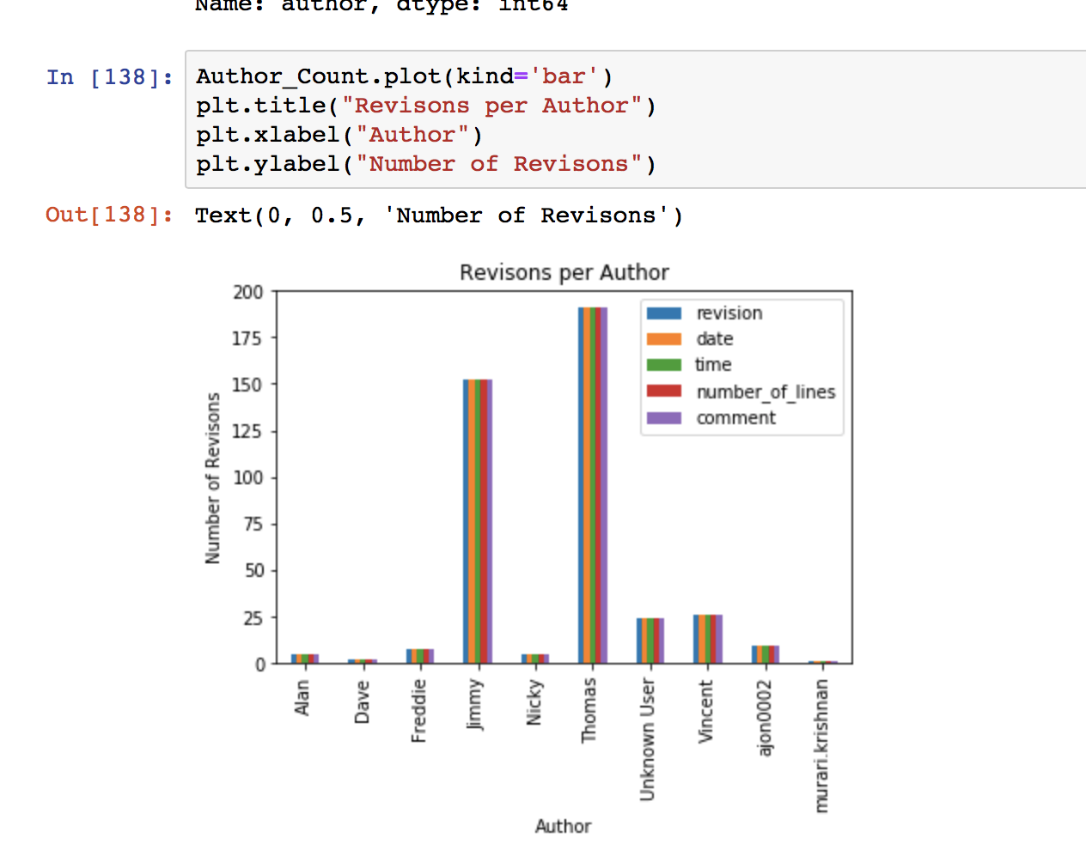

It is interesting that there are 24 from an unknown user which was displayed as **/OU=Domain Control Validated/CN=svn.company.net** in dataset. Perhaps this was the users not logging in correctly or was a temp name for a new joiner which later had their revisions recorded under their own name.

1. We can see that the number of revisions increases every day from Monday to Thursday then slightly drops of on a Friday and largely drops off for Saturday and Sunday which we can assume are overtime/on call revisions. It is interesting that more revisions get made steadily throughout the working week and then drop on Fridays when people may be more inclined to take leave or wind down for the week.

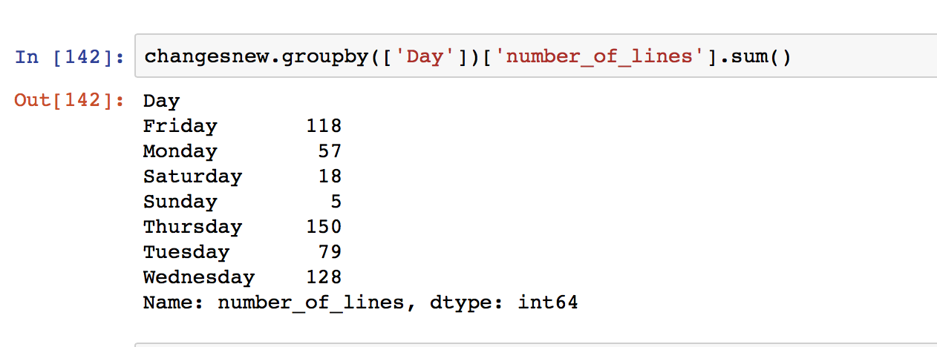

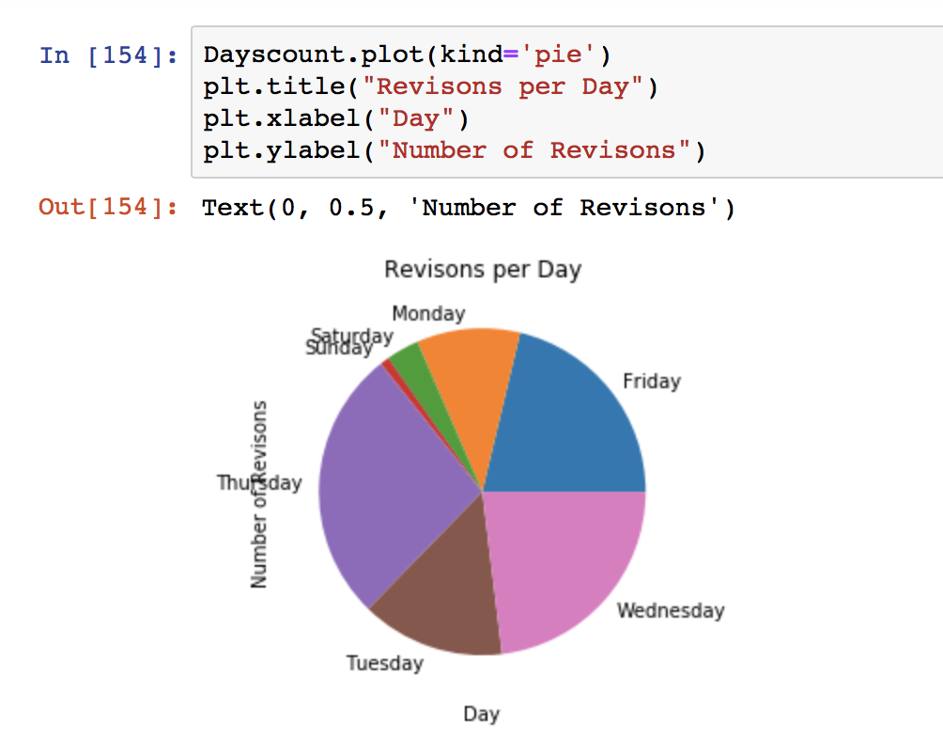

1. Changes were recorded from 2015-01-10 to 2015-12-11

The most amount of revisions where done on the 2015-11-26 when there was 30 revisions made. The mean amount of changes per day was 7 and there were 76 days when changes were made as below.

