SARAH KHAIRUNNISA ADI KUSUMA
Portfolio — Academy Submission
Bachelor of Management — Business Management in Telecommunications & Informatics, Telkom University (2020–2024), GPA 3.48/4.00
Phone: 081316231212 Email: sarahkhai48@gmail.com
LinkedIn: linkedin.com/in/sarahkhairunnisaadikusuma

This portfolio presents five selected projects from my studies, my professional experience, and my involvement in student organisations. Together they reflect my interest in business development, public relations, and project management: understanding what people need, communicating it clearly, and coordinating the work that turns an idea into something people can actually use.
Each entry below states whether the work was individual or a group project, my role in it, the impact I made, and what I took away from it. All photographs are my own documentation of the work described.
PROJECT 1 Financial Behavior, Financial Attitude & Investment Decisions
Type: Class assignment — undergraduate final project (thesis), Telkom University
Format: INDIVIDUAL PROJECT — sole researcher and author
Period: Completed September 2024
SUMMARY
A quantitative study of how financial behavior and financial attitude influence the investment decisions of active investors in Indonesia, with financial literacy tested as a moderating variable. The full title is "Pengaruh Perilaku Keuangan dan Sikap Keuangan Terhadap Keputusan Investasi dengan Literasi Keuangan sebagai Variabel Moderasi".
WHAT I DID
- Designed the research framework and hypotheses linking financial behavior, financial attitude, financial literacy, and investment decisions.
- Collected primary data through an online questionnaire distributed to 400 respondents who actively invest, using the Slovin formula at a 5% margin of error.
- Analysed the data with SmartPLS 3.0 (PLS-SEM), including bootstrapping and a specific indirect-effect test to measure the moderating role of financial literacy.
- Wrote and defended the full 134-page report before two examiners.
IMPACT
The study found that financial behavior and financial attitude both significantly affect investment decisions, and that financial literacy strengthens that relationship. On that basis I recommended more intensive education on personal financial management, on starting to invest early, and on the effect of impulsive buying — and argued for closer collaboration between financial institutions and government so that this information reaches people in every region. The work was accepted as the final requirement of my degree, which I completed with a GPA of 3.48/4.00.
WHAT I LEARNED
Working with 400 responses taught me to be careful with data: how a variable is defined determines what you are allowed to conclude from it. I also learned to run a long project on my own timeline — from proposal to defence — and to explain a statistical result to people who do not read statistics, which is the part I now find most useful in a business setting.
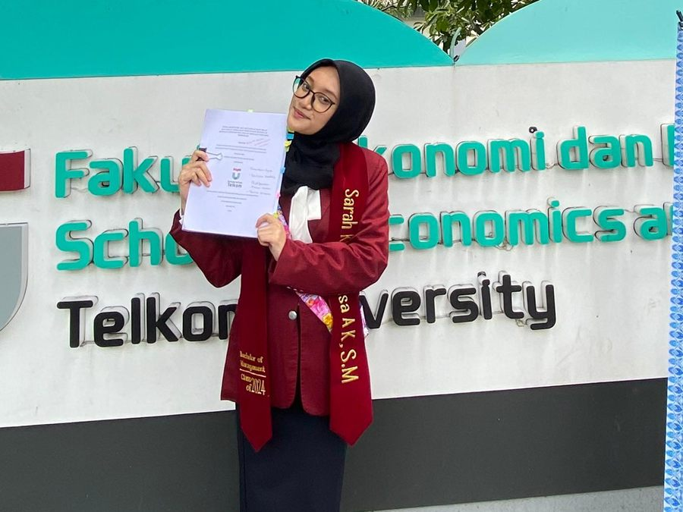
Final project submission at the School of Economics and Business, Telkom University
PROJECT 2 Ice See U — Banana Peel Ice Cream (Creative Entrepreneurship Festival)
Type: Class assignment — Entrepreneurship Project course (class MB-44-11), showcased at the Creative Entrepreneurship Festival
Format: GROUP PROJECT — a team of four students
My role: Production, Media & Marketing
Period: 28 March – 30 May 2023, Dayeuhkolot, Bandung
SUMMARY
Ice See U is a student culinary venture that turns banana peel — normally thrown away — into ice cream, sold in a banana-peel container instead of a plastic cup or cone. The idea was to prove that a food-waste ingredient could be made into something people genuinely want to buy.
MY CONTRIBUTION
- Built the digital marketing strategy and produced the social media content for the @ice_seeu Instagram account to grow brand awareness.
- Planned production requirements, selected the ripe banana peels and other raw materials, and processed the product under strict hygiene and food-safety standards.
- Ran periodic quality control on production output so that quantity and quality matched incoming demand.
- Helped run product introduction sessions on and around campus, handing out free testers and collecting customer feedback.
IMPACT
Over an eight-week selling period the team moved from an unknown product to a recognised one: brand awareness was built, the number of customers grew, and we secured consignment partnerships with warung and SRC shops around campus so the product could be sold without us being physically present. When competing ice cream sellers appeared, the differentiation I helped communicate — the sustainability angle and the edible container — was what set us apart.
WHAT I LEARNED
This was the project where marketing stopped being theory for me. I learned that a good product still needs someone to explain it: people would not try banana-peel ice cream from a poster, but they would try it from a sample and a conversation. I also learned how tightly marketing and operations are tied together — promising demand we could not produce hygienically and on time would have damaged us faster than having no customers at all.
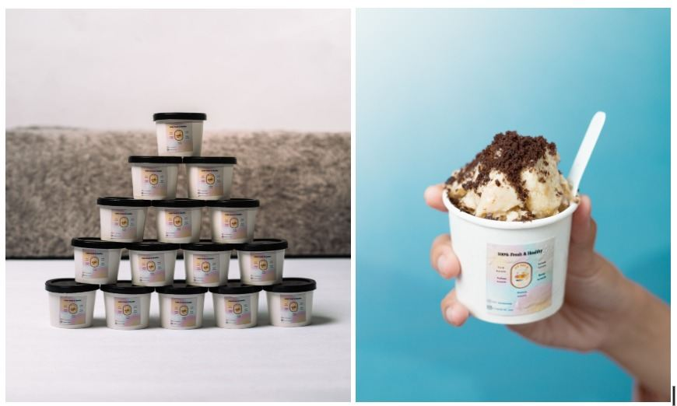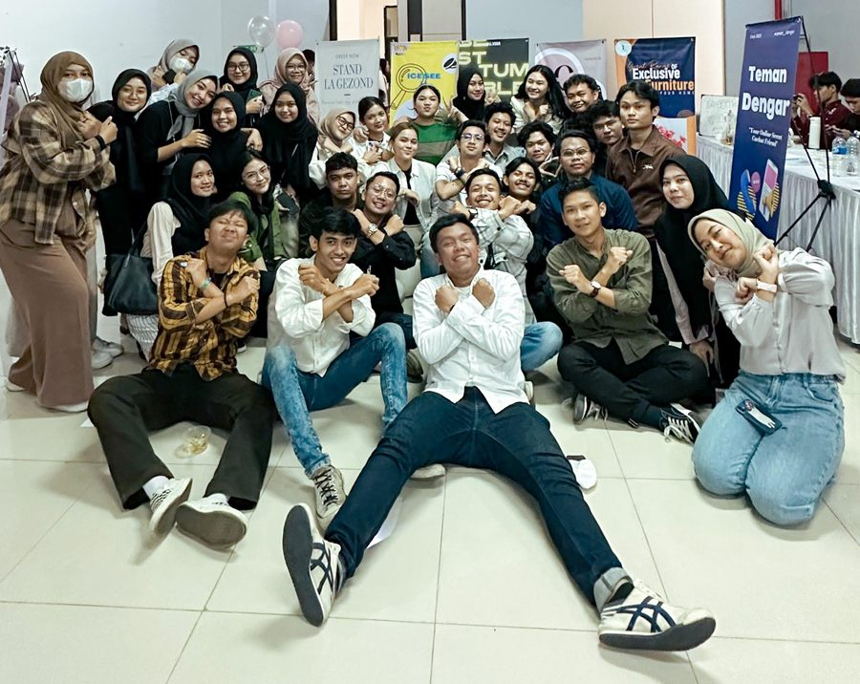
Ice See U product documentation, and the team at the Creative Entrepreneurship Festival
PROJECT 3 Digital Learning Content Management — CeLOE Telkom University
Type: Work assignment — Staff, Digital Content Management & Utilisation
Format: GROUP PROJECT — worked within the CeLOE digital content team
My role: Content production, platform management, and event & booth handling
Period: July – September 2023, Bandung
SUMMARY
CeLOE (Center of eLearning and Open Education) runs Telkom University's blended-learning ecosystem. I produced and curated the visual learning material that lecturers and students use, and kept it published on schedule on the e-learning platform.
MY CONTRIBUTION
- Produced and curated visual learning materials — PowerPoint slides and instructional videos — to the institution's quality standard on a daily basis.
- Managed and uploaded content on schedule to the e-learning platform so that the user experience stayed consistent for students.
- Took part in field coordination during events, staffed the booth, and communicated persuasively with visitors and partners.
IMPACT
My work kept a steady flow of course material live and on time, which is what students actually experience when they open the platform. Because the material was checked against a fixed quality standard before it went up, lecturers could rely on the content being ready rather than having to fix it themselves — and at events, I became one of the people representing CeLOE directly to visitors and partners.
WHAT I LEARNED
This was my first professional environment, and it taught me that consistency matters more than brilliance: a schedule that never slips is worth more to users than one excellent video. I also learned to work to someone else's quality standard rather than my own taste, and — at the booth — that explaining a product face to face is a completely different skill from designing its slides.
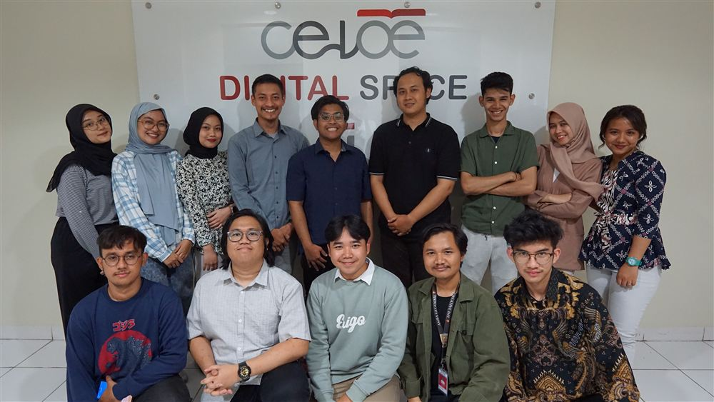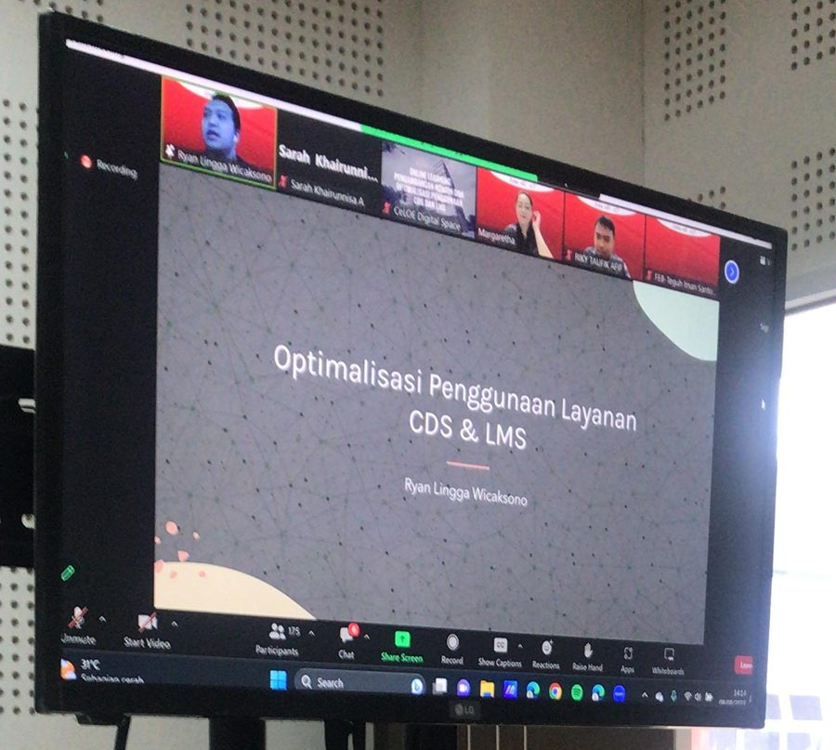
The CeLOE Digital Space team, and an online session on optimising CDS & LMS services
PROJECT 4 PERKARA — Student Organisation Events
Type: Self-initiated — voluntary student organisation for Telkom University students from Karawang
Format: GROUP PROJECT — organising committee
My role: Vice Head of Event (Wakil Ketua Acara)
Period: August 2022 – June 2024, Karawang & Bandung
SUMMARY
PERKARA exists to keep Telkom University students from Karawang connected to each other — a support network away from home. As Vice Head of Event I led the design and delivery of the organisation's events from first idea through to post-event evaluation.
MY CONTRIBUTION
- Led event concept design and execution end to end: ideation, budgeting, delivery, and final evaluation.
- Coordinated the team producing creative promotional material so that it stayed consistent with each event's theme.
- Supervised and took direct responsibility for the selection and retention of new members.
IMPACT
Holding the budget and the concept in the same pair of hands meant our events stayed within what we could actually afford, and the promotional material finally looked like it belonged to one organisation instead of to whoever designed it that month. Being responsible for retention also changed how I ran events: I stopped measuring an event by how it looked on the day and started measuring it by whether members came back to the next one.
WHAT I LEARNED
Two years in this role taught me delegation. Early on I tried to check everything myself and became the bottleneck; I learned to set the standard clearly at the start, then trust the team and review at agreed points. I also learned that a budget is a design constraint, not paperwork — deciding early what we would not spend on made the rest of the planning much faster.
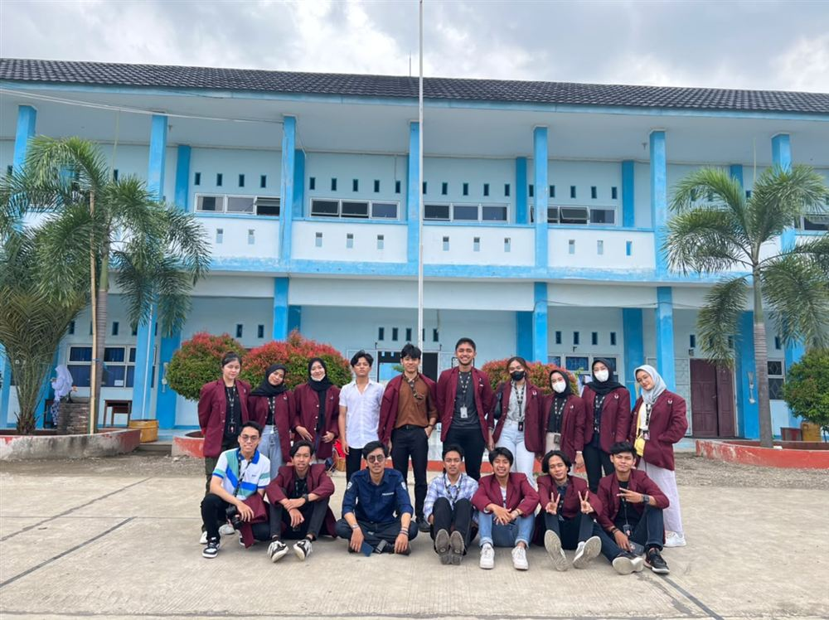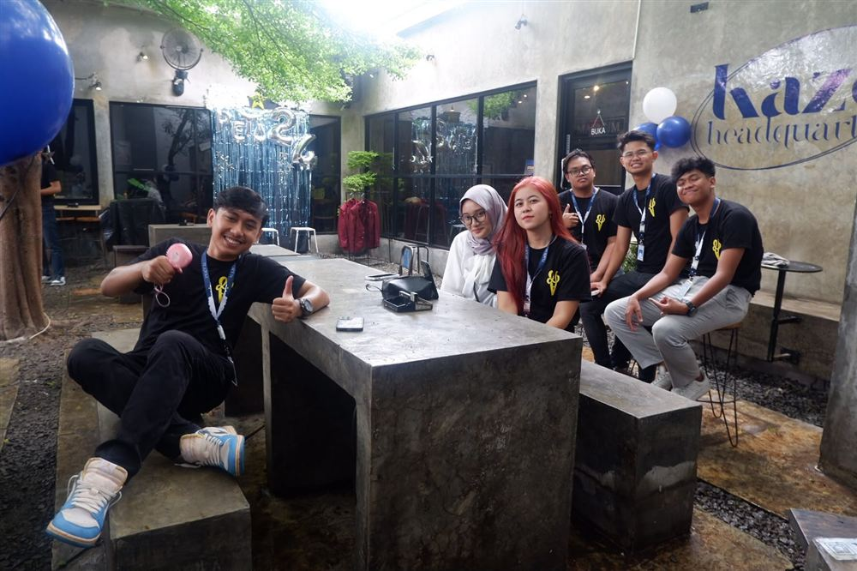
PERKARA members and the organising committee during organisational activities
PROJECT 5 Telkom University Roadshow & Edufair — "Peace" Committee
Type: Self-initiated — voluntary committee promoting Telkom University through roadshows, edufairs, and seminars/webinars
Format: GROUP PROJECT — committee of 34 members across seven divisions
My role: Secretary (Sekretaris 1) for the Roadshow and KEF events
Period: December 2022 – February 2023, Karawang
SUMMARY
A committee that introduced Telkom University to prospective students through school roadshows, education fairs, and seminars. As Secretary I ran the administrative backbone of the programme so that the people on stage could focus on the audience.
MY CONTRIBUTION
- Managed official organisational administration, including invitation letters, bureaucratic permits, and activity reports.
- Took the minutes of the regular committee meetings so that seven divisions stayed aligned on the same decisions.
- Compiled the post-event accountability report (Laporan Pertanggungjawaban) systematically and transparently.
- Managed the participant registration database that the team relied on for on-site operations.
IMPACT
Permits and invitation letters are the kind of work that is invisible when it is done and fatal when it is not — securing them on time is what allowed the roadshow to enter schools at all. Keeping accurate minutes meant decisions were not re-argued at the next meeting, and a clean registration database meant the team on the ground knew exactly who to expect instead of improvising at the door.
WHAT I LEARNED
I learned that documentation is a form of respect for other people's time, and that accountability reporting is a skill worth doing properly rather than at the last minute. Coordinating across seven divisions also taught me how to write so that people who were not in the room still understand exactly what was decided and what they now have to do.
Photographic documentation for this programme is available on request.
Certifications

- Manajemen Risiko (Risk Management) — BNSP, Badan Nasional Sertifikasi Profesi, 2023
- Intro to Digital Marketing — RevoU Mini Course, issued 31 January 2025
- Intro to Data Analytics — RevoU Mini Course, issued 3 October 2025
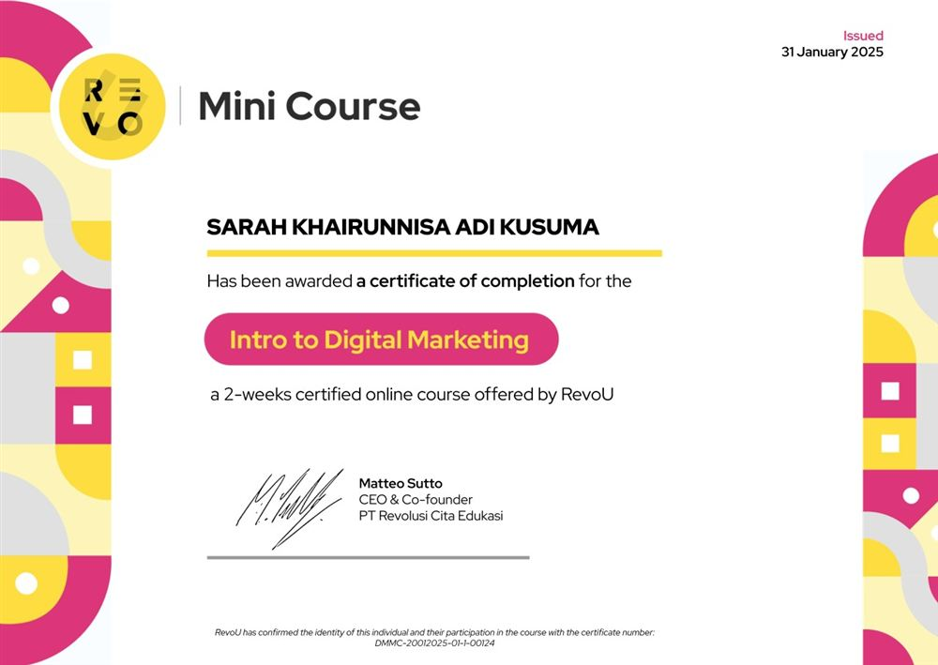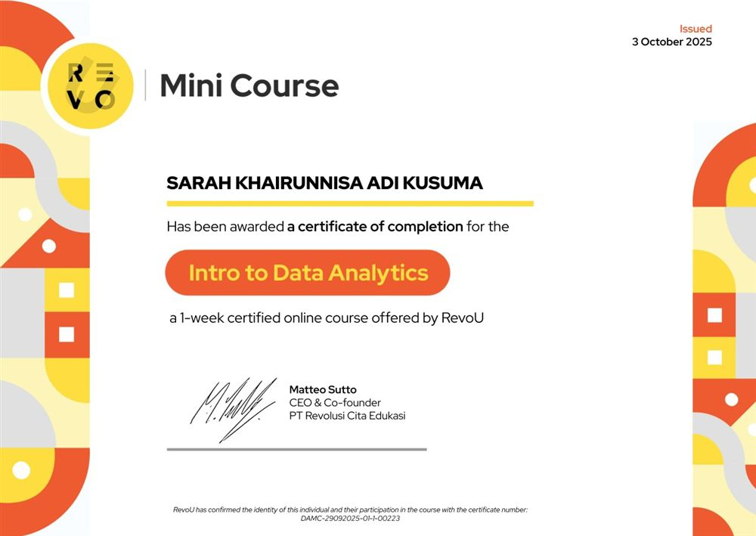
RevoU certificates of completion
Skills applied across these projects

Project management · Design thinking · Digital marketing and social media content · Market and customer research · Event planning and budgeting · Organisational administration and accountability reporting · Quality control · Data collection and analysis · Team management · Public and partner communication.
Tools: Microsoft Word, Microsoft PowerPoint, Microsoft Excel, Canva, SmartPLS.
Thank you for taking the time to read my portfolio.

