------
Document Title: KidsOR + Public Intervention
Document #: DHF 001 | Revision #: 01 | Previous Doc/Rev #: N/A

CHANGE HISTORY
Rev. | Date | Detailed change description (include rationale for change) | Affected Documents | Supporting Documents
01 | 08/27/24 | Initial Release | DH01 | EN-1

DOCUMENT REVIEW AND APPROVAL
Name | Title (Admin and Engineering Roles) | Contributed Sections | Signature/Date
Brooke Struyk | Project Lead and Design Engineering | Existing Solutions, User Profile, Use Environment, Standards & Statutory Requirements, System & Gap Analysis, Job Map, Customer Discovery Data, User Needs, |   9/22/2026
Kaayla Osborne | Client POC and Electronic Engineering | Proposed solution, Miro Board, User Needs, Standards & Statutory Requirements, and Customer Discovery Data. |   9/22/2026
Rachel Mensah | Testing and Validation Engineering | Problem statement, Table 001-4 Technology Readiness Levels and project Workflow, System and Gap Analysis, Table 001-5 Design Control Matrix, Standards & Statutory Requirements and Customer Discovery Data. | 9/22/2026
Sarah Krishnamoorthy | Software and Systems Engineering | Existing Solutions, Project Scope: Prototyping, Experimental, & Computational, Patient Profile & Tissue Interaction, Use Environment, Job Map | 9/22/2026

Purpose 2
Definitions 3
Document Definitions 3
Table 001-1 Document Definitions 3
Document Acronyms 4
Table 001-2 Document Acronyms 4
Project Description 4
Problem Statement 4
Existing Solutions 5
Proposed Solution 7
Project Management 7
Project Team 7
Table 001-3 Project Team 7
Project Scope: Prototyping, Experimental, & Computational 8
Table 001-4 Technology Readiness Levels 9
System and Gap Analysis 10
User Needs 11
User Profile 11
Patient Profile and Tissue Interaction 12
Use Environment 12
User Needs 1
Table 001-5 Design Control Matrix 1
Standards and Statutory Requirements 1
Table 001-6 Standards and Statutory Requirements 1
Miro Board 1
Job Map 1
Customer Discovery Data 3
References 1

Purpose

This document outlines the project scope and summarizes the basic user needs for a better way to track and collect anesthetic waste gas. This document is the first Design History File (DHF) of the series for this system. It is intended to convey the user's needs for the system and communicate the user's needs of the system to the entire team. By allowing public access to this file, anyone can continue and add their ideas to the project and create their own anesthetic gas waste monitoring and connection system.

Definitions

Document Definitions

Table 001-1 Document Definitions
Term | Definition
Design History File | A compilation of records containing the complete design history of a finished device or service
User Need | A clear statement of what a user requires from a product or system to complete a task or solve a problem.
Design Input | The design requirements relating to a device that are relevant and appropriate for the device’s intended use and user needs.
Design Output | An engineering characteristic or metric that translates a customer or user need into a technical requirement.
Verification | Confirmation by examination and provision of objective evidence that specified requirements have been fulfilled
Validation | Establishing objective evidence that system specifications conform to user needs and intended uses
Component | One of the parts that make up a system. A component may be hardware or software and may be subdivided into components
Functional Testing | Testing that ignores the internal mechanism of a system or component and focuses on the outputs generated in response to selected inputs
Scrubber | A device or system that removes unwanted gases from an air or gas stream.
Adsorbent | Describing a material that captures molecules on its surface.

Document Acronyms

Table 001-2 Document Acronyms
Acronym | Description
DHF | Design History File
ISO | International Organization for Standardization
POC | Point of Contact
WAG | Waste Anesthetic Gas
WAGD | Waste Anesthetic Gas Disposal
OSHA | American Occupational Safety and Health Administration
DI | Design Inputs
DO | Design Outputs
OR | Operating Room
AGSS | Active Gas Scavenging System
BMETs | Biomedical Equipment Technicians
HVAC | Heating, Ventilation, and Air Conditioning

Project Description

Problem Statement

“Problem Statement: A way to reduce healthcare personnel exposure to WAG in low-resource ORs by developing a low-cost WAG management system.”

WAGs are small amounts of anesthetic particles that remain in the ambient air of ORs even after a procedure has been completed [1]. Of these WAGs, isoflurane, sevoflurane, desflurane, and nitrous oxide are most common [1]. While there have been developments in WAG management, exposure to these chemicals remains a concern for healthcare personnel. OSHA estimates that over 200,000 health professionals are at risk of occupational diseases due to chronic exposure to WAGs [1].

The release of WAGs in ORs occurs in a variety of ways such as anesthesia workstation leaks, a lack of scavenging systems, connectivity issues in the respiratory circuit, face-mask seal troubles, and more [1]. While some ORs use a global or partial scavenging system, systems that collect and dispose of WAGs, others lack a scavenging system entirely [2].

The need to develop waste management systems in low-resource healthcare settings is especially important where the availability of scavenging systems, monitoring, financial resources, and exposure regulations may be limited. Developing countries often require additional measurement and regulation of WAG exposure due to the lack of scavenging systems within clinical settings [1]. This presents a need for a low-cost and reliable WAG management system that will reduce exposure while minimizing the dependence on local electrical infrastructure.

Existing Solutions

Several approaches are currently used to reduce WAG exposure in ORs. The primary and common ways to reduce WAG exposure are AGSS, passive scavenging systems, ventilation, and adsorption or scrubber systems [3]. The AGSS (Figure 1) is designed to collect anesthetic gas from the breathing circuit, purify the gas, and discharge it back into the OR [4].

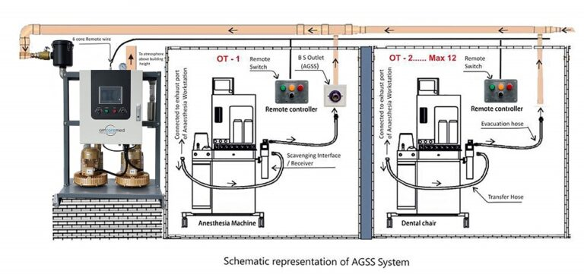
Figure 1. AGSS System Review [5].
The AGSS uses a blower to generate a negative pressure vacuum. When this happens, AWG is collected into the machine's gas pipelines, filtered, and released in a safe area. This system works automatically and prevents AWG from building in the OR [5].

The system uses negative pressure to suction to collect the AWG air. It has five main parts that operate automatically: a gas collection assembly, transfer tubing, an interface, gas-disposal pathway, and gas disposal assembly [3]. The disposal assembly could be routed to a variety of mediums, like a ventilation system, adsorber, or a vacuum. These systems are separated by active versus passive scavenging. An active system (Figure 2) works by using a vacuum or negative pressure in the gas disposal tubing. This system works well when a centralized vacuum system or a dedicated exhaust disposal system is used [3]. The active system can collect gas from multiple ORs, and when there is a leak, the scavenging system will not lose any gas.

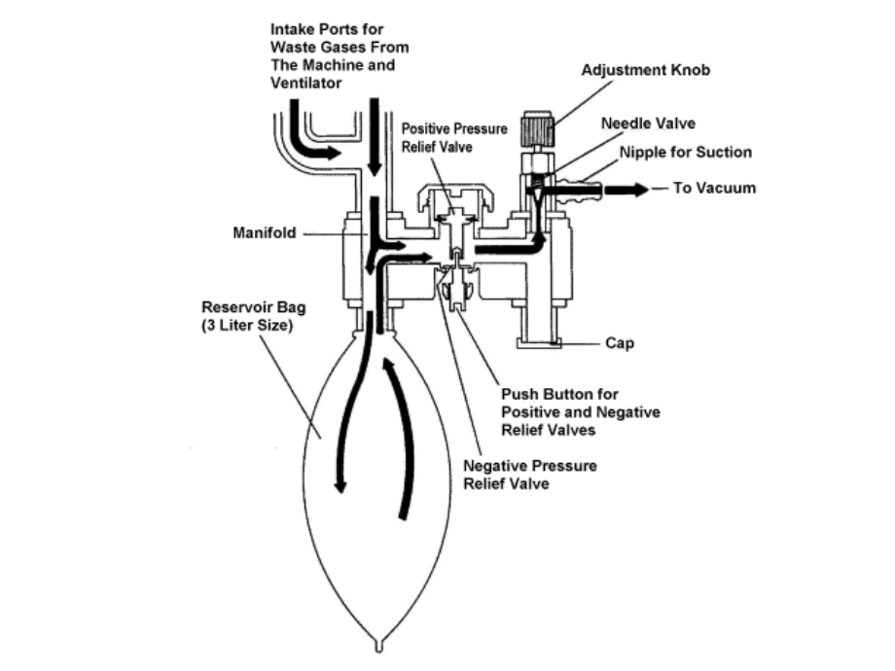
Figure 2. Active anesthetic gas scavenging interface with reservoir bag and pressure relief valves [3].
Waste gases enter through the intake ports, are collected into the reservoir bag, then drawn to the vacuum source. Positive and negative pressure relief valves help prevent excessive pressure or suction on patient breathing circuit [3].

A passive system (Figure 3) does not have a vacuum or negative pressure and works by using HVAC systems that are either nonrecirculating or recirculating [3]. Nonrecirculating systems take fresh air from the outside and circulate filtered and conditioned air throughout the OR. This system is concerning because it directly releases AWG into the outside air without filtration; however, AWG can be directed into the exhaust airflow. Recirculation reuses the same room air, and the AWG can only enter the exhaust after the air is taken for recirculation [3]. Some other passive systems include vents to the outside or holes in the ceiling. Overall, using ventilation or an HVAC system is good for reducing the amount of AWG in the room and that the gas the AGSS missed.

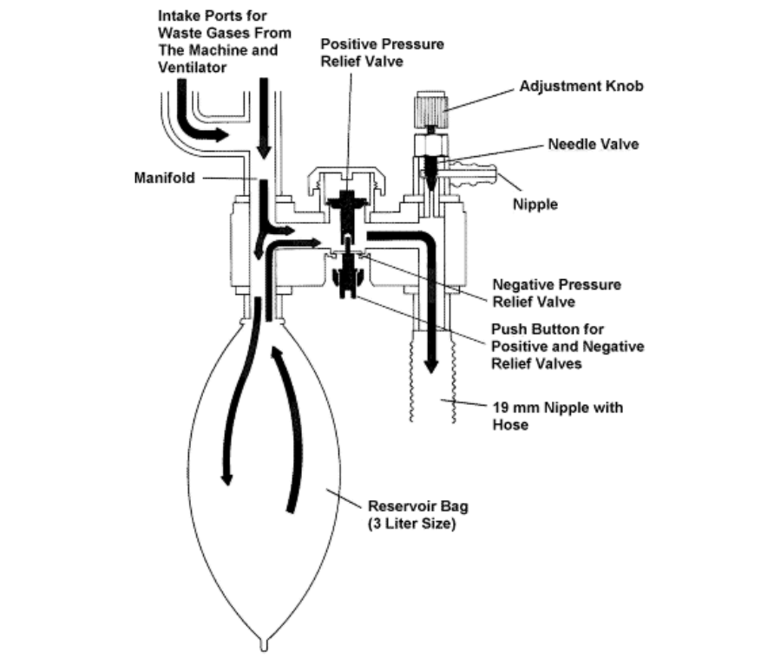
Figure 3. Passive AGSS interface [3].
Waste gases enter through intake ports, collect in the reservoir bag, then move to the outlet house without any applied force. Positive and negative pressure relief valves help prevent any excessive pressure or suction on the patient's breathing circuit [3].

Proposed Solution
“Intended Use Statement: The WAG sensor is intended for notification and possible eradication of excessive gas in the open air to keep medical personnel safe in the OR.”

Our WAG sensor has two main functions: sensing when the OR environment has reached unsafe levels of anesthetic gas and activating a fan to assist in removing WAG from the OR. The sensor will notify medical personnel when dangerous gas has reached its threshold; it will receive gas concentration data from the environment and create a WAG alert on a digital display and/or audible alarm. The modular fan will be placed near a door or window and will turn on when the sensor activates the display and/or alarm.

Project Management

Project Team

Table 001-3 Project Team
Name | Title | Role
Brooke Struyk | Project Lead and Design Engineering | Responsible for leading team and stakeholder meetings, taking meeting minutes, splitting up assignments, and keeping the team aligned. Also, responsible for any CAD modeling done for the solution.
Kaayla Osborne | Client POC and Electronics Engineering | Responsible for contacting our mentors for updates on the project and scheduling meetings. Also responsible for circuit analysis for our device and ensuring we have the correct electrical components.
Rachel Mensah | Testing and Validation Engineering | Responsible for developing and executing system validation tests to evaluate the functionality, safety, and performance of the device. This includes identifying performance criteria, creating test procedures, and documenting results.
Sarah Krishnamoorthy | Software and Systems Engineering | Responsible for translating user needs into system requirements, defining and understanding hardware and software interaction, and supporting integration. Also, assist in requirement traceability and verification testing to ensure system requirements were successfully translated and executed.

Project Scope: Prototyping, Experimental, & Computational

Fall (Proof-of-concept)
- Primary prototyping deliverable (TRL 3-4) for proof-of-concept build: The team plans on building a prototype that can monitor and remove WAG from a simulated OR environment. The prototype will include some major components such as a collection interface, tubing, a removal mechanism, and sensing components. The sensing system would include a sensor, an Arduino microcontroller, circuitry, and display for communicating measurements and alerts. The prototype would not need to be representative of the final product in terms of material or aesthetic design, but it should demonstrate that the different subsystems and components are able to function and operate together. Success is demonstrated by successful WAG redirection, components working in harmony in controlled conditions, and if the sensing system can detect the presence of gas or leakage.

- Primary experimental deliverable for quantitative test plan (TRL 5): The team can run tests under controlled conditions. Testing will focus on gas flow rate, sensor response, and system pressure. The sensing system will be evaluated for response time, repeatability, and detectability. If a removal component is incorporated, the team will determine if gas is moving through the intended path without creating excessive pressure or flow resistance. All these metrics can be compared to the computational model to identify potential weaknesses in our initial design. Conditions such as gas flow rate, removal system settings for measuring airflow, and system pressure will vary in testing [6].

- Primary computational deliverable for physics-based simulation (TRL 4): For the computation deliverable, the team plans to develop a low-to-intermediate fidelity COMSOL Multiphysics model of the major flow pathways in the prototype. This model will allow for the prediction of fluid flow, pressure, and transport behavior in the system. Gas concentration changes with operating flow conditions, while transport and adsorption behaviors are dependent on flow rate and contact time when evaluating removal system effectiveness [7]. The results from the COMSOL simulations will be compared to the experimental measurements of airflow, pressure, and gas concentration.

Spring (Full Functional)
- Primary prototyping deliverable (TRL 6-7) for full, functional build: The team plans to build a prototype that incorporates the design features chosen and refined in fall through prototyping, testing, and modeling. This spring prototype would fulfill the intended functions of monitoring and removing WAGs and reflect the end user's needs such as safety, ease of use, and a modular design. The sensing system, removal mechanism, circuitry, Arduino microcontroller, and display will be integrated into a single prototype. Success is demonstrated by reliable and repeatable operation of the solution under conditions similar to the OR.

- Primary experimental deliverable for quantitative test plan (TRL 7-8): Testing will be coordinated with Dr. Stone, who has contacts with access to anesthesia equipment and gases. The prototype will be tested under a broader and more varied range of conditions that are more reflective of expected usage. Variance in gas flow rate, removal settings, tubing, or other design parameters whilst measuring airflow, system pressure, leakage, and gas concentration. If any adsorbent or scrubber is added, breakthrough behavior, downstream gas concentration, and changes as saturation approaches should also be evaluated. Additionally, testing to ensure the sensing components (sensor, Arduino, circuitry, and display) integrate well with other parts of the prototype will be part of this deliverable. The final testing results will be compared against design requirements and predictions from computation testing to determine success.

- Primary computational deliverable for physics-based simulation (TRL 8): The team will further refine the COMSOL model developed during the fall to ensure it closely represents the final prototype configurations and conditions. Experimental data from iterative testing of low-fidelity prototypes can be utilized to improve the model’s predictions of parameters such as fluid flow and pressure. This refined model would allow the team to further evaluate major design variables to affect WAG capture and removal. If an adsorbent is included, then the model can also be utilized to see how this affects the removal of WAGs. The final computational model results can be used with the final verification testing to justify team design decisions.

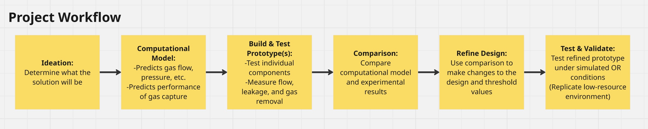
Figure 4. Project Workflow Miro Board
Overview of the proposed workflow for developing and evaluating the low-cost WAG management system.

Table 001-4 Technology Readiness Levels
TRL | Description | Supporting Information
1 - Basic principles  observed and reported | Lowest level of technology readiness. Scientific research begins to be translated into applied research  and development (R&D). Examples might include paper studies of a technology's basic properties. | Published research that identifies the principles that underlie this technology. References to who, where, when.
2 - Technology concept  and/or application  formulated | Invention begins. Once basic principles are observed,  practical applications can be invented. Applications  are speculative, and there may be no proof or detailed  analysis to support the assumptions. Examples are  limited to analytic studies. | Publications or other references that outline the application being considered and that provide analysis to support the concept.
3 - Analytical and  experimental critical  function and/or  characteristic proof of  concept | Active R&D is initiated. This includes analytical studies and laboratory studies to physically validate the analytical predictions of separate elements of the technology. Examples include components that are not yet integrated or representative. | Results of laboratory tests performed to measure parameters of interest and comparison to analytical predictions for critical subsystems. References to who, where, and when these tests and comparisons were performed.
4 - Component and/or  breadboard validation in  laboratory environment | Basic technological components are integrated to establish that they will work together. This is relatively “low fidelity” compared with the eventual system. Examples include integration of “ad hoc” hardware in the laboratory. | System concepts that have been considered and results from testing laboratory-scale breadboard(s).  References to who did this work and when. Provide an estimate of how breadboard hardware and test results  differ from the expected system goals.
5 - Component and/or  breadboard validation in  relevant environment | Fidelity of breadboard technology increases significantly. The basic technological components are integrated with reasonably realistic supporting elements so they can be tested in a simulated environment. Examples include “high-fidelity”  laboratory integration of components. | Results from testing laboratory breadboard system are integrated with other supporting elements in a simulated operational environment. How does the “relevant environment” differ from the expected operational environment? How do the test results  compare with expectations? What problems, if any, were encountered? Was the breadboard system refined to more nearly match the expected system goals?
6 - System/subsystem  model or prototype  demonstration in a relevant  environment | Representative model or prototype system, which is well beyond that of TRL 5, is tested in a relevant  environment. Represents a major step up in a technology's demonstrated readiness. Examples  include testing a prototype in a high-fidelity laboratory environment or in a simulated operational environment. | Results from laboratory testing of a prototype system that is near the desired configuration in terms of  performance, weight, and volume. How did the test environment differ from the operational environment?  Who performed the tests? How did the test compare with expectations? What problems, if any, were encountered? What are/were the plans, options, or  actions to resolve problems before moving to the next level?
7 - System prototype  demonstration in an  operational environment | Prototype near or at planned operational system. Represents a major step up from TRL 6 by requiring  demonstration of an actual system prototype in an operational environment (e.g., in an aircraft, in a  vehicle, or in space). | Results from testing a prototype system in an operational environment. Who performed the tests? How did the test compare with expectations? What  problems, if any, were encountered? What are/were the plans, options, or actions to resolve problems before moving to the next level?
8 - Actual system  completed and qualified  through test and  demonstration | Technology has been proven to work in its final form and under expected conditions. In almost all cases,  this TRL represents the end of true system development. Examples include developmental test and evaluation (DT&E) of the system in its intended weapon system to determine if it meets design specifications. | Results of testing the system in its final configuration under the expected range of environmental conditions  in which it will be expected to operate. Assessment of whether it will meet its operational requirements. What problems, if any, were encountered? What are/were the plans, options, or actions to resolve problems before finalizing the design?
9 - Actual system proven  through successful mission  operations | Actual application of the technology in its final form and under mission conditions, such as those encountered in operational test and evaluation (OT&E). Examples include using the system under operational mission conditions. | OT&E (operational test and evaluation) reports.

System and Gap Analysis

The largest knowledge gap for our team is understanding how WAG is currently handled within ORs. The team needs to learn how anesthesia machines utilize scavenging systems, gas flow rates, what happens when the system has too much or too little gas flow, and how these systems are powered. To address these gaps, we plan to use our interview data, literature reviews, and engineering standards to inform our design decisions and validation.

The high-level components we will be using are anesthetic gas sensors, electrical circuits, display screens, and Arduino and SolidWorks software. Brooke is responsible for the CAD design of the project. She has experience using CAD software, using an electrical circuit board, coding in Arduino, and reliability engineering. Rachel will also provide Brooke with any assistance needed as she has experience with CAD, sensors, electrical circuits, display screens, Arduino, and Raspberry Pi.

Another gap the team has is the computational modeling portion of the project. None of the group members have any direct experience working with COMSOL. Team members have prior experience in MATLAB, SolidWorks, and AutoCAD, which are transferrable skills to COMSOL. Sarah, the computer simulation lead, has experience in data visualization, multiple programming languages, as well as hands-on experience assisting with the testing of a microfluidic chip. Sarah is planning on following COMSOL tutorials and practicing with simplified models prior to modeling the project simulation. Kaayla has experience with modeling circuits and can assist Sarah in translating circuit systems to COMSOL. The other team members plan to assist by also watching introductory tutorials, so they understand the inputs and outputs of the model, ultimately helping in results analysis. An additional knowledge gap is understanding how simulation, prototyping, software, and hardware interact together. This gap will be remedied as the team plans, designs, and tests the prototypes.

User Needs

User Profile
The people who use this device the most are anesthesiologists, BMETs, and anesthesia technicians. Depending on the end solution, the anesthesiologist may have to add to their standard procedure to check the display sensor if the WAG is reaching harmful levels. The anesthesiologist is also the person who administers the anesthesia that is giving off waste gas. All anesthesiologists require 4 years of an undergraduate degree, 4 years of medical school, 4 years of anesthesiology residency, and 1 year of pediatric anesthesiology fellowship [8]. These doctors are highly trained, precise, and quick problem solvers. BMETs are also very important. They will need to be trained when to do preventative maintenance on the device and fix the device if it breaks. The BMET job requires a minimum, an associates applied science degree [9]. To become certified, one must complete 2 years of work experience and a 3-hour exam. These technicians are very good at problem solving and trouble-shooting difficult problems. An anesthesia technician will be the person who does daily checks and maintenance on the anesthesia machines, including the WAG system [10]. Typically, they are the first people who fix a small leak or change valves if there is an issue with the machines. These technicians have a high school diploma or GED and enrolled in an anesthesia technology program. After completing the program and gaining clinical experience they can optionally get an American Society of Anesthesia Technologists and Technicians certificate. The BMETs are the next people who will fix bigger issues that will take longer or require the manufacture’s input.

Patient Profile and Tissue Interaction
The intended patient population of KidsOR is pediatric surgical patients, ranging from newborns to adolescents, in low-resource areas globally. KidsOR enables local surgical teams to perform more complex and diverse procedures. They can treat cleft lip, hernias, orthopedic conditions, and a variety of other surgically treatable conditions [11]. The variation in patient age, size, and procedure type directly affect the device function as pediatric anesthesia practices and breathing circuits differ between neonates, smaller children, and adolescents [3]. Pediatric anesthesia may use lower-resistance breathing systems; this can affect how WAGs are scavenged.
The primary users of the device would be the anesthesia providers and other OR personnel responsible for monitoring the patient and anesthetic delivery. The device’s primary role would be to monitor and remove WAG from the OR during surgical procedures. The proposed device would not have direct contact with the patient or patient tissue. The device would be downstream in the WAG pathway of the anesthesia system or monitoring the gas in the OR environment. As such, there is no intact skin contact, mucosal, or respiratory tissue contact. However, the patient is indirectly exposed to the scavenging pathway, so ensuring pressure and airflow meet patient-safety considerations is crucial [3]. This would entail making sure there was no excessive positive or negative pressure on the patient’s lungs.

Use Environment

The WAGD monitoring system will be placed in small pediatric ORs in low-resource countries. The ORs were originally large shipping containers. The system itself will only be used when anesthesia is administered and the OR is in use, thus operating for several procedures and many hours in a single day. Electricity in these settings may be unreliable and limited; the system should have low power requirements and maintain function in case of power outages. The device will operate alongside other medical equipment and machines, without interfering with clinical workflows. Depending on the surgery, the flow rate of the anesthesia varies. When the rate is higher for an extended period, more WAG could escape into the air of the OR. The WAGD system will be used to help monitor the air quality. If the solution includes a display screen, information and warnings should be easy to interpret under varying lighting and long shifts. Additionally, the OR may have many personnel entering and leaving the room, along with noises from machines, and people talking. If the solution includes an alarm system, it will need to be distinguishable over other background noise and perhaps include a visual cue. The design should also account for limited space and tripping hazards as well. Given that the OR was a shipping container, it would prove difficult and costly to retrofit with built-in tubing or ventilation.

User Needs

Table 001-5 Design Control Matrix
No. | User Need | No. | Design Input | Values and Units | No. | Design Output | No. | Verification | No. | Validation | Priority | Rationale | Source
Performance and Physical Requirements
UN-1 | A device that can be independently powered. | DI-1 |  |  | DO-1 |  | VER-1 |  | VAL-1 |  | 5 | The OR itself uses a lot of power for the machines already there. Most of these countries that host the OR do not have the money or means to use more electricity. | Dr. Robert Read
UN-1 | A device that can be independently powered. | DI-2 |  |  | DO-2 |  | VER-2 |  | VAL-2 |  | 5 |  | Dr. Robert Read
UN-2 | A device that is modular. | DI-3 |  |  | DO-3 |  | VER-3 |  | VAL-3 |  | 4 | We want to be able to detect the gas continuously, but for the fan activation to be modular, so the fan isn't taking excessive power in large quantities so the battery can last longer. | Dr. Robert Read
UN-2 | A device that is modular. | DI-4 |  |  | DO-4 |  | VER-4 |  | VAL-4 |  | 4 |  | Dr. Robert Read
UN-3 | A device that can be transported easily. | DI-5 |  |  | DO-5 |  | VER-5 |  | VAL-5 |  | 3 | Our client travels frequently and needs to be able to pack up the device when they change cities or countries. | Dr. Robert Read
UN-4 | A device that is easy to read. | DI-6 |  |  | DO-6 |  | VER-6 |  | VAL-6 |  | 5 | Anesthesiologists must focus on ensuring the patient is safe and needs to be able to quickly view if the waste gas levels are too high in seconds. | Dr. Robert Read
Human Factors
UN-5 | A device that can be handled safely by all intended users. | DI-11 |  |  |  |  |  |  |  |  | 4 | Any person should be able to pack up the device, set up the device, and/or read the device in case the technicians are not available. | Dr. Robert Read
UN-5 | A device that can be handled safely by all intended users. | DI-12 |  |  |  |  |  |  |  |  | 4 |  | Dr. Robert Read
UN-6 | A device that can be assembled and disassembled easily. | DI-13 |  |  |  |  |  |  |  |  | 2 | Our client performs around 10 surgeries per day, so they need to set up equipment quickly to start on time. | Dr. Robert Read
Environmental Requirements
UN-7 | A device that doesn’t push anesthetic gas into the outside air. | DI-16 |  |  |  |  |  |  |  |  | 3 | Anesthesiologists are looking for ways to reduce the amount of WAG from  entering the Earth’s atmosphere. | Dr. Brian Struyk
Manufacturing Requirements
UN-8 | A system that is open- source. | DI-19 |  |  |  |  |  |  |  |  | 5 | What is being made must be open and accessible to the public to build, add to, and comment on. | Dr. Robert Read
Sterilization, Labeling, Packaging Requirements
UN-9 | A device that can meet the OR’s machine  sterilization requirements | DI-22 |  |  |  |  |  |  |  |  | 5 | OR machines need to meet the hospital’s own sterilization and machine cleaning standards. This way the device can be easily implemented into the typical OR equipment and machine cleaning procedures. | Dr. Brian Struyk
UN-10 | A device that can be cleaned regularly | DI-23 |  |  |  |  |  |  |  |  | 4 | The device needs to be easy to clean to prevent risking OR sterilization because of hard to reach or incense cleaning schedules and maintenance. | Dr. Brian Struyk
UN-11 | An alarm system that is clearly labeled | DI-24 |  |  |  |  |  |  |  |  | 2 | United States regulations require clearly labeled alarm systems, and even though other countries will also be using this system, the premise of the standard should be followed as a need. | IEC 60601-1-8

Standards and Statutory Requirements

Table 001-6 Standards and Statutory Requirements
Document Title | Document ID | Revision (Current or Year) | Rationale (how does it relate, e.g. User Need)
WHO: Classification and Minimum Standards for Emergency Medical Teams | WHO – WFSA: International Standards for Safe Practice of Anesthesia | 2021 | This standard was created by the World Federation of Societies of Anesthesiologists with the World Health Organization. It is the international standard for safe practice anesthesia to help providers, professional societies, hospitals, and governments worldwide. Understanding how anesthesia in other countries is administered and the rulings behind that can help us give our projects to other countries’ anesthesia teams that are in low-resource countries.
Medical Devices – General requirements, tests, and guidance for alarm systems in medical electrical equipment and medical electrical systems | IEC 60601-1-8 | 2020 | The standard states the general requirements, tests, and guidance for alarm systems in medical electrical equipment and medical electrical systems. It places alarms in categories of importance by degree of urgency and defines alarm signals and controls state consistency. This standard is important for our project in understanding how medical alarms are regulated, and how we can make our device have an alarm that is up to US code.
National Fire Protection Association 99 – Health Care Facilities Code for installation and operation of medical gas systems in the United States | NFPA 99-2024, Chapter 5, Section 5.3.1.15.5 | 2024 | This National Fire Protection Association code refers to the standard for installation and operation of medical gas systems in the United States. It states requirements for all WAG detection systems. The key requirements are that there must be a separate from the medical-surgical vacuum system for detection to prevent cross-contamination, the system must terminate an exhaust point outside, there must be non-interchangeable terminals, and there must be clear labeling of the system.
Association of Perioperative Registered Nurses (AORN) Recommended Practices for Cleaning, Handling, and Processing Anesthesia Equipment | MAN-858A-2012 | 2004 | This document provides guidelines on the proper cleaning and handling of medical equipment, specifically anesthesia equipment. These guidelines will help us make sure our device is able to be cleaned/handled properly but also makes sure our device will not interfere with the proper handling of other anesthetic equipment.
Society of Automotive Engineers (SAE) Lithium Battery Powered Portable Electronic Devices | SAE AIR5561 | 2013 | This standard provides safety guidelines for portable electronic devices powered by a lithium battery. Since our device aims to be portable and independently powered, it is a possibility that we must use a lithium battery. This document helps us understand the regulations around transporting said batteries as well as other safety regulations.
Anesthetic Gases: Guidelines for Workplace Exposures | OSHA Guidance | 2000 | Provides guidance on WAG exposure, scavenging systems, ventilation, monitoring, and workplace controls. This is one of the main references for the project’s scavenging and monitoring requirements. This is not a regulation, but rather guidance.
Biological evaluation of medical devices – Part 1: Requirements and general principles for the evaluation of biological safety within a risk management process | ISO 10993-1:2025 | 2025 | Used to determine if any potential solutions would require a biological safety assessment based on type and duration of contact. The team utilized the contact classifications to determine if the WAG system came into direct contact with patient tissue or not. Given the current proposed solutions would be downstream from the patient, direct contact would be limited.
Medical Devices – Part 1: Application of usability engineering to medical devices | IEC 62366-1:2015 | 2015 | Used to understand how usability engineering can identify and reduce exposure/use related risks. Given the final design could potentially feature displays, alarms, and maintenance tasks, this standard provides the design, controls, and warnings that are clear and standard.
Use of International Standard ISO 10993-1, “Biological evaluation of medical devices – Part 1: Evaluation and testing within a risk management process” | FDA Guidance | 2023 | Reviewed to understand exactly how ISO 10993-1 is applied in the US medical device submissions. This guidance adds additional clarification on topics like biocompatibility testing requirements and chemical assessments.

Miro Board

Job Map
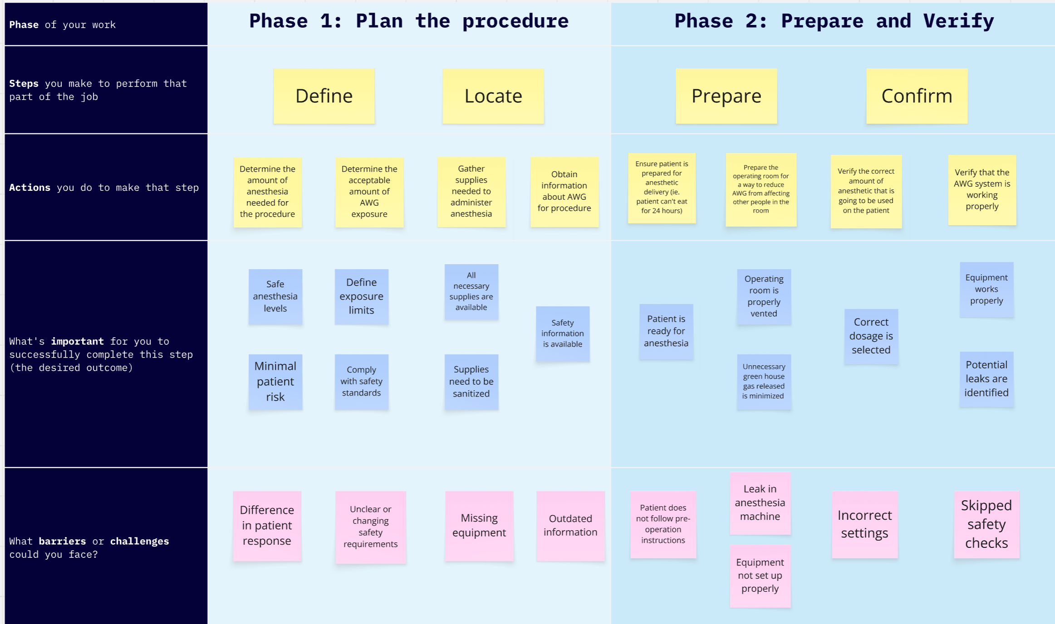
Figure 5. Job Map Miro Board
Overview of Phase 1 and 2 and how anesthesiologists interact with the AWG monitoring system
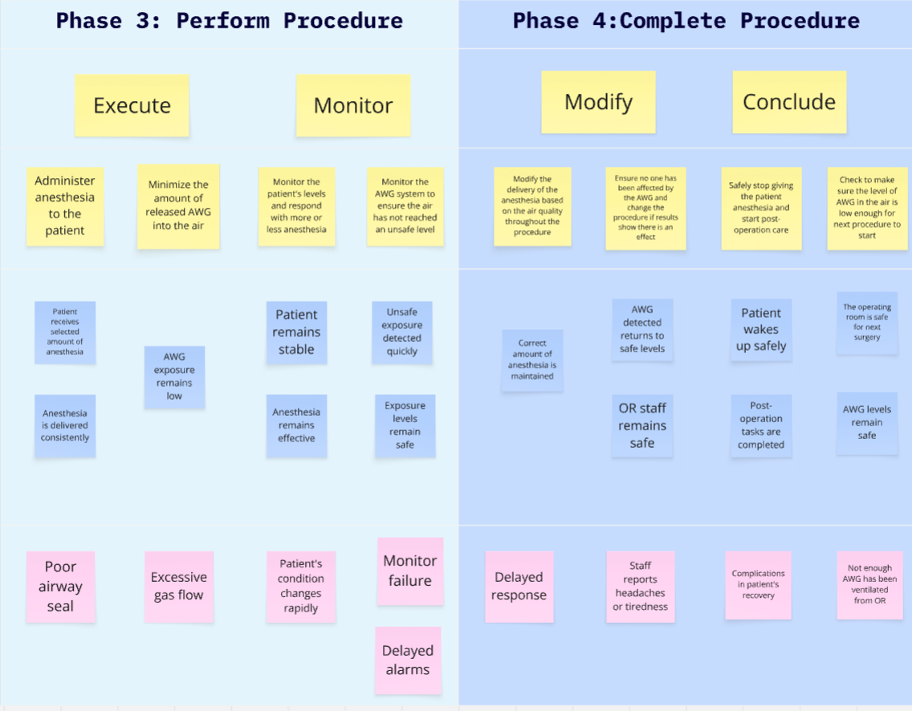
Figure 6. Job Map Miro Board (cont.)
Overview of Phase 3 and 4 and how anesthesiologists interact with the AWG monitoring system

Customer Discovery Data
Interviewer | Interviewee | Job Title | Interview Date | Contact Info | Questions | Key Insights
Brooke Struyk | Dr. Brian Struyk, MD | Pediatric Anesthesiologist and Director of Pediatric Anesthesia of the Pediatric Proton Therapy Center at the Children's Hospital of Philadelphia | 09/17/2026 | struykbp@CHOP.edu | -Do you know what WAG is?  -What is the typical procedure of an anesthesiologist?  -Have you heard of the environmental impacts of the WAG?  -Have you heard of low-flow anesthesia to reduce WAG impacts?  -Does your job require yearly health checks due to WAG?  -What type of WAG system does your hospital system use? Is it different for different buildings?  -Have you learned anything about WAG in medical school or residency?  -When the hospital gets a new machine or device, what is a metric for you to use versus not using the device?  -When going to pediatric anesthesiology conferences abroad did, they talk about AWG?  -I know you have worked previously on training doctors in Palestine, what are the main differences you see when comparing a low vs high resourced anesthesiologist? | -At CHOP and globally, anesthesiologists are talking about reducing the environmental effects of AWG  -Low-flow is the recommended way the anesthesiologist can reduce the about of AWG entering the air  -When there is high-flow after a period of 15 minutes, the anesthesia machine will send a message on the notification bar. This bar is checked regularly throughout surgery. A picture of what this looks like is below.  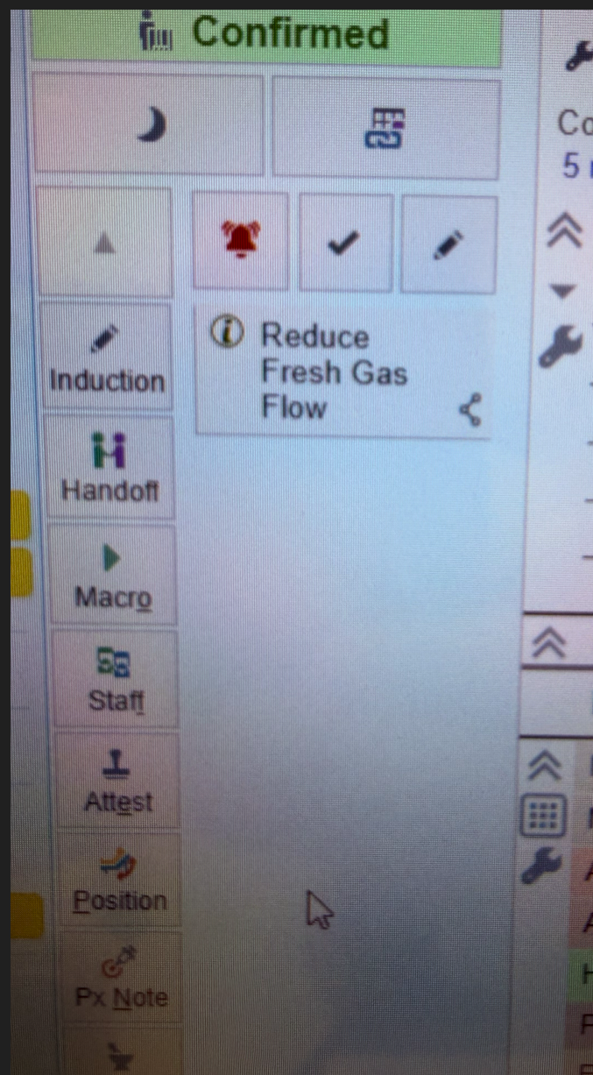  -There has also been a push to use sevoflurane over Nitrous oxide; however, in low resource countries nitrous oxide is the most common anesthetic because it is cheap.  -Anesthesiologists typically ensure prior to the surgery that the WAGD system has been turned on and it stays on the entire day.  -Anesthesiology technicians are the main maintenance team for leaks or issues. If the issue is bigger, BMET would be brought in.  The final say on a new technology goes more towards the BMET, and maintenance department is they can account for the new machine.  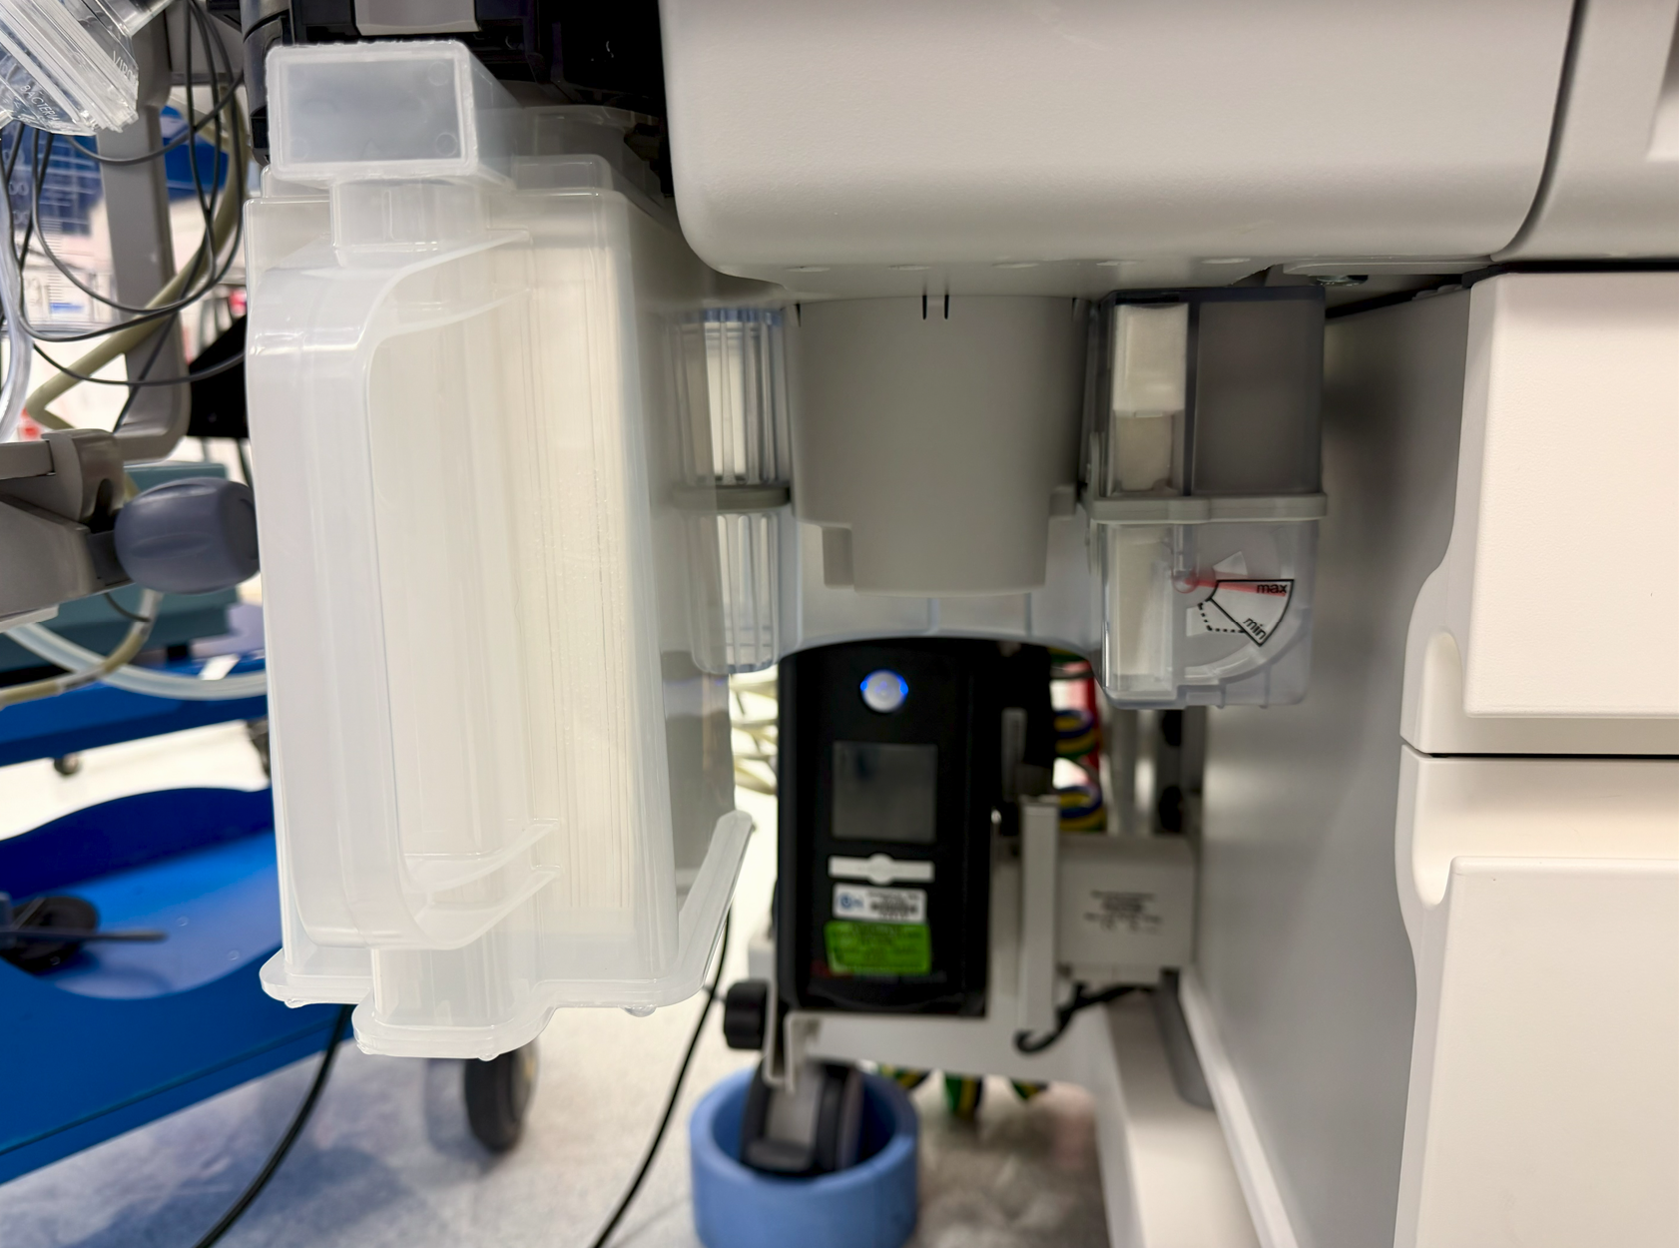  The picture above shows the WAGD device that is being used at CHOP. The white box is a CO2 scrubber, and the flapper valve on the right has a max and min dial to show if there is enough suction for the AWG.
Kaayla Osborne | Dr. Andy Muelenear | Pediatrician and Pulmonologist | 09/22/2026 | andrem1@vt.edu | -How do power grids work in low resource areas in Africa?  -How do the hospitals normally receive medical devices and what condition are they in?  -What do you know about scavenging systems in those hospitals? | -Measure out 18 feet in our space.  -Possibly running a scavenging system in a place it's not equipped to run in.  -Possibly not changing the filters.  -Machines are donated but not provided with refill filters.  -US Military has portable ORs called Deployable Medical that are 40ft modules.
Sarah  Krishnamoorthy | Mrs. Ashley Hunnicutt | Executive Director, Loudoun Free Clinic | 09/21/2026 | ashleyhunnicutt@loudounfreeclinic.org | When designing or renovating healthcare spaces, what building systems or infrastructure tend to create the greatest constraints for medical equipment?  In your experience with adaptive reuse, retrofitting the old Exxon Mobil HQ in Fairfax for INOVA, what challenges arise when converting a space that was not originally designed for healthcare usage?  How do you decide whether a healthcare need should be addressed through permanent infrastructure or standalone equipment?  For a system intended for facilities with limited infrastructure, what characteristics would make it easier to deploy across multiple locations?  What have you seen cause equipment or facility solutions to fail in practice even though they worked in theory?  When selecting vendors or equipment for a facility, what information do you expect the design team to provide?  If our system needed to exhaust WAGs outside, what facility-level concerns would you want to investigate prior? | Failure does not always mean the device doesn’t work. Failure can mean the device was too expensive, difficult to install, disruptive, or difficult to maintain.  Availability of parts for replacements and access to those who know how to service the system are vital. On-site staff could be trained or troubleshoot with a set of short videos.  Early prototyping and validation are key. She emphasized that mockups and models are crucial and can save time and money. Additionally, it’s an easy way to get feedback from end users dynamically.  The team should not just focus on initial cost, but the life cycle of the product.
Rachel Mensah | Dr. David Swedlow, MD | Medical doctor who specializes in Anesthesiology, Critical Care Medicine and Pediatrics | Received contact information from Dr. Stone: 9/16/26  Reached out to Dr. Swedlow via email: 9/16/2026  Followed up on interview request via email: 9/21/2026 | Dswedlow@yahoo.com | -How frequently do you directly interact with anesthesia machines?  -What does your day-to-day look like? Could you describe your role?  -How involved are you with anesthesia set-up in the OR?  -What equipment do you interact with most frequently during anesthetic procedure?  -Are there any problems you have experienced with current WAG management systems?  -Are there any risks we should consider when creating our device? (i.e safety)  -Are there any changes you would like to see in the current WAG solutions? | Dr. Swedlow has not responded to the interview request.
Sarah  Krishnamoorthy | Mr. Willan Rodriguez | Field Service Technician at Roche, BMET | Reached out 9/16/2026 via text message  Followed up on interview request: 9/19/2026 |  | -Do you use a CMMS system for maintenance?  -Do you write preventative maintenance procedures for the equipment?  -How closely do you work with anesthesia technicians?  -How often are the anesthesia technicians doing maintenance on the WAG machines? | This interview will occur the following week

References

[1] L. M. C. Lucio, M. G. Braz, P. do Nascimento Junior, J. R. C. Braz, and L. G. Braz, “Occupational hazards, DNA damage, and oxidative stress on exposure to waste anesthetic gases,” Brazilian journal of anesthesiology (Elsevier), vol. 68, no. 1. Brazil, pp. 33–41, 2018. doi: 10.1016/j.bjan.2017.05.001. Available: https://pmc.ncbi.nlm.nih.gov/articles/PMC9391701/ (accessed Sept. 21, 2026)

[2] N. Lahvic and M. Liu, “Waste Gas Scavenging System,” PubMed, 2022. Available: https://www.ncbi.nlm.nih.gov/books/NBK544254/ (accessed Sept. 21, 2026).

[3] OSHA Directorate of Technical Support and Emergency Management, “Anesthetic gases: Guidelines for workplace exposures | Occupational Safety and Health Administration,” US Department of Labor, https://www.osha.gov/waste-anesthetic-gases/workplace-exposures-guidelines (accessed Sep. 22, 2026).
[4] J. A. Barwise, L. J. Lancaster, D. Michaels, J. E. Pope, and J. M. Berry, “An initial evaluation of a novel anesthetic scavenging interface,” Anesthesia &amp; Analgesia, vol. 113, no. 5, pp. 1064–1067, Nov. 2011. doi:10.1213/ane.0b013e31822c9a2c
[5] AmcareMed, “What is an anesthetic gas scavenging system (AGSS) - amcaremed,” AmcareMed Medical Gas System, https://amcaremed.com/knowledge-anesthetic-gas-scavenging-system-agss/ (accessed Sep. 22, 2026).
[6] K. Nickel et al., “An observational laboratory study to evaluate an anesthetic gas adsorber without anesthetic gas scavenging system,” BMC Anesthesiology, vol. 25, no. 1, Jul. 2025. doi:10.1186/s12871-025-03223-7
[7] H. R. Karim and M. Keshwani, “Nitrous oxide in waste anesthetic gases with different fresh gas flow: A case-based pilot observation and a practical thought on scavenging,” Medical Gas Research, vol. 8, no. 3, p. 125, 2018. doi:10.4103/2045-9912.241066
[8] “Anesthesia as a career,” American Society of Anesthesiologists, https://www.asahq.org/education-and-career/career-resources/anesthesia-as-a-career (accessed Sep. 22, 2026).
[9] R. Farrell, “Biomedical Equipment Technician,” U.S. Bureau of Labor Statistics, https://www.bls.gov/careeroutlook/2024/youre-a-what/bmet.htm (accessed Sep. 22, 2026).
[10] “Understanding the anesthesia technician role & HOW TO BECOME ONE: Aug 21, 2026,” Understanding the Anesthesia Technician Role & How to Become One | Aug 21, 2026, https://www.readysethire.com/job-search/position-overview/anesthesia-technician (accessed Sep. 22, 2026).
[11] “Tinni, smiling with confidence,” Kids Operating Room, https://www.kidsoperatingroom.org/stories/tinni-smiling-with-confidence (accessed Sep. 22, 2026).

