COMP5623 Coursework on Image Caption Generation
Name | Sarah Smith
Student ID & username | 200940258 cm15sls

QUESTION I [40 marks]
1.1 Text preparation [15 marks]
Please submit your utils.py.
1.2 Extracting image features [10 marks]
Please submit your extract_features.py file.
1.3 Training DecoderRNN [15 marks]
Please submit your decoder.py file.
QUESTION II [60 marks]
2.1 Generating predictions on test data [10 marks]
2.1.1 Present three sample test images showing different objects, along with your model’s generated captions and the 5 reference captions.
Please note that all reference captions were encoded and decoded using the training vocab and therefore some captions include ‘<unk>’.
Image | Reference captions | Model generated caption
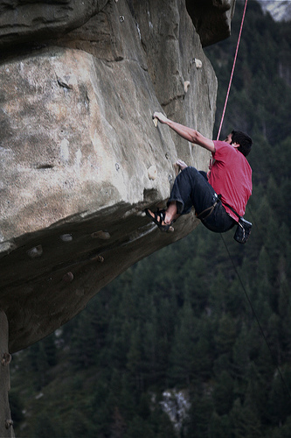  Image ID:  997722733_0cb5439472 | a man in a pink shirt climbs a rock face  a man is rock climbing high in the air  a person in a red shirt climbing up a rock face covered in <unk> handles  a rock climber in a red shirt  a rock climber practices on a rock climbing wall | a man is climbing a rock wall
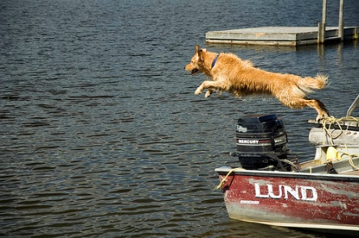  Image ID:  967719295_3257695095 | a dog jumps into the pond  a dog leaping into the water near a <unk>  a light colored dog jumping off the back of a boat into the water  a tan dog jumping off of a boat into the water  the yellow dog is jumping off of a ship into the water | a dog is jumping into the water
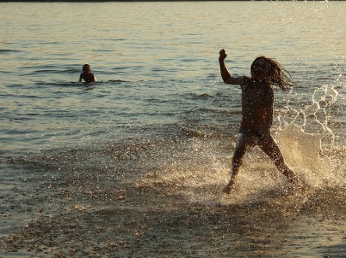  Image ID:  827941668_2e4ac6cb39 | a child is splashing in the water at the beach  a girl is playing in the ocean at dusk  a kid splashes in the ocean  a person is standing in water with it splashing all around them while another person <unk> in the background  two children playing in the surf | two girls are playing in the water
2.2 Caption evaluation via text similarity [30 marks]
(1) BLEU for evaluation
2.2.1 Report the trained model’s performance on the test set using the BLEU method, and discuss.
The average BLEU score of the test set was calculated as a cumulative BLEU-2 score and was found to be 0.2993. The cumulative BLEU scores for both BLEU-3 and BLEU-4 were also calculate but discarded as these scores were very close to zero (e⁻¹⁵¹). The average BLEU score increases to ~0.5 when calculating BLEU-1. However, BLEU-2 was selected as it provides a more expressive score as it considers adjacent words in the captions (i.e. it is more difficult to correctly generate ‘black dog’ than just ‘dog’).
The reference captions for each image were encoded using the training vocabulary (vocab object) and decode in the same manner as the model generated caption. This was done to allow for a fair comparison between the reference captions and the generated captions as not all words in the test reference captions were present in the training vocabulary.
While evaluating the model’s performance (see 2.2.2), it becomes clear that the model is able to generate captions involving dogs fairly accurately and produces a high BLEU-2 score for these captions. The model, however, struggles a lot more when it comes to people. In the low BLEU score example below (see 2.2.2) the model was able to pick out the green from the shrubbery and recognize that there is a person in the image but fails to generate a satisfactory caption for the more complex scene shown in the image. This suggests that the training data set did not have enough images and captions of these more complex scenes but appears to have provided a good a more of simpler scenes involving dogs.
Overall, the model performs well for some specific types of images (such as dogs) but poorly for others (such as more complex scenes involving people). This leaves lots of room for the model to improve if provided with more training data.

2.2.2 Present one sample test image with a high BLEU score and one sample with a low score, along with your model’s generated captions and the 5 reference captions.

One sample with high BLEU score
Image | Reference captions | Model generated caption
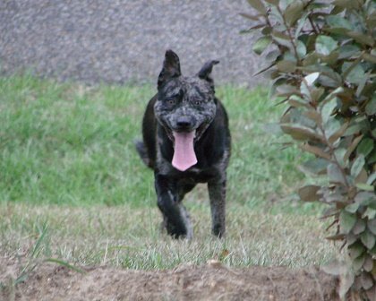  Image ID:  689776124_07f560a920  BLEU-2 score: 1.00 | a black dog is happily running through the grass  a black dog running toward the camera  a black dog runs with its tongue out  a dark dog with its tongue hanging out runs through the grass  a dog plays in the grass | a black dog runs through the grass
One sample with low BLEU score
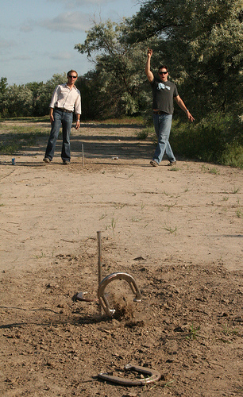  Image ID:  837919879_94e3dacd83  BLEU-2 score: 0.00 | two guys are playing horse shoe together  two guys playing <unk>  two men playing <unk>  two men wearing jeans and sunglasses are playing <unk>  two people play <unk> | a boy in a green shirt is jumping over a hurdle

(2) Cosine similarity for evaluation
2.2.3 Report the trained model’s performance on the test set using the cosine similarity method, and discuss.
The same reference captions as in 2.2.1 were used. The average cosine similarity score for the test set was found to be 0.3528. This suggests that most of the model generated captions are similar to their respective average reference caption as their average caption vectors must be close in space with an angle less than 90° to score above 0.
Looking at 2.2.4 and the high cosine similarity score example, there is good agreement between the reference captions and the generated caption with one reference caption matching completely. Dissimilarly, the low cosine similarity has much less agreement between its’ reference captions and model generated captions. However, the cosine similarity is closer to 0 than -1 which suggest that the captions are not entirely dissimilar. For example, both the reference captions and the model generated caption mention a dog which could account for the cosine similarity score not being lower.

2.2.4 Present one sample test image with a high cosine similarity score and one sample with a low score, along with your model’s generated captions and the 5 reference captions.

One sample with high cosine similarity score
Image | Reference captions | Model generated caption
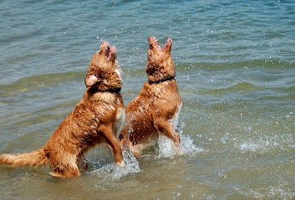  Image ID:  481827288_a688be7913  Cosine similarity: 0.74 | two brown dog play together in the water  two brown dogs playing in water  two dogs playing in the ocean  two dogs play in the water  two identical brown dogs in the water with their noses in the air | two dogs play in the water
One sample with low cosine similarity score
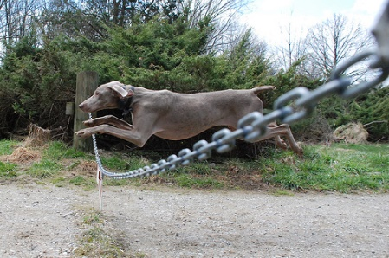  Image ID:  465994762_1760e83c5d  Cosine similarity: -0.05 | a brown dog jumps over a chain  a dog jumps over a chain  a dog leaping over a chain  a greyhound jumps over a chain  brown dog leaps over a chain suspended over a gravel road | two dogs play in the snow

2.3 Comparing text similarity methods [15 marks]
2.3.1 Compare the model’s BLEU and cosine similarity scores on the test set and identify some weaknesses and strengths of each method.
From the examples presented in 2.2.2 and 2.2.4, the cosine similarity appears to be more expressive than BLEU-2. For example, the high cosine similarity example in 2.2.4 would have resulted in a BLEU-2 score of 1.00 (a perfect score) whereas the cosine similarity acknowledges the similarity between the reference captions and the model generated caption but does not give a perfect score of 1 due to the reference captions themselves having some variability.
Cosine similarity appears to be the superior metric when measuring similarity between the model generated caption and their respective reference captions as it would provide a better score than BLEU when similar but not identical words are used for the same semantic meaning. However, cosine similarity is not good at accounting for frequency of occurrence of words when calculating similarity. BLEU is better at measuring the similarity between captions when the use of the same words is important as it does not account for semantically similar words unless these are provided in the reference captions.

2.3.2 Show one example where both methods give similar scores, and another example where they do not and discuss.
Similar
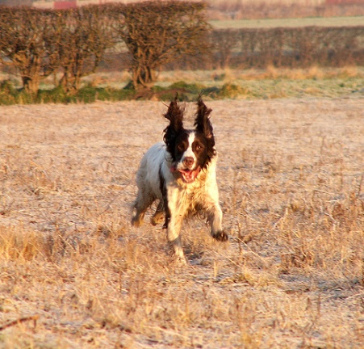
Image ID: 421932359_edbf181f44
Model generated caption:
- a black and white dog is running on the grass
Reference captions:
- a black and white dog is running towards the <unk>
- a brown and white dog is running across a brown field
- a dog running through a field towards a camera
- a dog with its ears up runs on brown grass
- a white dog running on dirt
BLEU-2 score: 0.8820
Cosine similarity (rescaled): 0.8138

Dissimilar
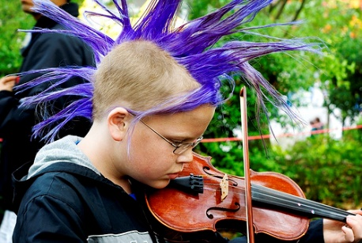
Image ID: 518144037_9a1754b2a6

Model generated caption:
- a man in a white shirt and tie is holding a <unk>
Reference captions:
- a blonde boy with a long purple mohawk is playing the violin
- a boy with a blue mohawk plays the violin
- a boy with a purple spiky mohawk plays violin
- a kid with a blue mohawk is playing a violin
- a young boy with a purple mohawk playing the violin
BLEU-2 score: 0.00
Cosine similarity (rescaled): 0.7372

Marks reserved for overall quality of report. [5 marks]
No response needed here.

