**Part A**

**I**

**A**

**B**

**C**

**D**

**E**

**F**

**G**

**Objective** : Name and decribe each component

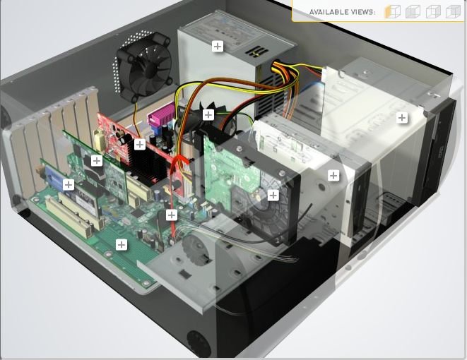

**H**

|  |  |  |
| --- | --- | --- |
| Download [**http://tinyurl.com/CW208-CAG-SIM**](http://tinyurl.com/CW208-CAG-SIM) PC Build Simulator.  Go through steps of building a PC, as you complete the simulation find and describe in detail components A to I. To run simulator first install <http://www.swffileplayer.com/> and open ***RootMovie.swf*** using SWF player. Alternatively install [Macromedia Flashplayer](https://fpdownload.macromedia.com/pub/flashplayer/updaters/32/flashplayer_32_sa.exe) . Ideally use a simulator as listed in class. | | |
| Label | Name each component | Description |
| A | RAM |  |
| B |  |  |
| C |  |  |
| D | Power supply |  |
| E | Hard drive |  |
| F |  |  |
| G | Optical drive |  |
| H |  |  |
| I |  |  |

**Part B**

**Objective**

Compare a pre-assembled system and the components that could be assembled to build a comparable system. After completing this practical, you should be able to:

1. Identify the components of a pre-assembled system
2. Locate prices for components needed to assemble a comparable system
3. Compare the cost of a pre-assembled system and a self-assembled system.

If you can’t find exact match for components, find the closest possible substitute. Use the Internet and available computer-related publications as your sources for information. Examples of websites for computer parts [www.komplett.ie](http://www.komplett.ie), [www.dell.ie](http://www.dell.ie), [www.custompc.ie](http://www.custompc.ie) [www.amazon.de](http://www.amazon.de)

MAKE SURE TO INCLUDE VALID LINKS TO WEB REFERENCES

|  |  |  |
| --- | --- | --- |
|  | **Pre-Assembled Computer Package** | **Computer Package**  **Components** |
| **CPU** |  |  |
| **Storage / Memory** | | |
| |  | | --- | |  | | RAM | | Hard Drive | |  | | |  | | --- | |  | |  | |  | |  | |  |
| **Input/Output** | | |
| |  | | --- | | Keyboard | | Pointing Device | | Monitor | | Speakers | | Network Adapter | |  | |  | |  |  |
| **Bundled Software**  (Including Operating System) |  |  |
| **Total Cost** |  |  |

**Part C**

**Objective**

You have been asked by a family friend to assist them with a computer purchase. They’re unfamiliar with technology and the terms used and have presented you with two alternatives machine choices. They would like to be able to write word documents, surf internet and play Minecraft © Mojang and Half-Life © Valve Software. They are considering playing Fortnight but are not sure yet, as it depends on machine cost and if they can extract some money from their Bitcoin wallet.

Compare Personal Computer Option A and B in relation to each of the side headings and recommend a system and any alterations.

|  |  |  |
| --- | --- | --- |
|  | Personal Computer  Option A | Personal Computer  Option B |
| CPU | 2.2 GHz Intel Celeron 450 | 3.2 GHz Intel Core i5 |
| Memory |  |  |
| |  | | --- | | Cache | | RAM | | Hard Drive | | CD-ROM/DVD | | |  | | --- | | 512 KB Cache | | 4 GB RAM | | 320 GB Hard Drive | | DVD+/-RW drive | | |  | | --- | | 4 MB Cache | | 8 GB RAM | | 1 TB Hard Drive | | DVD+/-RW drive | |
| Input/Output |  |  |
| |  | | --- | | Keyboard | | Pointing Device | | Screen | | Speakers | | Network Adapter | | |  | | --- | | USB multifunction keyboard | | USB optical mouse | | 20’’ HD flatscreen monitor | | Multimedia Speaker System | | Integrated 10/100/1000 Ethernet | | |  | | --- | | wireless multifunction keyboard | | wireless optical mouse | | 25’’ HD flatscreen monitor | | Dolby Surround Sound Speakers | | Integrated 10/100/1000 Ethernet | |

|  |
| --- |
| **Recommendations** |
|  |

**Your Recommend System**

|  |  |
| --- | --- |
|  | Personal Computer  Recommendation |
| **CPU** |  |
| **Memory** | |
| |  | | --- | |  | | RAM | | Hard Drive | | SSD Drive | | |  | | --- | |  | |  | |  | |  | |
| **Input/Output** | |
| |  | | --- | | Keyboard | | Pointing Device | | Screen | | Speakers | | Network Adapter  GPU | | |  | | --- | |  | |  | |  | |  | |  | |

Hand up this practical report at the end of session and ensure it has been checked

|  |  |  |  |
| --- | --- | --- | --- |
| **Student Name** |  | **Student Number** |  |
| **Date** |  | **Checked** |  |
| **Group** | **A / B** |  |  |