Interim Report
A website to aid with restaurant booking
Sarah Miah
2025
Contents
Aims and Objectives 2
Aims 2
Objectives 2
Related Work and References 3
Literature Review / Survey of Existing systems 3
Open Table: 4
Quandoo: 6
Reflection: 9
Requirements, Specifications and Design 10
Functional Requirements 10
Authentication/ authorisation: 10
Restaurant and table management 10
Search, browsing and discovery: 11
Booking Management 11
QR Check in and Occupancy 11
Notifications 12
Recommendations, reviews, Admins, Analytics 12
Non-Functional Requirements 12
Performance and scalability: 12
System Architecture 12
Database Design 15
Use case diagram: 15
Design Decisions and Justifications 18
Frontend: react 18
Backend: node.js and Express 18
Database: PostgreSQL 18
Object Relational Mapping: Prisma 18
Real-time: Socket.io + Redis 18
Email: NodeMailer (SMTP) 19
Authentication: JWT 19
Authorisation: Role based access control 19
Important Algorithms and Data Structures: 19
Plans and time-scales 22
Risk table: 22
Project timelines 22
Sprint table: 22
Gant chart: 23
Current progress: 23
Progress Tracking and Milestones 24
Semester 1: 24
Semester 2: 24
References: 25

Interim Report

Declaration

All sentences or passages quoted in this report, or computer code of any
form whatsoever used and/or submitted at any stages, which are taken from other people’s work have been specifically acknowledged by clear citation of the source, specifying author, work, date and page(s).Any part of my own written work, or software coding, which is substantially based upon other people’s work, is duly accompanied by clear citation of the source, specifying author, work, date and page(s).I understand that failure to do this amounts to plagiarism and will be considered grounds for failure in this module and the degree examination as a whole.

Name: Sarah Islam Miah
Signed: Sarah Islam Miah
Date:20/11/2025

Aims and Objectives

Aims
The aim of this project is to design and implement a web-based restaurant booking and management system that allows customers to make and manage reservations in real time and provide them with personalised recommendations and accessibility-aware searches. The system also gives restaurant owners and administrators with tools for scheduling, monitoring capacity, and managing their data.

Objectives
The restaurant app aims to follow the following objectives:
- Implement a secure authentication system and RBAC (role based access control)for three user types
  - Customer
  - Restaurant Owner
  - Admin
- Create an interface that allows owners to
  - Add or change restaurant details
  - Manage menus
  - Create and edit special events
- Integrate table management and walk-in protection, allowing owners to
  - Mark tables as walk-in only or online reservable.
  - Add/edit tables with capacity and accessibility attributes
  - Optionally set online booking quotas for certain time slots
- Implement a customer dashboard where they can:
  - View current and past bookings
  - Manage reservations (edit/cancel)
  - Access booking confirmations and QR codes
  - Receive system notifications and personalised recommendations
- Provide a recommendation engine that suggests restaurants based on
  - Previous bookings
  - Popularity
  - Open availability
- Ensuring that booking integrity is kept using database level limits and safe concurrency control to prevent double bookings and conflicting reservations
- Developing dashboards for owners and administrators, allowing them to:
  - View daily/ weekly bookings
  - Approve or cancel reservations
  - Verify restaurants and review system logs
- Implement QR code-based check ins, enabling owners to:
  - Scan customers on arrival
  - Mark attendance
  - Update live occupancy counts automatically
- Provide a live tracker and analytics dashboard that displays for owners to
  - Current occupancy levels
  - Busy periods
  - No show statistics
  - Simple forecasts of expected busyness
- Integrate real time email notifications to inform users about
  - Booking confirmations
  - Cancellations
  - Approvals
  - Reminders
- Introduce accessibility and preference options within the system. For example including indicators for:
  - Wheelchair access
  - Parking
  - Braille menus
  - Hearing assistance
  - Dietary accommodations (e.g. halal, vegan)
- Create a review system to allow users to leave feedback and ratings for restaurants they have visited, giving owners insight into customer satisfaction

Related Work and References

Literature Review / Survey of Existing systems
As part of my research, I have observed some popular sites that provide online restaurant booking to understand common designs and current limitations.
Examples include:

Open Table:
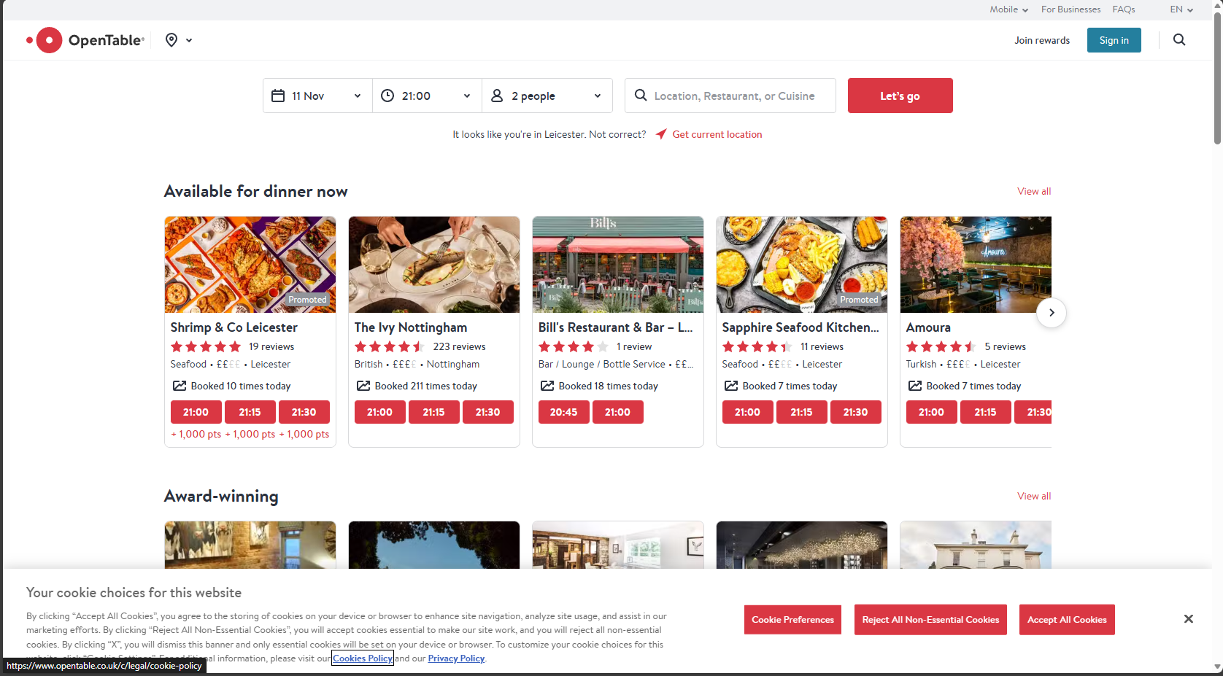
Flexible search inputs (location, cuisine, restaurant)
Multiple recommendation sections
Rewards scheme for users
Bookable timeslots - real time availability
Filter aids

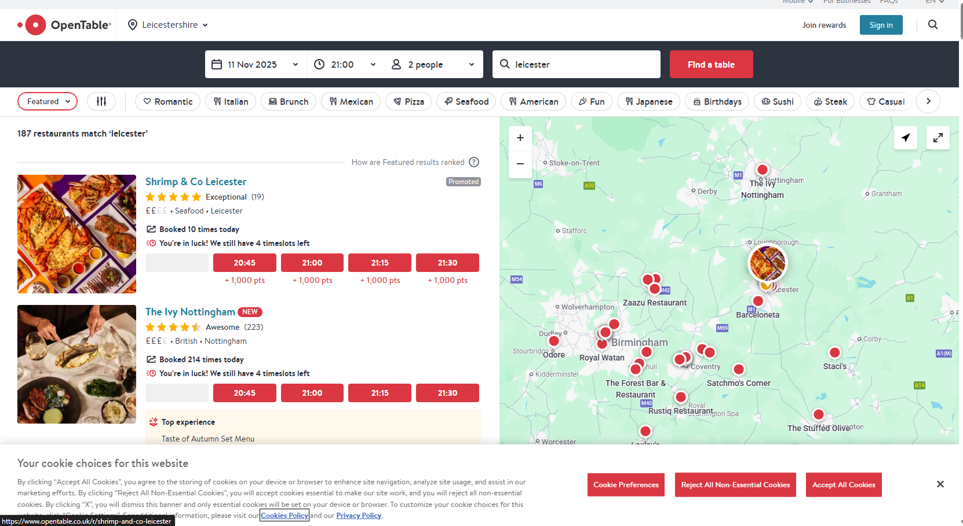
Interactive map highlighting exact location
Sort results
Tag filters
New tag helps restaurants gain visibility compared to the already popular restaurants

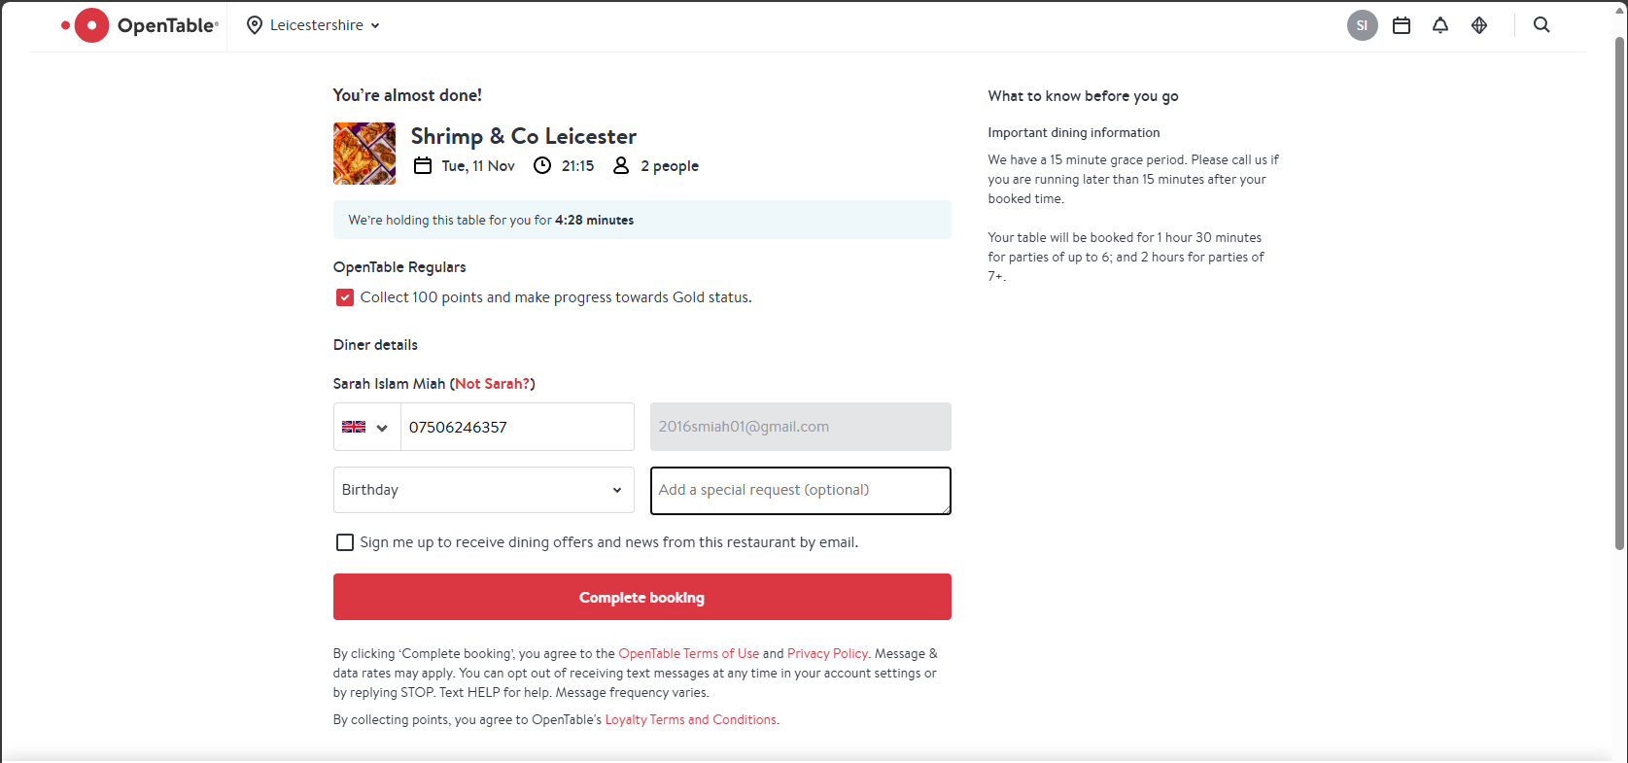
Optional booking notes + event
Timer for holding reservation
Clear view of booking details

Pros:
- Simple user-friendly UI
- Responsive designs across devices
- Filter tools for exploration
- Clear restaurant metadata in exploration
- Visual rating indicators (including “£”)
- Notifications for confirmations, cancellations, or reminders
- Rewards program
- Map based location view
- Popularity-driven recommendations
- Favourites list

Limitations:
- Accessibility and dietary information aren’t displayed
- Smaller/unpopular restaurants are harder to discover
- Parking information isn’t available
- No accessibility or dietary specific filters

Quandoo:
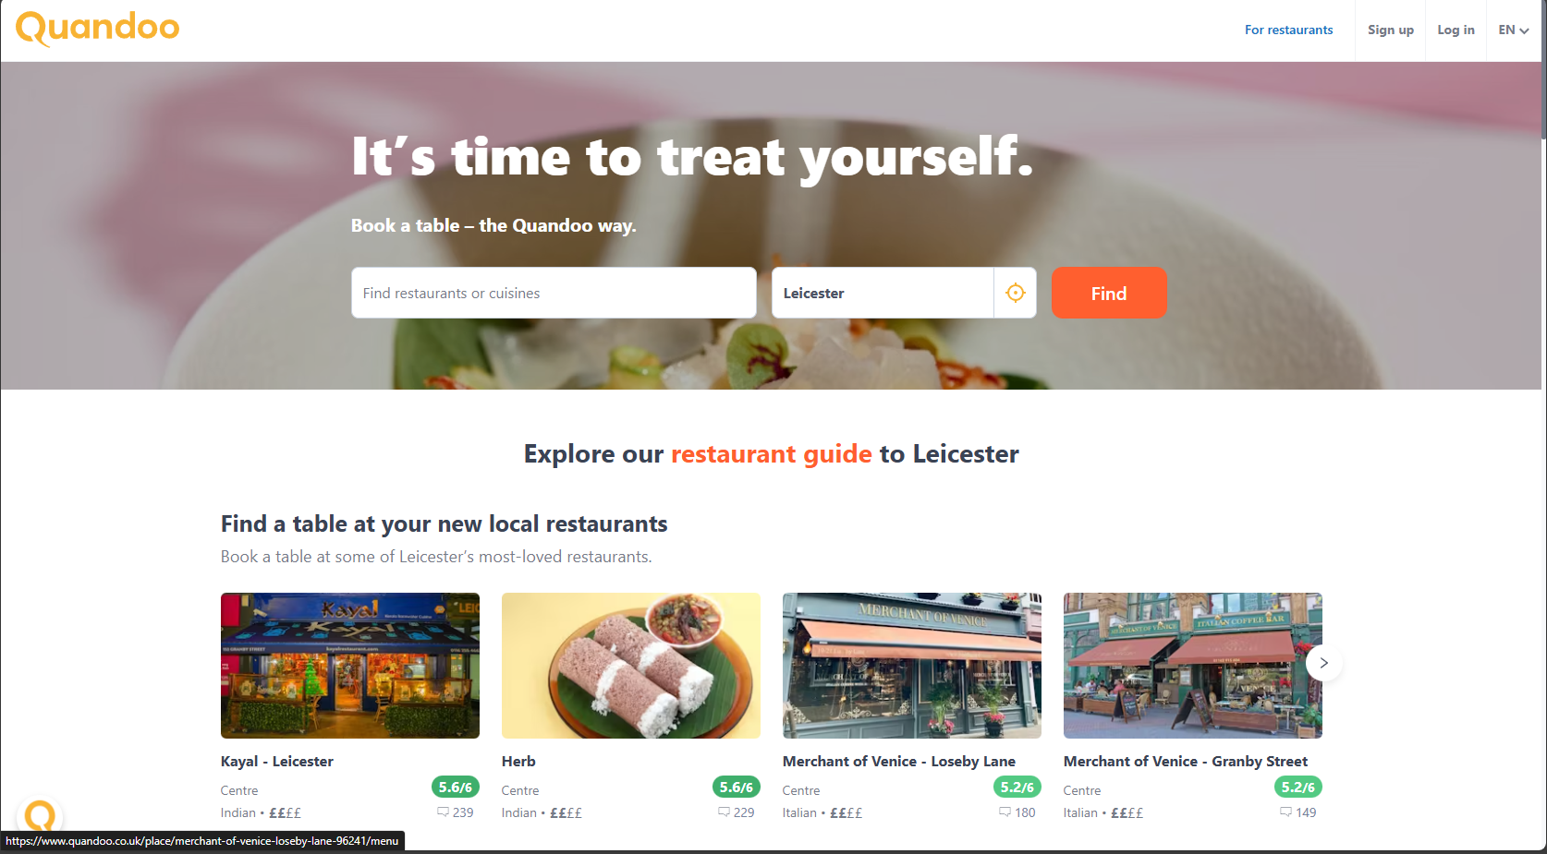
Flexible search based on( restaurant, cuisine or location)
Location based recommendations
Log in with a rewards scheme – acting as an incentive for users
Further down on the front page:
City based tabs for recommendations
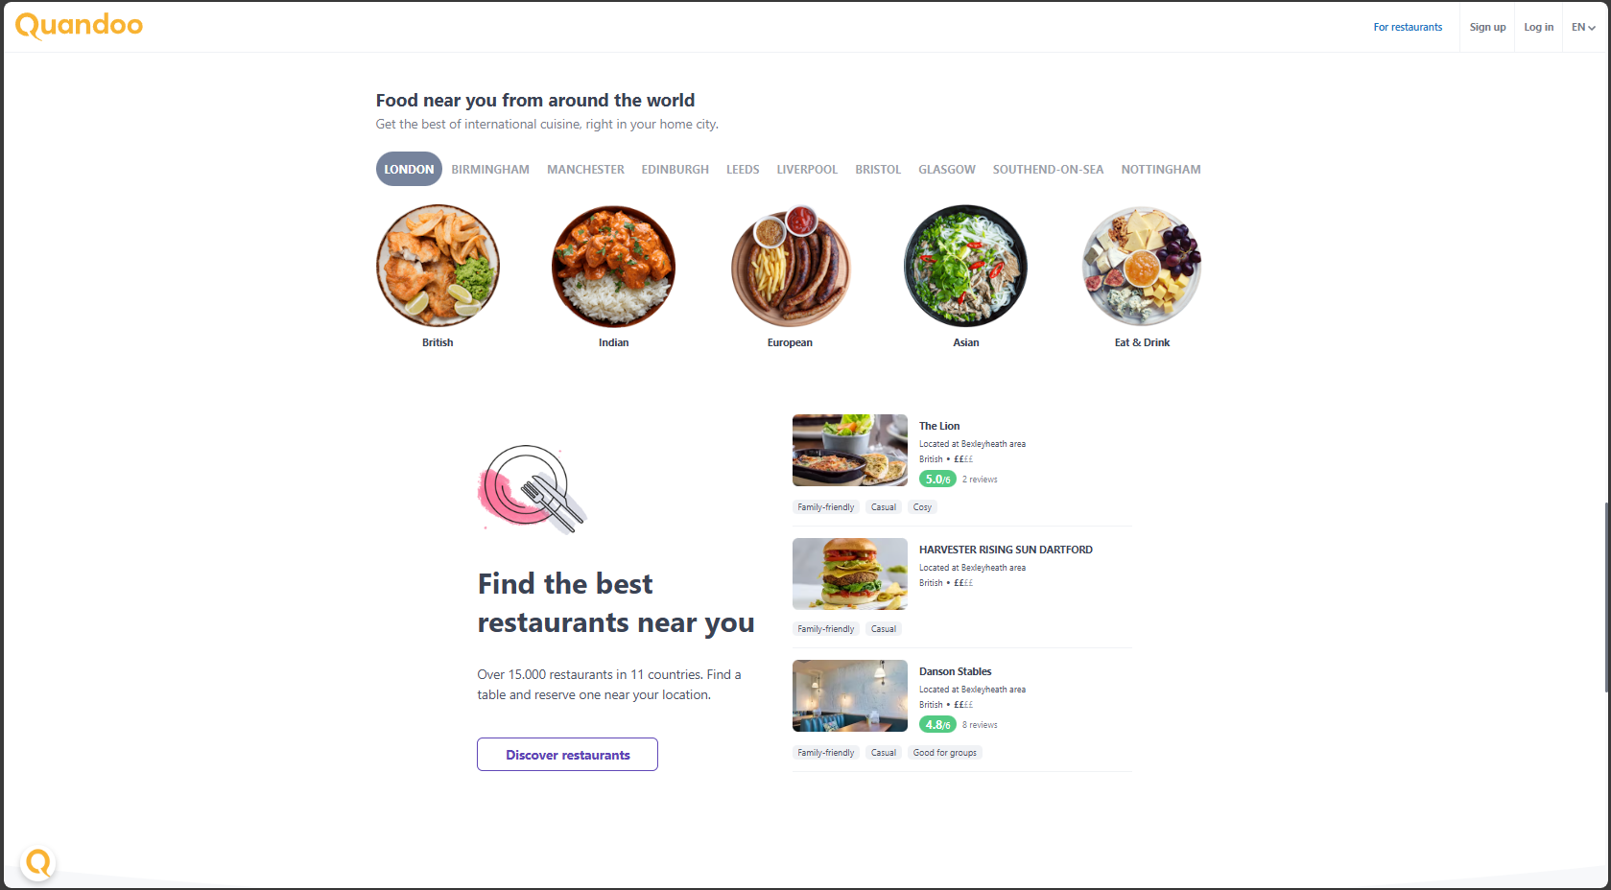
Cuisine icons for quick filtering
Location based search users can apply
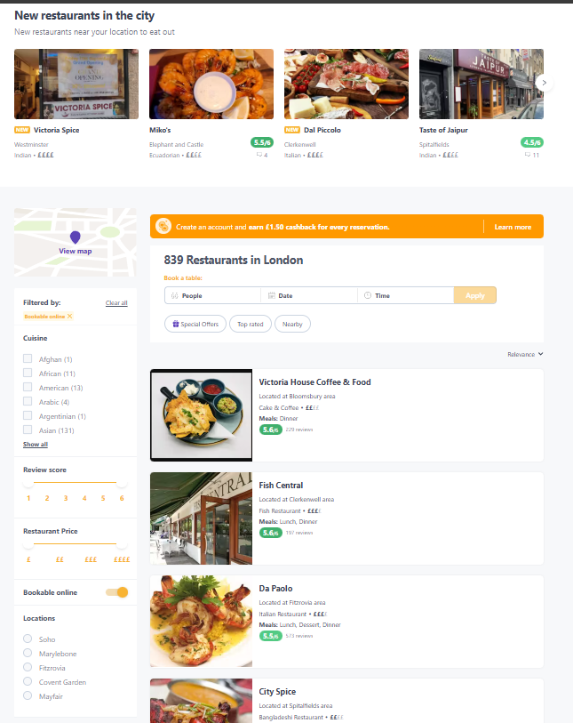
Sorted results

Filter/ tag options for specific searches
Can switch to a map view
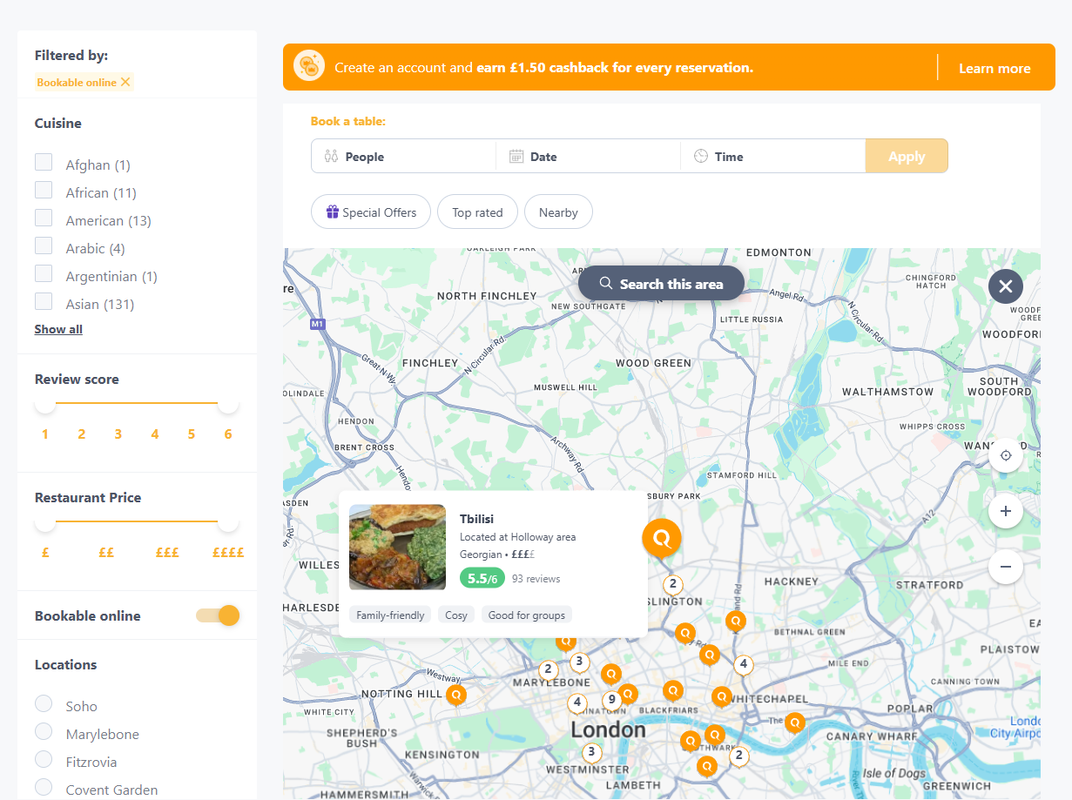
Dynamic map – results updates while panning
Map markets show restaurant preview
Interactive map with filtered results

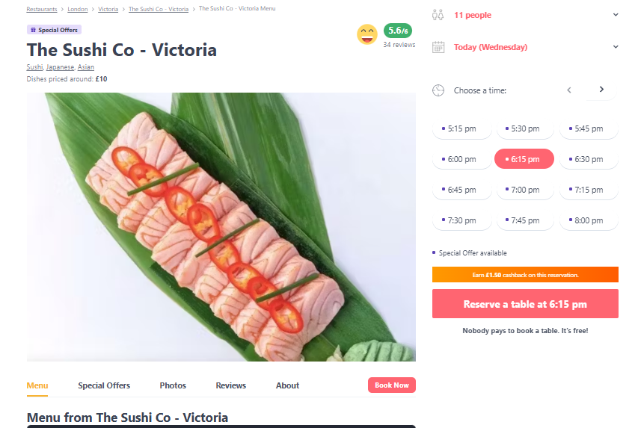
Clear defined available/ unavailable booking options
Sectioned shortcuts for in-depth detail
Main restaurant details at the top
The sections that appear under the tabs:
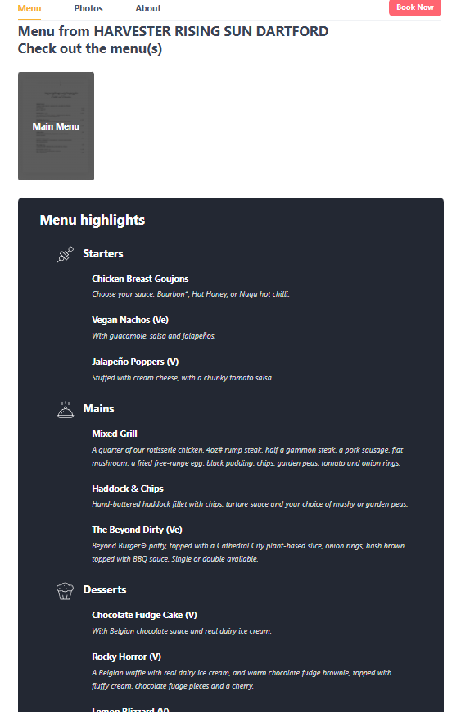
Sectioned layout that helps users find meals of interest
Full menu with dietary labels – limited to popular dishes
Shows full menu – not available for all restaurants
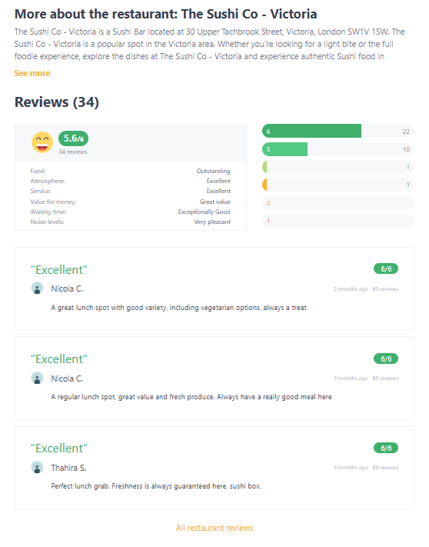
Reviews displayed clearly with a score, username and description
Brief mid-page overview that users may miss
Allows users to be able to view more reviews without cluttering the page
Summary card that shows overall ratings and category breakdown

Pros:
- Simple, easy to navigate UI
- Fully responsive across screen sizes
- Clear, plain English labels throughout
- Filter options help refine results
- Results show key details (cuisine type, price level, and reviews)
- Visual rating indicators (stars, “£”) support quick comparisons
- Guest booking available (no required signup)
- Rewards program incentives for registered users
- Map integration for location awareness

Limitations:
- No dietary search options
- Search restricted to city-level (no postcode filtering)
- No accessibility or parking information
- No personalised recommendation feed

Reflection:
From analysing other systems, I learned they mostly focus on showcasing users popular restaurants rather than a more personalised feed. Although many users want to explore what’s already trending, it could make recommendations feel biased or repetitive. This inspired me to create an algorithm that suggest more personalised page. There were accessibility and dietary information shown to the users however it was shown to the users when they click on specific restaurant cards on the system which I aim to put as options when users are exploring for restaurants.
When looking users opinions on Trustpilot, they complimented that all three platforms made the booking process easier to do through having key features like:
- Clean and easy to navigate interfaces
- Provided useful restaurant information such as:
  - Location
  - Cuisine Type
  - Price level
  - User ratings
I’ve decided to take inspiration from several design ideas from these systems. For example, OpenTable map allows users to see restaurant cards and points on the map while labelling them with the restaurant name so users can differentiate between points. When hovering over a certain restaurant card it makes that point on the map more visible. In Quandoo they make use symbols and colours to make easy comparisons between restaurants. They all also presented images and menus so users can get a feel of how the restaurant looks like and how much they would spend.
On the contrary, Trustpilot reviews has also highlighted many reoccurring issues across the three systems including:
- OpenTable having unreliable bookings as when checked with the restaurant they booked with there is no records of their bookings [1]
  - My solution: After users book their chosen slot, it will enter a pending state, that specific table would be reserved in the system to prevent double bookings. The restaurant will then receive a new booking request where they can accept or decline the booking within a certain time period – if declined they’ll say why.
- Owners using Quandoo have mentioned that less popular restaurants may be buried under the more popular options [2]
  - My solution: when having restaurants recommended to users on their dashboard, they will get more personalised recommendations based on the bookings they have had recently. Allows restaurants to be recommended to people who are more likely to visit them again.

Requirements, Specifications and Design

Functional Requirements

Authentication/ authorisation:

FR1: Registration
The system shall allow users to register as a customer or restaurant owner

FR2: Login
The system shall allow users to log in and reject invalid credentials

FR3: RBAC
The system shall enforce role-based access (customer, owner, admin)

Restaurant and table management

FR4: Restaurant Profiles
The system shall allow owners to create and edit restaurant profiles

FR5: Zones
The system should allow owners to define seating zones

FR6: Tables
The system shall allow owners to create, edit and delete tables with attributes (capacity, zone, accessibility, walk in/ online status )

FR7: Table types
The system shall allow tables to be marked as walk-in only or online reservable. Online tables may be markable as unavailable.

FR8: Table Assignement
The system shall automatically assign a suitable table based on party size, accessibility, and availability.

Search, browsing and discovery:

FR9: Search
The system shall allow customers to search restaurants by name, location, cuisine, price, reviews

FR10: Filters
The system shall allow customers to filter results using dietary options, accessibility and tags

FR11: Favourites
The system shall allow customers to save restaurants to a favourites list

Booking Management

FR12: Create Booking
The system shall validate rules before creating a pending booking.

FR13: Booking Approval
The system shall notify owners of pending bookings and customers should be notified of the outcome

FR14: Prevent double bookings
The system shall enforce constrains preventing overlapping bookings

FR15: Turnover Time
The system shall apply a configurable turnover time between bookings

FR16: Modify/ Cancel Bookings
The system shall allow customers to view/modify/ cancel bookings within the notice period

QR Check in and Occupancy

FR17: QR Code
The system shall generate unique QR code for each confirmed booking.

FR18: QR Check in
The system shall allow staff to scan QR codes to check customers in and update occupancy

FR19: No show Handling
The system shall owners to mark bookings as no-shows after a defined period.

Notifications

FR20: User notifications
The system shall email users when bookings change.

FR21: Owner notifications
The system shall notify owners of booking requests and cancellations

Recommendations, reviews, Admins, Analytics

FR22: Recommendations
The system shall generate personalised restaurant recommendations

FR23: Reviews
The system shall allow customer to submit ratings and reviews and appears on restaurants profile

FR24: Admin tools
The system shall allow administrators to verify restaurants to manage user and logs

FR 25: Analytics & logging
The system shall provide booking analytics and maintain logs

Non-Functional Requirements

Performance and scalability:

NFR1: Response Time:
The system shall respond to user actions within acceptable time

NFR2: Scalability
The system shall support multiple restaurants and concurrent users without performance degradation

NFR3: Password Security:
The system shall store passwords using hashing

NFR4: Access Control
The system shall enforce authentication and RBAC for all protected operations

NFR5:

System Architecture
The system is built in three parts: react website, Node.js/Express backend and a PostrgreSQL database. Standard functions such as authentication, browsing restaurants and creating bookings run through RESR API’s, while real time features like live table availability use WebSockets which have been shown to significantly improve responsiveness in web applications[3]. Redis supports fast Publish/Subscribe messaging to distribute updates efficiently, and Mailtrap handles email delivery during testing.
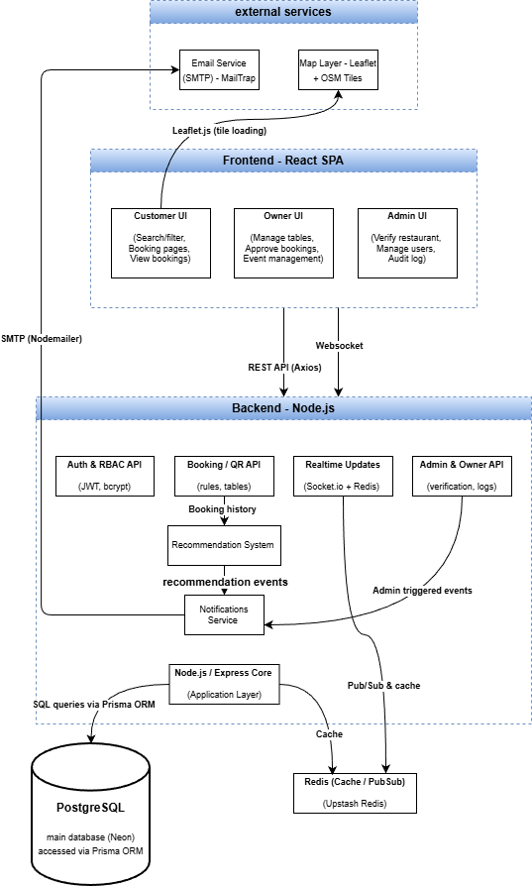

Database Design
This Entity Relationship Diagram represents the core data required for the restaurant booking system. Users interact with the restaurant based on the user role that they have (Customers, Admins, Owners) such as booking and reviews. Restaurants contains tables, zones, opening hours, accessibility options and events. Booking links users to tables and generates a QR code for check ins, while notifications record system messages. BookingRules defines a restaurants booking term and TableUnavailable stores temporary table closures. Tags and RestaurantTags support personalised recommendations. AuditLog records administrative actions for transparency.
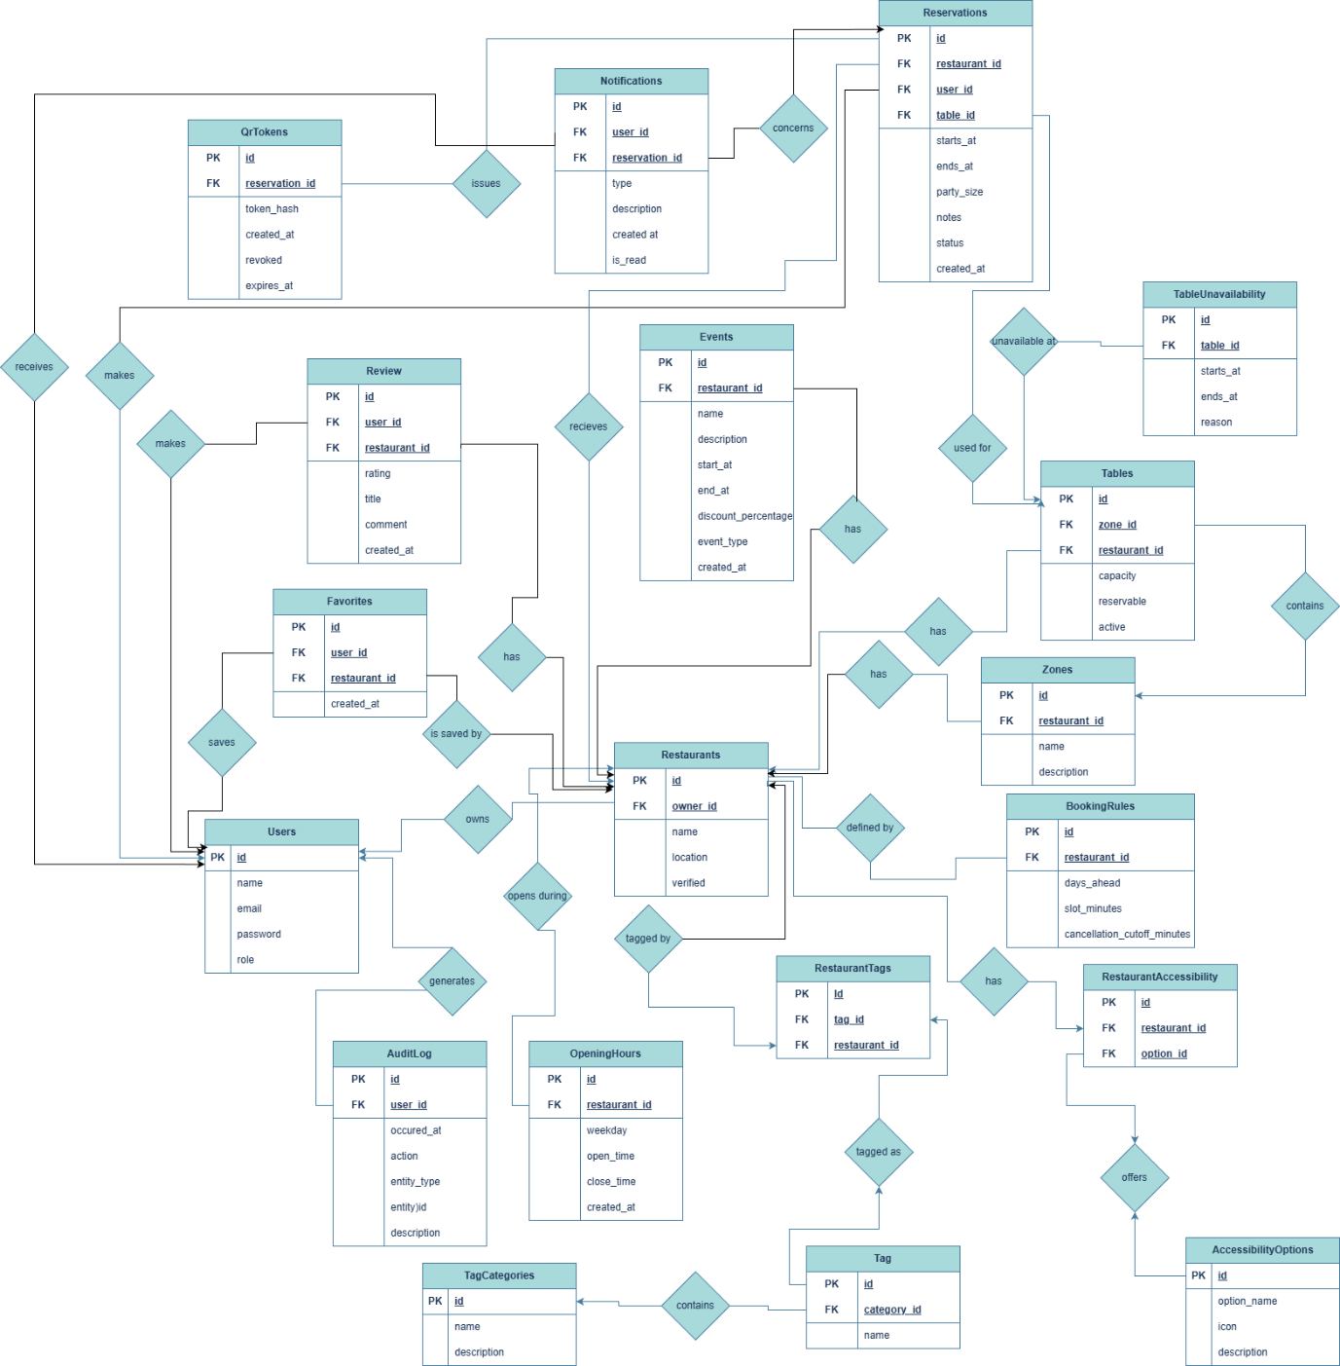

Use case diagram:
This use case diagram shows how customers, restaurant owners and administrators interact with the system. Customers can browse restaurants, make bookings and view recommendations. Owners manage their restaurant details, tables, menus, events, booking approvals, check in customers and view analytics. Administrators approve restaurants, manage users, and review audit logs.
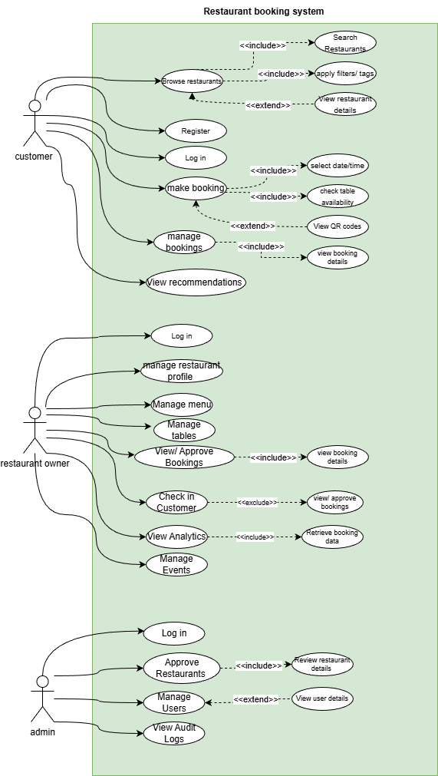

Design Decisions and Justifications

Frontend: react
In my system, a lot of the pages would repeat components and have similar layouts, such as restaurant cards and booking forms. React was chosen as using its component based structure helps keep my code more consistent without needing to write UI logic repeatedly, reducing redundancy and making it more easier to maintain. Studies have compared modern JavaScript frameworks as it works for single page applications, reusable components and has an efficient update system [4].

Backend: node.js and Express
My system would handle lots of requests simultaneously e.g. when multiple users check for restaurant availability, create bookings or owners approving requests concurrently, the backend must stay responsive and data needs to be updated. Node.js uses non-blocking input/output operations, allowing it to handle many of my requests instead of waiting for each one to finish. It also performs well for real time and high-concurrent web applications because of its event driven architecture [5] meeting my objectives.
Express is used to make it easier to organise all the API routes that my system needs (authentication, bookings, restaurant management…etc) keeping the backend easier to maintain. . It also works well with JSON which my front end uses. Currently, it’s a popular choice for node.js API’s because it follows an MVC style structure and works across many operating systems [6]. My project currently follows an MVC style structure where Prisma manages the data models, react acts as the view layer and express routes acting as containers.

Database: PostgreSQL
The system has to have a reliable storage and must prevent issues like double bookings when many users interact with the system simultaneously. PostgreSQL is a relational database that supports strong consistency, ACID transactions and constraints which enforces rules such as avoiding overlapping bookings. These features are apart of PostgreSQL’s built in transaction and isolation system which maintains consistent data under simultaneous access [7].

Object Relational Mapping: Prisma
As my database has many tables and relationships, the system would need something that could manage this while keeping the backend organised. Prisma allows me to do this by letting me work with the database through models instead of writing raw SQLs for every operation, allowing me to progress faster through my project. Since it provides type-safe queries it also helps me identify errors earlier.

Real-time: Socket.io + Redis
Sockey.io is used ton send real-time updates to the frontend so users can see booking changes and tables availability instantly, without needing to refresh the page. Redis helps share these updates quickly even when there are multiple backend processes running. Together they should keep booking status and occupancy up to date

Email: NodeMailer (SMTP)
NodeMailer is used to send booking confirmations, cancellations and reminders directly to users. It works directly with Node.js and doesn’t require any extra setup or external email services

Authentication: JWT
JWT is used as it makes login stateless. The token carries the users identity and role, so the backend can verify them quickly without storing session data.

Authorisation: Role based access control
RBAC was chosen a it lets me separate what customers, owners and admins are allowed to access, keeping the system organised whilst being secure.

Important Algorithms and Data Structures:
Booking logic to avoid conflicts:
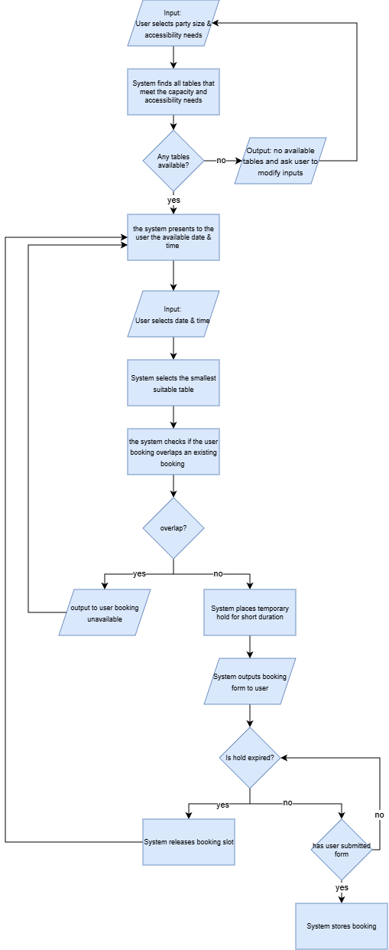

QR code logic:
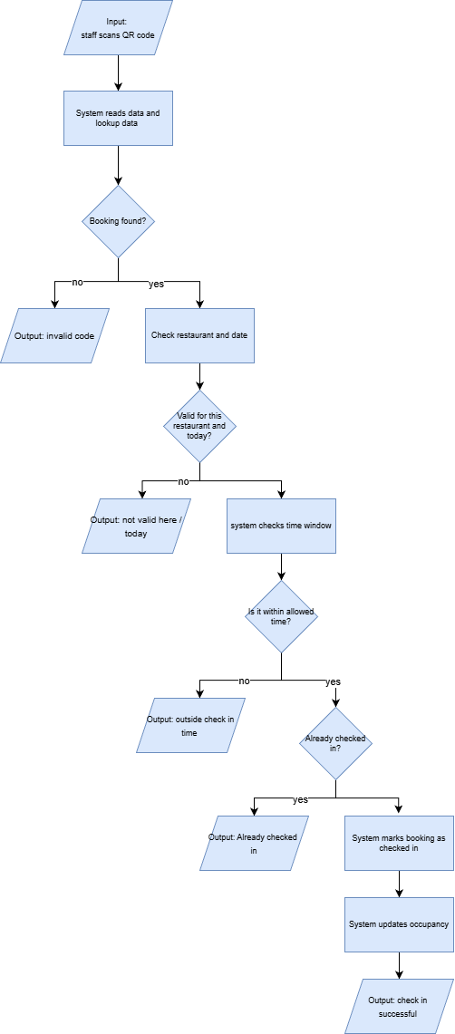

Plans and time-scales

Risk table:
Risk | Likelihood | Impact | Possible Solution
Faling behind on development | Medium | High | Break sprints into smaller tasks
Double booking errors | Medium | High | PostgreSQL constraints, testing and
Real time updates failing | Low | Medium | Socket and Redis as fallback
Feature creep | Medium | Medium | Stay to MVP features before implementing other features

Project timelines

Sprint table:

Semester 1:
Sprint | Name
0A | Research
0B | Setup and Initial Design
1 | System Design & Preparation
2 | Backend & Authentication
3 | Restaurant & Table Management Features

Semester 2:
Sprint | Name
4 | Booking Logic
5 | Real Time & Notifications
6 | Customer UI & Frontend Integration
7 | Recommendation System
8 | Admin Dashboard
9 | Testing and Refinement
10 | Documentation, Deployment & Submission

Gant chart:
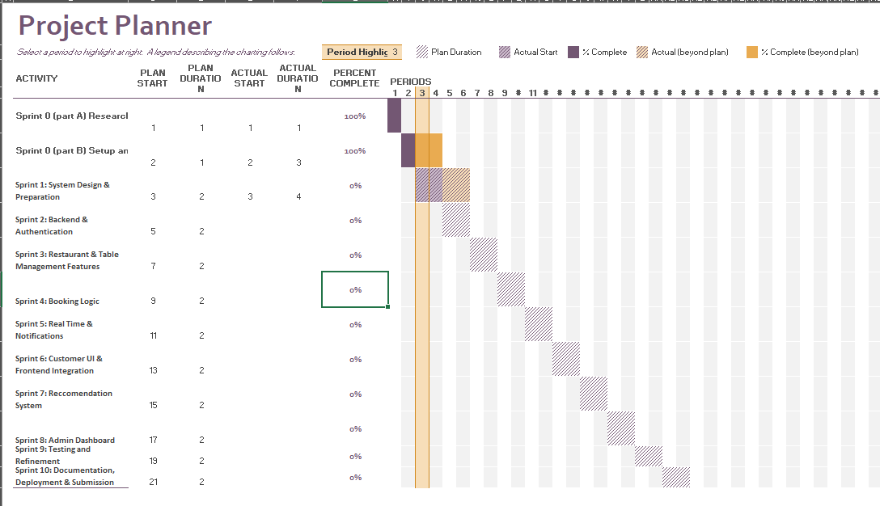

Current progress:
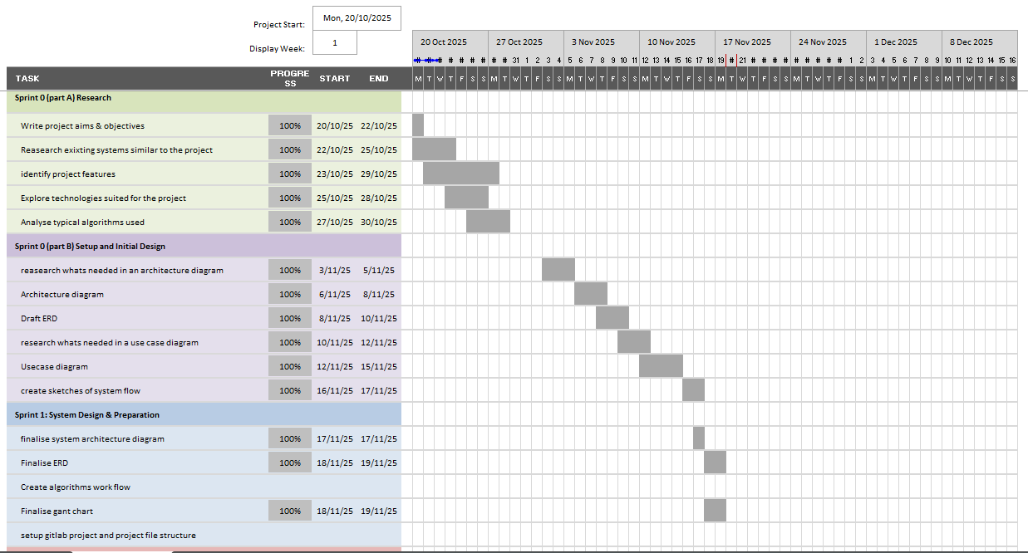
So far my project Is mostly on track with my timeline I had created at the start of then project. Sprint 0A was completed within the time frame however sprint 0B had taken slightly longer which was essential to get completed before I moved onto sprint 1. Some tasks om sprint 1 I had to start earlier in order to meet the requirements of the interim report but this has overall allowed the project to stay on track overall.

Progress Tracking and Milestones

Semester 1:

Milestone 1: Project proposal completed (sprint 0a)
- Aim & objectives finalised
- Research current systems
- Identified key features of project
- Diagrams like ERD, use case, system architecture, flow diagram explaining logic details
- Gitlab repo and board created

Milestone 2: Project proposal completed (sprint 0b & 1)
- Functional and non-functional requirements finalised
- Updates and finalised diagrams
- Designs are backed up by research
- Gant chart finalised

Milestone 3: backend foundations of the projects is operational (sprint 2)
- Backend of the project is set up
- Database has the tables as stated in the ERD
- Authentication system is set up
- RBAC
- Basic user routes tested on post man

Semester 2:

Milestone 4: Core functionality (sprint 3,4,5)
- Restaurant and table management
- Full booking logic implemented
- QR check ins and live occupancy details
- Email notifications (confirmations and cancellations )
- All core backend routes have been tested

Milestone 5: front end fully built (sprint 6 & 8)
- Customer pages
- Owner and admin pages
- Connect all front end pages to the backend routes
- User interface must be clean and simplistic

Milestone 6: Recommendation system fully working (sprint 7)
- Implement a content based recommendation system using restaurant tags, user preferences, and past bookings
- Create a scoring logic ranking restaurants based on relevance
- Integrate recommendations on the customer dashboard
- Test recommendation accuracy

Milestone 7: Full testing & modifications (sprint 8)
- Implement full admin dashboard
- Add analytic visual components such as:
  - Booking trends
  - Cancellations
  - Restaurant performance summaries
- Integrate admin actions

Milestone 8: final submission(sprint 7)
- Final report
- Screenshots of the system and GitLab evidence

References:
Bibliography
[1]TrustPilot, “OpenTable UK is rated ‘Bad’ with 1.4 / 5 on Trustpilot,” Trustpilot, Nov. 02, 2025. https://uk.trustpilot.com/review/www.opentable.co.uk?page=4 (accessed Nov. 13, 2025).
[2]TrustPilot, “Quandoo is rated ‘Excellent’ with 4.7 / 5 on Trustpilot,” Trustpilot, Oct. 16, 2025. https://uk.trustpilot.com/review/www.quandoo.com?languages=all&topics=app (accessed Nov. 13, 2025).
[3]R. Ahmed, P. Biradar, R. Bharadwaj, and R. P, “Real Time Communication using Web Sockets,” Ssrn.com, Jul. 20, 2024. https://papers.ssrn.com/sol3/papers.cfm?abstract_id=4912638
[4]P. Sekhar Emmanni, “Comparative Analysis of Angular, React, and Vue.js in Single Page Application Development,” International Journal of Science and Research (IJSR), vol. 12, no. 6, pp. 2971–2974, Jun. 2023, doi: https://doi.org/10.21275/sr24401230015.
[5]I. Journal, “IRJET- Role of Node.js in Modern Web Application Development,” IRJET, vol. 7, no. 6, Jun. 2020, Accessed: Oct. 11, 2025. [Online]. Available: https://www.academia.edu/44278861/IRJET_Role_of_Node_js_in_Modern_Web_Application_Development
[6]MDN, “Setting up a Node development environment - Learn web development | MDN,” MDN Web Docs, Dec. 19, 2024. https://developer.mozilla.org/en-US/docs/Learn_web_development/Extensions/Server-side/Express_Nodejs/development_environment
[7]PostgreSQL, “PostgreSQL: About,” Postgresql.org, 2025. https://www.postgresql.org/about/

