**V1_Character_body**

* To begin I used the starter cube and doubled it in size.
* I added an edge loop and then deleted the faces on one half of the cube
* Added a mirror modifier
* Used the knife tool to makes cuts along the sections that wanted to extrude
* Cut and extruded the top part of the body where the head will go

**V2_Character_body**

* Added detailing to the top and front of the body using the knife tool and extruding the shapes inwards or outwards
* Cut out the holes for the arms
* Beveled the edges at the back of the body
* Added detailing to the sides of the body

**V3_Character_body**

* 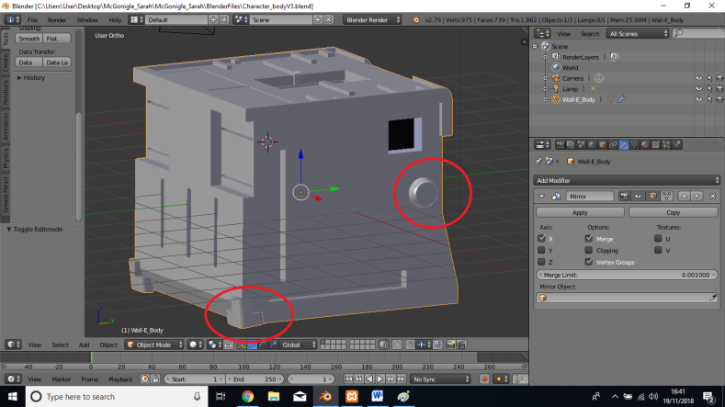Added a cylinder in object mode
* Scaled in Z
* Rotated in Y by 90 degrees
* Scaled down to the size of the reference image
* Scaled the outer face down and extruded
* Positioned the object and joined it to the main body so it would be mirrored on the other side
* Cut parts out to suit shape
* Beveled edges
* Joined to main object
* Re-named the main body “Wall-E_Body”
* Added more detail to the back of the body by cutting and extruding shapes.

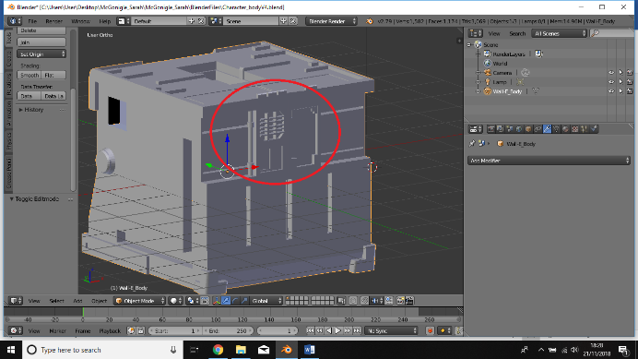**V4_Character_body**

* Applied the mirror modifier to work on individual sections
* Added buttons to the top of the body using the knife tool and extrusions
* Beveled the front edges of the buttons
* Worked on the front face details as shown in picture:
* Cut out a face on the right side of the front and extruded inwards
* Added a cylinder
* Scaled to make a pipe shape and positioned on the left side of the body
* Added a second cylinder and scaled down to create a ring around the pipe
* Copied this object to make a second ring
* Joined the 3 cylinders to the main body
* Cut out more faces and extrusions to add more detailing to the left side of the front face

**V5_Character_Neck**

* Added a cube and narrowed it down to create a hinge to hold the neck
* Scaled to size, added a loop cut and beveled the top edges
* Added a cylinder, scaled down and rotated in y by 90 degrees to create a bolt to place on the hinge.
* Joined the bolt to the cube object
* Copied and pasted the cube to create the same shape on the opposite side
* Rotated the copied neck object in Z by 180 degrees
* 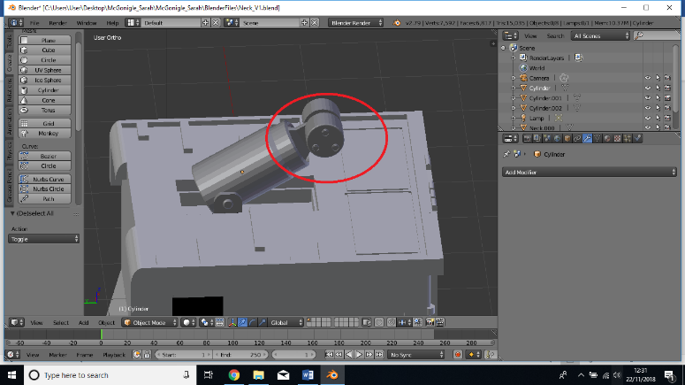Added another cylinder to create the neck.
* Scaled down and positioned between the two hinges
* Extruded and scaled the top face of the cylinder to add design
* Extruded the top face inward to create a hollow
* Made cuts on the inside face and extruded the new face up to create a hinge coming out of the neck
* Added a cylinder to create the rounded part of Wall-E’s neck
* Scaled it down and narrowed it to the required size
* Placed on one side of the hinge
* Beveled the outer edge slightly
* Added another cylinder and scaled way down to create bolt on the cylinder
* Made extrusions on the face of the bolt to add design
* Made 2 copies of the bolt and placed on the same cylinder
* Joined the bolts to the cylinder object
* Copied and pasted the cylinder, rotated by 180 degrees and placed on the opposite side of the hinge

**V6_Character_Neck**

* Brought in a cube object
* Scaled to place on top of the two cylinders from the previous version
* Made a cut across the front face and then pulled the top edge back to create a slanted edge
* 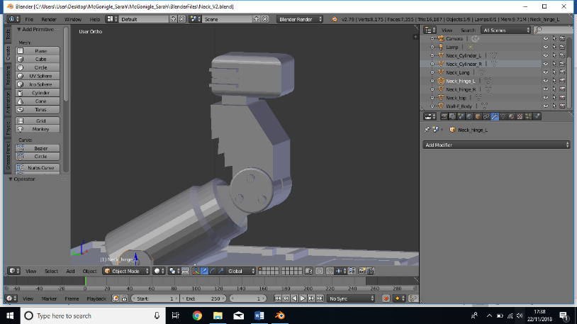Made horizontal cuts along the along the back of the cube, pulled some of the edges out and down to create a jagged edge effect
* Cut out a square on top of the cube and extruded it up
* Added another cube and scaled to a rectangular shape
* Beveled the top and bottom faces
* Placed on top of the previous extrusion
* Placed a control loop around the object, deleted the faces on one side and added a mirror modifier
* Added more loop cuts and extruded the new faces to create an edge sticking out around the back of the cube
* Applied the mirror modifier and joined the neck pieces together

**V7_Character_Head**

* Added a Bezier Circle and adjusted to create the shape for the eyes
* Converted to a mesh object, selected edge loops and created a face
* Extruded that face back to create the shape
* Extruded and scaled the front of the face, then extruded that new face back
* Positioned the eye where I wanted it and added a mirror modifier
* 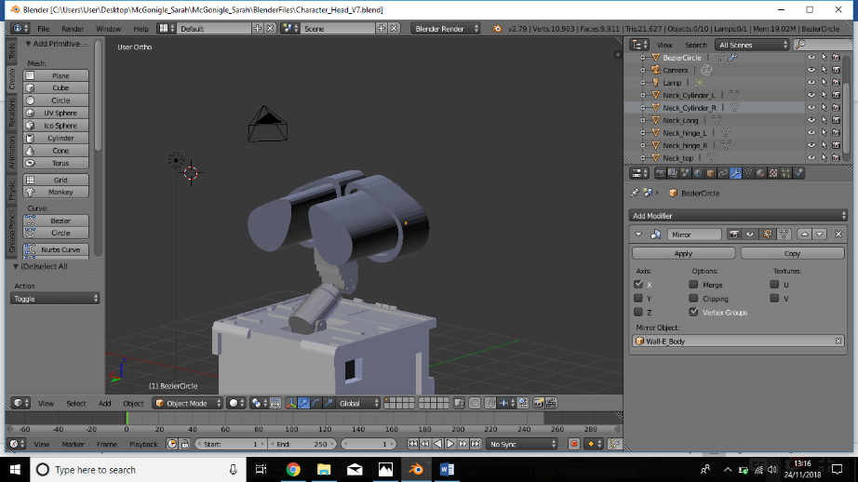Mirrored the eye to the body object to position the other eye on the other side
* Selected edge loops at the back of the eye and created a new face
* Extruded and scaled this face
* Extruded again and pulled the face out to create the back of the eyes as shown:
* Beveled the front edged of the eyes
* 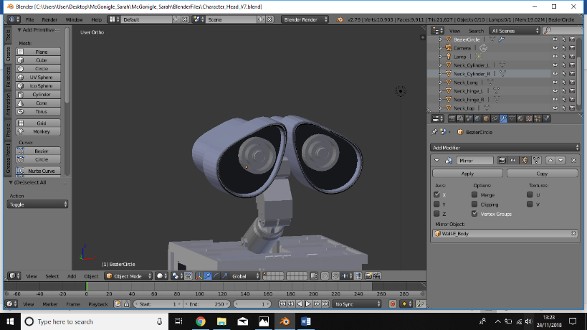Added a cylinder to create the eye balls
* Rotated in X by 90 degrees
* Scaled to size and then scaled in Y to make it narrower
* Extruded and scaled the face of the eye and repeated to create the desired design of the eye ball
* Joined the cylinder to the eye object so it would appear on the mirrored object.

**V8_Character_Head**

* Added a cube to create the flat part at the back of Wall-E’s eyes
* Scaled it down to make it flat
* Positioned and rotated it to fit on the back part of the eyes
* Beveled the outer edges
* Added another cube to create the box at the back of the eyes
* Scaled to desired size and rotated to line up with the previous cube
* Beveled, added loop cuts and extruded faces inwards for fine detailing
* Added a nurbs curve to create the arches that support the box at the back of the eyes
* 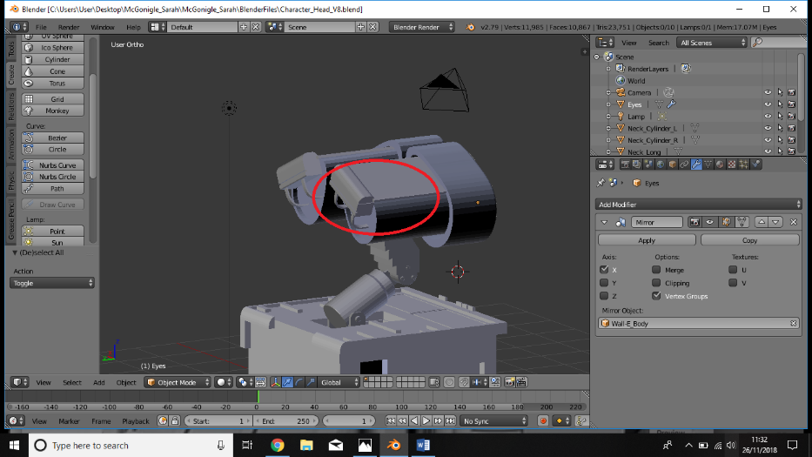Scaled and shaped to create desired arch
* Converted to a mesh object
* Selected edge loops and extruded to make it wider
* Added the Solidify modifier to make the object thicker
* Positioned and rotated to fit between the back of the eye and the cube
* Copied and pasted the curve and positioned on the opposite side of the eye
* Selected the two curves and the two cubes and joined to the eye object
* Added a cylinder
* Scaled down and positioned in the back of the eye, between the two curves (this is where the leads will come out of)
* Extruded and scaled face of the cylinder to add detail
* 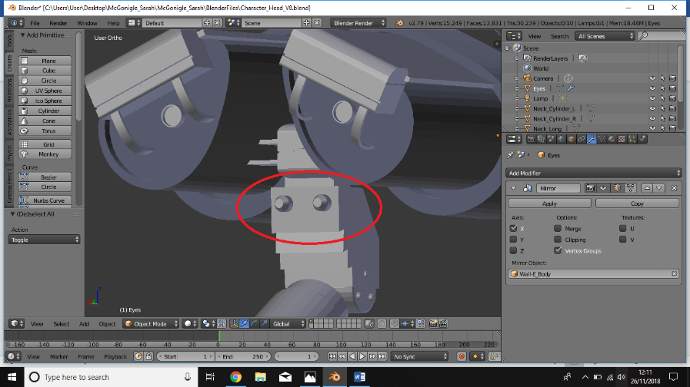Added another cylinder and positioned on the back of the neck
* Extruded and scaled the face a few times to create a narrowing effect
* This will act as a connecter for the leads/wires
* Copied and pasted the cylinder and moved to the opposite side of the neck
* Joined these cylinders to the neck object.

**V9_Character_Head**

* Added a path
* Rotated in Z by 90 degrees
* Placed the path at the center of the connecter at the back of the head
* 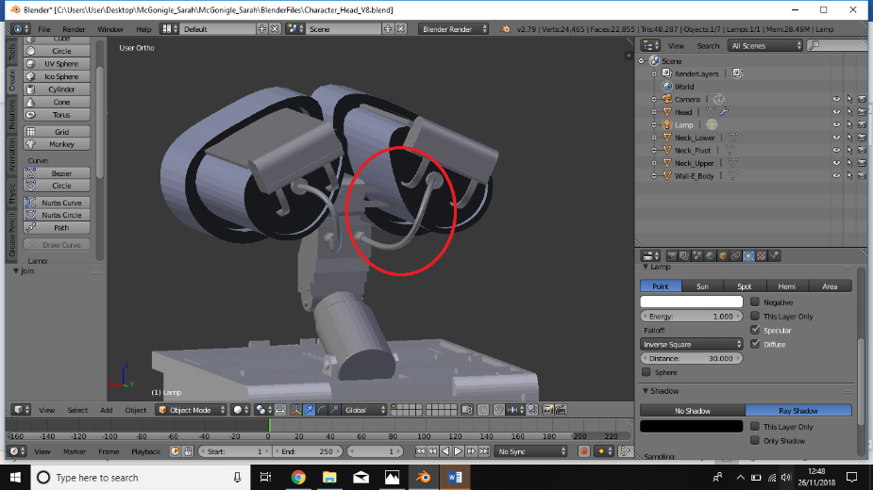Manipulated the path so the other end joined with the center of the connecter at the back of the neck
* Created a Nurbs circle
* Extruded along the path to create the wire/pipe
* Scaled and thinned it down
* Converted to a mesh object and joined it to the head so it mirrored on the opposite side

**V10_Character_Back**

* Added a cylinder to create the pipe going across Wall-E’s back
* Scaled and narrowed it down until it was almost flat and positioned at the right-hand corner of the back
* Added a mirror modifier so the same would appear on the other side
* Began extruding and scaling at various places to add the rivets appear on the pipe
* Kept extruding until the two sided met
* Added a cube to create the panel with the handle on Wall-E’s back
* Scaled to size and positioned at the under the cylinder/pipe
* Added loop cuts and extruded to create the raised areas
* Added more loop cuts and extruded to create the handle
* Rotated the panel so that is sits at a slant coming out of the back
* Added a cube, scaled and positioned under the slanted panel
* Added loop cuts and extruded five faces to create raised panels on the back
* 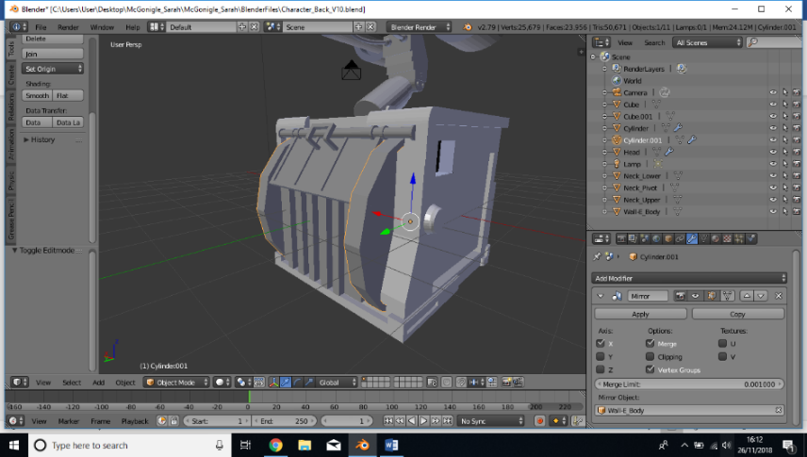Brought in a cylinder
* Lowered the vertices to 14
* Rotated in Y by 90
* Scaled in X to make it narrower
* Positioned to the right side of the cube and slanted panel and pushed into the body so only half is showing
* Mirrored the object to the body so it appears on the opposite side

**V11_Character_Arm**

* Added a cylinder
* Scaled, rotated and positioned in the hole cut out for the arms
* Added a mirror modifier so the same would appear on the opposite side
* Created another cylinder with 6 vertices to create a hexagon shape
* Scaled down, rotated and placed flat on top of the previous cylinder
* Copied and pasted the hexagon, scaled down and placed on top of itself
* Joined the two hexagon shapes to the original cylinder
* Added a cube, scaled and placed sticking out from the hexagon
* Joined to the rest of the arm piece
* Added another cylinder, this time with 25 vertices
* Scaled down to create the vertical cylinder piece for the arm
* Positioned on the cube
* Selected edge loops at the top of the cylinder, extruded and scaled to add design
* 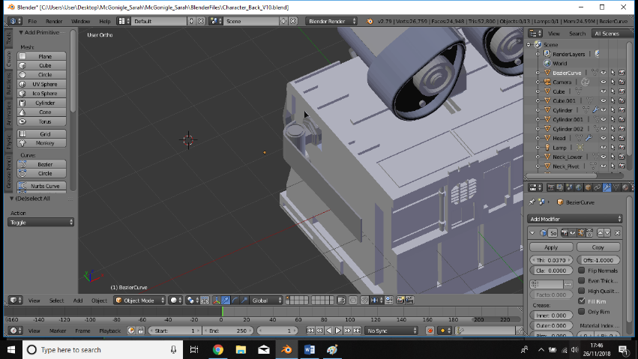 Added a Bezier curve
* Manipulated so that it curved around the cylinder but had a straight edge along the body
* Converted to a mesh object
* Selected edge loops and extruded along the Z axis
* Added the solidify modifier to up the thickness
* Positioned the arm piece so that it just intersects with the cylinder
* Joined this to the rest of the arm.

**V12_Character_Arm**

* Added a cylinder and rotated in X by 90
* Scaled and positioned on the inner side of the arm piece created in the previous version
* Deleted half the faces that were sticking out from the other side of the arm piece
* Scaled down in Z and scaled up in Y to elongate the arm
* Extruded and scaled the front face of the cylinder and then beveled the edges
* 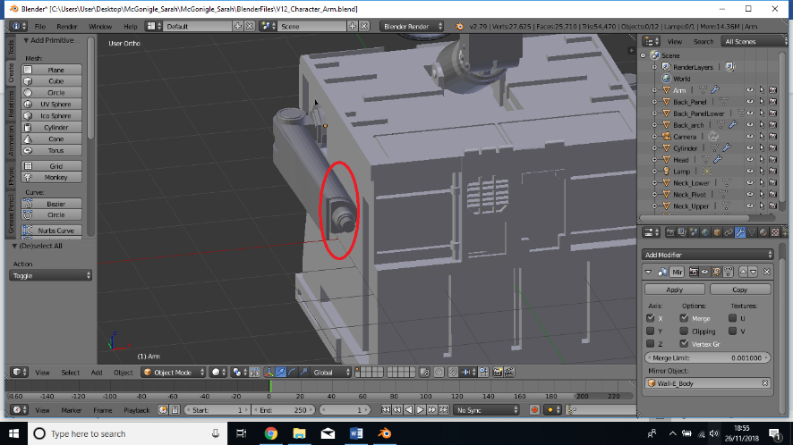Joined to the rest of the arm object
* Added another cylinder to create the wrists
* Rotated and positioned at the front of the arm
* Scaled down, beveled the outer edge
* Extruded and scaled the front and repeated until the desired wrist shape was achieved
* Joined the wrist object to the arm

**V13_Character_Hands**

* Added a cylinder to create the hinge that will hold the hands
* Scaled in Z to thin down and rotated in Y by 90 degrees
* Selected edges on one half of the cylinder and dragged out to create a flat top
* Added a loop cut and deleted the curved edge on one side of the cylinder
* Selected remaining edges and created a new face with a flat edge
* Added another loop cut and moved towards the new flat edge of the cylinder
* On the right (inside) face, I extruded the face created from the loop cut half way across the wrist
* Added a mirror modifier to create the other half of the hinge
* Merged the pieces together, placed on the wrist and the joined the hinge to the rest of the arm
* Added a cylinder to create a pipe shape that runs through the hinges to hold the hand in place
* Rotated and scaled to desired shape
* Joined this cylinder to the arm object
* Added a cube to create the hand
* Scaled down and places on the cylinder/pipe
* 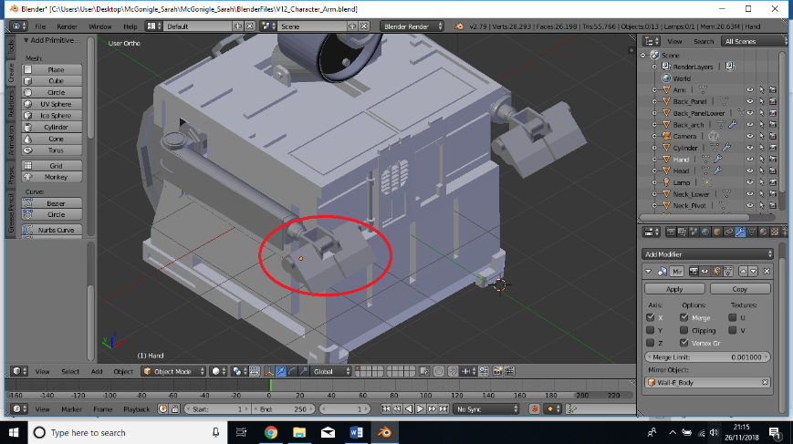Added loop cuts, extrusions and moved edges until I got the desired shape of the hand
* Added a mirror modifier to create the other half of the hand
* Applied the modifier then added a new mirror modifier for the hand object so it appears on the opposite side

(Didn’t join the hand to the arm object in case I need to animate them separately later)

* Rotated the hands in X so that they are pointing down

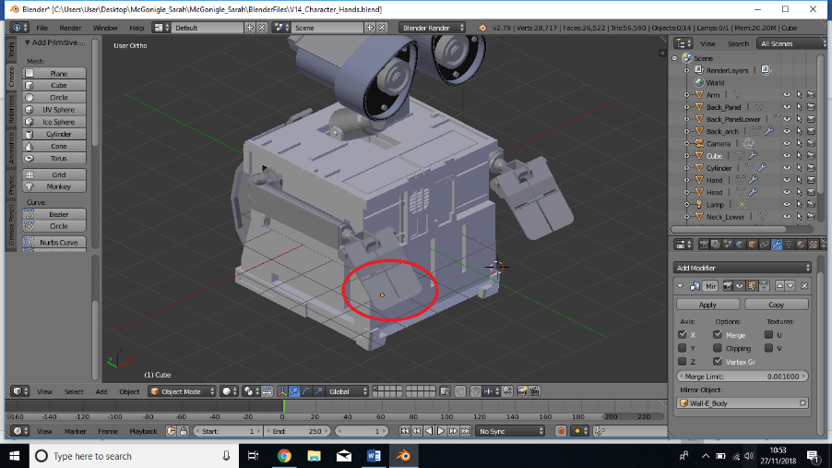**V14_Character_Hands**

* Added a cube to create the fingers
* Flattened to match the width of the hand
* Positioned in line with the hand
* To create the tapered end, I selected the bottom edge and pulled it up
* Beveled the outer corner to curve it
* Added a cylinder to create a hinge between the hand and the fingers
* Added a mirror modifier

**V15_Character_Wheels**

* Added a cylinder with 22 vertices to create the first wheel
* Scaled down in X to make it thinner
* Positioned where I want it to go under the body
* Extruded every 2nd face around the perimeter by 0.25 to create 11 spikes
* Scaled the extruded faces by 0.8 to make them narrower at the top
* Extruded and scaled the front face a few times to create a dome shape
* Extruded the back of the wheel out half way to where it will meet the mirrored wheel
* 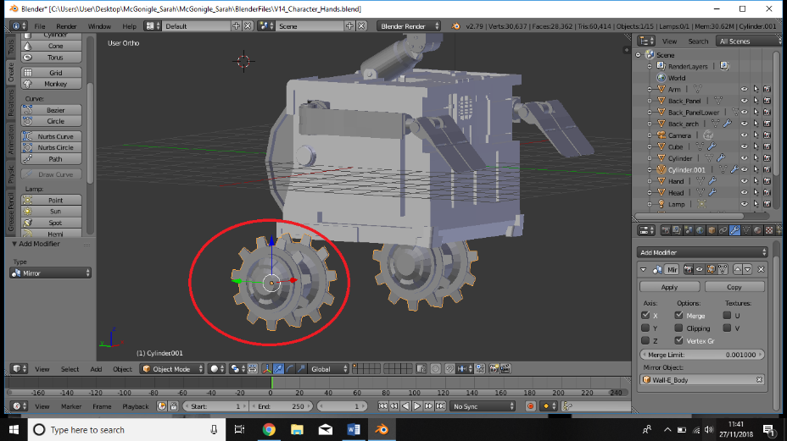Added a mirror modifier to the wheel, mirrored it on Z and joined the two objects together to make a double-sided wheel
* Applied the modifier
* Added another mirror modifier to the wheel, mirrored it to the body so the wheel copies to the opposite side.

**V16_Character_Wheels**

* Duplicated the first wheel, dragged it across and scaled down to create the front wheels
* In the front view I scaled the front wheels up in X so that they were the same width as the back wheels
* 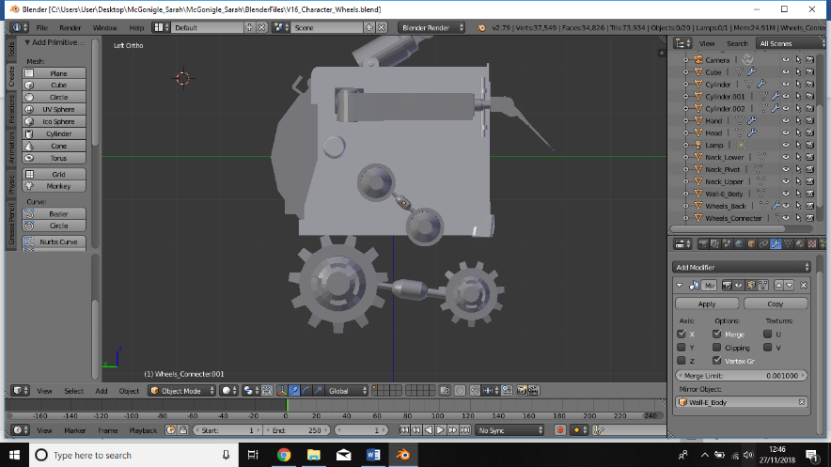Added a cylinder to create a connecter for the two wheels
* Scaled down to size, positioned between the wheels and extruded to create pipes coming out of the cylinder to connect the two wheels
* Rotated slightly
* Added another cylinder to create a wheel at the top
* Carried out similar steps as before
* Duplicated this wheel and moved down slightly, in line with the front wheel
* Duplicated the connecter pipe, scaled and positioned between the top wheels

**V17_Character_Wheels**

* Added a cube to create a bracket to join the wheels to the body
* Scaled to size, added loop cuts and extrusions
* Extruded one of the top faces up to connect with the body
* 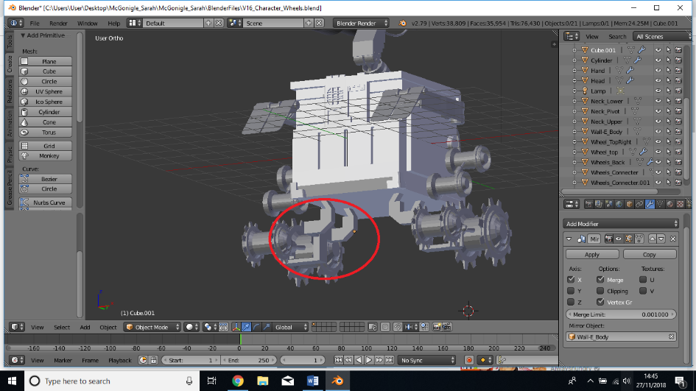Created a mirror object of the bracket and placed one above each wheel
* Added a loop cut on one bracket and extruded this face to join with the other bracket
* Applied this modifier then added another mirror modifier to copy the bracket to the opposite side
* Added more loop cuts and extrusions until the desired shape was achieved

**V18_Character_Tracks**

* Added a cube to create the first piece of the track
* Positioned under one of the spikes on the wheel
* Scaled to desired size and thickness
* Cut out holes where the spikes will fit into
* Using the knife tool, I cut out a shape and extruded it to create the grips for the track
* 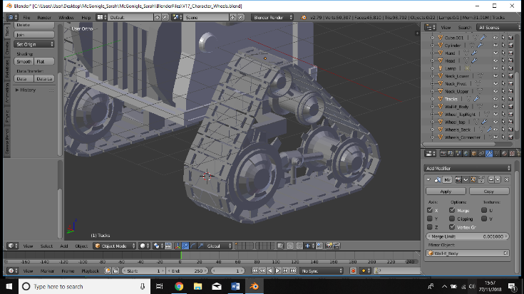Used loop cuts and extruded two faces on one edge of the track to create spikes that will join the tracks together
* Copied and pasted the track object, rotated where needed and repeated the whole way around the wheels to create the tracks
* Selected all the track objects and joined to make one
* Added a mirror modifier to mirror to the opposite side