

Lebanese University - Faculty of Sciences
Section - I

Department of Computer Science

2025-2026

Project submitted in the context of the course
I3306 Database II

Prepared by
Sarah NASSEREDDINE
Student ID: 112872

Acknowledgements

I would like to offer my sincere thanks to Dr. Mohammad Dbouk for providing the technical foundation necessary to complete this project. Your dedication to teaching advanced database concepts allowed me to transition from basic data storage to building a complex, automated management system.
I also acknowledge the Faculty of Sciences at the Lebanese University for providing the resources and support required for our computer science curriculum. This project represents not only a technical milestone but a personal one, and I am grateful for everyone who assisted in its successful completion.

Table of Contents
Introduction 4
CHAPTER 1: 5
Database Application Architecture 5
1. Introduction 5
2. Role of each component 5
User Client 5
Database Server 5
CHAPTER 2 : 6
Database Modeling 6
1. Introduction 6
2. Adopted topic – business requirements 6
3. Entity Relationship Diagram 6
4. Mapping ERD to database schema 6
CHAPTER 3: 7
Services and Interface modeling 7
CHAPTER 4: 8
Application Implementation and testing 8
1. DDL scripts 8
2. DML scripts 8
Data insertions 8
Data modification and deletion 8
Set of relevant extractions - queries 8
3. Conclusion 8
Conclusion: 9

Introduction
In today’s rapidly evolving digital economy, retail businesses face immense pressure to modernize their operations. In Lebanon, many local computer shops and technology retailers still rely on manual processes, paper-based records, or basic Excel spreadsheets to track their inventory and sales. While these methods may work for very small operations, they lead to significant issues as a business grows: data redundancy, human error in stock counting, lack of real-time visibility, and a fragmented customer experience.
The computer hardware sector, characterized by high-value products and fast-moving technical specifications, demands a more sophisticated approach. This project presents a comprehensive Database Management System (DBMS) designed specifically for TechZone Computers. The core philosophy behind this project was to bridge the gap between traditional "offline" management and modern digital commerce. By replacing static spreadsheets with a dynamic, relational database, we provide a solution that ensures data integrity while offering a user-friendly interface for both the shop owner and the end customer.
The primary objective is to demonstrate how advanced database design—using Microsoft SQL Server and PHP—can solve these authentic business challenges. This report documents the transition from manual data handling to an automated system featuring real-time stock validation, secure transaction management, and advanced filtering, specifically tailored to the needs of the Lebanese tech retail environment.

……

CHAPTER 1:

Database Application Architecture

Introduction
Modern database applications follow a multi-tier architecture that separates different concerns and responsibilities into distinct layers. This architectural approach provides numerous benefits including improved maintainability, scalability, security, and flexibility. In this chapter, we explore the three-tier architecture adopted for our Computer Store Database Management System, examining how each layer contributes to the overall functionality and how they interact to deliver a seamless user experience.
The three-tier architecture divides the application into three logical and physical computing tiers: the presentation tier (user interface), the application tier (business logic and processing), and the data tier (database management system). This separation of concerns allows developers to modify or replace one tier without affecting the others, facilitating easier maintenance and future enhancements. For our Computer Store system, we have implemented this architecture using modern web technologies and Microsoft SQL Server, creating a robust and scalable solution suitable for real-world deployment.

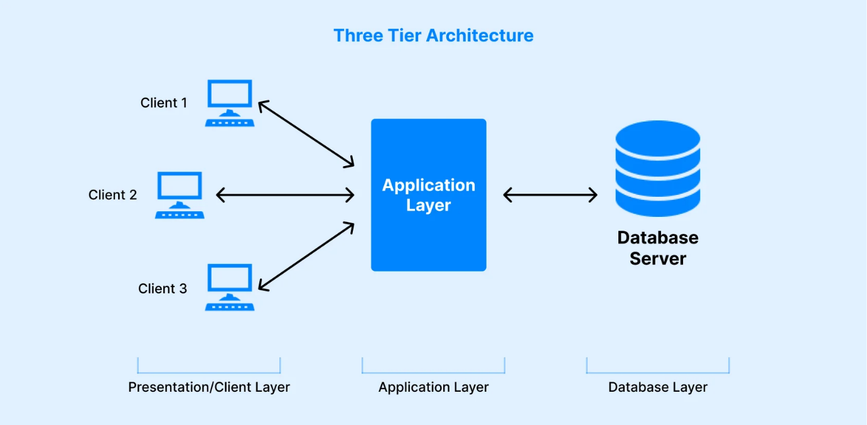

Role of each component
Our Computer Store Database Management System is built on a classic three-tier client-server architecture, which has proven to be highly effective for web-based database applications. This architecture provides clear separation between the user interface, business logic, and data storage, enabling each component to be developed, tested, and maintained independently while working together as a cohesive system.

Presentation Tier (Client Layer)
The presentation tier represents the user-facing component of our system, acting as the primary entry point for both customers and administrators. Implemented using modern web technologies—including HTML5 for structure, CSS3 for styling, JavaScript for interactivity, and Font Awesome for visual communication—this tier runs entirely in the user's web browser.
The client's primary responsibility is to render the user interface and handle direct interaction. The Home Page serves as the landing hub, while the Products Catalog provides advanced filtering by category and price. For the consumer, the Shopping Cart and Checkout System manage the transition from browsing to purchasing. For the administrator, the Dashboard provides a secure interface for sales analytics and inventory control. By performing client-side validation, the user client provides immediate feedback to the user, ensuring a responsive experience while reducing unnecessary server load.
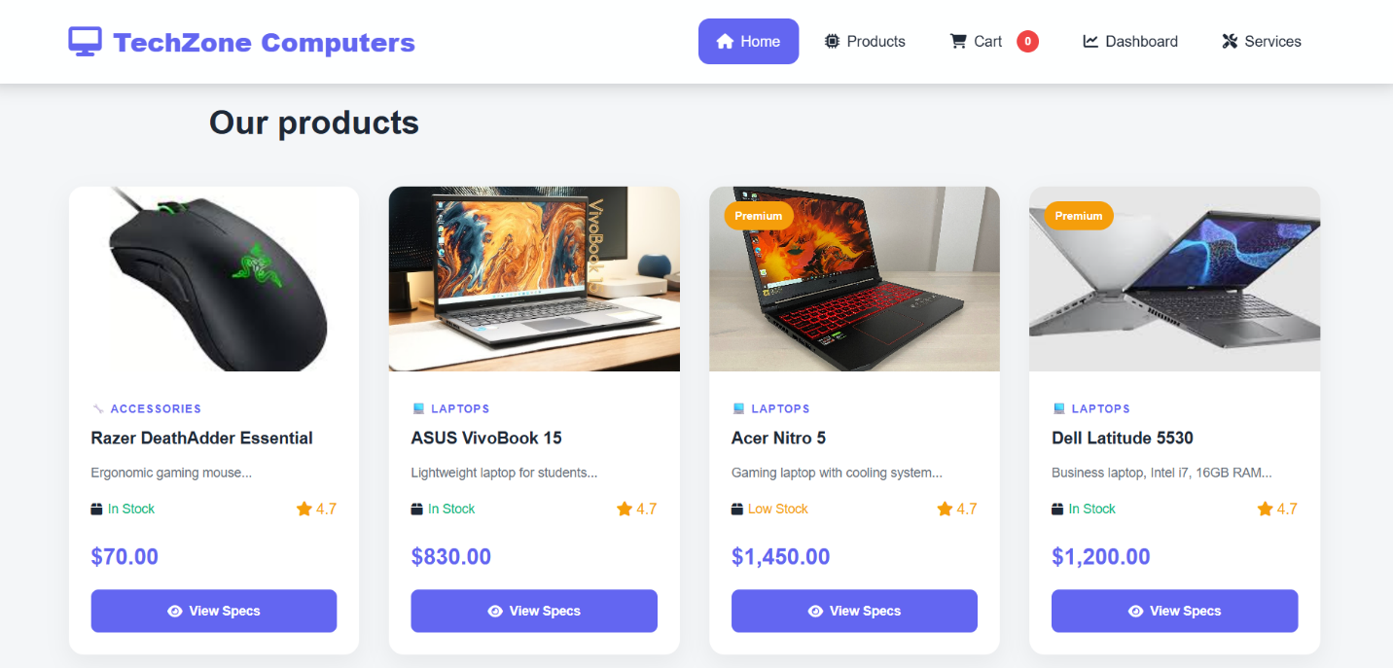

The Dashboard provides administrative analytics including sales charts, inventory status, low stock alerts, and order management. All interfaces are designed with responsive layouts that adapt seamlessly to different screen sizes, ensuring optimal user experience across desktop computers, tablets, and mobile devices.
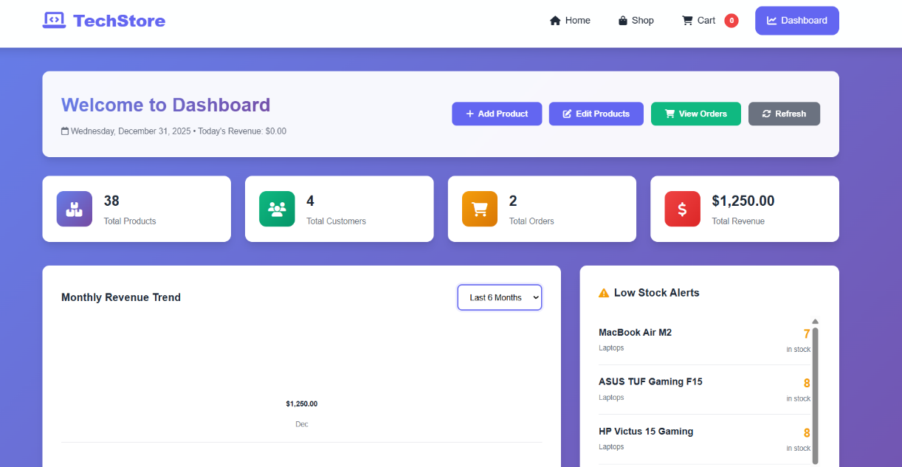

Application Tier (Business Logic Layer)
The application tier serves as the core processing engine and the intermediary between the user and the data. This layer is implemented using PHP, running on an Apache or IIS web server environment. It houses the "intelligence" of the system, transforming user actions into database commands.
When a user interacts with the client (e.g., adding an item to the cart), the Application Tier handles Database Connection Management and Business Logic Implementation. This includes calculating 11% VAT, managing session-based carts, and enforcing security protocols like input sanitization to prevent SQL injection and XSS attacks. The application tier communicates with the database via the sqlsrv extension, constructing parameterized queries that ensure data integrity. Through files like checkout.php and add_product.php, this layer manages the complex workflows of order processing and inventory updates before the final data is committed to storage.
<?php
// Database configuration for MS SQL Server
$serverName = "localhost";
$connectionOptions = array(
"Database" => "ComputerStore",
"CharacterSet" => "UTF-8"
);

// Create connection
$conn = sqlsrv_connect($serverName, $connectionOptions);
// Check connection
if ($conn === false) {
die(print_r(sqlsrv_errors(), true));
}

// Start session for cart
session_start();

// Initialize cart if not exists
if (!isset($_SESSION['cart'])) {
$_SESSION['cart'] = array();
}
// Store Information
define('STORE_NAME', 'TechZone Computers');
define('STORE_TAGLINE', 'Your Ultimate Computer Destination');
define('STORE_EMAIL', 'support@techzone.com');
define('STORE_PHONE', '+961 1 234 567');
define('STORE_ADDRESS', 'Beirut Digital District, Lebanon');

// Helper function for queries
function executeQuery($conn, $sql, $params = array()) {
$stmt = sqlsrv_query($conn, $sql, $params);
if ($stmt === false) {
die(print_r(sqlsrv_errors(), true));
}
return $stmt;
}

// Helper function to format price
function formatPrice($price) {
return '$' . number_format($price, 2);
}
// Helper function to get cart count
function getCartCount() {
$count = 0;
if (isset($_SESSION['cart'])) {
foreach ($_SESSION['cart'] as $quantity) {
$count += $quantity; }
}
return $count;}
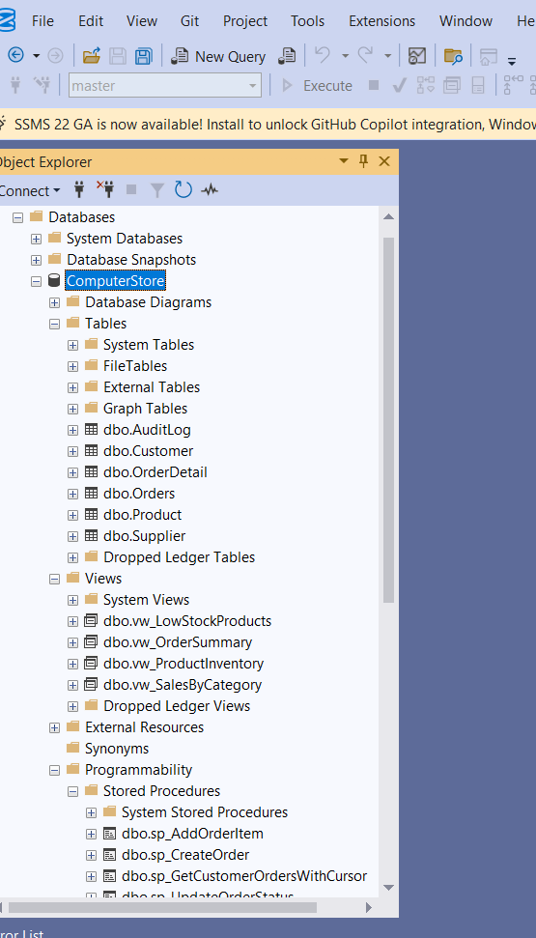

Data Tier (Database Layer)
The data tier represents the foundation of our system, powered by Microsoft SQL Server. This component is responsible for persistent storage, transaction consistency, and enforcing the relational rules of the business. SQL Server was chosen for its robust enterprise features, such
The database server, powered by Microsoft SQL Server, represents the persistent storage layer of the TechZone Computers system. Unlike a simple spreadsheet, this component is responsible for securely storing all business data, enforcing complex integrity rules, and ensuring that every transaction—such as a customer placing an order—is consistent and reliable.
In our architecture, SQL Server runs as a dedicated service, accepting secure connections from our PHP application and executing optimized SQL commands. The database server performs several critical functions that are essential for a professional retail environment:
- Data Storage and Integrity: It maintains structured storage of business entities (Customers, Products, Suppliers) in normalized tables. It enforces Referential Integrity through foreign key constraints, ensuring, for example, that an order cannot exist without a valid customer. It also uses Check Constraints to prevent logical errors, such as a product having a negative price or stock level.
- Transaction Management (ACID Properties): One of the most important roles of the server is managing transactions. It ensures the ACID properties:
  - Atomicity: An order and its details are saved together; if one fails, the whole transaction rolls back.
  - Consistency: The database moves from one valid state to another (e.g., stock is deducted exactly when the order is confirmed).
  - Isolation: Multiple customers can shop at the same time without their data interfering.
  - Durability: Once an order is saved, it remains safe even in the event of a system crash.
- Business Logic Execution (Server-Side Automation): Instead of relying solely on the PHP code, we offload heavy logic to the database. This includes:
  - Stored Procedures: Like sp_CreateOrder, which bundles multiple SQL commands into one efficient call.
  - Triggers: Like trg_CheckStock, which fires automatically to validate inventory the moment an insertion is attempted.
  - Views: Like vw_SalesByCategory, which provide pre-calculated reports to the application layer.
- Query Optimization: The server uses Indexes (which we created on columns like Email and Category) to ensure that searching through thousands of products happens in milliseconds, providing the "User Friendly" speed we promised in our solution.

CHAPTER 2 :

Database Modeling

Introduction

The development of the TechZone Computers database was not a random process of creating tables; it followed a rigorous Database Life Cycle (DBLC). This methodology ensures that the final system is scalable, secure, and—most importantly—mathematically sound to prevent data corruption.
Below is a detailed breakdown of how each engineering phase was applied to our computer store:
- Engineering steps
- Phase 1: Requirement Analysis (The Discovery Phase): In this stage, we acted as business analysts to define the "Rules of the Game." We identified that a computer store isn't just about selling; it’s about managing complex relationships.
- Example: We determined that a "Product" must always have a "Supplier" and a "Stock Level." We also identified the Lebanese fiscal requirement: every order must calculate an 11% VAT and check for a $100 threshold for free shipping. This phase defined our Business Rules.
- Phase 2: Conceptual Design (Abstract Modeling): Here, we created the Entity-Relationship Diagram (ERD). This is the "Blueprint" of the building before the first brick is laid. We focused on the entities and their interactions without worrying about the software yet.
- Example: We decided that an Order is a separate entity from a Product, and because one order can have many products, we discovered the need for an associative entity called OrderDetail. This prevented a "Many-to-Many" mess and kept the design clean.
- Phase 3: Logical Design (Normalization & Schema Mapping): This is the most critical technical step for a Database II project. We transformed the ERD into a Relational Schema and applied Normalization (1NF, 2NF, 3NF).
- Normalization Example: We ensured that the Customer address is stored in the Customer table and not repeated in every Order. This satisfies Third Normal Form (3NF) by removing transitive dependencies.
- Integrity Example: We defined Primary Keys (like ProductID) to ensure uniqueness and Foreign Keys (like SupplierID in the Product table) to enforce Referential Integrity, meaning you cannot delete a supplier if you still have their products in your warehouse.
- Phase 4: Physical Design (Implementation & Optimization): The final stage was translating our logic into DDL (Data Definition Language) scripts specifically optimized for Microsoft SQL Server.
- Data Types: We chose DECIMAL(10,2) for prices to ensure financial accuracy and NVARCHAR for names to support special characters.
- Performance Optimization: We didn't just create tables; we implemented Non-Clustered Indexes on columns like ProductCategory and CustomerEmail to ensure that searches stay fast even if the store grows to 10,000 products.
- Automation: We wrote SQL Triggers (like trg_CheckStock) to move the business logic from the application level directly into the data level, making the system "self-aware" and much more secure.

Adopted topic – business requirements
The transition from a manual "Spreadsheet" system to a "Relational Database" is not just about changing where data is stored; it is about changing how the business operates. The TechZone Computers system was designed to eliminate the "Excel Bottleneck"—a common failure point in Lebanese SMEs where data is fragmented and inconsistent.
Below are the expanded functional requirements and the logic behind our design decisions:

A. Hierarchical Inventory Management (Beyond Flat Lists)
Traditional spreadsheets treat every item as a single row. Our system recognizes that technology hardware has complex relationships.
- The Logic: We implemented a categorization system that allows for granular filtering. For example, a "Laptop" isn't just a name; it is an entity linked to a price, a stock level, and a specific technical description.
- Database Solution: By using indexed Category columns, the system can instantly generate reports like "Show me all GPUs under $500 that are currently in stock," a task that would take minutes of manual scrolling in Excel.

B. Supplier Relationship & Supply Chain Tracking
In the Lebanese tech market, sourcing is critical. Shops often deal with multiple distributors (e.g., TechSupply Lebanon, Global Components).
- The Logic: We moved away from "Hardcoding" supplier names. Instead, we established a One-to-Many (1:N) relationship between Suppliers and Products.
- Impact: This allows the store manager to click on a supplier and immediately see their entire portfolio, contact information, and delivery performance. It ensures that if a supplier's phone number changes, it is updated in one place (The Supplier Table) and reflected everywhere, maintaining Referential Integrity.

C. Automated Transaction Reliability (ACID Enforcement)
This is the core of our "Intelligence." In a manual system, when a sale happens, the seller might forget to update the stock.
- The Logic: We shifted the responsibility from the human to the SQL Server. When an order is processed, the system triggers a sequence of events:
  - Stock Validation: It queries the Product table. If Stock < RequestedQuantity, it throws a RAISERROR, stopping the sale before it happens.
  - Inventory Sync: It automatically decrements the Stock count.
  - Revenue Calculation: It pulls the latest UnitPrice and calculates the TotalAmount for the order.
- Example: If Ahmad buys 2 Monitors, the database ensures that the store doesn't "over-sell" a 3rd monitor to Sara at the same time. This solves the Concurrency issues found in shared spreadsheets.

D. Financial Compliance & Localization (VAT & Shipping)
To make the system production-ready for Lebanon, we integrated local financial rules directly into the application and service layers.
- The 11% VAT Rule: Instead of the user manually adding tax, the system automatically applies an 11% surcharge to the subtotal.
- Shipping Incentives: To encourage higher sales, we implemented a business rule: "Orders > $100 = Free Shipping ($0), otherwise = $15 Flat Fee."
- Impact: This ensures that every receipt generated is legally compliant and financially accurate, removing the possibility of human calculation errors.

E. Strategic Auditability (The Security Layer)
In a multi-user environment (Manager + Employees), internal security is paramount.
- The Logic: We created an AuditLog to track "High-Stakes" changes.
- Real-World Example: If an employee changes the price of a High-End Gaming PC from $2,500 to $1,500 just to buy it for a friend, the trg_ProductAudit trigger will capture the Old Value, the New Value, the User, and the Exact Timestamp.
- Impact: This creates a "Culture of Accountability." The database becomes its own security guard, ensuring that every sensitive modification is transparent and traceable.

Entity Relationship Diagram

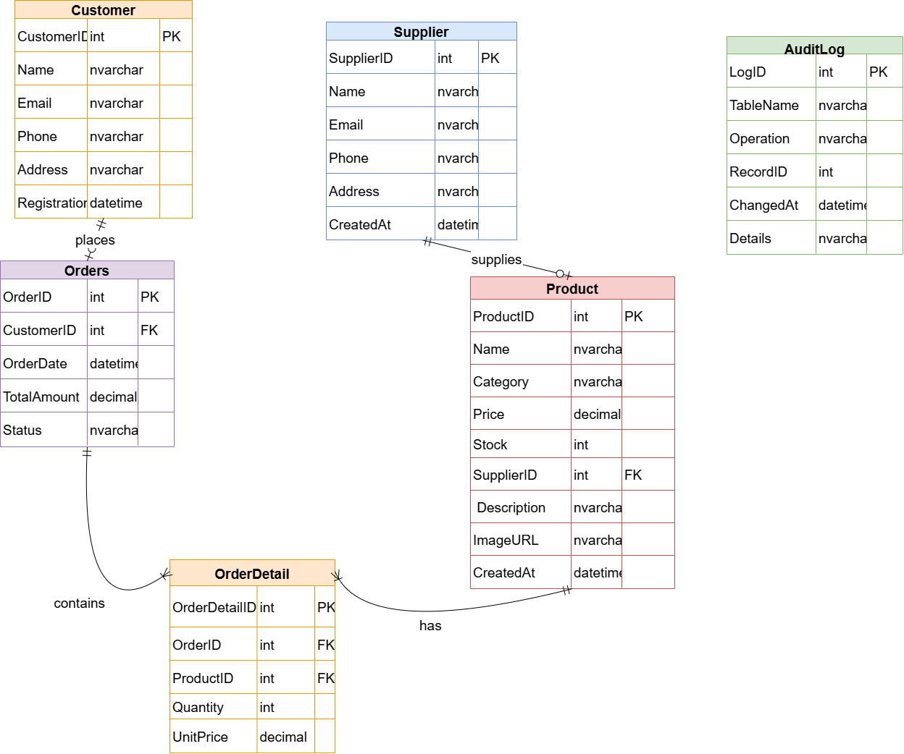

- Key Entities and Attributes:
- Customer: Stores essential client data including a unique CustomerID (PK), Name, Email (Unique), and Address.
- Product: Represents the inventory. It includes ProductID (PK), Name, Category, Price, and Stock. It is linked to a SupplierID (FK).
- Supplier: Manages vendor information such as Name, Contact Email, and Office Address.
- Orders & OrderDetail: To avoid a Many-to-Many relationship between Orders and Products, we implemented the OrderDetail associative entity. This allows an order to contain multiple products, each with a specific Quantity and UnitPrice recorded at the time of sale.
- AuditLog: An independent entity used for system governance, tracking all INSERT and UPDATE operations on sensitive tables.
- Relationship Logic (Cardinality):
- Supplier to Product (1:N): One supplier can provide multiple products (e.g., "TechSupply Lebanon" provides various Laptops and GPUs), but each product is tracked back to one primary supplier for restocking consistency.
- Customer to Orders (1:N): A single customer can place multiple orders over time, while each order belongs to exactly one registered customer.
- Orders to OrderDetail (1:N): An order acts as a header that can contain several line items. This structure is essential for calculating the total invoice.
- Product to OrderDetail (1:N): A specific product (e.g., "Dell Inspiron") can appear in many different customer orders.
- Design Considerations:
- Normalization: The diagram reflects a Third Normal Form (3NF) design. For instance, supplier contact details are not repeated in the Product table; they are linked via a Foreign Key to minimize data redundancy.
- Integrity Constraints: We have defined mandatory attributes (NOT NULL) for critical fields like Price and Email to ensure that no "garbage data" enters the system.

Mapping ERD to database schema
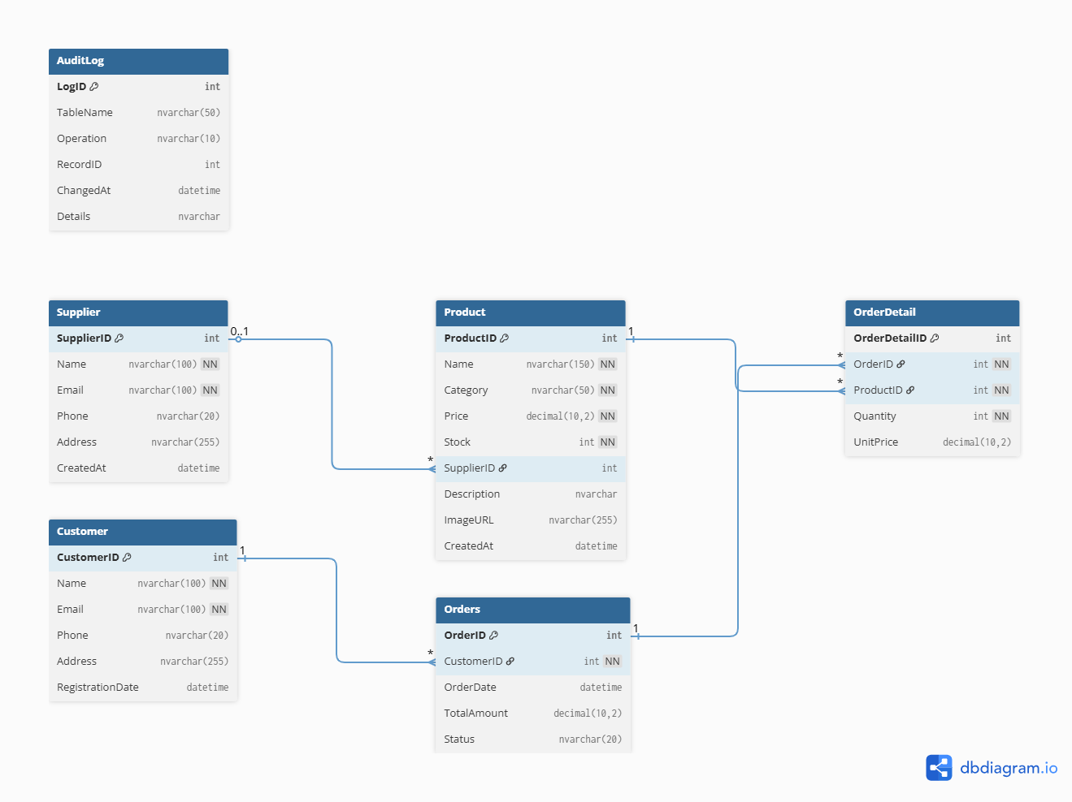

CHAPTER 3:

Services and Interface modeling

1. Introduction
The TechZone Computers interface is designed as a Data-Driven Application. Each module serves a specific business function, ensuring that the user interacts with a clean GUI while the backend handles complex relational logic, transaction integrity, and automated stock management.
2. Customer Journey & Transactional Flow
A. Discovery & Navigation (index.php & products.php)
- The Interface: A dynamic landing page and a comprehensive catalog where users can browse hardware.
- The DB Link: I implemented Advanced Filtering (Category, Price, and Search). When a user selects "Laptops," the interface executes a SELECT query with a WHERE clause. This solves the "Information Overload" problem by fetching only relevant data from the Product table.
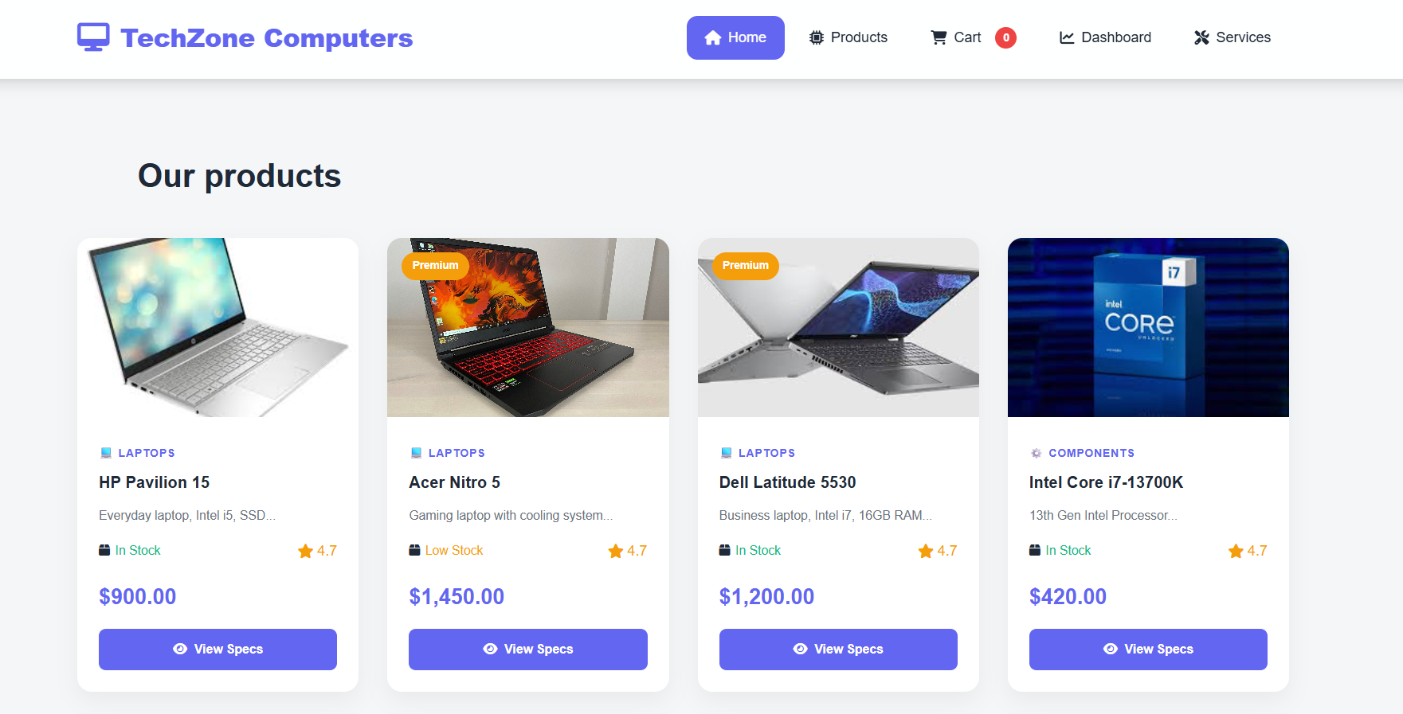
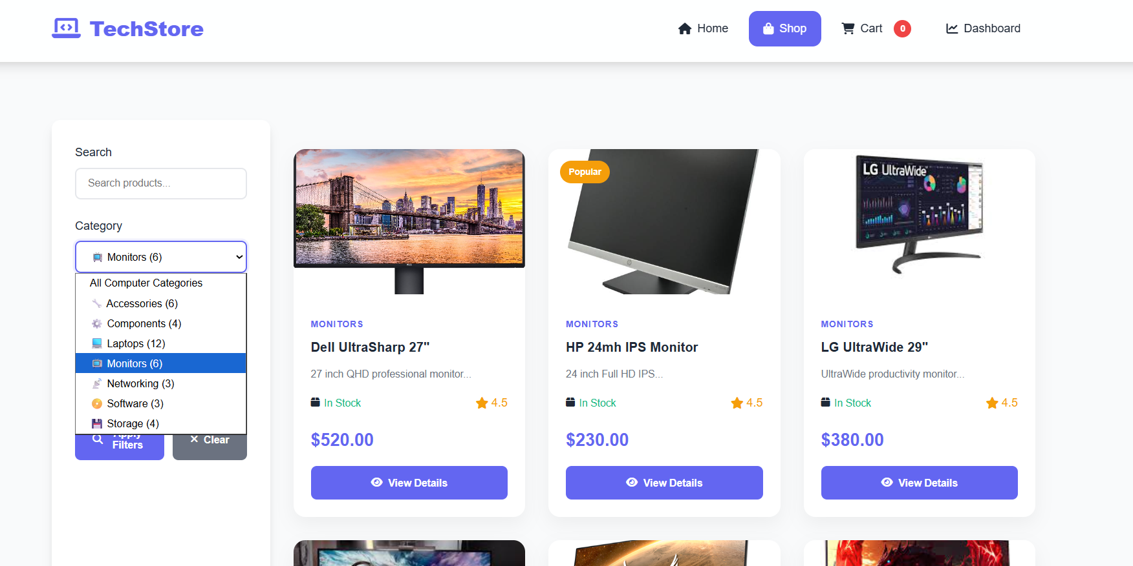
B. Decision & Cart Management (product_detail.php & cart.php)
- The Interface: A detailed view of each component (Specs, Supplier name) and a session-based shopping cart.
- The DB Link: The "Add to Cart" function checks the Stock column in real-time. If the stock is 0, the button is disabled. In cart.php, we use the ProductID to pull the latest price, ensuring the user always sees accurate costs.
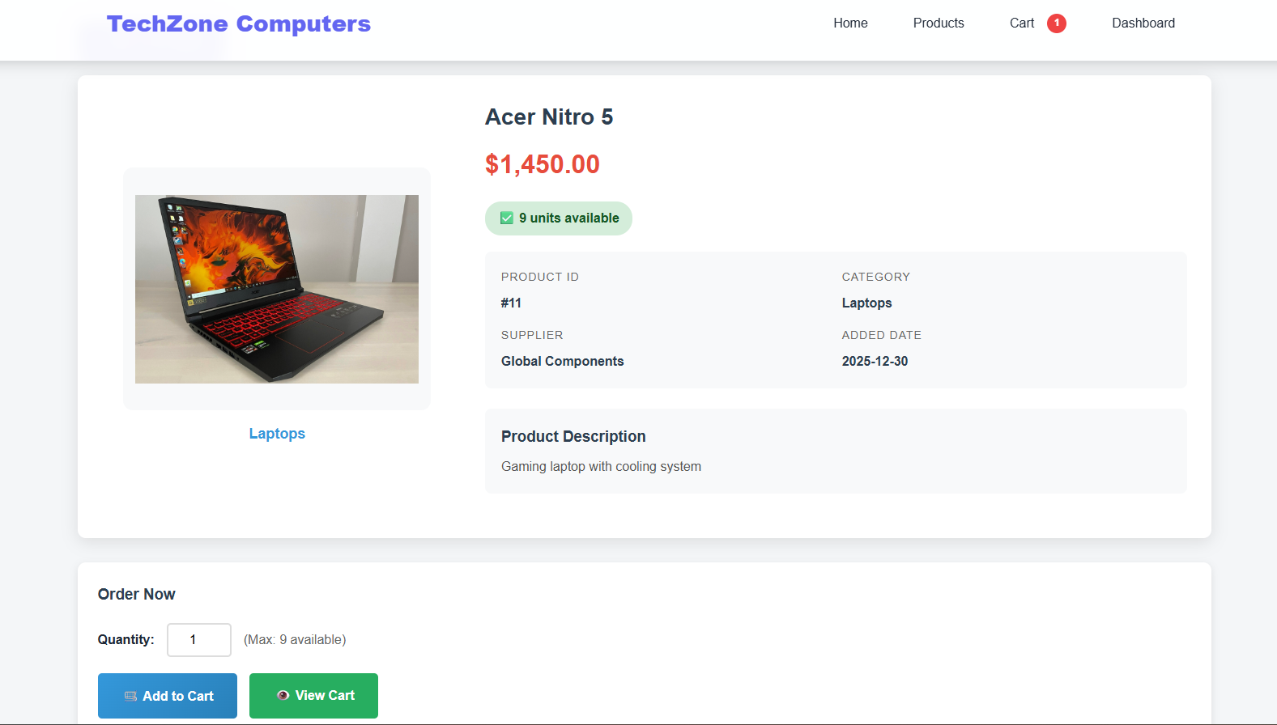

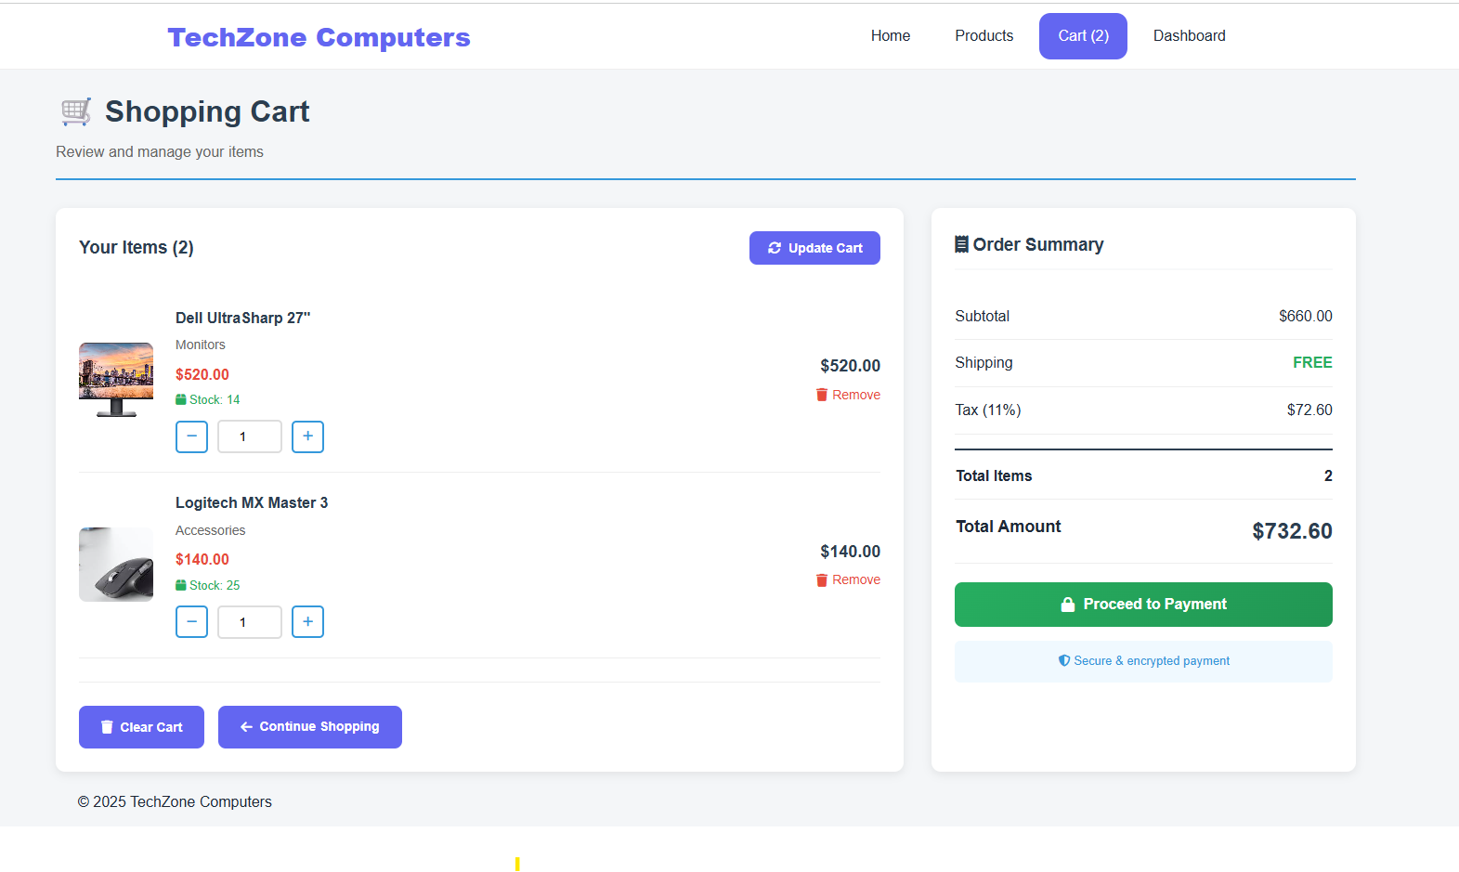
C. The Checkout & Payment Engine (checkout.php)
- The Interface: A secure form for customer details and order finalization.
- The DB Link (Crucial): This is the most complex part of the system.
  - Identity Management: The system checks if the email exists in the Customer table. If not, it performs an INSERT to register the new customer automatically.
  - Atomic Transactions: We use the sp_CreateOrder and sp_AddOrderItem stored procedures.
  - Business Rules: The database automatically calculates the 11% VAT and applies the Shipping Logic ($0 if total > $100).
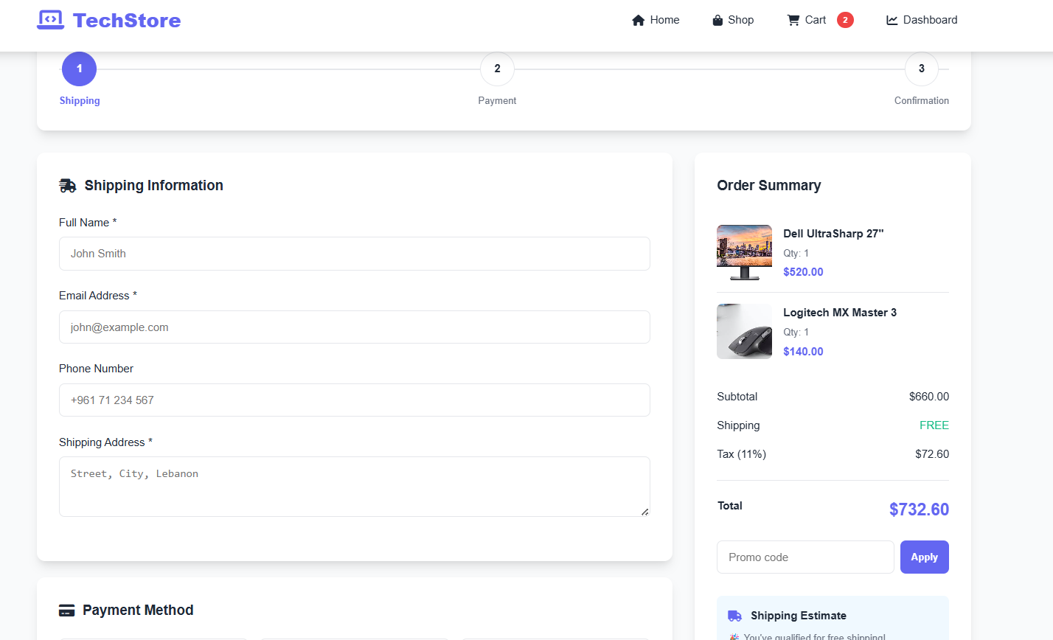

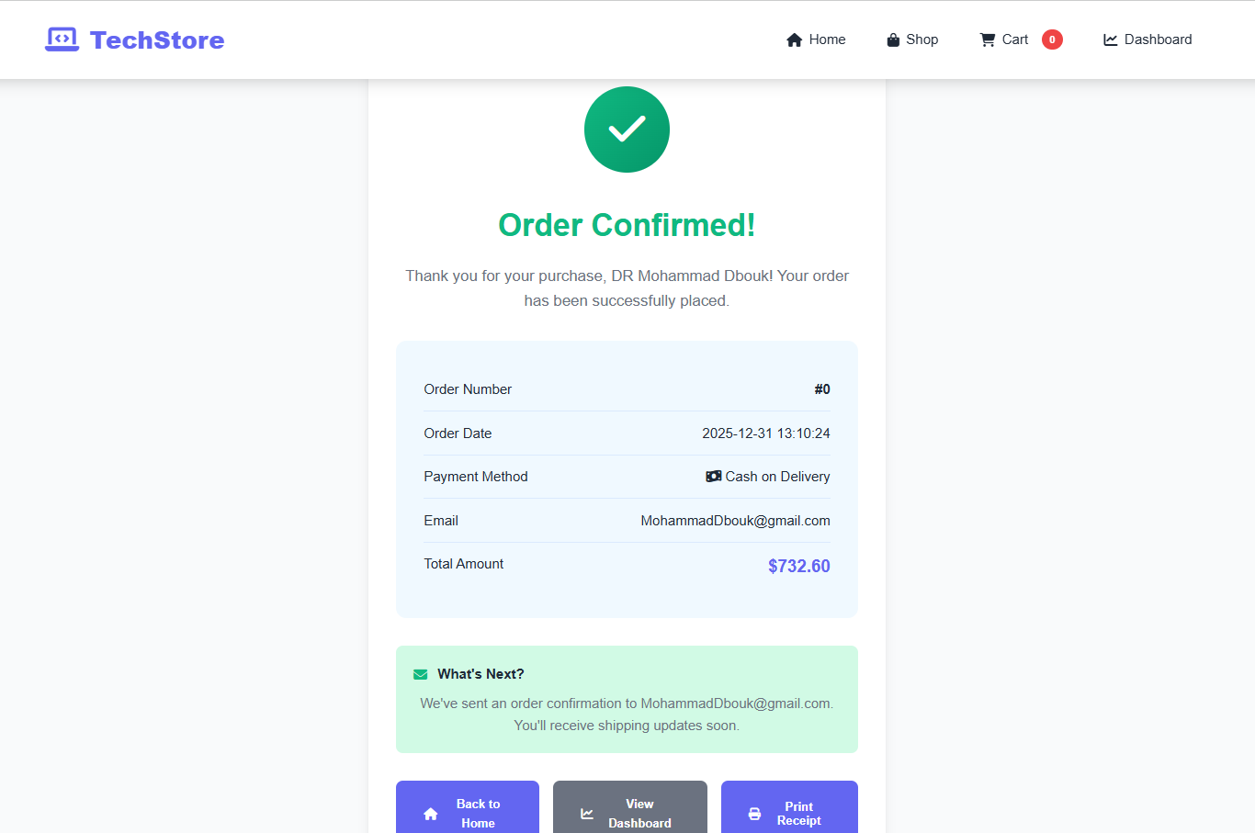

- 3. Administrative Control & Business Intelligence
A. The Operational Dashboard (dashboard.php)
- The Interface: A real-time command center for the store manager.
- The DB Link: Instead of static data, we use SQL Aggregate Functions (SUM(TotalAmount), COUNT(OrderID)). It pulls "Low Stock" alerts directly from the vw_LowStockProducts view, allowing for proactive inventory management.
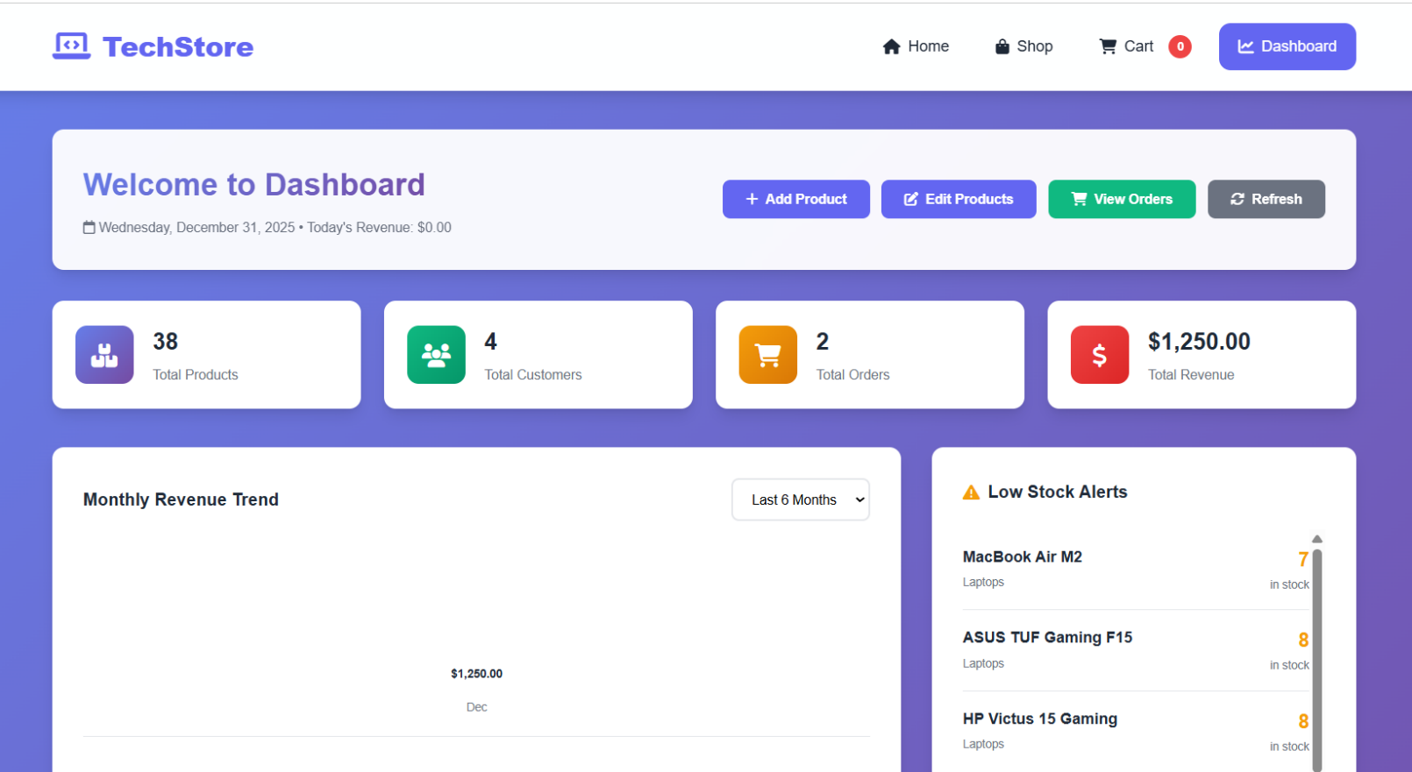

B. Inventory & Supplier Management (add_product.php, edit_product.php, products_admin.php)
- The Interface: Forms to add, update, or delete products and manage orders.
- The DB Link:
  - Data Governance: When adding a product, a dropdown pulls names from the Supplier table, enforcing a Foreign Key relationship.
  - Advanced Administrative Filtering: To handle a large inventory, the products_admin.php includes a multi-criteria filter. This allows the admin to filter by Supplier, Category, or Stock Status (e.g., "Show all Laptops from TechSupply Lebanon that are Low in Stock").
- Technical Implementation: This uses a dynamic SQL query with multiple AND conditions. By filtering at the database level, we reduce the data load on the browser, ensuring a fast and responsive management experience.
  - Auditability: When the Admin edits a price in edit_product.php, the trg_ProductAudit trigger fires, saving the old and new price in the AuditLog.
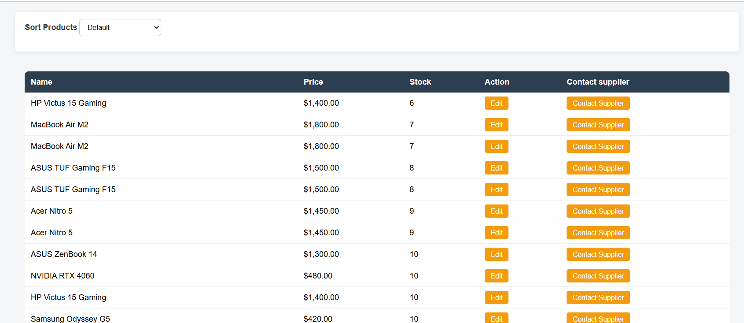
  - Supplier Communication: In the admin list, we integrated a "Contact Supplier" feature. By joining the Product and Supplier tables, the admin can click a button to immediately see the phone/email of the vendor responsible for that specific item.
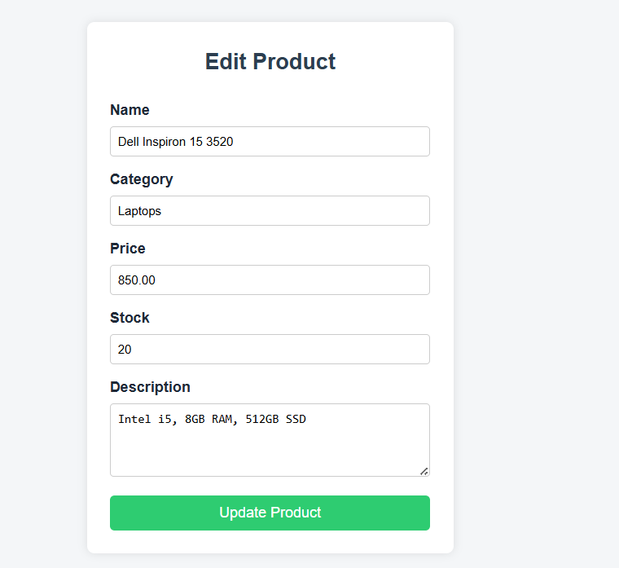
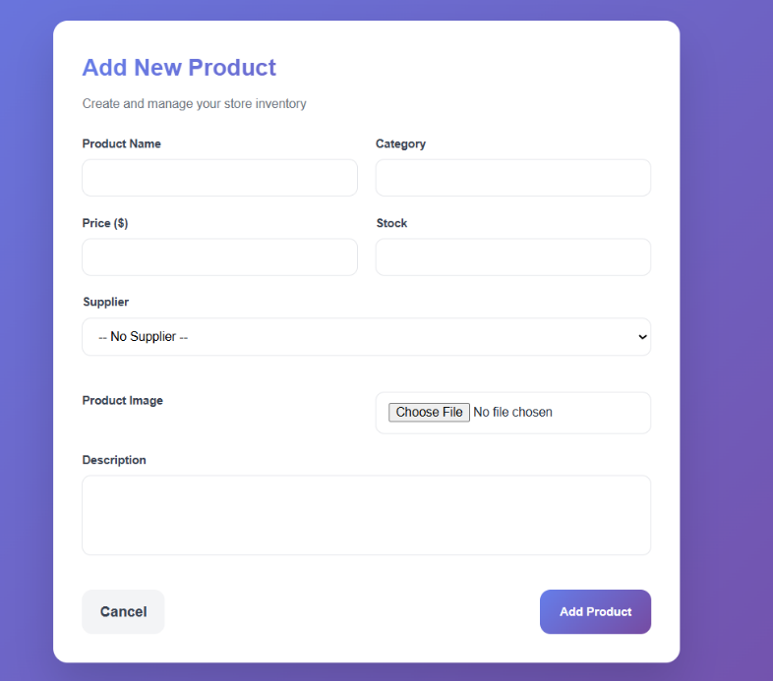

C. Order Lifecycle & Deletion (orders.php & delete_order.php)
- The Interface: A list of all historical sales.
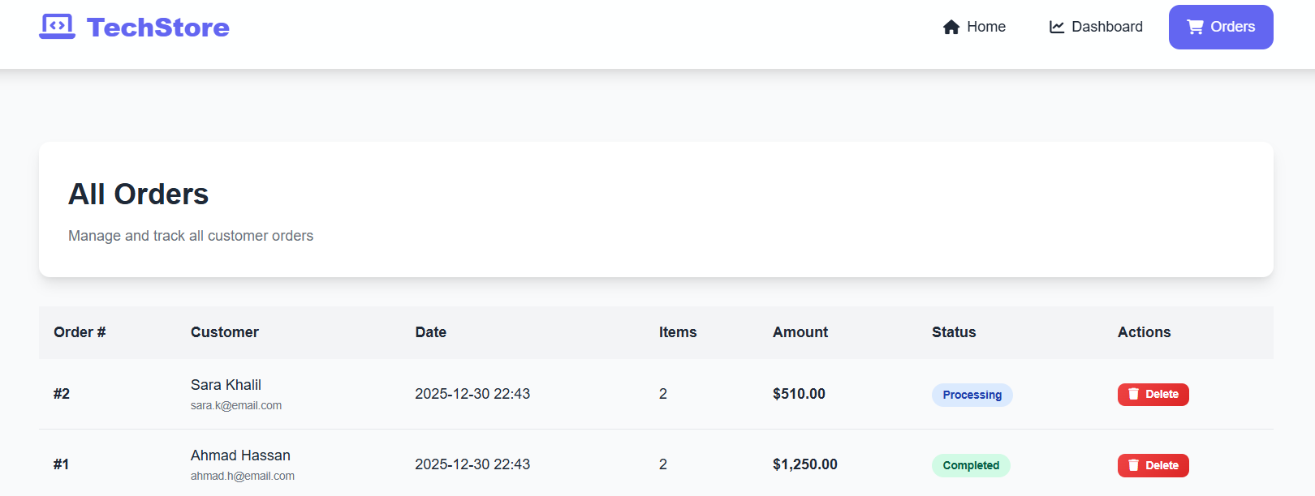
- The DB Link: If an order is cancelled or deleted, we use ON DELETE CASCADE or the trg_RestoreStock trigger to ensure that the products are returned to the inventory automatically. This maintains Data Consistency without manual work.

CHAPTER 4:

Application Implementation and testing

6.1 DDL scripts

-- Computer Store Database Creation

USE master;
GO

-- Drop database if exists
IF EXISTS (SELECT name FROM sys.databases WHERE name = 'ComputerStore')
BEGIN
ALTER DATABASE ComputerStore SET SINGLE_USER WITH ROLLBACK IMMEDIATE;
DROP DATABASE ComputerStore;
END
GO

-- Create database
CREATE DATABASE ComputerStore;
GO

-- Use the database
USE ComputerStore;
GO

PRINT 'Database ComputerStore created successfully';
GO

-- Create Tables

USE ComputerStore;
GO

-- Table: Supplier
CREATE TABLE Supplier (
SupplierID INT IDENTITY(1,1) PRIMARY KEY,
Name NVARCHAR(100) NOT NULL,
Email NVARCHAR(100) NOT NULL UNIQUE,
Phone NVARCHAR(20),
Address NVARCHAR(255),
CreatedAt DATETIME DEFAULT GETDATE()
);
GO

-- Table: Customer
CREATE TABLE Customer (
CustomerID INT IDENTITY(1,1) PRIMARY KEY,
Name NVARCHAR(100) NOT NULL,
Email NVARCHAR(100) NOT NULL UNIQUE,
Phone NVARCHAR(20),
Address NVARCHAR(255),
RegistrationDate DATETIME DEFAULT GETDATE()
);
GO

-- Table: Product
CREATE TABLE Product (
ProductID INT IDENTITY(1,1) PRIMARY KEY,
Name NVARCHAR(150) NOT NULL,
Category NVARCHAR(50) NOT NULL,
Price DECIMAL(10,2) NOT NULL CHECK (Price >= 0),
Stock INT NOT NULL DEFAULT 0 CHECK (Stock >= 0),
SupplierID INT,
Description NVARCHAR(MAX),
ImageURL NVARCHAR(255),
CreatedAt DATETIME DEFAULT GETDATE(),
FOREIGN KEY (SupplierID) REFERENCES Supplier(SupplierID) ON DELETE SET NULL
);
GO

-- Table: Orders
CREATE TABLE Orders (
OrderID INT IDENTITY(1,1) PRIMARY KEY,
CustomerID INT NOT NULL,
OrderDate DATETIME DEFAULT GETDATE(),
TotalAmount DECIMAL(10,2) DEFAULT 0.00,
Status NVARCHAR(20) DEFAULT 'Pending' CHECK (Status IN ('Pending', 'Processing', 'Completed', 'Cancelled')),
FOREIGN KEY (CustomerID) REFERENCES Customer(CustomerID)
);
GO

-- Table: OrderDetail
CREATE TABLE OrderDetail (
OrderDetailID INT IDENTITY(1,1) PRIMARY KEY,
OrderID INT NOT NULL,
ProductID INT NOT NULL,
Quantity INT NOT NULL CHECK (Quantity > 0),
UnitPrice DECIMAL(10,2) NOT NULL,
FOREIGN KEY (OrderID) REFERENCES Orders(OrderID) ON DELETE CASCADE,
FOREIGN KEY (ProductID) REFERENCES Product(ProductID)
);
GO

-- Table: AuditLog
CREATE TABLE AuditLog (
LogID INT IDENTITY(1,1) PRIMARY KEY,
TableName NVARCHAR(50),
Operation NVARCHAR(10),
RecordID INT,
ChangedAt DATETIME DEFAULT GETDATE(),
Details NVARCHAR(MAX)
);
GO

PRINT 'All tables created successfully';
GO

-- Create Indexes

USE ComputerStore;
GO

-- Foreign Key Indexes
CREATE INDEX idx_product_supplier ON Product(SupplierID);
CREATE INDEX idx_orders_customer ON Orders(CustomerID);
CREATE INDEX idx_orderdetail_order ON OrderDetail(OrderID);
CREATE INDEX idx_orderdetail_product ON OrderDetail(ProductID);

-- Search Optimization Indexes
CREATE INDEX idx_customer_email ON Customer(Email);
CREATE INDEX idx_product_category ON Product(Category);
CREATE INDEX idx_orders_date ON Orders(OrderDate);
CREATE INDEX idx_orders_status ON Orders(Status);

PRINT 'All indexes created successfully';
GO

6.2 Advanced Database Objects & Logic Automation: Triggers,Views, Stored procedures and functions.

-- Create Triggers

USE ComputerStore;
GO

-- Trigger: Check stock before inserting order detail
CREATE TRIGGER trg_CheckStock
ON OrderDetail
INSTEAD OF INSERT
AS
BEGIN
DECLARE @ProductID INT;
DECLARE @Quantity INT;
DECLARE @AvailableStock INT;

SELECT @ProductID = ProductID, @Quantity = Quantity FROM inserted;

SELECT @AvailableStock = Stock FROM Product WHERE ProductID = @ProductID;

IF @AvailableStock < @Quantity
BEGIN
RAISERROR ('Insufficient stock for this product', 16, 1);
ROLLBACK TRANSACTION;
END
ELSE
BEGIN
INSERT INTO OrderDetail (OrderID, ProductID, Quantity, UnitPrice)
SELECT OrderID, ProductID, Quantity, UnitPrice FROM inserted;

-- Update stock
UPDATE Product
SET Stock = Stock - @Quantity
WHERE ProductID = @ProductID;

-- Update order total
UPDATE Orders
SET TotalAmount = (
SELECT SUM(Quantity * UnitPrice)
FROM OrderDetail
WHERE OrderID = (SELECT OrderID FROM inserted)
)
WHERE OrderID = (SELECT OrderID FROM inserted);
END
END;
GO

-- Trigger: Restore stock when order detail is deleted
CREATE TRIGGER trg_RestoreStock
ON OrderDetail
AFTER DELETE
AS
BEGIN
DECLARE @ProductID INT;
DECLARE @Quantity INT;
DECLARE @OrderID INT;

SELECT @ProductID = ProductID, @Quantity = Quantity, @OrderID = OrderID FROM deleted;

UPDATE Product
SET Stock = Stock + @Quantity
WHERE ProductID = @ProductID;

-- Update order total
UPDATE Orders
SET TotalAmount = ISNULL((
SELECT SUM(Quantity * UnitPrice)
FROM OrderDetail
WHERE OrderID = @OrderID
), 0)
WHERE OrderID = @OrderID;
END;
GO

-- Trigger: Audit log for product changes
CREATE TRIGGER trg_ProductAudit
ON Product
AFTER UPDATE
AS
BEGIN
INSERT INTO AuditLog (TableName, Operation, RecordID, Details)
SELECT
'Product',
'UPDATE',
i.ProductID,
'Price: ' + CAST(d.Price AS NVARCHAR) + ' -> ' + CAST(i.Price AS NVARCHAR) +
', Stock: ' + CAST(d.Stock AS NVARCHAR) + ' -> ' + CAST(i.Stock AS NVARCHAR)
FROM inserted i
INNER JOIN deleted d ON i.ProductID = d.ProductID;
END;
GO

PRINT 'All triggers created successfully';
GO

-- Create Views

USE ComputerStore;
GO

-- View: Product Inventory
CREATE VIEW vw_ProductInventory AS
SELECT
p.ProductID,
p.Name AS ProductName,
p.Category,
p.Price,
p.Stock,
p.ImageURL,
s.Name AS SupplierName
FROM Product p
LEFT JOIN Supplier s ON p.SupplierID = s.SupplierID;
GO

-- View: Order Summary
CREATE VIEW vw_OrderSummary AS
SELECT
o.OrderID,
c.Name AS CustomerName,
c.Email AS CustomerEmail,
o.OrderDate,
o.TotalAmount,
o.Status,
(SELECT COUNT(*) FROM OrderDetail WHERE OrderID = o.OrderID) AS TotalItems
FROM Orders o
INNER JOIN Customer c ON o.CustomerID = c.CustomerID;
GO

-- View: Low Stock Products
CREATE VIEW vw_LowStockProducts AS
SELECT
ProductID,
Name,
Category,
Stock,
Price
FROM Product
WHERE Stock < 10;
GO

-- View: Sales by Category
CREATE VIEW vw_SalesByCategory AS
SELECT
p.Category,
COUNT(DISTINCT o.OrderID) AS TotalOrders,
SUM(od.Quantity) AS TotalQuantitySold,
SUM(od.Quantity * od.UnitPrice) AS TotalRevenue
FROM Product p
INNER JOIN OrderDetail od ON p.ProductID = od.ProductID
INNER JOIN Orders o ON od.OrderID = o.OrderID
WHERE o.Status = 'Completed'
GROUP BY p.Category;
GO

PRINT 'All views created successfully';
GO

-- Create Stored Procedures and Functions

USE ComputerStore;
GO

-- Procedure: Create new order
CREATE PROCEDURE sp_CreateOrder
@CustomerID INT,
@OrderID INT OUTPUT
AS
BEGIN
INSERT INTO Orders (CustomerID, Status)
VALUES (@CustomerID, 'Pending');

SET @OrderID = SCOPE_IDENTITY();
END;
GO

-- Procedure: Add item to order (with transaction)
CREATE PROCEDURE sp_AddOrderItem
@OrderID INT,
@ProductID INT,
@Quantity INT
AS
BEGIN
BEGIN TRANSACTION;
BEGIN TRY
DECLARE @Price DECIMAL(10,2);

SELECT @Price = Price FROM Product WHERE ProductID = @ProductID;

INSERT INTO OrderDetail (OrderID, ProductID, Quantity, UnitPrice)
VALUES (@OrderID, @ProductID, @Quantity, @Price);

COMMIT TRANSACTION;
END TRY
BEGIN CATCH
ROLLBACK TRANSACTION;
THROW;
END CATCH
END;
GO

-- Procedure: Get customer orders using cursor
CREATE PROCEDURE sp_GetCustomerOrdersWithCursor
@CustomerID INT
AS
BEGIN
DECLARE @OrderID INT;
DECLARE @OrderDate DATETIME;
DECLARE @TotalAmount DECIMAL(10,2);
DECLARE @Status NVARCHAR(20);

-- Create temp table for results
CREATE TABLE #CustomerOrders (
OrderID INT,
OrderDate DATETIME,
TotalAmount DECIMAL(10,2),
Status NVARCHAR(20)
);

-- Declare cursor
DECLARE order_cursor CURSOR FOR
SELECT OrderID, OrderDate, TotalAmount, Status
FROM Orders
WHERE CustomerID = @CustomerID
ORDER BY OrderDate DESC;

OPEN order_cursor;

FETCH NEXT FROM order_cursor INTO @OrderID, @OrderDate, @TotalAmount, @Status;

WHILE @@FETCH_STATUS = 0
BEGIN
INSERT INTO #CustomerOrders VALUES (@OrderID, @OrderDate, @TotalAmount, @Status);
FETCH NEXT FROM order_cursor INTO @OrderID, @OrderDate, @TotalAmount, @Status;
END;

CLOSE order_cursor;
DEALLOCATE order_cursor;

SELECT * FROM #CustomerOrders;
DROP TABLE #CustomerOrders;
END;
GO

-- Function: Calculate total sales
CREATE FUNCTION fn_TotalSales(@StartDate DATE, @EndDate DATE)
RETURNS DECIMAL(10,2)
AS
BEGIN
DECLARE @Total DECIMAL(10,2);

SELECT @Total = ISNULL(SUM(TotalAmount), 0)
FROM Orders
WHERE OrderDate BETWEEN @StartDate AND @EndDate
AND Status = 'Completed';

RETURN @Total;
END;
GO

-- Procedure: Update order status
CREATE PROCEDURE sp_UpdateOrderStatus
@OrderID INT,
@NewStatus NVARCHAR(20)
AS
BEGIN
UPDATE Orders
SET Status = @NewStatus
WHERE OrderID = @OrderID;
END;
GO

PRINT 'All procedures and functions created successfully';
GO

-- Create Users and Roles
USE ComputerStore;
GO

-- Note: In development, we typically use Windows Authentication or sa account
-- For production, create specific users with limited privileges

-- Create a read-only role for reports
IF NOT EXISTS (SELECT * FROM sys.database_principals WHERE name = 'ReportUser')
BEGIN
CREATE USER ReportUser WITHOUT LOGIN;
END
GO

-- Grant read permissions to views
GRANT SELECT ON vw_ProductInventory TO ReportUser;
GRANT SELECT ON vw_OrderSummary TO ReportUser;
GRANT SELECT ON vw_LowStockProducts TO ReportUser;
GRANT SELECT ON vw_SalesByCategory TO ReportUser;
GO

PRINT 'Users and roles configured successfully';
GO

DML scripts

Data insertions

USE ComputerStore;
GO

-- Insert Suppliers
INSERT INTO Supplier (Name, Email, Phone, Address) VALUES
('TechSupply Lebanon', 'contact@techsupply.lb', '+961 1 234567', 'Beirut, Lebanon'),
('Global Components', 'info@globalcomp.com', '+961 1 345678', 'Jounieh, Lebanon'),
('Elite Hardware', 'sales@elitehw.com', '+961 1 456789', 'Tripoli, Lebanon');
GO

-- Insert Customers
INSERT INTO Customer (Name, Email, Phone, Address) VALUES
('Ahmad Hassan', 'ahmad.h@email.com', '+961 70 123456', 'Hamra, Beirut'),
('Sara Khalil', 'sara.k@email.com', '+961 71 234567', 'Ashrafieh, Beirut'),
('Mohamed Ali', 'mohamed.a@email.com', '+961 76 345678', 'Saida, Lebanon'),
('Layla Fares', 'layla.f@email.com', '+961 78 456789', 'Tripoli, Lebanon');
GO

-- Insert Products
INSERT INTO Product (Name, Category, Price, Stock, SupplierID, Description, ImageURL) VALUES
('Dell Inspiron 15 3520', 'Laptops', 850, 20, 1, 'Intel i5, 8GB RAM, 512GB SSD', 'laptop01.webp'),
('Dell Latitude 5530', 'Laptops', 1200, 15, 1, 'Business laptop, Intel i7, 16GB RAM', 'laptop02.jpg'),
('HP Pavilion 15', 'Laptops', 900, 18, 2, 'Everyday laptop, Intel i5, SSD', 'laptop03.jpg'),
('HP Victus 15 Gaming', 'Laptops', 1400, 10, 2, 'Gaming laptop with RTX GPU', 'laptop04.jpg'),
('Lenovo IdeaPad 5', 'Laptops', 780, 22, 3, 'Slim laptop, Ryzen 5', 'laptop05.avif'),
('Lenovo ThinkPad E14', 'Laptops', 1100, 12, 3, 'Professional business laptop', 'laptop06.jpg'),
('ASUS VivoBook 15', 'Laptops', 830, 20, 1, 'Lightweight laptop for students', 'laptop07.jpg'),
('ASUS ZenBook 14', 'Laptops', 1300, 10, 1, 'Premium ultrabook', 'laptop08.jpg'),
('ASUS TUF Gaming F15', 'Laptops', 1500, 8, 1, 'Gaming laptop, high performance', 'laptop09.jpg'),
('Acer Aspire 5', 'Laptops', 760, 25, 2, 'Affordable daily laptop', 'laptop10.jpg'),
('Acer Nitro 5', 'Laptops', 1450, 9, 2, 'Gaming laptop with cooling system', 'laptop11.jpeg'),
('MacBook Air M2', 'Laptops', 1800, 7, 1, 'Apple M2 chip, ultrathin design', 'laptop12.jpg'),

('Dell UltraSharp 27"', 'Monitors', 520, 14, 1, '27 inch QHD professional monitor', 'monitor01.jpg'),
('HP 24mh IPS Monitor', 'Monitors', 230, 20, 2, '24 inch Full HD IPS', 'monitor02.jpg'),
('LG UltraWide 29"', 'Monitors', 380, 12, 2, 'UltraWide productivity monitor', 'monitor03.jpg'),
('Samsung Odyssey G5', 'Monitors', 420, 10, 1, 'Gaming curved monitor', 'monitor04.jpg'),
('ASUS TUF Gaming 24"', 'Monitors', 310, 16, 3, '144Hz gaming monitor', 'monitor05.png'),
('Acer Nitro VG240Y', 'Monitors', 260, 18, 3, 'Gaming IPS monitor', 'monitor06.jpg'),

('Logitech G Pro Mouse', 'Accessories', 120, 30, 2, 'Professional gaming mouse', 'accessory01.webp'),
('Razer DeathAdder Essential', 'Accessories', 70, 40, 2, 'Ergonomic gaming mouse', 'accessory02.jpg'),
('Logitech MX Master 3', 'Accessories', 140, 25, 1, 'Advanced wireless mouse', 'accessory03.jpg'),
('Redragon K552 Keyboard', 'Accessories', 85, 35, 3, 'Mechanical RGB keyboard', 'accessory04.jpg'),
('Corsair K70 RGB Keyboard', 'Accessories', 170, 15, 1, 'Premium mechanical keyboard', 'accessory05.jpg'),
('SteelSeries Arctis 5', 'Accessories', 150, 18, 3, 'Gaming headset with surround sound', 'accessory06.jpg'),

('Samsung 970 EVO Plus 1TB', 'Storage', 160, 30, 1, 'High speed NVMe SSD', 'storage01.jpg'),
('Kingston NV2 500GB', 'Storage', 70, 40, 2, 'Affordable NVMe SSD', 'storage02.jpg'),
('WD Blue 2TB HDD', 'Storage', 85, 35, 2, 'Internal hard drive', 'storage03.png'),
('Seagate Barracuda 1TB', 'Storage', 60, 45, 3, 'Reliable HDD storage', 'storage04.jpg'),

('Intel Core i7-13700K', 'Components', 420, 20, 1, '13th Gen Intel Processor', 'component01.jpg'),
('AMD Ryzen 5 5600X', 'Components', 260, 25, 2, 'High performance CPU', 'component02.jpg'),
('Corsair Vengeance 16GB RAM', 'Components', 95, 40, 3, 'DDR4 Gaming RAM', 'component03.jpg'),
('NVIDIA RTX 4060', 'Components', 480, 10, 1, 'Next-gen graphics card', 'component04.jpg'),

('TP-Link Archer AX55', 'Networking', 150, 25, 2, 'WiFi 6 Router', 'network01.jpg'),
('ASUS RT-AX58U', 'Networking', 180, 20, 1, 'High speed WiFi router', 'network02.jpg'),
('NETGEAR 8-Port Switch', 'Networking', 90, 30, 3, 'Gigabit Ethernet switch', 'network03.jpg'),

('Windows 11 Pro', 'Software', 190, 100, 1, 'Microsoft OS License', 'software01.jpg'),
('Microsoft Office 365', 'Software', 99, 120, 2, '1 Year subscription', 'software02.png'),
('Adobe Photoshop', 'Software', 120, 80, 3, 'Photo editing software', 'software03.png');

GO

-- Insert sample orders
DECLARE @OrderID1 INT, @OrderID2 INT;

INSERT INTO Orders (CustomerID, Status) VALUES (1, 'Completed');
SET @OrderID1 = SCOPE_IDENTITY();

INSERT INTO Orders (CustomerID, Status) VALUES (2, 'Processing');
SET @OrderID2 = SCOPE_IDENTITY();

-- Insert order details (triggers will update stock and totals)
INSERT INTO OrderDetail (OrderID, ProductID, Quantity, UnitPrice) VALUES
(@OrderID1, 1, 1, 1200.00),
(@OrderID1, 3, 2, 25.00);

INSERT INTO OrderDetail (OrderID, ProductID, Quantity, UnitPrice) VALUES
(@OrderID2, 2, 1, 350.00),
(@OrderID2, 4, 2, 80.00);
GO

PRINT 'Sample data inserted successfully';
GO

- Advanced Feature: Database Deployment Automation (.BAT Script)
To ensure the system is production-ready and easily deployable, I developed an automation script (DBapp-I3306.bat).
- The Functionality: This script connects to the SQL Server Instance, creates the TechZoneDB from scratch, builds all tables (DDL), and populates them with initial data (DML).
- Business Value: This allows the store manager or a technician to restore the entire system in seconds if the server is changed. It guarantees that the Triggers, Views, and Procedures are always installed correctly without manual errors.
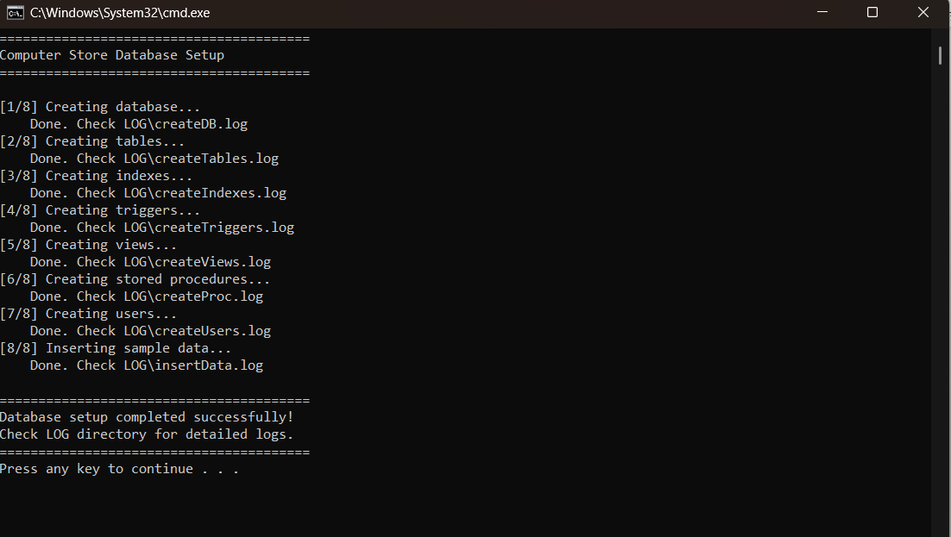

Set of relevant extractions - queries

  - Query 1: Inventory Wealth Analysis (Category Level):
• Purpose: Let the manager know which category has the most tied-up capital.
• SQL: 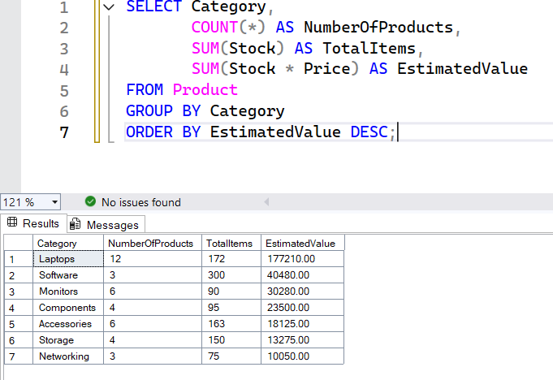

  - Top-Tier Products (Filtering & Logic)
• Purpose: Identifying expensive items that need security or immediate restocking.
• SQL:
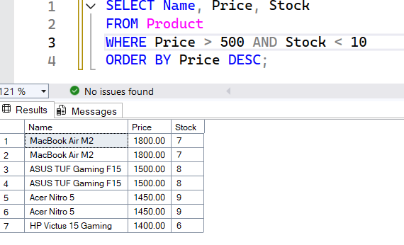
  - Customer Activity Logging (Date Extraction)
- Purpose: Financial month-end reporting.
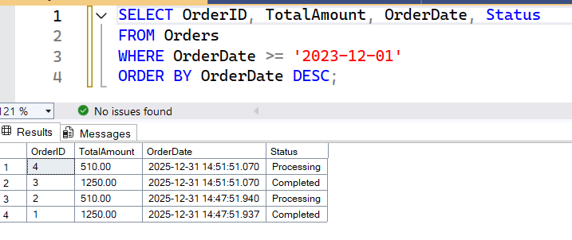
- SQL:

Conclusion:

The development of the TechZone Computers database system marks a significant transition from traditional, fragmented data handling to a centralized, high-integrity relational ecosystem. This project was not merely an exercise in writing SQL queries; it was a comprehensive engineering challenge to build a "Single Source of Truth" for a retail business operating in a demanding market like Lebanon.
By meticulously following the Database Life Cycle (DBLC), we have successfully addressed the "Excel Bottleneck" that plagues many local SMEs. The implementation of advanced database objects—such as ACID-compliant transactions, automated audit triggers, and relational views—ensures that the system does not just store data, but actively protects and analyzes it.
Key achievements of this project include:
- Operational Integrity: Through the use of SQL constraints and "Instead Of" triggers, we have created a system that is "self-aware," preventing common retail errors such as over-selling stock or price inconsistencies.
- Strategic Transparency: The integration of an Audit Log ensures full accountability, bridging the gap between database security and business management.
- Deployment Maturity: The creation of an automated deployment script (.BAT) demonstrates a commitment to software portability and professional delivery standards.
In conclusion, TechZone Computers serves as a robust blueprint for digital transformation in the tech-retail sector. It proves that when sophisticated backend logic is paired with a user-centric interface, the result is more than just a tool—it is a scalable asset that provides real-time business intelligence and long-term operational stability. This project has solidified my understanding of Database II (I3306) principles, moving beyond theoretical normalization into the realm of practical, industrial-grade data management.

