**Sarah Nikkhah**

**H575 Project: London’s 1854 Cholera Epidemic Interactive Data Visualization**

**Fall, 2018**

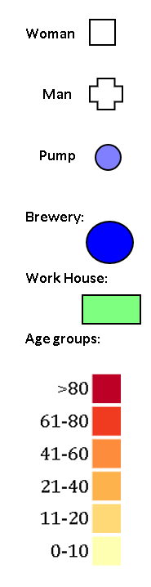**_______________________________________________________________**

To start the design process, I first referred to the original John Snow’s map. The first step was to visualize the map itself. After that I thought about how to visualize the pumps, I thought it can be a good idea to visualize them in blue to better understand that they are pumps. The next step was deciding on age range and gender and how to visualize them as gender had 2 types I decided to visualize it by the square for women and cross for men. So that I could save the color channel for visualizing the age groups. This way I could visualize both the age and gender of the deaths at the same time.

For visualizing the deaths on the map, I decided to combine the whole data set so that I have each individual death with unique information related to their age, sex, location, and date. I decided to use sequential colors for showing the age groups. I used color brewer to generate the colors which were best for visual blinds. I chose a set of color which started as yellow for the lowest age group to red color for older ages. In my perspective brewery color should be blue again but I changed its opacity so that it can be distinguished from the pumps. However, workhouse is totally different, so I decided to distinguish it both by color and shape. it is the only rectangle in the map.

To understand the relationship between the age, sex, and the death rate, I decided to create two separate bar graphs. Showing the total number of deaths by age group and the other by sex. To visualize the timeline and other graphs, I first wanted to choose line graph but as the professor mentioned that there is no data between the genders, ages, dates, it could be better not to use line graph, so I decided to use paragraphs for all of my charts.

To visualize the time window, I used a range slider. So that I could both visualize the data per day and per a window of dates. However, it is not possible to choose days which are not consecutive in this method.

From looking at the results there is a clear relationship between the deaths and the age groups. Sounds like the old people and the small children were more prone to death by the disease which makes sense.

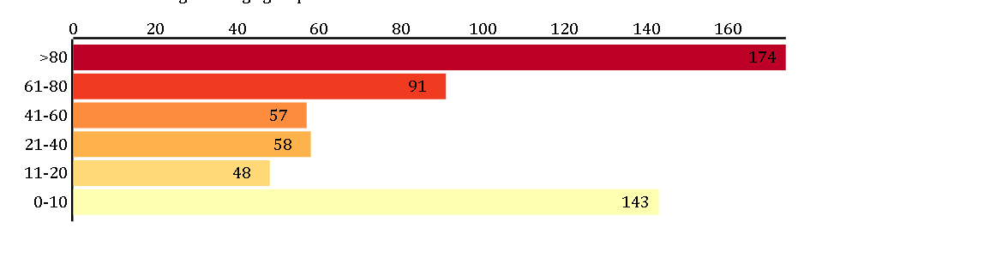

In addition, there seems to be no relationship between age and the deaths according to the results.

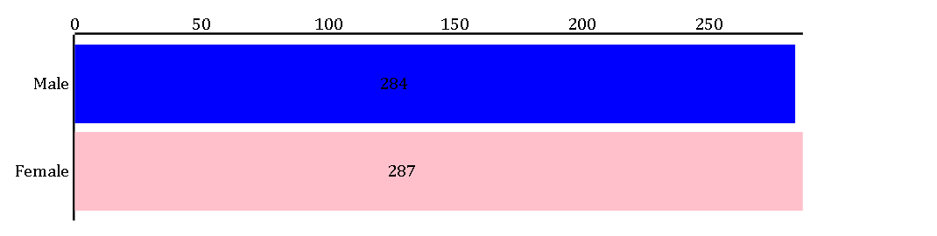

It is also evident that most of the deaths were between August 27th to September 7th . with September 1st and 2nd being the worst days for the people according to deaths.

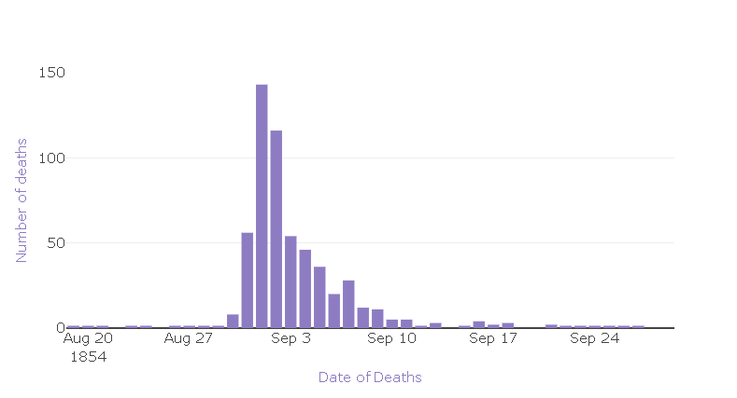

To choose the colors I used <http://colorbrewer2.org/#type=sequential&scheme=BuGn&n=3> To make sure the colors are colorblind safe. At the end I used Color Oracle which as the color blindness simulator to test the visualization.