My Favorite Fruit?

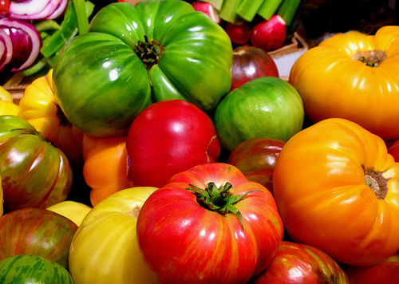

\*97th Street Green Market, West 97th Street and Columbus Avenue

I grew up in Hawaii with my crazy hippie family. My mom, to this day, grows a lot of her own fruits and vegetables. Bananas, papayas, guava, passion fruit, mangos, tangerines, sweet potatoes, carrots, eggplant and tomatoes were always on our table. I never really appreciated how great it was to have these products available year round until I moved here to New York City. A few years ago, my friend Sue, who has a farm in Woodstock New York, gave me a crazy looking fruit; she told me it was an heirloom tomato. It was misshaped, wrinkled and speckled with odd colors and patterns. When I got home that evening, I anxiously cut into this strange fruit; it was undoubtedly the best tomato I have ever tasted. I now look forward to “tomato season” where you can find me scouring my local green market to find my favorite fruit.

\*This is a sample of the assignment; the photo is a stock photo