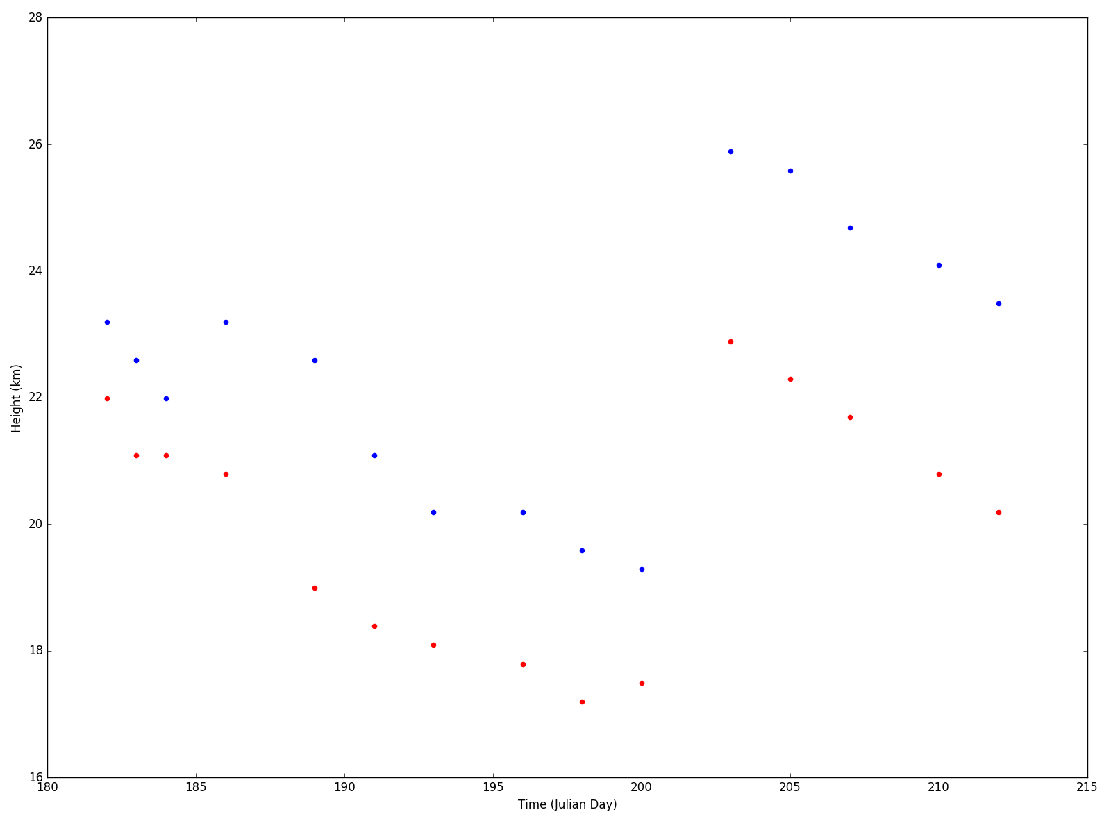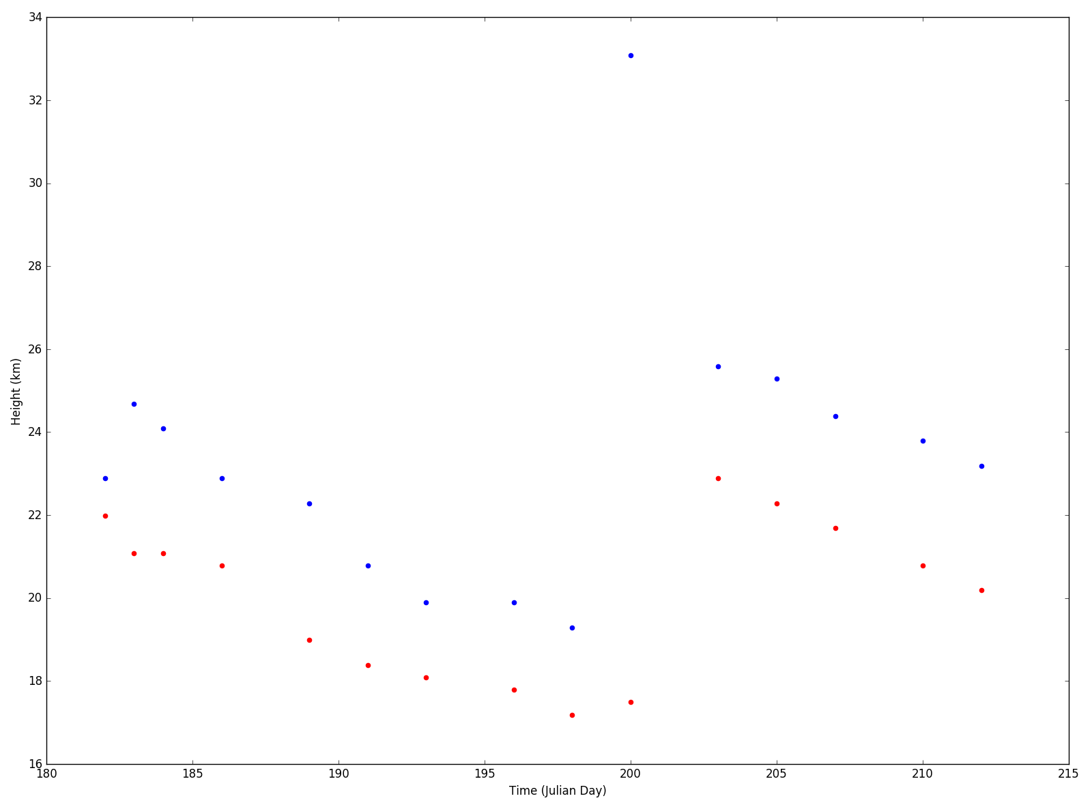

**Above average indices – First [0] and last [-1]** values – results in one outlier.

**Above average indices – First [0] and first point where goes back to below average.**