# Bugs

## Vanilla (NTSC-U_C)

1. During the Darwin event in the Dwarven Pass, his player box should be a tad higher when fighting monsters, on the same X axis coordinate as his face box, which is just slightly above it. This will fix an issue where his character box is blocking out some text.
2. ~~Forest of Sorrows: The Flytrap, Dryad, and Bee enemy encounter formation has 3 cards all stacked o top of each other vertically. This is the only enemy formation I’ve seen like this that doesn’t utilize the extra space on the sides to spread out the cards, and should probably be fixed.~~
3. Axs equipment unequips itself from chapter 3 to 4. (Axs leaves the party before the fight with Sauza)
4. Elemental Spirit’s magic menu reordering gets reset every time you change one out with the Call command. (I think they leave the party too.)
5. I’m not sure if this is a bug or not, but the threshold for when your HP turns read seems to be a much different (percentage?) then yuou have more of it, then when you have less of it. Ex. When you have 999 HP, it doesn’t turn red until you have 49 or 50 HP, which would mean about 5% of your max total. It (seemed) like it would trigger much sooner when you had say, anywhere from 300-500 HP (the percentage for triggering it was higher). This one is a bit difficult to confirm.
6. ~~Gaining triple digits during your final level up will report a strange value displayed for that field. This is because on level 59 to 60, you will gain +100 HP, but 3 digits cannot be displayed properly on this screen, only 1-2. I have save states to show this oddity. Thanks to Sherry Shriner for the info.~~
7. The music during the endings where you see an image of a mountain sounds REALLY choppy. I really doubt this was the way the sound designer intended for this to sound, I *think* it’s glitched out. During the Sound Test, this is track 51, and it plays out the same.
8. You can use stat boosting items AFTER your said stat is already maxed out, and it’ll let you do it, and it will still say your stat has increased, even though it hasn’t.
9. The Goblin “family” of monsters all have non-black outer borders. No other enemy in the game behaves this way, it should be black outer border, and a colored inner border. I’ve attached a sample artwork I made below.

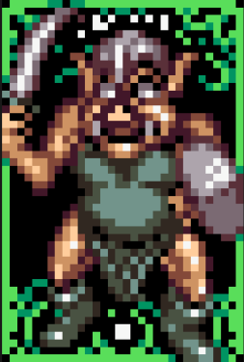 → 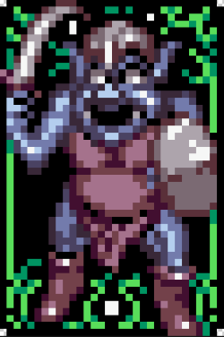

1. Rimsala Phase 2 is missing the top background card artwork design. In my bestiary for Gamefaqs, I added it in.
2. The sky shows on the ground in some screens, like Doraf. (Fastrom bug)

## Seal of Rimsala Patch, V1.0C

1. ~~PATCH: The title screen has parts of the text that are overlayed on other text, but either aren’t fully transparent, or the image from the background isn’t burned on correctly on the letter box overlays. The result is some letters with square cut outs from the rest of the BG.~~
2. ~~PATCH: Stavery tower was renamed to Remorse 1F?, but in the Sarah Cutscene at the door, it’s still called Stavery Tower. (See Screenshot).~~
3. ~~PATCH?: Some of the text on use-items like the honey stat boosters have an empty space before the second line. Attack/defense impair abilities... See screenshots.~~
4. ~~PATCH: Stavery tower has been renamed to Remorse tower, but in the Sarah / Chapter 4 door cutscene, it still says Stavery Tower.~~
5. ~~“Mentecore” should be “Manticore”~~
6. ~~“Aurane”, a Medusa-type enemy, was renamed to “Mandrake”, a type of plant. Should have a different name.~~
7. PATCH: Fastrom causes graphics issues like the 3 Treasures to glitch out, can cause softlocks.

## Known Seal of Rimsala 1.0c Patch Bugs (By Sherry Shriner)

1. ~~When selecting Continue, the "of" in "Seal of Rimsala" turns gray. No big deal.~~
2. ~~If you lose to the final boss and start a new game, there will be graphics junk. Just reset...~~
3. ~~Sometimes spell or item names insert an extra space when referenced, like when casting "Lightning 1 ."~~

# Improvement Ideas

1. Ability to stack items in your menu.
2. Ability to buy more than 1 of the same item at a time in a shop.
3. Ability to scroll around the map screen.
4. Save your previous position in the shop when buying items (like cards), so when you renter it after a purchase, it goes back to where you were.
5. ~~Change 5 of the 7 return rings in chapter 3 dungeons to other items...~~
6. Using the same power-up ability on a character more than once should report some type of error message, like “but it had no effect”.
7. When multi-hit abilities hit your party, it does not follow the order as presented on the screen, but instead a script ordering scheme, as to who gets hit first. IT SHOULD be: 1 = Top left, 2 = Top Right, 3 = Bottom Left, 4 = Bottom Right, player positions. Instead, Rooks is always first, spirit is 2nd, third is third character recruited in said chapter, 4th is 4th character recruited. Overall, if you rearrange your party, it comes off as very odd.
8. Fewer solo boss fights. (Keep Axs in party for Ch3)
9. Make paralysis/petrify allow action but prevent attack/magic.
10. Make Change Element not work if you have elemental weapon/armor.
11. Add a cutscene skip to the intro.
12. Allow opening the map with the X button.

# Script Errors

1. MANUAL: Page 4. “Their whereabouts is still unknown.” Should read “are still unknown.”
2. MANUAL: Page 6: “What could be her plan”? should be “What could her plan be.”
3. ~~PATCH: Naming inconsistency. During the final cutscene to end chapter 1, first the priest is known as “Priest”. During the second half of the cutscene, this changes to “High Priest”. This may have been intentional, but I’m not sure. This is the same entity, though.~~